University of Minnesota and MN Space Grant Consortium

AEM 1905 Freshman Seminar: Fall 2009
Spaceflight with Ballooning
Team Project Documentation

A Team

Alex Cole – Dennis MacAvaney – Paul Kuechenmeister
Seth Sammons – Sean Mateer

December 4th, 2009
Revision C
Revision Log

Revision | Contents | Due Date
A | Conceptual Design | Friday, Oct. 16, 4 p.m.
B | Build/Testing Report | Friday, Nov. 6, 4 p.m.
C | Flight/Analysis Final Report | Tuesday, Dec. 4, 4 p.m.

User Notes (entire document adapted from Colorado Space Grant documentation):

This template describes the topics which should be discussed during the evolution of your documentation. The following sections have a Rev (Revision) letter following the section description. This indicates when this section is expected to be a part of this document. If a section is required in Rev A, then that section should be written for Rev A then updated if necessary in subsequent revisions. As your project becomes more defined, return to previous sections and update them accordingly.

Each time when you submit your Team Project Documentation, remove any unnecessary template notes and to-be-written sections. For example, if you are submitting Rev A, don’t include sections not requested until Rev C.

This report is due in electronic form (Microsoft Word, not pdf) at the times listed in the table above. Please follow this template format exactly.

Write your text sections just like this page – single spaced, 1 inch margins, 12 point font of your choice, leaving single blank lines between paragraphs.
Table of Contents

- Team Assignments…………….………………………………………………………4
- Introduction…………………………………………………………………….……...6
- Mission Overview………………………………………………………………….….6
- Payload Design………………………………………………………………………..7
- Project Management…………………………………………………………………..8
- Project Budgets………………………………………………………………………..9
- Payload Photographs…………………………………………………………………10
- Test Plan and Results………………………………………………………..……….12
- Expected Science Results………………………………………………..…………..13
- Launch and Recovery………………………………………………………………..15
- Results and Analysis…………………………………………………………………18
- Conclusions and Lessons Learned…………………………………………………..24
- Appendix: Program Listings………………………………………………………...24

0.0 Team Project Documentation Writing Assignments
Assign one lead author to each section except for Results and Analysis (that needs to be worked on by everyone!). Each person should be the lead author on two sections. Notice that the sections vary widely in length and complexity. (Rev 0)

Introduction Alex
Mission Overview Alex
Payload Design Dennis
Project Management Paul
Project Budgets Seth
Payload Photographs Sean
Test Plan and Results Paul
Expected Science Results Seth
Launch and Recovery Sean
Results and Analysis All
Conclusions and Lessons Learned Dennis

Oral Presentation Assignments
Assign two team members to help make slides for each of the first two oral presentations. All group members need to pitch in when working on the final oral presentation. (Rev 0)

Conceptual Design Review (CDR) Seth Sean
Flight Readiness Review (FRR) Paul Dennis

Payload Build Assignments
Assign one person to be the overall “team lead” (AKA “team contact”). Their job is to keep tabs on the whole project and keep the teaching staff informed as need be, to organize team meetings, to make sure everything gets done in a timely manner, and once the build is complete to be in charge of ground testing. Assign each of the other four team members to “lead” one item in the first 4 tasks and one item in the last 4 tasks listed below. (Rev 0)

Overall team lead and ground-testing lead Alex

Flight computer (BalloonSat Easy) build Paul
Weather station build Seth
Payload box build Dennis
Photographer Sean

Programmer (of flight computer(s)) Paul
Camera and camera experiment Seth
HOBO (payload “health” (internal temp)) Sean
“Other” science experiment Dennis

Launch Day Assignments
Assign each team member a specific responsibility for launch day. (Rev 0)

Photographer Sean
Prediction/tracking assistant Alex
Balloon filling and release assistant Paul
Payload/stack handling specialist Seth
Recovery specialist (needs to go on chase for sure) Dennis

1.0 Introduction

Near-space is between 65,000 feet and 325,000 feet, and is the part of the atmosphere between air space and outer space. Near-spaceflight is when any object is sent up into near-space for any reason. This is most often achieved using the basic principles of density, in the same way that allows submarines to dive and resurface. Most often, it includes an expandable latex balloon filled with helium to provide enough buoyancy to lift a package (or set of packages) to the desired altitude. The balloon is then popped by a controlled device onboard, or is simply allowed to explode due to the low pressure, and the remaining parts are accompanied down by a parachute and recovered. The pocket of atmosphere has its benefits for high-altitude experimental work: anything traveling in near-space does not have to worry about the constant traffic of commercial airlines, any interferences or extremely hostile conditions found in outer space, and it is accessible with a relatively low budget. High-altitude balloons (or weather balloons) are currently the most commonly found objects in near-space, due to their efficiency and cost-effectiveness for achieving that altitude. We have utilized this simple technology to carry our payload to near-space on the 31st of October (2009). When traveling into near-space, one must keep in mind factors that become more extreme (in comparison to those at normal altitudes), such as pressure differences, radiation levels, and temperature extremes. Any overlooked factors could result in a mission failure, and it is important to over-estimate the conditions of near-space.

2.0 Mission Overview

Our team has two missions that we are hoping to gather data on while in near-space: we hope to observe and attempt to quantify physical changes in balloon throughout flight, and also monitor external radiation levels. Our payload box needs to be in working order before take-off in order to survive extreme conditions. The temperature in near-space can reach lower than -65 degrees Celsius. To counter this extreme cold, we have installed an onboard heater, and built our box almost entirely out of insulating materials. This heater should provide enough heat to keep our flight computer and other devices warm enough to function. Our payload box also needs to be able to survive a hard fall should something go wrong in descent. We believe that the box we built has the strength to withstand this complication. Unlike other teams, we decided it would help us to wrap our foam core box in the black foam rather than install it on the inside. This will protect our box against cold and absorb sunlight, and also help stabilize our monitoring instruments should it hit the ground hard. As far as our experiments go, we will be using a video camera to record the change in diameter of the weather balloon during flight. We will be pointing our camera upwards at the balloon and, using time and altitude measures, we will compare the diameter (using the scale of the camera) at various times in flight up until it bursts. Our other unique experiment, monitoring radiation levels, requires us to use a Geiger counter. This instrument will be placed inside our box, and we will hopefully gather sufficient data to show that the higher you fly in Earth’s atmosphere, the more radiation there is. We may also gather extra radiation from the sun and, will see if and how that affects the radiation levels. Along with the two missions unique to our payload, we have included a weather station and HOBO unit to measure temperature, pressure, and relative humidity. The HOBO unit will also monitor the internal temperature of the payload.

3.0 Payload Design

Our idea for payload design was simple: build something that will work the way it needs to! But this proved to require a little more thought. So our final design for our payload turned out different and better than we first imagined. Our team decided that in order to monitor the change in the diameter of the weather balloon, we need to have out camera pointed up. So we installed our camera on the inside of our box, but fixed to the side so that when we attach our payload to the others, the camera can face up and monitor the balloon. Besides our weather station, which is also installed on the inside and, like the camera, has a hole cut in the box for its instrument panel to gather data from the outside, every other device is placed inside the box. Our payload has no limitations, besides the fact that it cannot fly on its own. The parts and equipment that we are using are:
- Foam core
- Tubing, Rigging strings, Key rings, Zip ties, Glue, Tape, Mylar, etc.
- Heater Circuit
- 5 Nine-Volt Batteries (for our Geiger Counter and our Heater)
- Weather Station
- One BalloonSat Easy Flight Computer
- One BalloonSat Mini Flight Computer
- Geiger Counter
- Camera
- HOBO

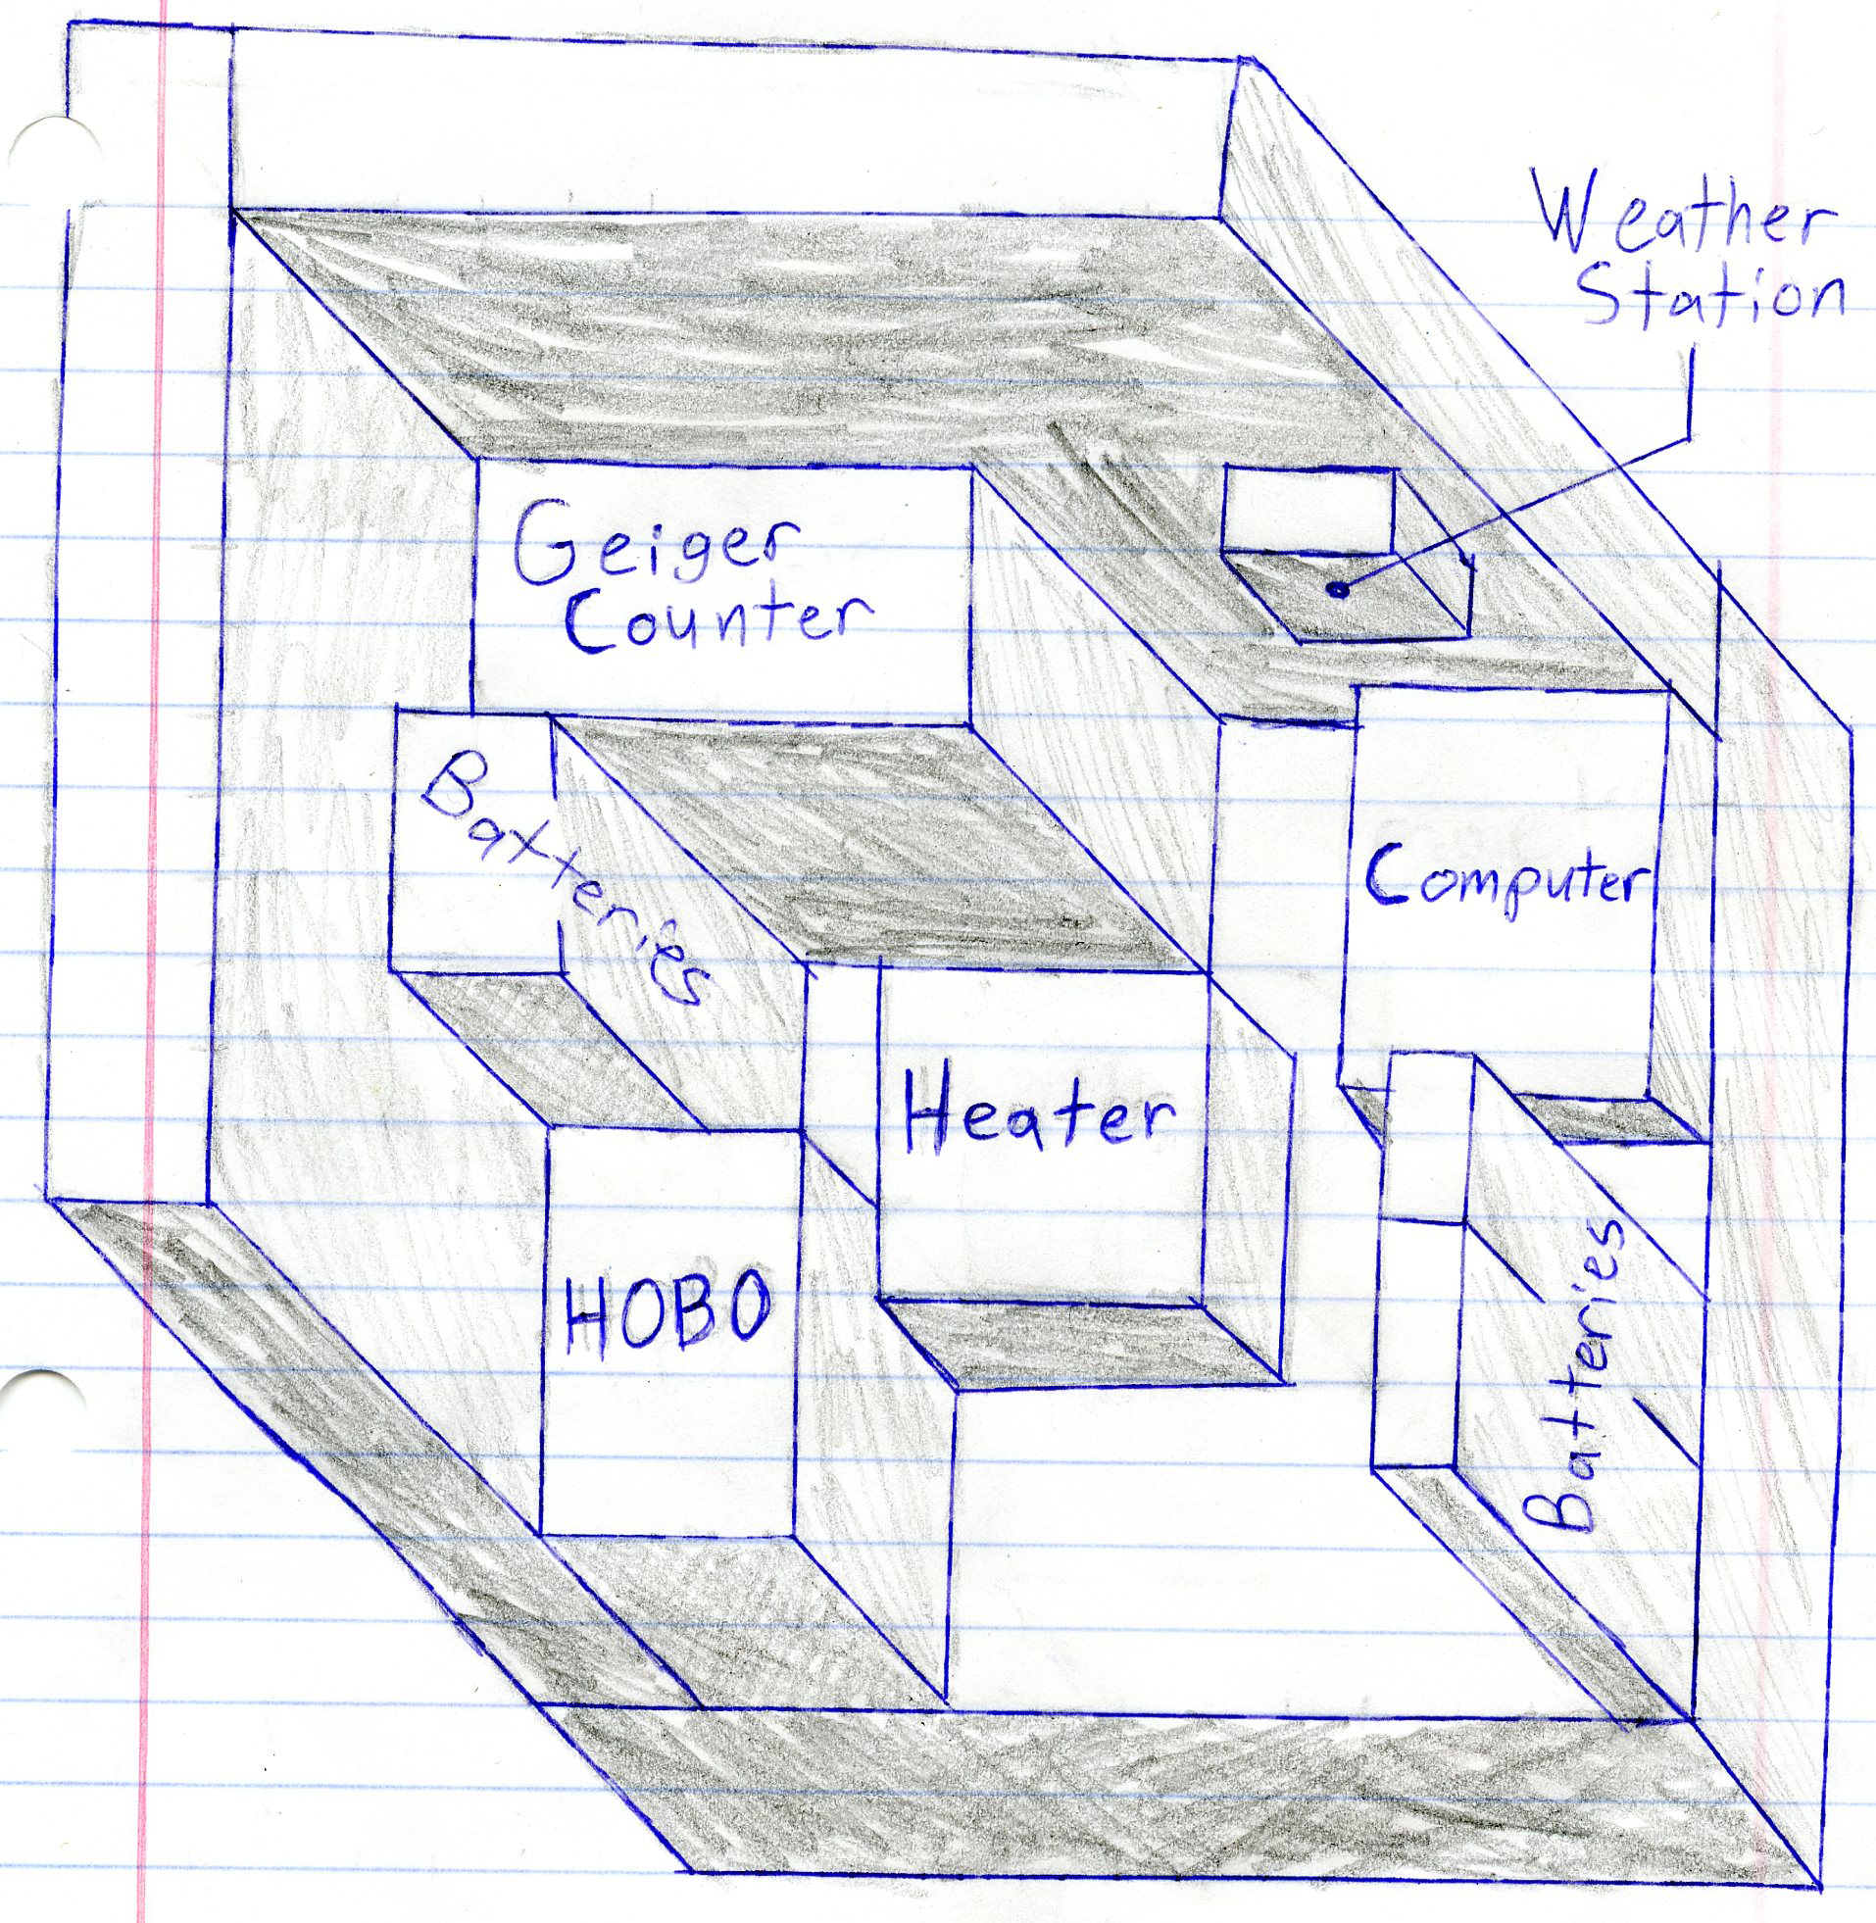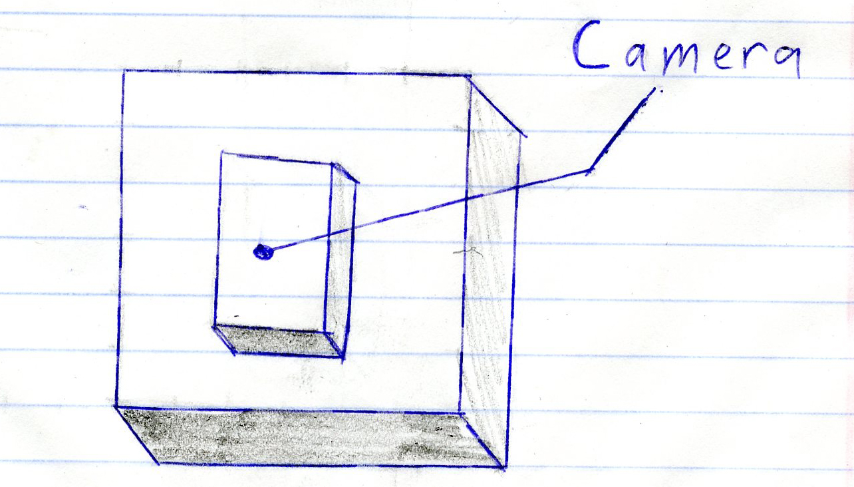

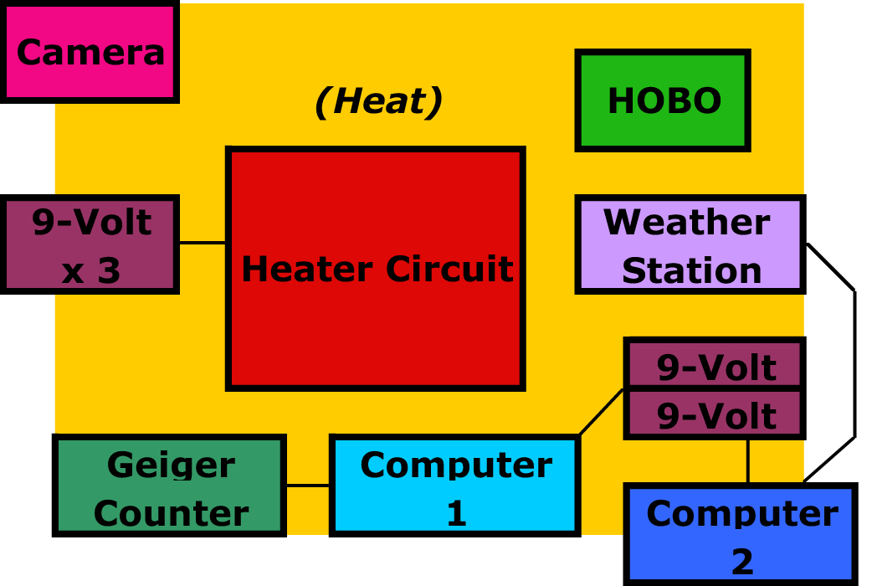

4.0 Project Management

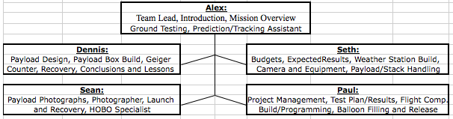

Schedule:

- Wednesday, Sept. 23: Have heater circuit built
- Wednesday, Sept. 30: Have Conceptual Design for payload
- Tuesday, Oct. 6: Proposal/Conceptual Design Review PowerPoint complete
- Wednesday, Oct. 14: Payload construction complete; test durability, weather station, and flight computer
- Friday, Oct. 16: Team Project Documentation – Revision A
- Tuesday, Oct. 27: Have box complete with everything attached and ready to go
- Saturday, Oct. 31: Flight and Chase!
- Friday, Nov. 6: Team Project Documentation – Rev B
- Wednesday, Nov. 18: Final Team Presentation complete and ready to go
- Friday Dec. 4: Team Project Documentation – Rev C

5.0 Project Budgets

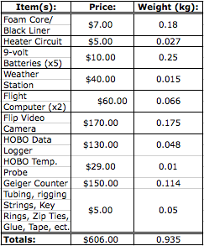

Rev B Correction: The second flight computer used was a balloonsat mini. Its cost and weight were approximately $40.00 and .044kg respectively. This brought our total cost and expected weight to $586.00 and .913kg

Rev C: Final Cost was $586.00. Final weight was 1.05 kg.

6.0 Payload Photographs

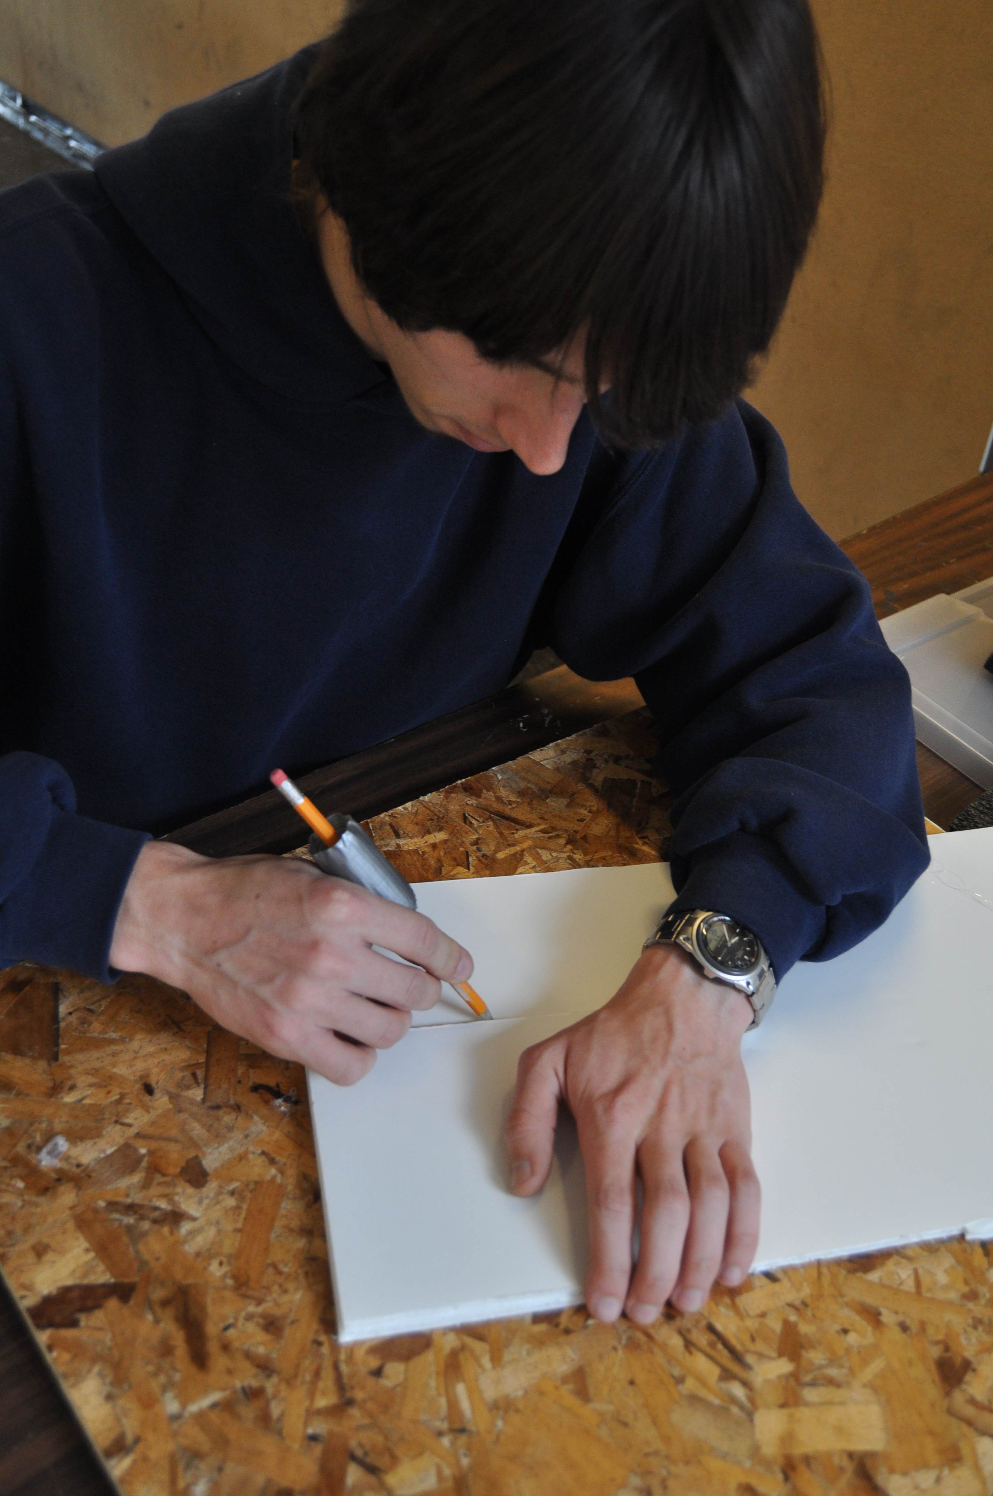
Making initial measurements for inner form core 6x6 box.

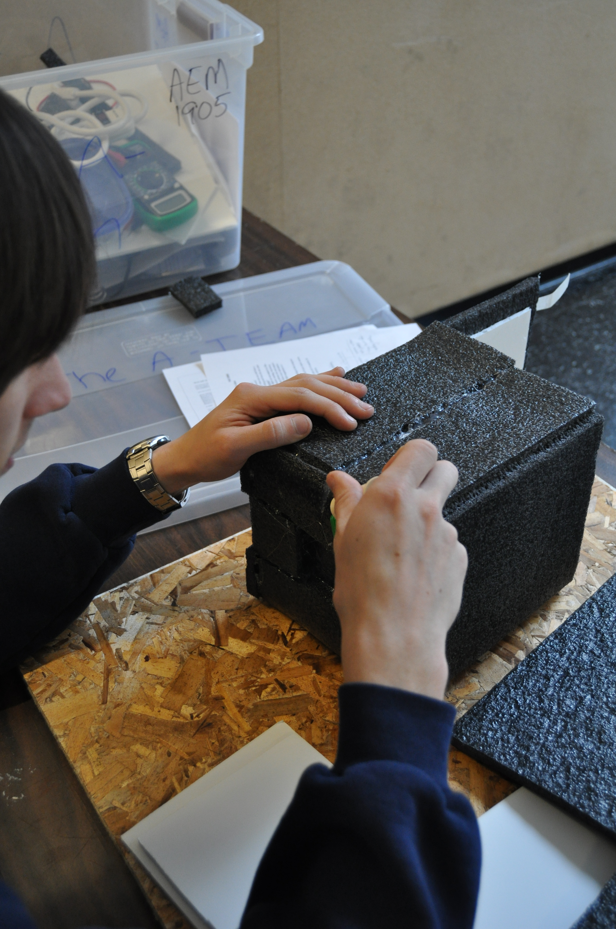
We chose to put the black form lining on the outside of the box instead of inside.

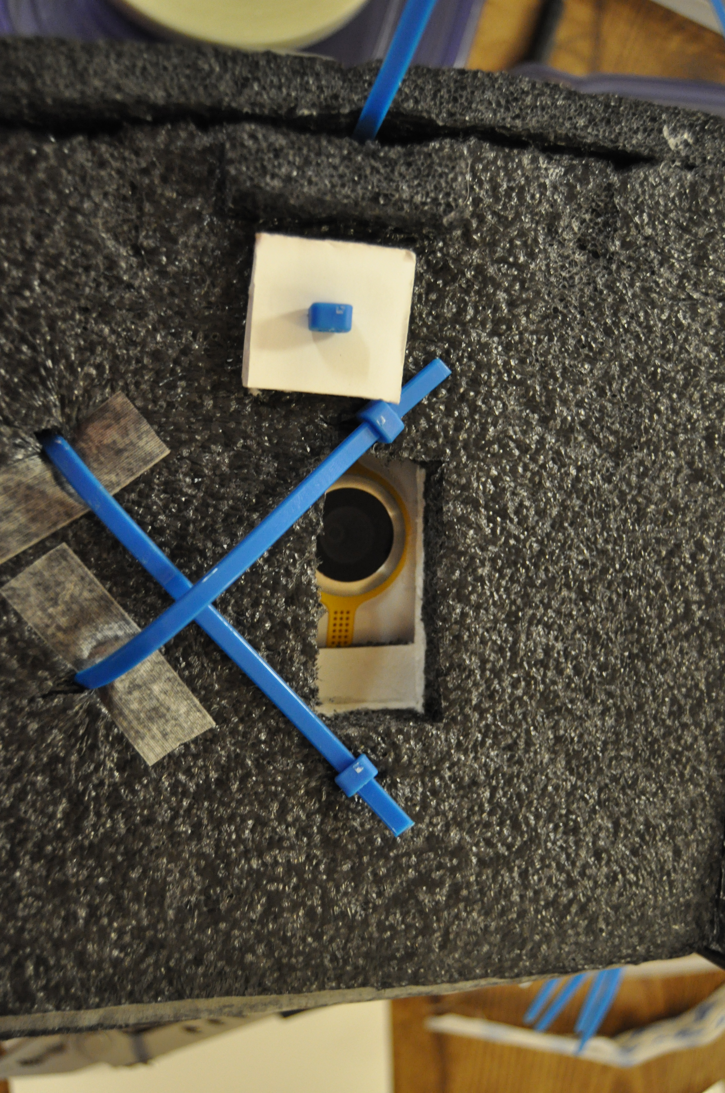

Our camera was mounted on the lid of the box to look up at the balloon throughout flight.

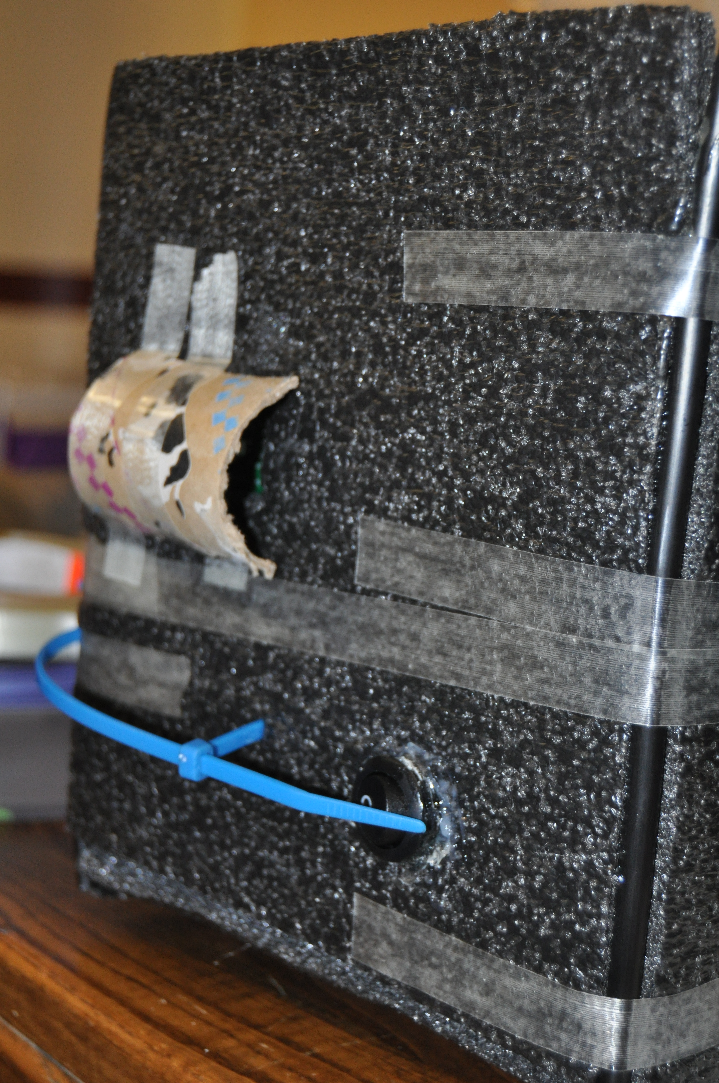
The weather station was protected from direct sunlight by a piece of cardboard tubing. Our heater switch was mounted on the outside of the box so it could be easily turned on.
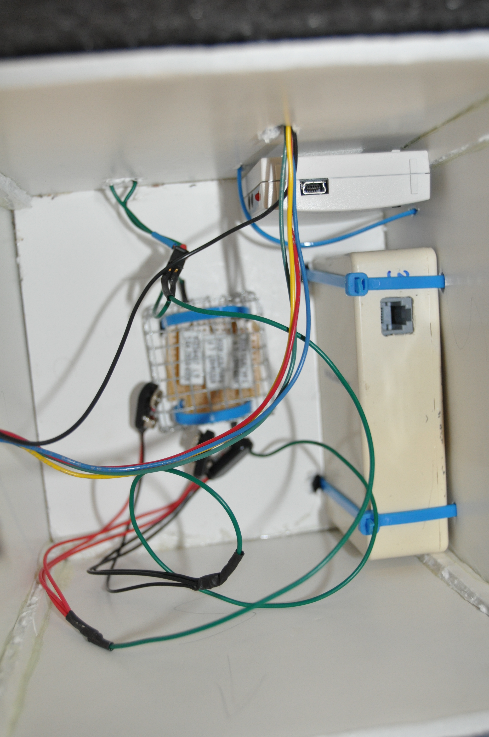
Inside of box without flight computers and batteries.

7.0 Test Plan

We have to test each part individually to ensure that it will work throughout the duration of our box’s flight. The weather station, Geiger counter, and the flight computer all have manuals telling us what to do to prove that they are working properly. However, others such as the heater and the camera do not; we have to test these ourselves. The heater will be easiest to test. We will attach it to 3 9-volt batteries and if it begins to heat up we know that it works. As for the camera, we have to make sure that it can take video for the length of time that we need. In addition, we will need to check and see if the lens works, if it takes batteries or if it needs to be charged, and if the lens has a wide enough angle to see the whole balloon. We should also test our camera by taking it out and filming an object at a certain distance to compare with the results that we receive from our flight. We want to know how far the object can expand before it reaches the edges of our recording screen. This will be done my measuring out a length equal to the full diameter of the balloon, and finding the distance from that area we need to be to see the entire area in the camera. To test our payload, we first need to administer a “drop test.” This test will tell us if our box is built strong and stable enough for flight. We will also need to, once everything is attached and ready for flight, shake it around and make sure that nothing comes unattached or starts rattling around inside our box. We want to test our Geiger counter for radiation changes, and our weather station to see if it is accurately telling the temperature. All of these are necessary to complete before sending our payload into near-space.

7.5 Test Results

Our testing was very successful; only the heater was not working properly at the final test, but it was a simple fix. The weather station and Geiger counter worked perfectly. We tested various conditions on the weather station (such as temperature and pressure differences). The camera testing also yielded definitive results. To be able to view the full diameter of the balloon (roughly 40 feet) the camera would need to be about 60 feet away from the balloon. This would put us at the bottom of the stack, possibly with extra string above our payload. The initial drop test (with a loose weight inside) was very promising: the lid stayed shut, and the box showed no sign of damage. All the same, we decided to zip tie virtually everything with significant weight (everything except the flight computers) down to the box. Everything but the heater was also held in place with Velcro, to prevent anything from shaking loose, and to test the layout without installing anything permanently. To prevent the camera from shaking, we also decided to zip-tie the lid shut. Testing the rigging went well, too. The tubing stayed steady, and the contents held in place. We were confident that the payload was ready for launch.

8.0 Expected Science Results
We expect several results from our mission: radiation levels to rise, and weather conditions to vary with altitude, and the balloon to expand with close correlation to the Ideal Gas Law (PV=nRT).
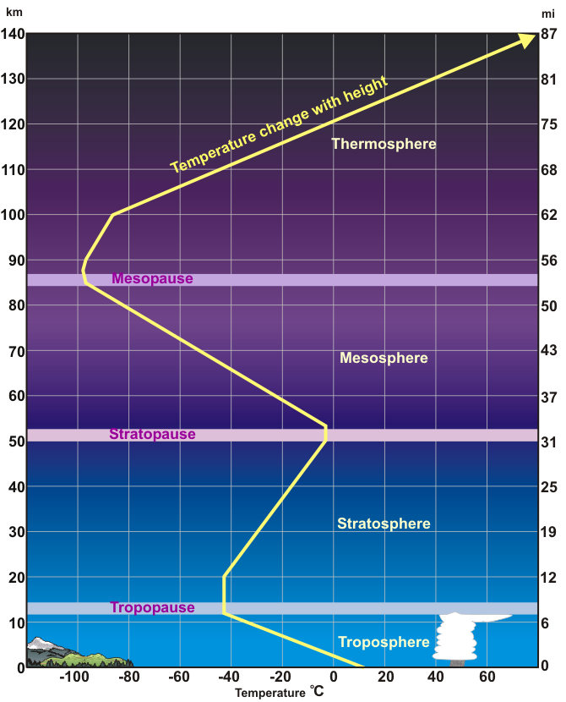

As you can see from this graph, temperatures will drop below -40 degrees Celsius at some point in our flight (expected to go up to 90,000+ feet).

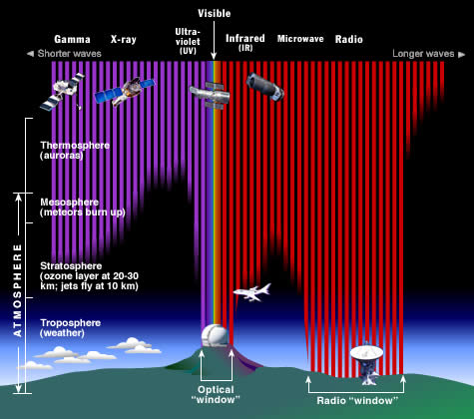
At this altitude, the pressure is about .018 kg per cubic cm (about 1.7% of the pressure at sea level).
We are also expecting the radiation levels to rise with altitude, as there will be less atmosphere to absorb the radiation (as shown

9.0 Launch and Recovery
Our Launch date was scheduled for October 31st since the first day of class with several other dates as backups. Luckily, conditions were okay for launching on Halloween. The four teams met at 6:30 A.M. in front of Akerman Hall. We drove to our planned launch site at a baseball field northwest of Pine City, MN.
Upon arriving, we unpacked our payloads and other equipment and helped prepare the Continuing Education Class for their launch, scheduled one hour before ours. While some teams had to make quick last minute changes to their payloads, we only had to make slight adjustments to the length of our strings.
Blowing up the balloons on flight day proved to be a more difficult task than usual because of the cold temperature and high winds. About ten people wearing latex gloves were needed to stand around the balloon at all times to make sure that it didn’t bump into something sharp.
The freshman seminar class was scheduled to launch at 10:45 A.M. but we ended up launching slightly late at 10:53 A.M. because of complications with JM7737’s payload. Ten minutes before our scheduled launch time we turned on our heater and made sure that it was starting to heat up. Once we confirmed this we turned on our flip video camera and pulled the pin on our Geiger counter computer just before sealing the box with a zip tie. We checked to make sure the camera was recording by looking for the red light near the lens. Shortly after, we pulled the pin on our main flight computer from outside of the box using a string connected to the pin. We knew that the computer started to take data when the green light installed by Professor Flaten on the outside of the box changed its blinking pattern. Unfortunately, we had no way of knowing for sure that our balloonsat mini was taking data from our Geiger counter.
After securing our box lid we regretting doing so because JM7737 was having a problem with their payload and we would not be able to launch on time. We were concerned that with only 2 hours of recording time available on our flip camera that we may run out of time.
At 10:53 A.M. we officially launched our payload along with the rest of the payloads from the freshman seminar class. The expected landing site was over 100 miles away near Bloomer WI.
The payloads flew a little further than expected. This may be due to the fact that the payloads climbed to 112,000 feet or because of the strong and irregular wind gusts. The payloads were found in a tree northeast of Bloomer. We were able to park on the side of the road from where we could hear the siren attached to the stack and made our way about 400 feet into the dense woods where we found the stack approximately 30 feet up tangled in several trees.
The stack was spread out with a large portion of it strung between two trees. Because of its orientation, our first attempt for getting the payloads down was throwing a stick with a long string attached over the stack lines. This was difficult because the trees were very dense and the lines kept getting caught in other trees. Our next attempt utilized a slingshot with the string attached to a small weight. After several attempts, we managed to loop the string around the payload lines. Yanking the boxes out of the tree took several people because the payload lines were so tangled. We were eventually able to get everything out and carried the tangled stack out of the woods. Our box had no significant damage to the outside of the box so we opened it up to see if anything had become dislodged. Upon opening the box, we found that one of our batteries had become dislodged from where it was Velcroed and zip tied, but it had not been disconnected from the wires. Everything else appeared to be in working order. The heater was still running. We turned our camera on and were happy to see that it took a solid 2 hours of video. The other teams around us complained about getting less than adequate results from their optical experiments. After giving our flight computers to Philip for data extraction we were disappointed to hear that our Geiger counter did not record any data. We are not sure what caused this error. Luckily, Professor Flaten flew our Geiger counter a second time with a UMN Morris flight the next weekend. We got much better data from this second flight.

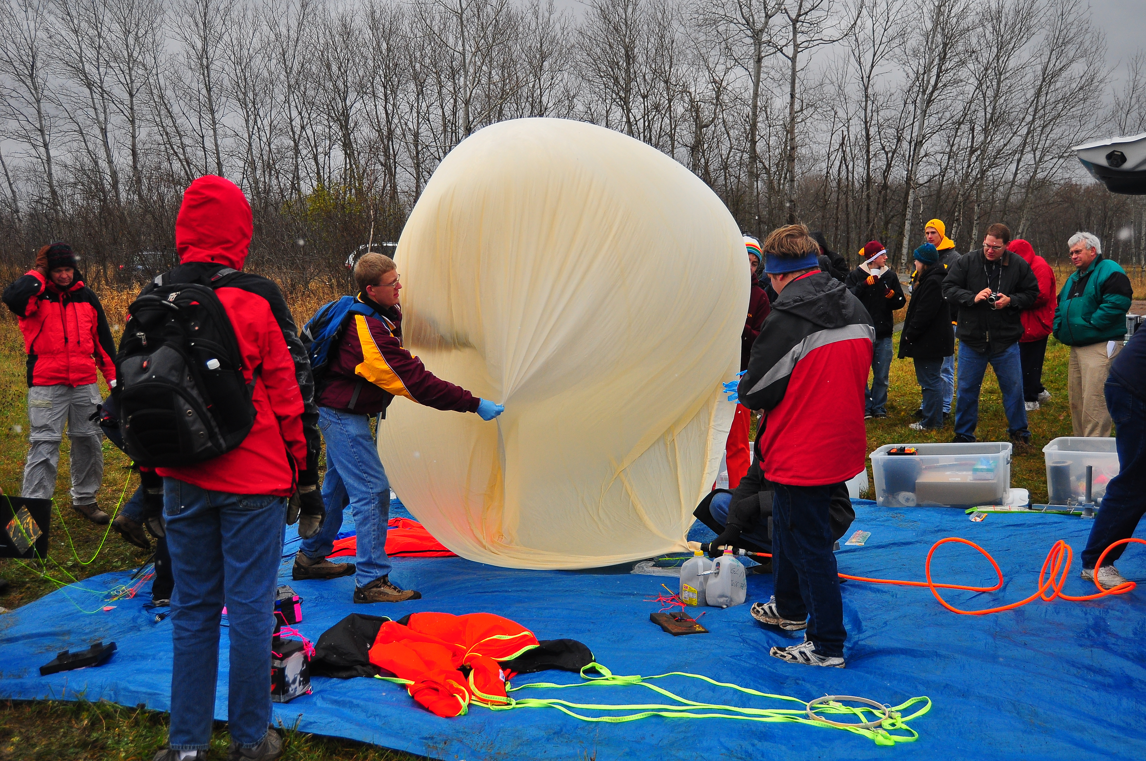
The wind made filling the balloon difficult.

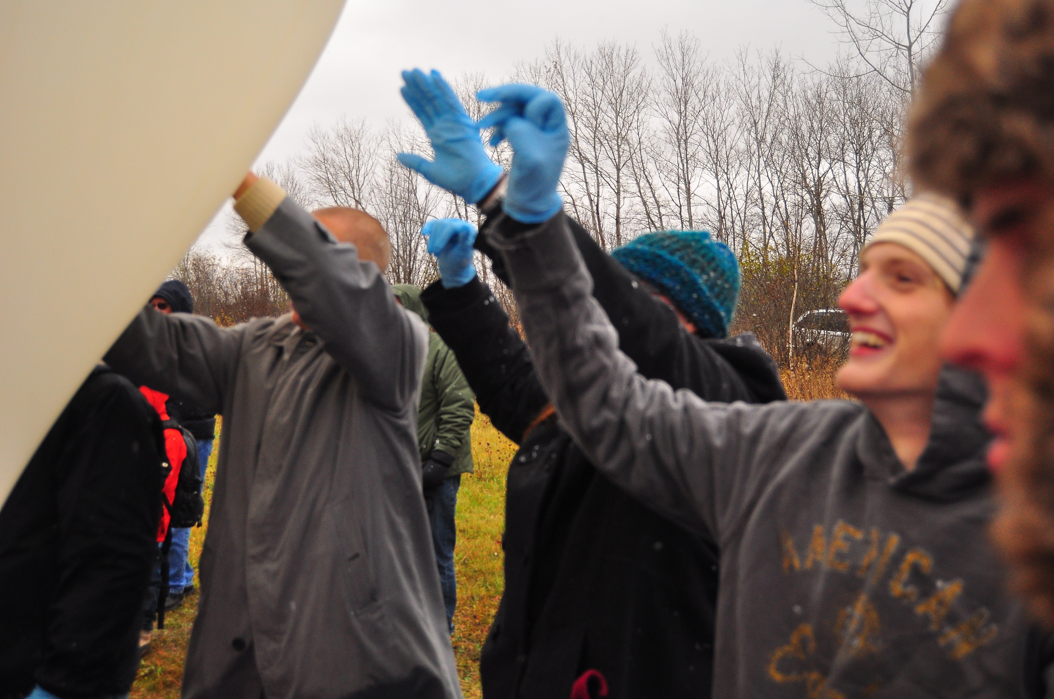
We needed 8-10 people standing around the balloon at all times so that it wouldn’t blow and hit something sharp.

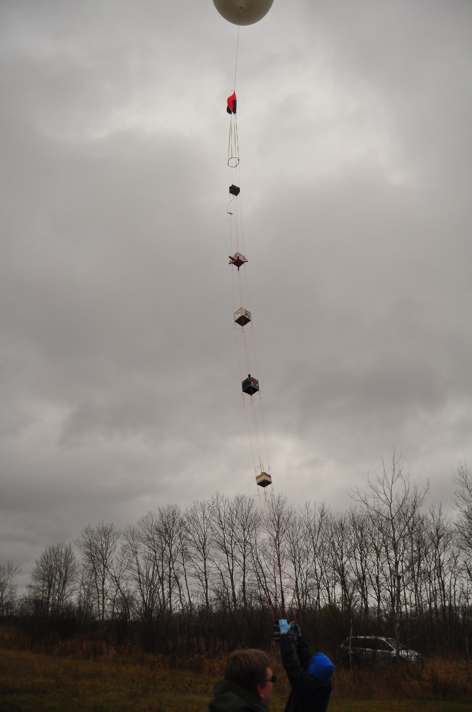
The stack a few seconds before launch

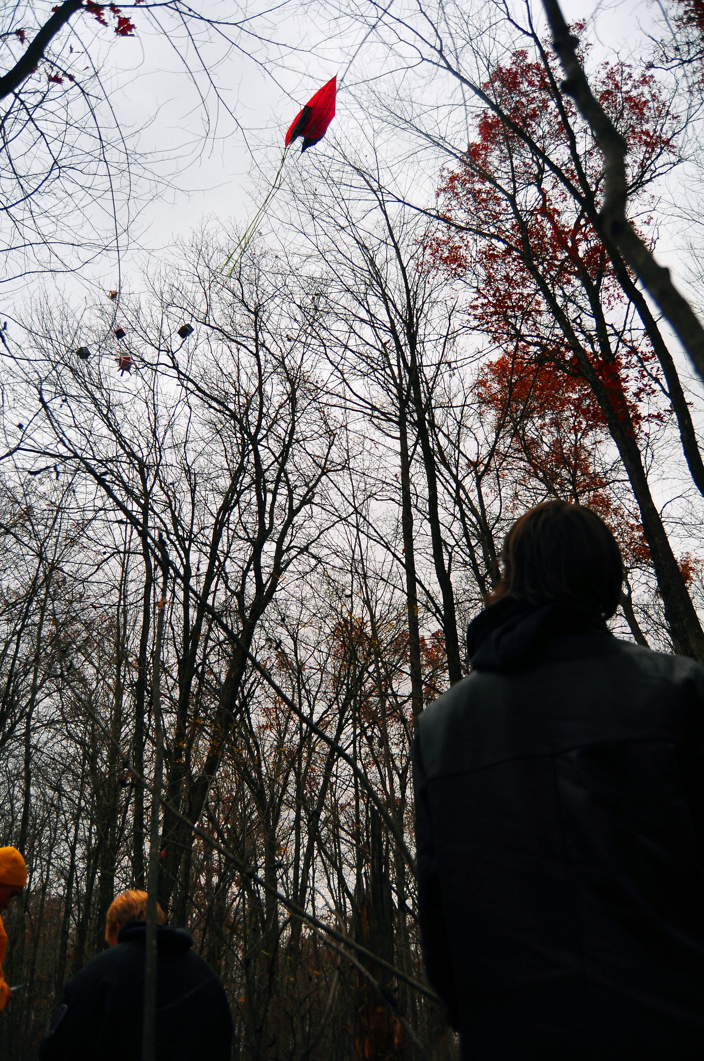
Payloads caught up in a tree

10.0 Results and Analysis

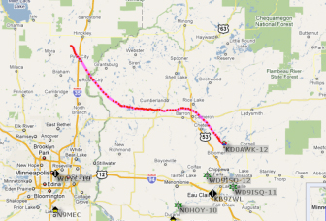

Actual Flight Map- We expected to land a few miles southwest of where we actually landed.

Altitude Vs. Time

The flight lasted about 130 minutes and the balloon traveled to 112,000 feet. The burst occurred around 90 minutes.

The internal temperature was around 5 degrees Celsius at the time of launch. While traveling through the atmosphere it was first must colder but then gradually got warmer. Because of this, our internal temperature first decreased but then increased until burst where the temperature dropped rapidly as the box fell. After recovering the payload and putting it in the car, the temperature increased greatly until the hobo shut off.

Our weather station did not get accurate relative humidity data because the cord was plugged in sideways. This relative Humidity graph is from Icarus. Based on expected data, the relative humidity should decrease until burst and then increase again as it does after 90 minutes but for some unknown reason the sensor said that there was a large jump in relative humidity in the middle of the flight. We hypothesized that clouds could have caused this, but this is not theoretical because there would not be clouds at those elevations. Because of this we can assume that there was some sort of error with the sensor or computer that caused this spike in relative humidity.

This is pressure data from our team’s weather station. It shows that pressure decreases throughout flight until burst at 85 minutes where it rapidly increases again until landing. The wires being twisted most likely caused the gap missing in our data. Based on expected data we can assume that the line would continue slopping downwards and meet where it picks up again. The fact that the pressure actually drops below zero instead of leveling out at zero probably means that the there was a calibration error.

Counts per 5 seconds (taken every 2 minutes) vs. Time

The counters per 5 seconds vs. time graph shown here is from data collected during the UMN Morris flight. Radiation increases until a certain point (around 30 minutes into the flight) where it levels off until burst. After burst, the radiation levels decrease until landing.

Altitude vs. Geiger Counter counts per 5 seconds( taken every 2 minutes)

As predicted, radiation levels increase until about 60,000 feet where they level off. This data is also from the UMN Morris flight.

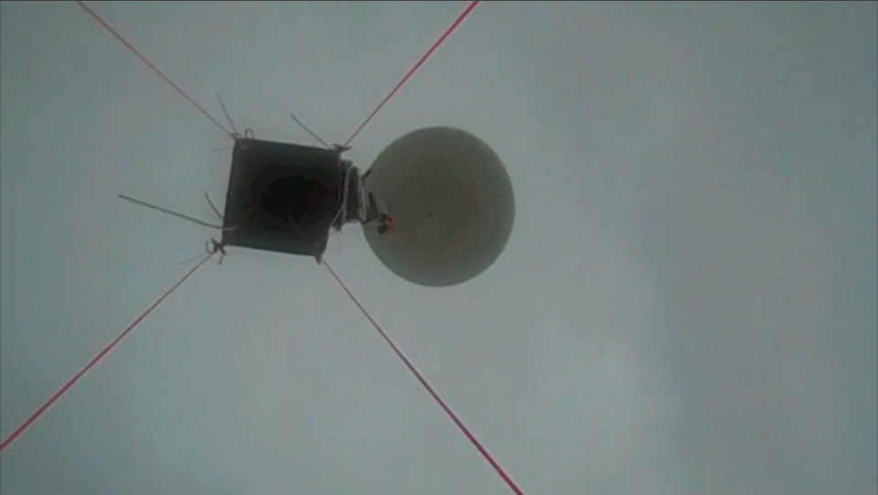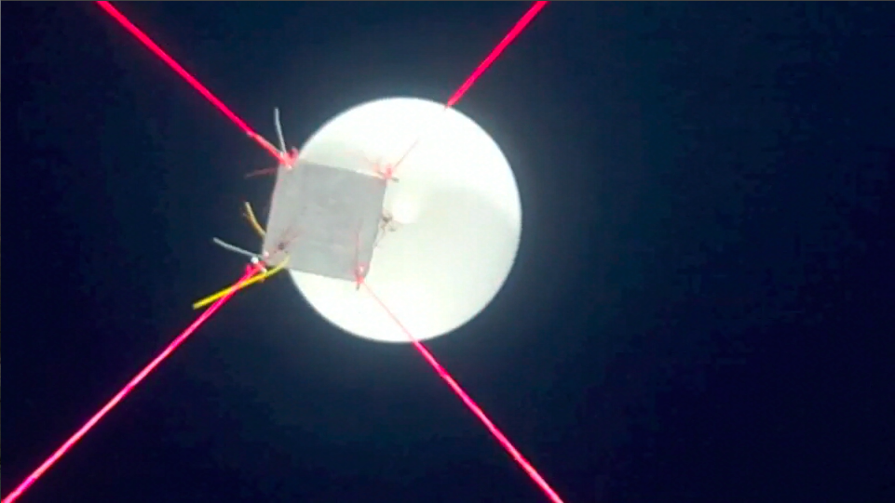

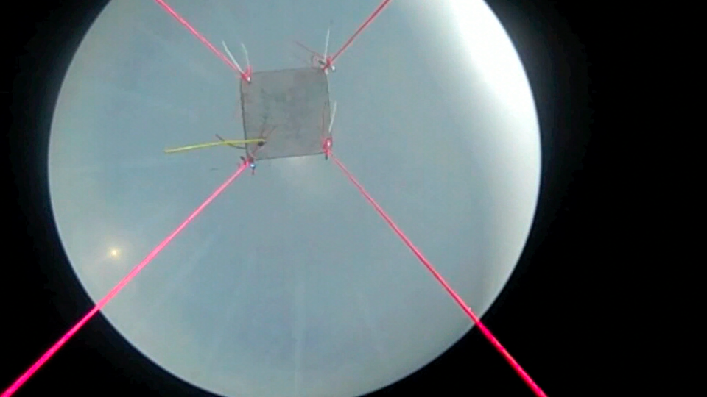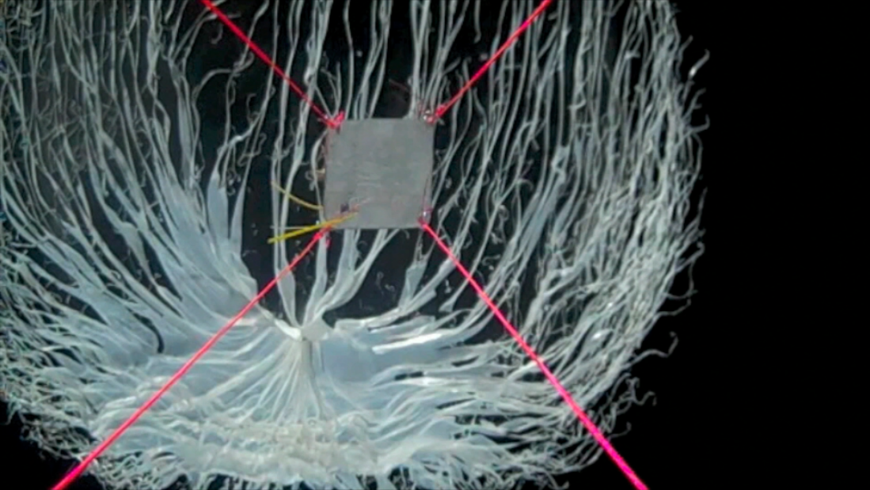

These frames were taken from our video camera at different parts of the flight showing the increasing diameter of the balloon.

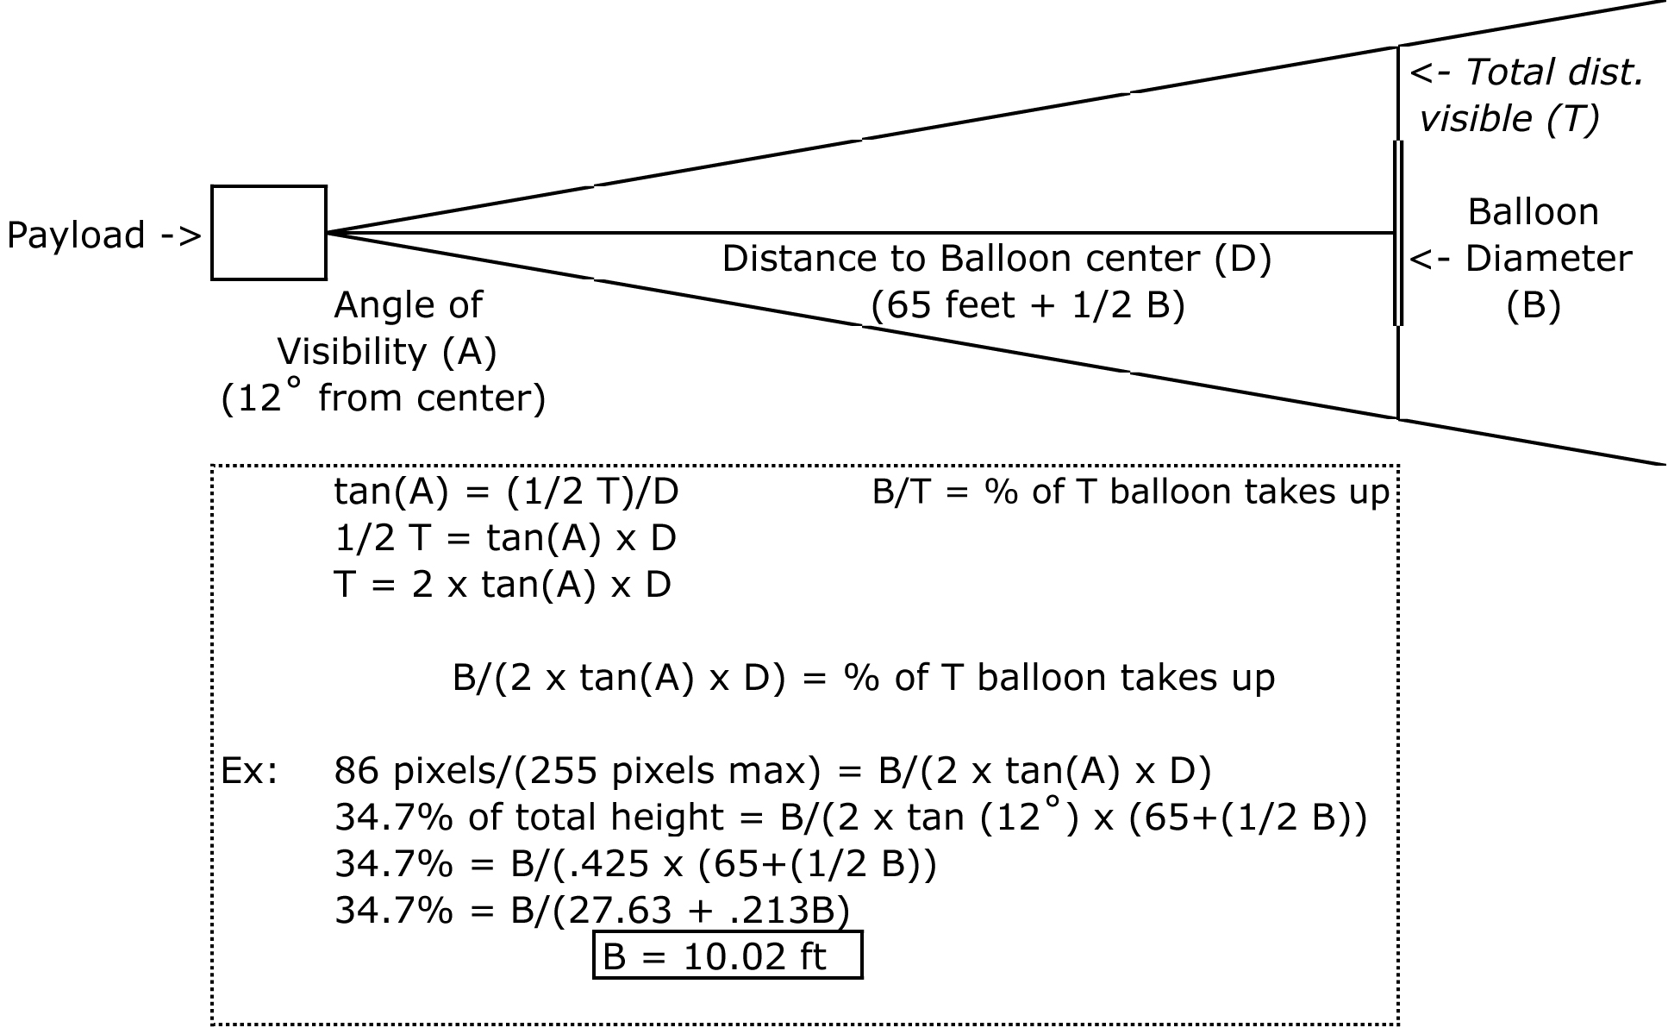
Because the center of the balloon was actually getting farther away from the camera in our payload as it grew, we needed to come up with an equation for finding the diameter of the balloon over time. Simply counting pixels would not suffice.

As expected, the balloon grew in diameter over time before bursting due to the lower pressure high in the atmosphere.

Theoretical Balloon Diameter and Measured Balloon Diameter

Using the equation and the expected data we calculated a theoretical graph for the balloon diameter. Our measured data was very close to the theoretical data.

11.0 Conclusions and Lessons Learned
Geiger Counter- After obtaining data from the UMN Morris Flight, we found that indeed radiation increases with altitude but levels out at about 60,000 feet.
Camera Experiment- Analyzing our video allowed us to quantify how quickly and to what diameter the helium balloon expanded before exploding.
Weather Station and Hobo- Our weather station data gave us temperature, humidity, and pressure data that we used to compare to the rest of the data.

-Final thoughts/modifications-

-Finding a better way to measure the diameter of the balloon may have led to more accurate data.
-Make sure all items are secured well with Velcro and zip ties.
-Building our payload box “inside out” proved to insulate the same or better than normal.

-Words of Wisdom-

-On the day of flight, make it clear to you roommate that you will be waking up at 6 AM and don’t want to be kept up until 4:30
-Bring a pillow for the car ride
-Bring more warm clothes than you think you will need
-Double and triple check experiments to make sure they are working
-Make sure to pull all of your commit pins

12.0 Appendix: Program Listings

Weather Station Flight Code

symbol record=w0 'This is the section where the variables are declared
symbol index=w1
symbol value=b4

BalloonSat:
symbol Max_ADC = 2 ' maximum adc channel usedstarting with 0
symbol Mission_Delay = 15000 ' length of pause in mission loop

Mission_Prep:
i2cslave %10100000,i2cfast,i2cword ' set memory speed to 400 kHz
if pin7 = 1 then Download_Data 'and one word records

flasher: 'this section is the section that waits
high 3 'for commit pin to be pulled
pause 10000 'the flahser is also in this section
low 3 ' it flashes at a specific rate
pause 1000
if pin7=0 then flasher

Mission: ' will change pattern of flashing when data is being taken
high 3
pause 2000
low 3
gosub Analog ' collect analog voltages
write 0,record ' store the number of records collected
pause Mission_Delay ' pause.....
goto Mission ' ....before starting all over

Analog:
for index = 0 to Max_ADC ' loop for number of analog voltages to record
readadc index,value ' get next adc value
gosub Record_Data ' go store the value
next ' until last voltage is recorded
return ' return to main mission loop

Record_Data:
if record = 2047 then End_Mission ' check that aren't writing too many records to memory
record = record + 1 ' increment record number
low 0 ' unwrite protect memory
writei2c record,(value) ' write the next record to memory
pause 10 ' wait 10 ms for write
high 0 ' write protect memory
return ' return to the calling calling subroutine

Download_Data:
read 0,record ' get the number of data records recorded in this flight
for index = 1 to record ' until the number of data records
readi2c index,(value) ' read the recorded record
sertxd (#value,",") ' serial out the data record
next ' until last data record read out
goto fail

fail: ' this is wht flashing patern that will occur if the
high 3 'battery dies some time during flight and the computer
pause 1000 ' has restarted and not taken data
low 3
pause 5000
goto fail

End_Mission: 'this is if data was recorded during the whole flight
low 3 ' this shows that the memory is full
pause 1000 ' and that the flight computer functioned properly for the flight
high 3
pause 5000
goto End_Mission

end ' end of mission

The weather stations were programmed to send data to the flight computer every 5 seconds. We were unable to extract data after 256 readings.

Geiger Counter Flight Code- Halloween flight

'*****************************************************
'* Sample BalloonSat Mini Mission *
'* *
'* Every Minute *
'* Collects radiation data 10 sec ON, 50 sec pause *
'* from from RM-60 Geiger Counter *
'* *
'* Program size = 77 bytes *
'* Left over memory = 178 bytes *
'* So stores 174 records, or for about 87 minutes *
'* Paul Verhage code with added comments by J Flaten *
'*****************************************************

symbol WordValue = W0 'varible declartaions
symbol ByteValue = B2
symbol Record = B3

symbol MaxData = 174 ' pin declarations
symbol MissionPause = 50000 ' and data timing and maximum nuber of
symbol GM = 4 'data records

Begin_Mission: ' go to download data if commit pin not present
if pin3 = 1 then Download_Data ' when powered up

Wait_for_Launch: ' wait for commit pin to be pulled to
if pin3 = 0 then Wait_for_Launch ' begin collecting data

Mission_Loop: 'main mission loop

Geiger: ' this takes the Geiger counter data for 10 sec (10000 millisec)
count GM,10000,WordValue
ByteValue = WordValue
gosub Save_Data

End_Mission_Loop: 'mission delay loop for 50 seconds so 1 full minute between data reads
pause MissionPause
goto Mission_Loop

Save_Data: 'saves the Geiger counter data to memory
if Record = MaxData then End_Mission
Record = Record + 1
write Record, ByteValue
return

'***********************************************
'* Data Format *
'* GM (counts / 10s), Temp (compressed 10-bit) *
'***********************************************
Download_Data: ' upload data to computer
for Record = 1 to MaxData
read Record,ByteValue
sertxd (#ByteValue, ",")
next

End_Mission:
End

This was the code we used for our Halloween balloon flight. We did not get data from this flight but we are not sure what caused this. This program told the Geiger counter to take counts for 10 intervals seconds every 1 minute. We successfully obtained data from this flight.

Geiger Counter Flight Code- UMN Morris Flight

'*****************************************************
'* Sample BalloonSat Mini Mission *
'* *
'* Every Minute *
'* Collects radiation data 5 sec ON, 115 sec pause *
'* from from RM-60 Geiger Counter *
'* *
'* Program size = 77 bytes *
'* Left over memory = 178 bytes *
'* So stores 174 records, or for about 174 minutes *
'* Paul Verhage code with added comments by J Flaten *
'*****************************************************

symbol WordValue = W0 'varible declartaions
symbol ByteValue = B2
symbol Record = B3

symbol MaxData = 174 ' pin declarations
symbol MissionPause = 115000 ' and data timing and maximum nuber of
symbol GM = 4 'data records

Begin_Mission: ' go to download data if commit pin not present
if pin3 = 1 then Download_Data ' when powered up

Wait_for_Launch: ' wait for commit pin to be pulled to
if pin3 = 0 then Wait_for_Launch ' begin collecting data

Mission_Loop: 'main mission loop

Geiger: ' this takes the Geiger counter data for 5 sec (5000 millisec)
count GM,5000,WordValue
ByteValue = WordValue
gosub Save_Data

End_Mission_Loop: 'mission delay loop for 115 seconds so 2 full minutes between data reads
pause MissionPause
goto Mission_Loop

Save_Data: 'saves the Geiger counter data to memory
if Record = MaxData then End_Mission
Record = Record + 1
write Record, ByteValue
return

'***********************************************
'* Data Format *
'* GM (counts / 10s), Temp (compressed 10-bit) *
'***********************************************
Download_Data: ' upload data to computer
for Record = 1 to MaxData
read Record,ByteValue
sertxd (#ByteValue, ",")
next

End_Mission:
end

This code was used with our Geiger counter on the UMN Morris flight. The code told the counter to take data for 5 second intervals every 2 minutes.

The flight computer connected to the Geiger counter failed to record data (See “Results and Analysis”).
http://www.chemicool.com/idealgas.html http://www.srh.noaa.gov/srh/jetstream/atmos/atmprofile.htm
http://www.windows.ucar.edu/tour/link=/earth/Atmosphere/earth_atmosph_radiation_budget.html

