University of Minnesota and MN Space Grant Consortium

AEM 1905 Freshman Seminar: Fall 2009
Spaceflight with Ballooning
Team Project Documentation

JM 7737

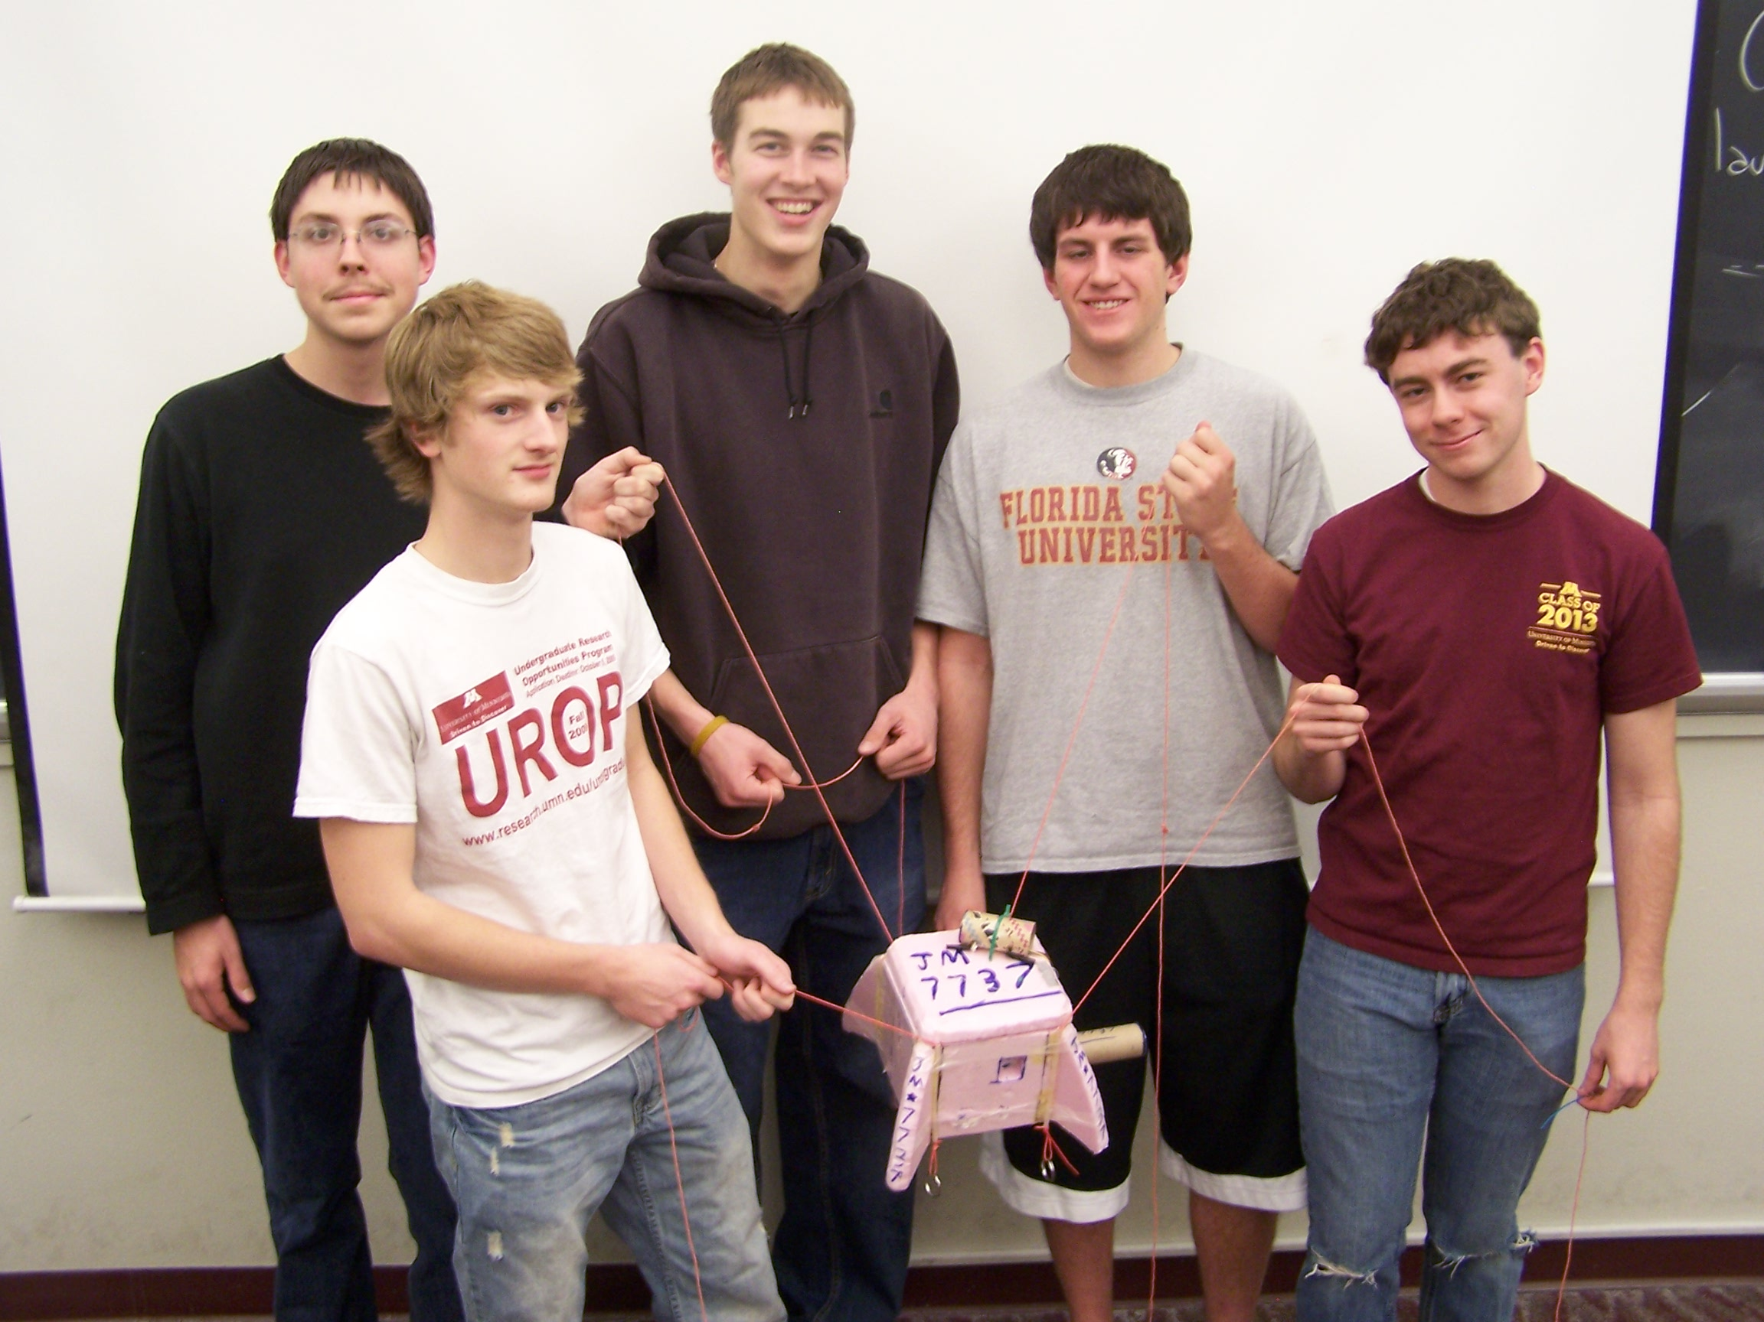

Written by:
Ryan Olin, Joey Senkyr, R.J. Kakach,
Seth Frick, and Austin Granger

Report Date:
Friday, December 4th

Revision C
Revision Log

Revision | Contents | Due Date
A | Conceptual Design | Friday, Oct. 16, 4 p.m.
B | Build/Testing Report | Friday, Nov. 6, 4 p.m.
C | Flight/Analysis Final Report | Tuesday, Dec. 4, 4 p.m.

User Notes (entire document adapted from Colorado Space Grant documentation):

This template describes the topics which should be discussed during the evolution of your documentation. The following sections have a Rev (Revision) letter following the section description. This indicates when this section is expected to be a part of this document. If a section is required in Rev A, then that section should be written for Rev A then updated if necessary in subsequent revisions. As your project becomes more defined, return to previous sections and update them accordingly.

Each time when you submit your Team Project Documentation, remove any unnecessary template notes and to-be-written sections. For example, if you are submitting Rev A, don’t include sections not requested until Rev C.

This report is due in electronic form (Microsoft Word, not pdf) at the times listed in the table above. Please follow this template format exactly.

Write your text sections just like this page – single spaced, 1 inch margins, 12 point font of your choice, leaving single blank lines between paragraphs.
Table of Contents

- Team Assignments……………………………………………………………………4
- Introduction…………………………………………………………………………..6
- Mission Overview…………………………………………………………………….6
- Payload Design………………………………………………………………………..7
- Project Management…………………………………………………………………..9
- Project Budgets………………………………………………………………………10
6.0 Payload Photographs…………………………………………………………………12
7.0 Test Plan and Results………………………………………………………………...16
- Expected Science Results……………………………………………………………17
10.0 Results and Analysis…………………………………………………………………??
11.0 Conclusions/Lessons Learner………………………………………………………...??
12.0 Appendix: Program Listings…………………………………………………………??
0.0 Team Project Documentation Writing Assignments
Assign one lead author to each section except for Results and Analysis (that needs to be worked on by everyone!). Each person should be the lead author on two sections. Notice that the sections vary widely in length and complexity.

Introduction Ryan
Mission Overview Ryan
Payload Design Seth
Project Management Joey
Project Budgets Joey
Payload Photographs Austin
Test Plan and Results R.J.
Expected Science Results Seth
Launch and Recovery R.J.
Results and Analysis All
Conclusions and Lessons Learned Ryan

Oral Presentation Assignments
Assign two team members to help make slides for each of the first two oral presentations. All group members need to pitch in when working on the final oral presentation.

Conceptual Design Review (CDR) Ryan R.J.
Flight Readiness Review (FRR) Seth Joey

Payload Build Assignments
Assign one person to be the overall “team lead” (AKA “team contact”). Their job is to keep tabs on the whole project and keep the teaching staff informed as need be, to organize team meetings, to make sure everything gets done in a timely manner, and once the build is complete to be in charge of ground testing. Assign each of the other four team members to “lead” one item in the first 4 tasks and one item in the last 4 tasks listed below.

Overall team lead and ground-testing lead Ryan

Flight computer (BalloonSat Easy) build Seth
Weather station build R.J.
Payload box build Joey
Photographer Austin

Programmer (of flight computer(s)) R.J.
Camera and camera experiment Austin
HOBO (payload “health” (internal temp)) Joey
“Other” science experiment Seth

Launch Day Assignments
Assign each team member a specific responsibility for launch day.

Photographer Austin
Prediction/tracking assistant R.J.
Balloon filling and release assistant Ryan
Payload/stack handling specialist Joey
Recovery specialist (needs to go on chase for sure) Seth

1.0 Introduction

Near space is an unforgiving environment. Extremely low temperatures, low air pressure, and high radiation levels. It can break equipment and kill people and animals if they are exposed to its harsh environment. So why would anyone want to send someone to this barren landscape? Near space is an excellent alternative to going to outer space. Near space has many of the same conditions possessed by outer space, and near space can be reached at a fraction of the cost. This makes near space the ultimate destination for amateur scientists who dream of sending a craft to space. Because near space possesses the characteristics of outer space it allows amateurs to conduct experiments similar to the one conducted by real scientists in outer space.
One of the primary ways of getting a craft to near space is the use of ballooning. Using latex weather balloons it is possible to take crafts to heights of over 100,000 feet. Ballooning is commonly used by amateurs because of its relatively low cost. Ballooning is far cheaper than using a rocket or any other method of launching a craft to near space. Ballooning is also popular because of its ease of use. It is not overly complicated to fill the balloon with helium and release it. The real challenge comes in when tracking and recovering the balloons payload. Often times the payload ends up 60+ miles away and it does not always land in places that are easy to retrieve.
Ballooning to near space is the best alternative the curious amateur to explore and experiment in a space-like environment. It is cheap, reliable, and easier to use than other methods. Ballooning is a fun and interesting way to explore the world around you.
2.0 Mission Overview

A mission to near space encounters many hardships when it comes to environmental factors. A near spacecraft faces low air pressure, extreme changes in temperature, and the potential for water freezing on the craft. We plan on battling these factors by creating a relatively controlled environment in our payload. By keeping the box well insulated we can maintain the heat generated by our heater circuit and keep water and air pressure out. If we fail to maintain a fairly high level of separation from the outside environment it is possible our whole mission could fail. The cold is our biggest enemy however, because it causes a variety of problems such as: battery failure and overall equipment failure.
Along with concentrating on avoiding the elements, we are going to be conducting some experiments during the flight. Our primary experiment with be using a Peltier cell. We are hoping to tack the Peltier cell and see how much electric current it can generate. The cell generates electricity when one side becomes hot and the other side is cooled. So by mounting the cell so one side is inside the box and warm, and the other side is outside and cold, we hope to see how much electricity it can generate. We will also be performing an experiment with a camera during flight. We will be taking pictures through a diffraction grating in order to see what wavelengths of light are visible at different altitudes. This will be challenging because not only are we battling the cold that could disable the camera, but also the challenge of making sure the camera works throughout the flight so that it generates pictures.

3.0 Payload Design

Our payload design and assembly began with the construction of the payload box. We chose to use pink Styrofoam for its insulating properties and high strength-to-weight ratio. However, this material can be difficult to work with, and our interlocking side tab design included some complex cuts that were, indeed, difficult to execute with our equipment. The extra work paid off though, as the design proved to be much stronger than having our sides simply glued together, easily surviving drop testing with dummy weights. With our design, each corner is reinforced by not just one of the sides it joins, but both sides. In addition, the design increases the surface area on which adhesive can be applied at each junction of two sides.
Before rigging and other accommodations are to be made to the payload, the empty box (with lid) weighs in at 108 grams with exterior dimensions of 7” x 7” x 7” and interior dimensions of 5” x 5” x 5”.

List of Parts
7”

1”

5”
Top View (without lid)
Side View (without lid)
7”

1.5”

3” 6”

1”
Payload Box Design

- Camera
- Hobo
- Flight Computer
- Weather Station
- Weather Station Shade
- Batteries 4x
- Heater
- Peltier Cell
- Diffraction Grating
- Diffraction Grating Tube
- Styrofoam
- Black paint
- Corner Support
- Wires
- Velcro
- Cable Ties
- Duct Tape
- Hot Glue
- Heat Shrink Cover
- High Heat Caulking
- Voltage Limiter Circuit

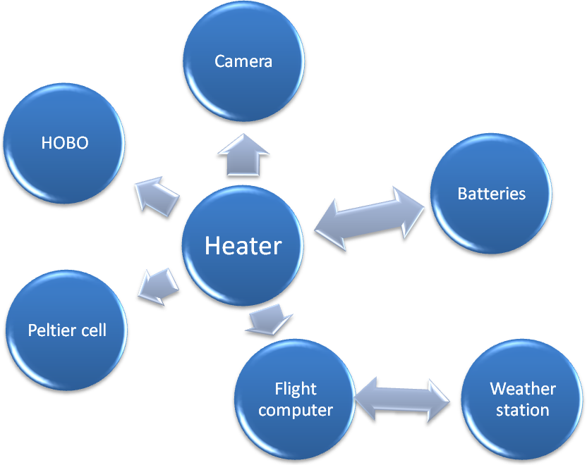
Functional Block Diagram
The heater provides heat to all components to ensure they are working properly. The batteries supply power to the heater, and to the flight computer as well. The flight computer provides power to the weather station, which returns data to the flight computer. Finally, the Peltier cell sends a signal (voltage) to the HOBO, which stores the value of each voltage.

Preliminary Payload Layout

Final Payload Layout

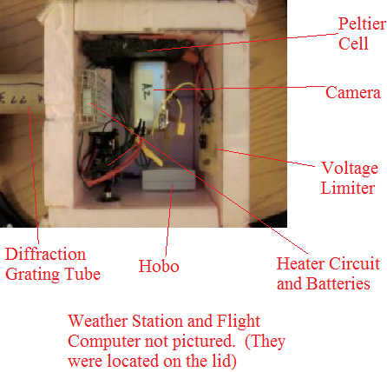

Due to size constraints, the heater and camera cannot be placed on the same side, as originally thought. Also, the camera-diffraction grating assembly will require a cardboard tube to limit the amount of light that reaches the camera and keep the diffraction grating in focus. Therefore, the HOBO will move to the lower left corner, and the camera will take its place on the left side, still facing to the right, with a cardboard tube extended from the lens, through the box, and through the side of the box, protruding up to five inches out of the box. Finally, interior or exterior corner supports will not be necessary due to the interlocking payload box design.

4.0 Project Management

We will have one or two meetings a week, on Saturdays and Sundays, for 90-120 minutes. This is where most of the build will occur. Our Org Chart for the team is as follows:

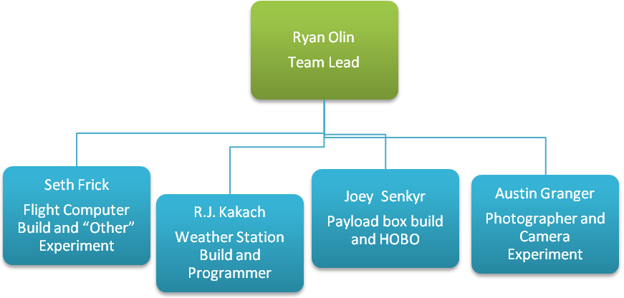

Schedule

- Team Building and Experiment Planning – 9/20/09 – 9/27/09
- Weather Station – Completed – 10/4/09
- Heater Circuit – Completed – 10/4/09
- Flight Computer – Completed – 10/4/09
- CDR Presentation – 10/6/09
- Payload Construction – Began – 10/11/09 – Completed – 10/23/09
- Test and Program Flight Computer/HOBO – 10/20/09
- FRR Presentation – 10/27/09
- Weather Station Testing and Cold Soak – 10/27/09 or 10/28/09
- Final Weigh-in/Payload Turn-in – 10/29/09
- Halloween Launch – 10/31/09
- Team Project Documentaion – 11/6/09
- Final Oral Presentation – 11/24/09
- Final Project Documentation – 12/4/09

5.0 Project Budgets

Mass Budget:
Pink Styrofoam | 0.150 kg
Tubing, rigging, zip ties, glue, paint, etc. | 0.050 kg
Heater circuit | 0.027 kg
3-pack 9-volt battery for heater | 0.150 kg
Weather station | 0.015 kg
BalloonSat Easy flight computer | 0.033 kg
9-volt battery for flight computer | 0.046 kg
Canon Powershot still camera | 0.223 kg
HOBO data logger | 0.048 kg
HOBO voltage probe | 0.010 kg
Peltier cell | 0.020 kg
Diffraction grating | 0.005 kg
Voltage Limiter Circuit | 0.015 kg
Cardboard Tubing | 0.02 kg
Total Mass | 0.837 kg
Actual Mass | 0.860 kg

Cost Budget:
Pink Styrofoam | $8.00
Tubing, rigging, zip ties, glue, paint, etc. | $5.00
Heater circuit | $6.00
3-pack 9-volt battery for heater | $6.00
Weather station | $40.00
BalloonSat Easy flight computer | $30.00
9-volt battery for flight computer | $2.00
Canon Powershot still camera | $166.00
HOBO data logger | $130.00
HOBO voltage probe | $9.00
Peltier cell | $5.00
Diffraction grating | $7.00
Voltage Limiter Circuit | $1.00
Cardboard Tubing | Free
Total Cost | $414.00

6.0 Payload Photographs

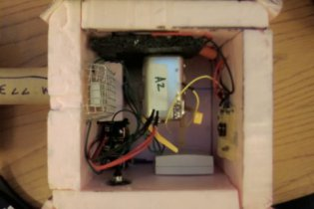
Payload Interior

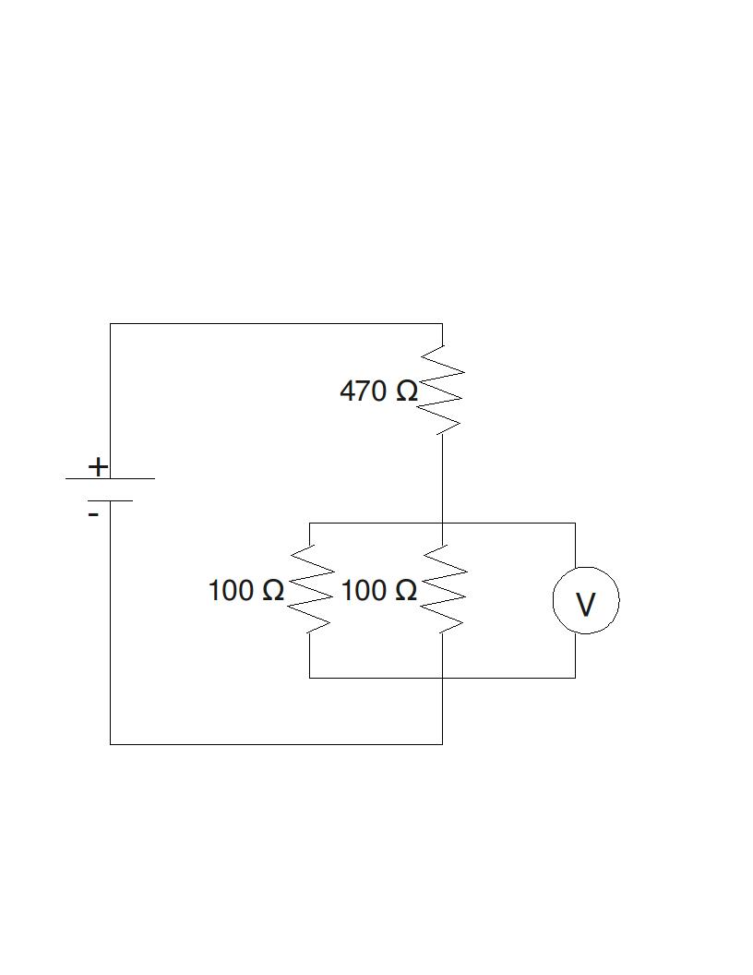
Voltage Limiter Diagram

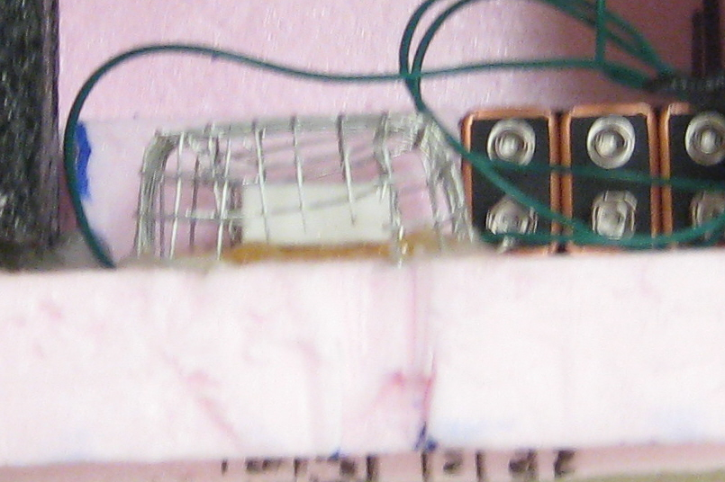
Heater Circuit and Batteries

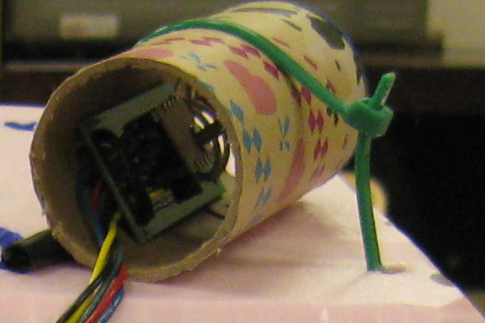
Weather Station

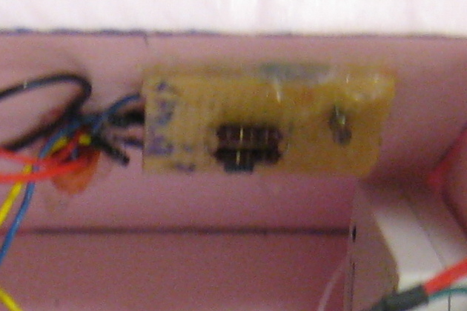
Voltage Limiter

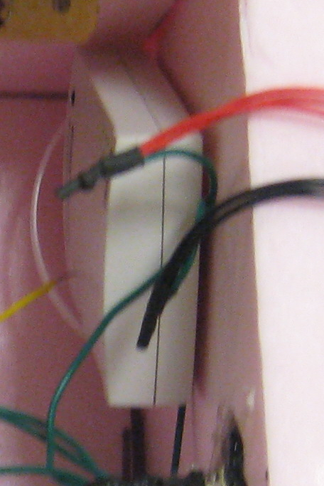
Hobo

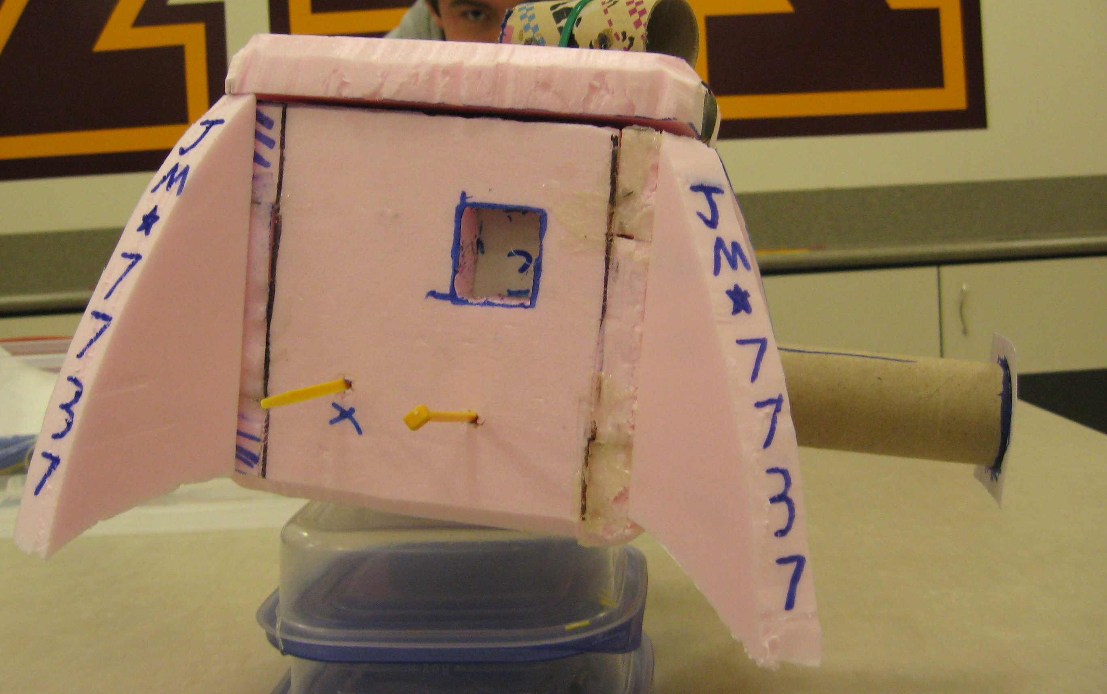
Side View with Peltier Cell

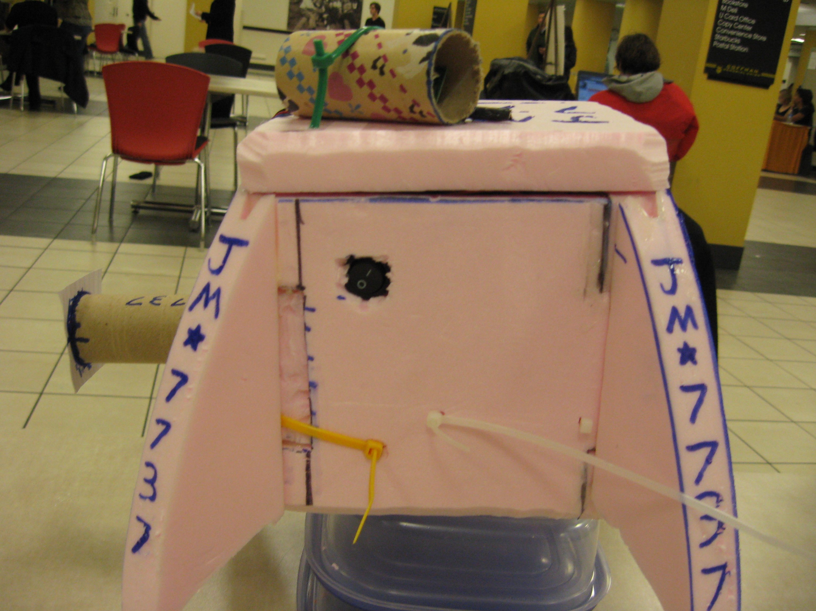
Side View with heater circuit switch

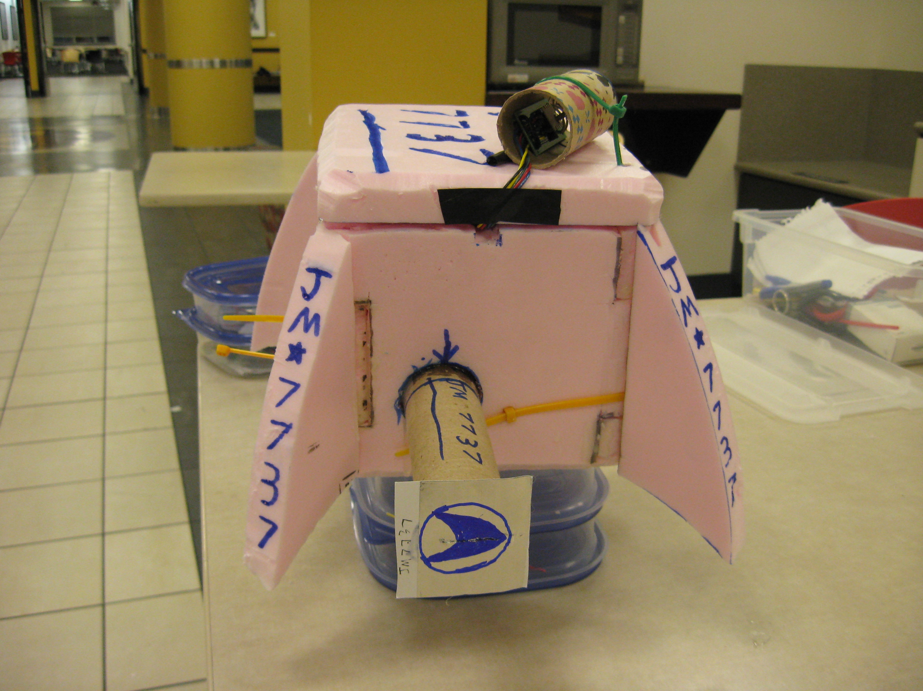
Front View with Weather Station and Diffraction Grating Tube

7.0 Test Plan and Results

Checklist: (Test completed in red)
Payload Shell Impact test
Heater Circuit gets hot
Flight Computer No Chip Test
Weather Station Testing
Diffraction Grating Picture on Land
Peltier Cell Test
Weather Station Final Test
Cold Soak Payload
Yank Test

The first test we conducted was throwing our payload down a flight of stairs while it was full of two pounds of sand. Our shell didn’t break, so we knew the payload would be safe upon impact with the ground. Next, made make sure our heater got hot enough to keep the inside of our payload warm and the batteries working. We did this by turning on the heater, and checking how hot it is after 5 minutes. After the 5 minutes the heater was getting hot, and we knew it worked. The next two tests we ran were checking to see if current runs through both the flight computer and the weather station before we hook them together. It worked, and we then soldered them together. We then took pictures on the ground through our homemade diffraction grating tube, so that we could later compare them with pictures from the flight. Testing the peltier cell was somewhat difficult. The weather station final test was done by turning on the flight computer and HOBO, we then altered the temperature and saw that all of the systems worked and the temperature difference was recorded. The last two tests related directly to the day we fly. The cold soak test proved that our box was warm enough to take temperatures of near space, whereas the yank test assured our box would not fall off on the way up or down. The cold soak involved exposing our payload, with the power on inside, to extreme cold temperatures and seeing how it held up. We also used to cold soak as an opportunity to test our peltier cell and make sure that it would generate electricity as we thought it would. The yank test was conducted by someone pulling as hard as possible on the cords attached to the payload to make sure they hold during flight. We passed all the tests and are ready to fly.

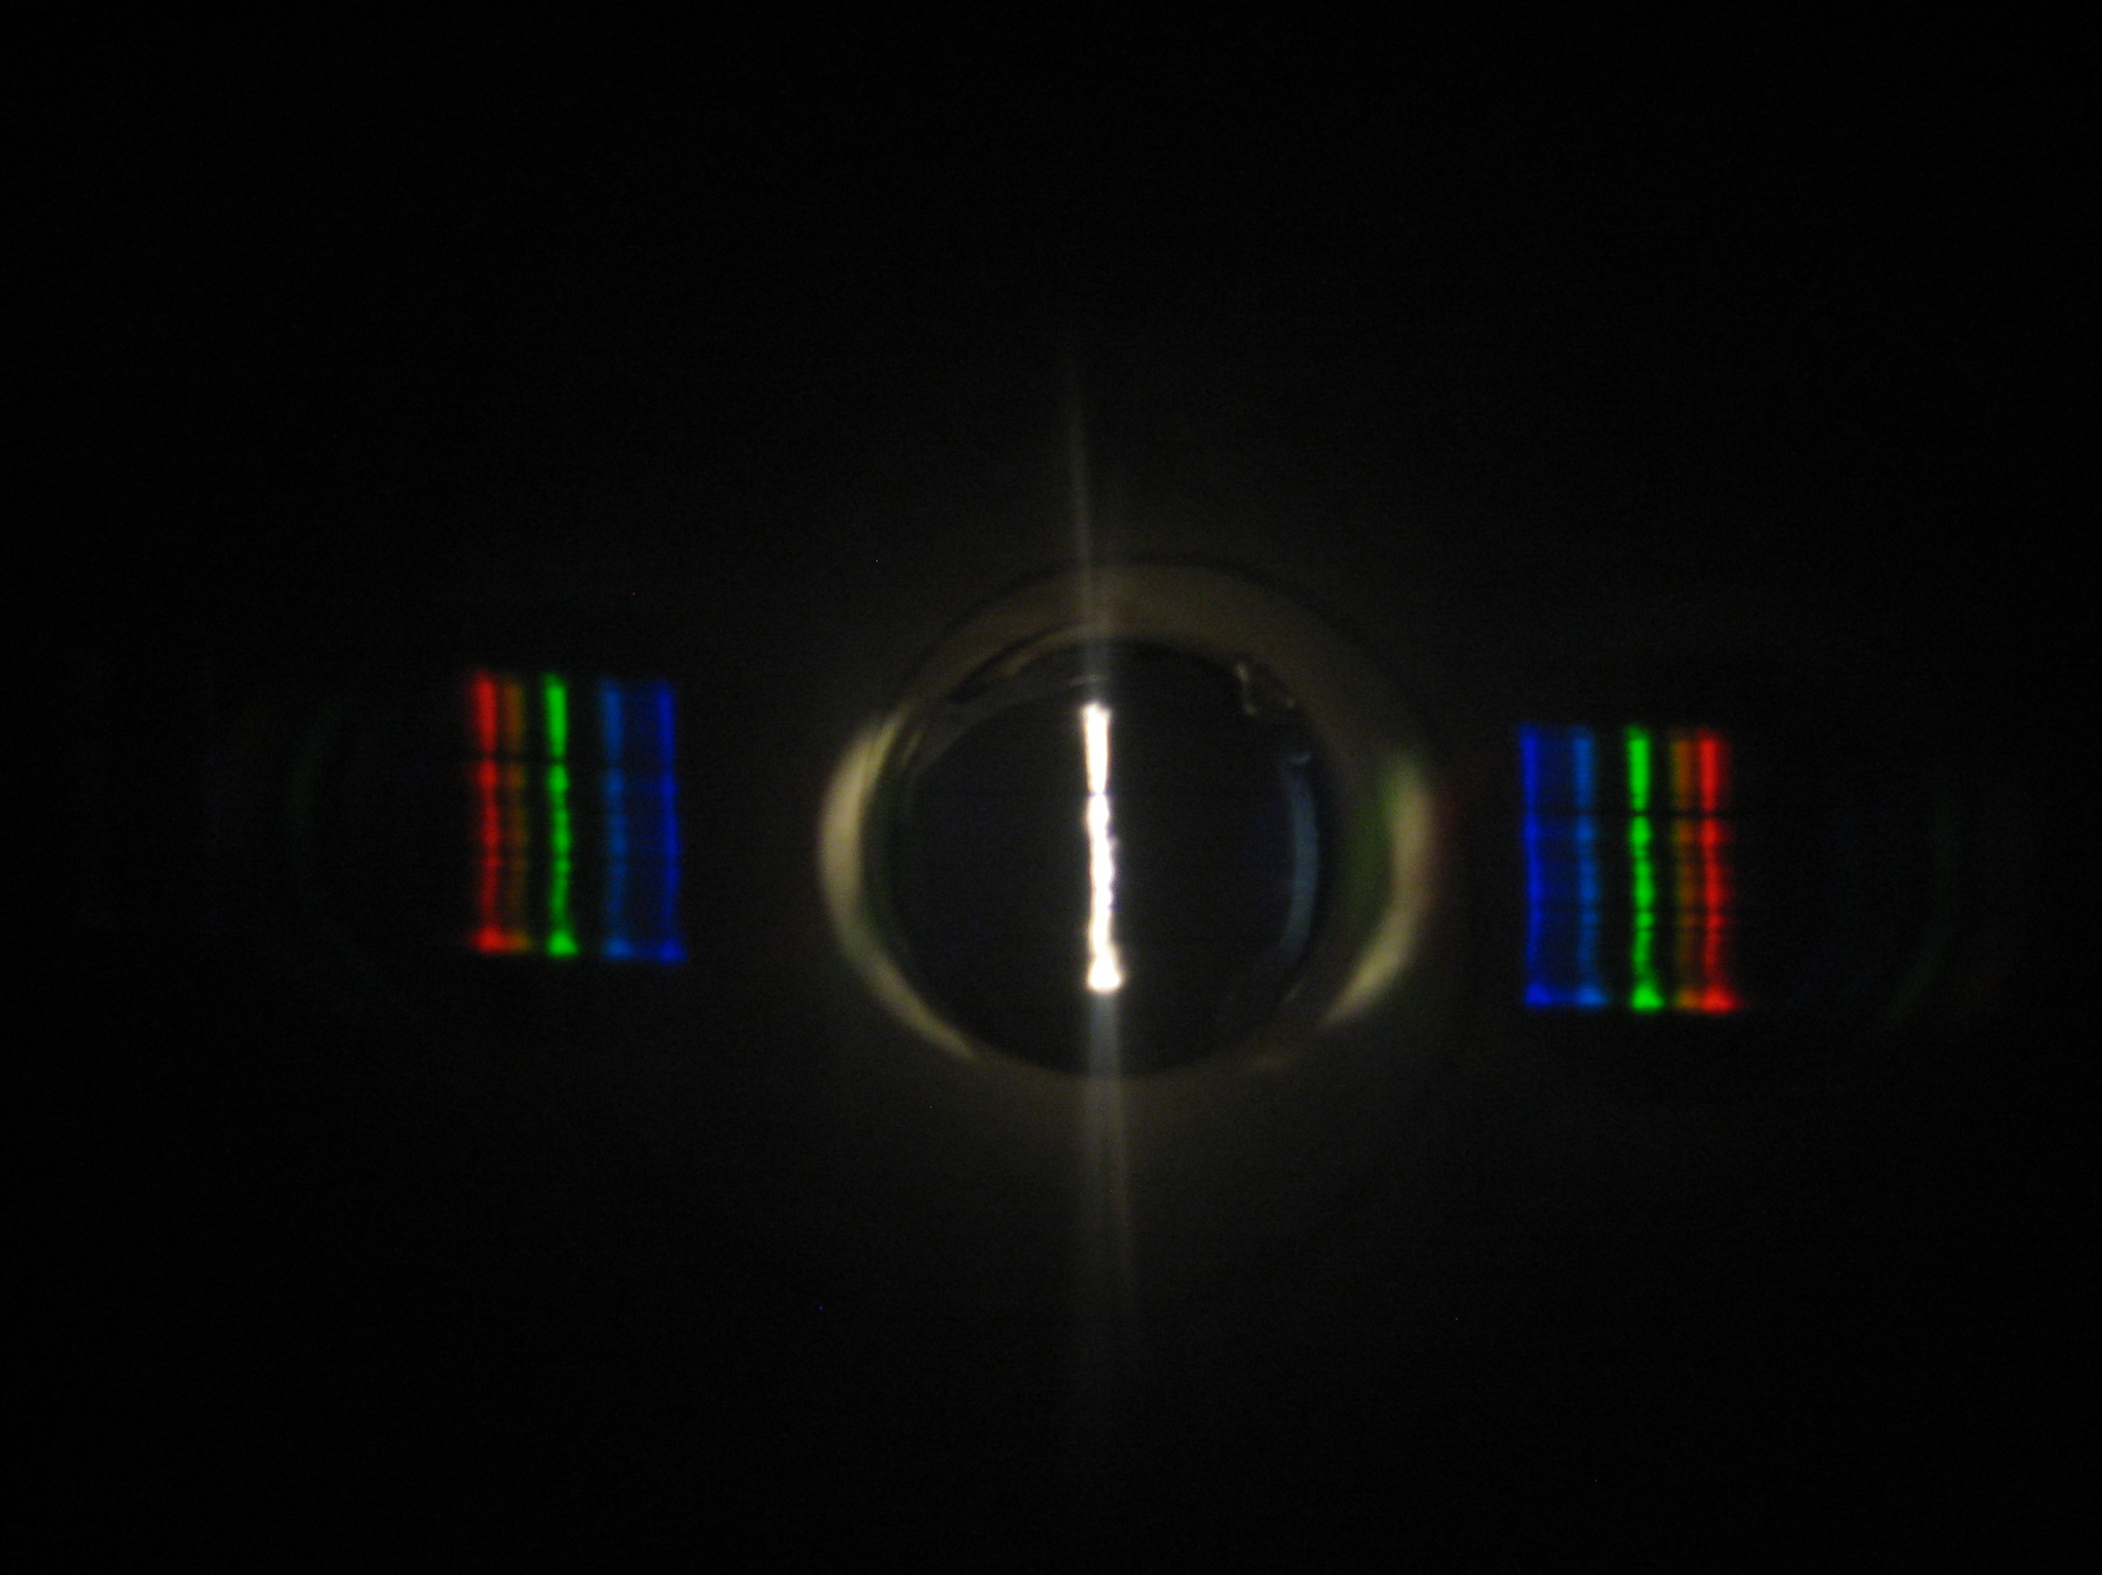
Diffraction Grating Ground Test Picture

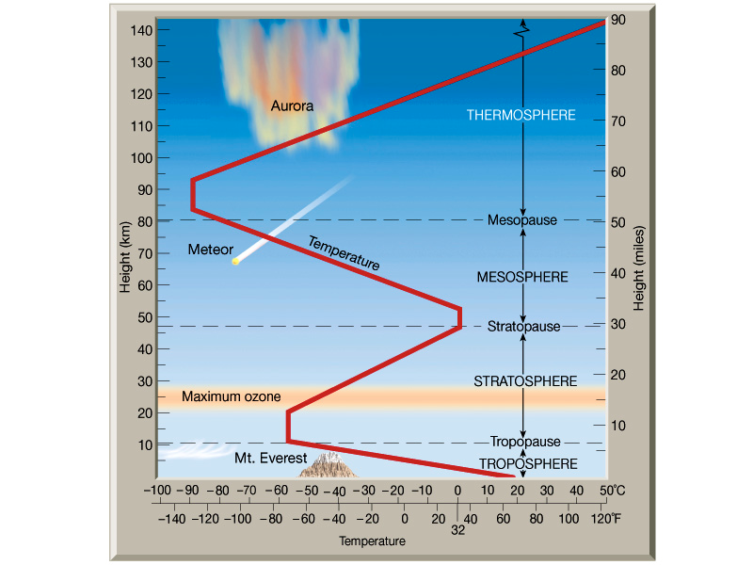
http://www.colorado.edu/geography/class_homepages/geog_3251_sum08/06_temp_vs_height.JPG
Temperature vs. Altitude Graph

8.0 Expected Science Results

- Camera Experiment: We expect to start with a continuous spectrum on the ground. And as we go high we expect to see a change in the absorption spectra of various atmospheric gases (such as water vapor when we are in cloud cover). And finally when we get high enough we expect to go to the emission spectrum of helium, of which the sun is mainly composed.
Helium emission
Continuous spectrum
Courtesy of Tom’s River Regional Schools
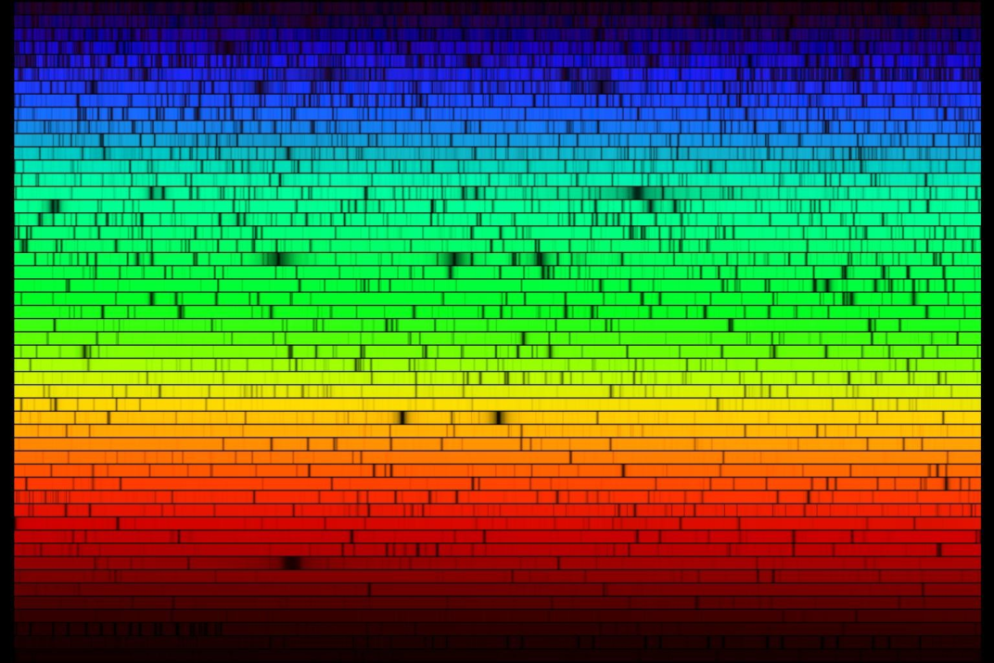
Full visible Solar spectrum
Courtesy of University of Alaska Anchorage

- Because the HOBO cannot read in voltages higher than 2.5 volts, we needed to construct a voltage limiter circuit that would decrease the voltage by a constant factor. The schematic for this circuit is pictured below.
- Using Kirchhoff’s voltage law, we know that the voltage across the battery in the circuit must be equal to the sum of the voltage drops across the resistors. Plugging in Ohm’s Law, we get:
- We can then solve for the current (which is constant for both resistors, since they are in series):
- 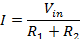
- The output voltage (to the HOBO) will be the voltage across the second resistor (or in this case, a pair of resistors in parallel with an equivalent resistance of 50 ohms). Using Ohm’s Law again and plugging in the value of the current, we get the relationship between the input voltage (from the Peltier cell) and the output voltage:
- 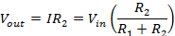
- Plugging in the resistance values, we get the final equation:
- 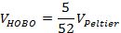
- When we get our HOBO data, we will multiply each voltage value by this conversion factor of 10.4 to find the actual voltage on the Peltier cell. 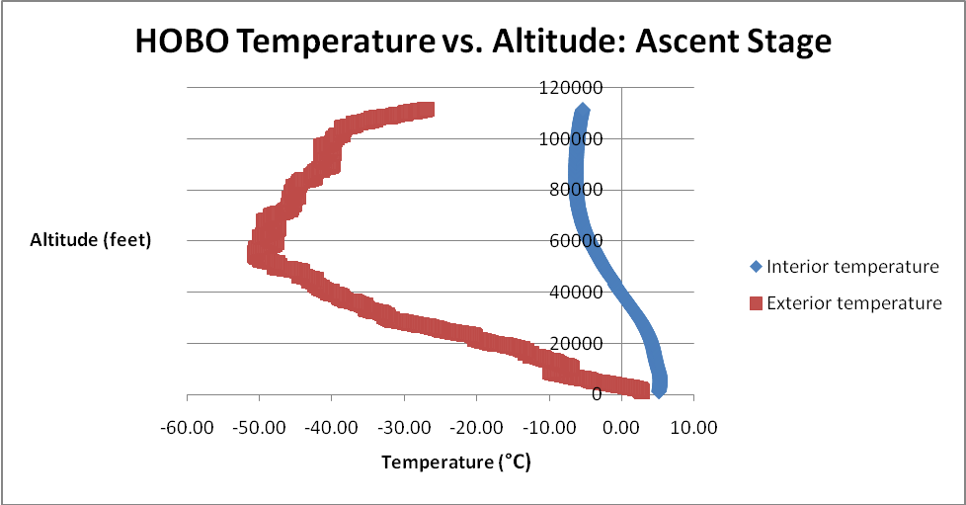

- Weather Station: We think the weather station will detect lower pressure, humidity and temperatures at higher altitudes (except during the O-zone layer, where it will be warmer).

http://www.colorado.edu/geography/class_homepages/geog_3251_sum08/06_temp_vs_height.JPG
Temperature vs. Altitude Graph

9.0 Launch and Recovery

Flight Day Launch

The launch took place in Brook Park Minnesota, 8 miles east of Hinckley. It was quite windy and cold for a Halloween morning, which had some effect on filling the balloon and some experiments. We arrived around 9am and started unpacking the gear into a “baseball field” where the launch took place. Two balloons were scheduled to launch that morning, an adult class and our class. We assisted with the adult class’s balloon filling and we ended up launching their balloon at 10am, right on schedule. After the adult class’s balloon was gone, we proceeded to fill out balloon with helium and layout our payloads. Laying out the payloads was relatively easy once every team ready. All we did was space each payload a specific distance apart and laid them in the field. Filling the balloon on the other hand was not as easy. For starters, the balloon needed to be supported be five to six people with latex gloves to not damage the balloon. The gloves actually made your hands colder (if that’s possible), which made stabilizing the balloon rather difficult. To do this efficiently, we changed personal on this duty every 15 minutes or so. Though the cold was hard to bear, the wind was the real killer. Not only did it make the balloon blow out of control, it made the cold that much harder to endure. Finally after what seemed like hours, the balloon was ready to launch. The problem was most of the payloads weren’t ready, including ours. Everyone was tinkering with last minute adjustments and other problems with their payloads so the balloon launch was delayed about ten minutes. Our group had the biggest problem out of all the payloads; our camera lens would not extend into our tube. To top it off, everyone’s hands were frozen which made it nearly impossible to work on. We cut a slit in the tube thinking the lens might fit in the tube if it were bigger, but it still wouldn’t fit. We ended up having to cut one of our tie straps holding the camera in place, which was difficult because everyone’s hands were numb. We cut the slit as Dr. Flaten said “15 seconds!” until we launched. We still had to fasten the lid with strapping tape. We scrambled to get the lid on right, strapped it down, and were finally ready to launch. The launch occurred about a minute after we got the lid on and all the stacks were up in the air. The strings stabilizing the stack were removed as Dr. Flaten let go and all of the payloads went up. After the launch, many kids went into the van to warm up but we stuck around to clean up the mess from the hot chocolate and the tarp we set up the balloon on. Everything got cleaned up and we were ready to go onto the chase.

Flight Day - Recovery
As we began tracking, the flight path data was lining up very well with the predicted data, so we simply decided to head for the predicted landing site. Unfortunately, our ham radio went dead about half way through the flight and we lost all ability to follow our payload. Since the flight seemed to be on track, we continued to head toward the predicted landing site. However, our larger-than-normal balloon ended up going quite a ways past our estimated burst altitude, resulting in a flight surpassing our estimated landing site by nearly 30 miles. Fortunately, periodic updates from the other team alerted us to the deviation and we were able to change course to follow the balloon. We arrived at the landing site about 45 minutes after our payload did, and were greeted by the other balloon team which had beaten us there. We followed the sound of the siren off the road and into the woods where we found the entire stack dangling 30 feet in the air between two trees, but fortunately still intact. The first thing most people thought of was throwing something at or over the payload to either knock it down or pull it down. After many failed attempts with a large stick, we tried using a lead weight tied to a string. A dozen misses later we had a string running from the payload to the ground. Everybody grabbed on and pulled the payload through the leafless branches. The parachute and the A-Team’s box snagged on the trees right before the entire payload came crashing down, leaving our box dangling just 2 feet off the ground. We were pleased to find everything still intact, despite the violent landing. Even our fins had stayed on. However, when we picked up our box a loud rattling sound immediately alerted us that something had gone wrong. We hauled our boxes out of the woods still attached to one another and everybody disconnected their payloads. Ripping off the lid, we saw our camera rolling around loose in our box. We immediately concluded that cutting the zip tie right before launch was a big mistake. What was worse, when we turned on our camera to retrieve our images we found that only 3 pictures had been taken. Our camera experiment had been a complete failure. We did, however, find our weather station indicator LED to be functioning, and we managed to get usable HOBO data as well.

10.0 Results and Analysis

GopherLaunch 22B – AEM 1905 flight Oct. 31, 2009

KD0IES-11 (Daedalus) screenshots

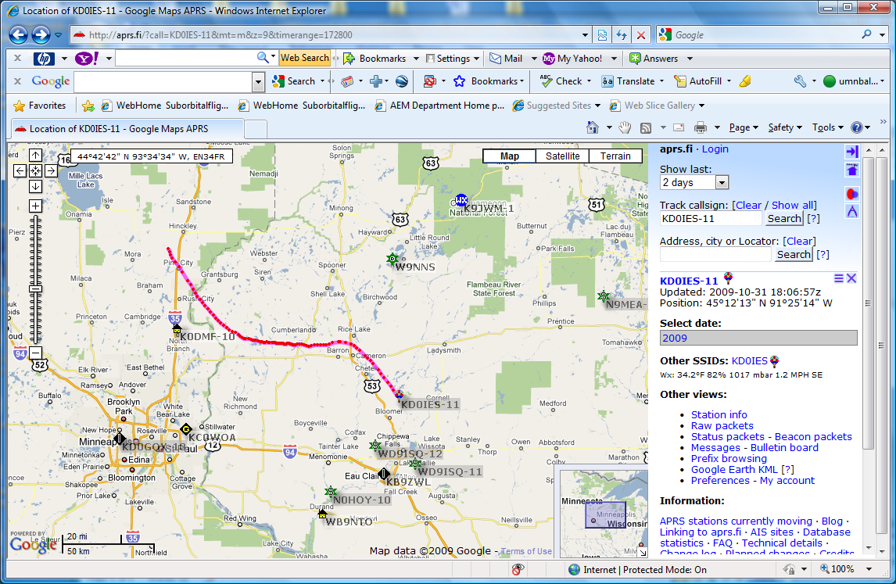
Actual Flight Path

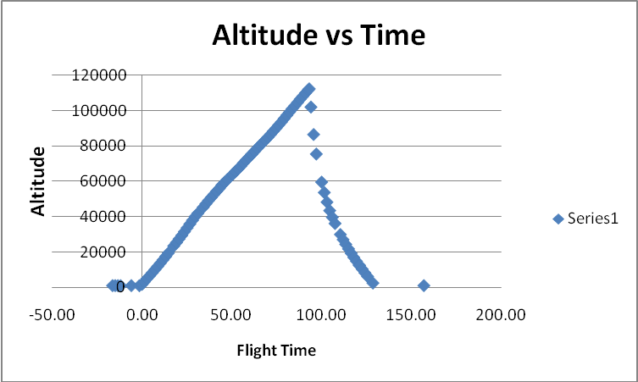
Altitude vs Time graph
Provided by Dr. Flaten

The Peltier cell results match our prediction. The data showed that as the absolute temperature difference increased, the voltage output increased as well. This effect is not dependent only on one temperature, i.e. the interior of the box being particularly warm or the exterior being particularly cold, but the difference between the two temperatures. Also, as the absolute temperature difference decreased just before the burst, the voltage output decreased. This effect is evident in the voltage versus temperature difference graph (with data only from the ascent stage until burst), and interestingly, the voltage follows a hysteresis curve. This means that the voltage at a given time is dependent not only on the temperature difference at that time, but it is also dependent on the temperature difference at earlier times. Because of this effect, when the voltage decreased prior to burst, it did not decrease along the same line on which it increased, but produced slightly higher voltages. This is likely due to the fact that the specific heat capacities of the metals in the Peltier cell are much higher than that of the atmospheric gases, especially when the gases are present in such small quantities at high altitudes. This means that the two sides of the Peltier cell take a longer time to experience temperature changes than the environment surrounding the payload. Because of this, residual “heat” (or more accurately, a lack thereof) would have remained absorbed by the Peltier cell even after the external temperature had changed, causing the voltage output to be higher for a given temperature difference the second time around.
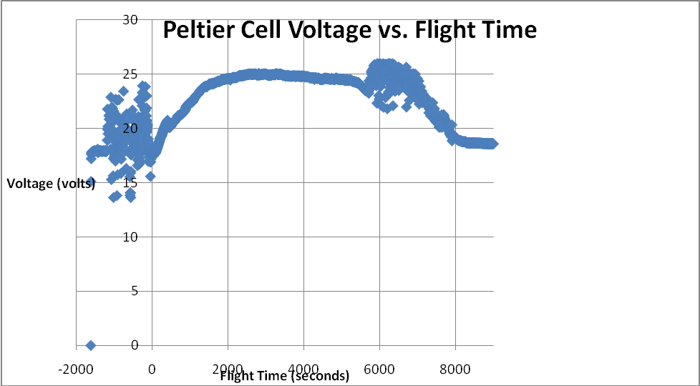
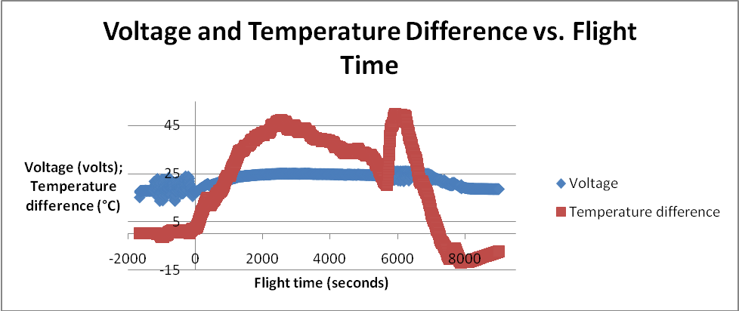

Weather station excitement
Our weather station was only a partial success. Out of the three sensors, only one returned useful data. Our temperature sensor failed, returning results with no apparent trend or relation to the flight, so we used data from our HOBO’s external temperature sensor, which matched the trends we predicted. 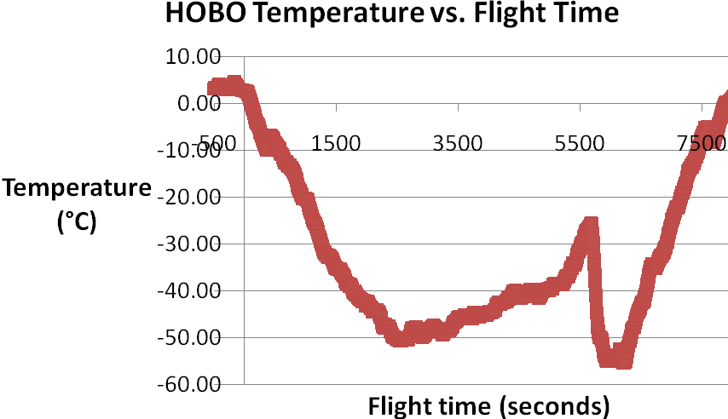
This data shows that, as expected, temperature dropped after launch and continued to drop until the package began to pass through the ozone layer at roughly 70000 feet, when the temperature began to rise until burst. After burst, the package fell out of the ozone layer and back into the cold region of the atmosphere, where the temperature began to fall accordingly as the package fell through the cold region of the atmosphere again. Our relative humidity sensor returned useful results: 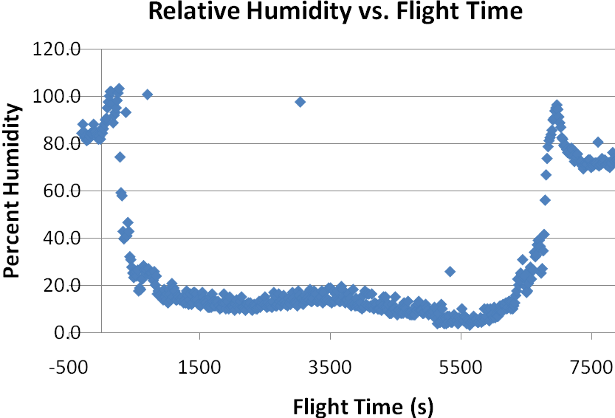
Ignoring the occasional out of place data point, the relative humidity data shows a clear trend that relates to our predictions just as predicted. The humidity starts at about 80% at launch, climbs to 100% as it passes through the dense cloud layer a few hundred feet above the ground, then drops quickly to nearly zero as it passes into the upper atmosphere. We think that the small hump in the relative humidity reading midflight may have been caused by condensation as humidity that froze in the cold middle regions of the atmosphere began to melt in the warmer areas of the upper area, then froze again as the package passed through the cold zone on the descent. Near the end of the flight, another spike can be seen as the package passed through the cloud layer again, then levels off upon landing.
Our pressure sensor also failed, giving back the exact same reading as the relative humidity sensor. For that reason, we used the sensor data from Team Icarus.
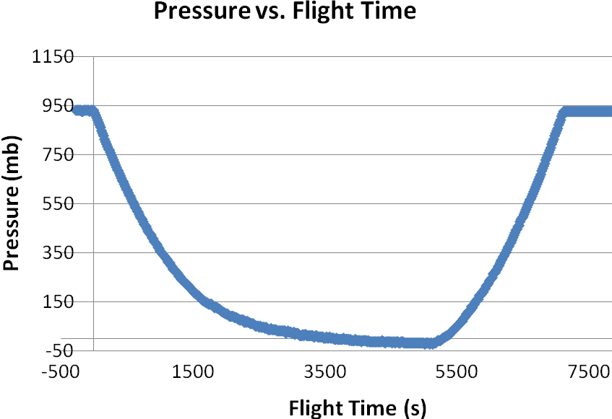
Pressure Data courtesy of Team Icarus
The pressure data also followed our predictions very closely. It started off before launch at atmospheric pressure, dropped consistantly as the package ascended, then began to increase again after burst as the package dropped back through the atmosphere.

11.0 Conclusions/Lessons Learned

In conclusion, our ballooning experiment went fairly well. The two main experiments we ran were the Peltier cell and camera experiments. For the most part, we got the data expected from these tests aside from the one complication with the camera. The day of our flight, the camera lens would not extend into the diffraction grating tube so we were forced to cut one of the tie straps holding the camera in place. When we found the camera, it was still running, but had only taken three pictures all flight. We think that cutting the tie strap may have caused this. Another reason we thought the camera malfunctioned was in the programming. We changed the program to accommodate our camera and it may have came back to haunt us. We will never know what really went wrong with the camera, but we have are pretty sure it was on of these two things. We still were able to get our data because Dr. Flaten flew our camera experiment on another balloon. The results were as we expected, as the balloon rose, the UV and Violet light became more visible, which makes sense because there are less layers of atmosphere to filter the light. If we were to do something different next time, it would be to check and double check the programming and make sure the straps are loose enough so the lens can extend. The Peltier cell on the other hand did the total opposite of the camera, it worked twice as well as we expected. As the temperature difference increased, the Peltier cell generated almost twenty-five volts of current. This could easily power a second heater and weighs quite a bit less than the batteries. Overall, we learned that not everything in life or ballooning goes as planned, as shown in our camera experiment. If you’re lucky, people will help you along the way, but don’t always count on others to pick you up when you fall. When your payload is underweight, add unnecessary weight (fins) to taunt the other teams.

12.0 Appendix: Program Listings

Camera Code
“30 sec code” for Canon PowerShot A570 IS still cameras.

rem Interval shooting
rem For Canon A570IS
rem CAMERA MUST BE IN AV (aperture priority mode)

rem For 3 hour MNSGC flight photo every 30 seconds

@title MNSGC Intervals
@param a Shoot count
@default a 360
@param b Interval (Minutes)
@default b 0
@param c Interval (Seconds)
@default c 30

d=1000

rem reset camera
sleep d
click "menu"
sleep d
click "right"
sleep d
click "up"
sleep d
click "set"
sleep d
click "right"
sleep d
click "set"
sleep 3000

rem set menu values
sleep d
click "menu"
sleep d
click "down"
sleep d
click "down"
sleep d

rem Digital Zoom off
click "right"
sleep d
click "down"
sleep d
click "down"
sleep d

rem Red-Eye off
click "right"
sleep d
click "down"
sleep d

rem Safety FE off
click "right"
sleep d
click "down"
sleep d

rem set MF-Point Zoom off
click "right"
sleep d
click "down"
sleep d

rem Safety MF off
click "right"
sleep d
click "down"
sleep d

rem AF-assist Beam Off
click "right"
sleep d
click "down"
sleep d

rem Review off
click "left"
sleep d
click "down"
sleep d
click "down"
sleep d

rem IS Mode = Shoot Only
click "right"
sleep d
click "menu"
sleep d

rem set apeture to 2.5 by overkill
for n=1 to 10
sleep d
click "left"
next n

rem select manual focus
sleep d
click "down"
sleep d
click "down"
sleep d
click "down"

rem set focus to infinity
for n=1 to 10
sleep d
click "right"
next n

t=b*60000+c*1000
if a<2 then let a=10
if t<1000 then let t=1000

print "Total time:", t*a/60000; "min", t*a%60000/1000; "sec"

sleep 3000

click "display"
click "display"

shoot
for n=2 to a
sleep t
shoot
next n

end

The camera code forces the camera to take pictures at intervals of 30 seconds. The code also shuts off the camera display to conserve battery. This is important so that the camera can take pictures throughout the whole flight.

Weather Station Code
symbol record=w0 'This is the section where the variables are declared
symbol index=w1
symbol value=b4

BalloonSat:
symbol Max_ADC = 2 ' maximum adc channel usedstarting with 0
symbol Mission_Delay = 15000 ' length of pause in mission loop

Mission_Prep:
i2cslave %10100000,i2cfast,i2cword ' set memory speed to 400 kHz
if pin7 = 1 then Download_Data 'and one word records

flasher: 'this section is the sectionthat waits
high 3 'for commit pin to be pulled
pause 10000 'the flahser is also in this section
low 3 ' it flashes at a specific rate
pause 1000
if pin7=0 then flasher

Mission: ' will change pattern of flashing when data is being taken
high 3
pause 2000
low 3
gosub Analog ' collect analog voltages
write 0,record ' store the number of records collected
pause Mission_Delay ' pause.....
goto Mission ' ....before starting all over

Analog:
for index = 0 to Max_ADC ' loop for number of analog voltages to record
readadc index,value ' get next adc value
gosub Record_Data ' go store the value
next ' until last voltage is recorded
return ' return to main mission loop

Record_Data:
if record = 2047 then End_Mission ' check that aren't writing too many
'records to memory
record = record + 1 ' increment record number
low 0 ' unwrite protect memory
writei2c record,(value) ' write the next record to memory
pause 10 ' wait 10 ms for write
high 0 ' write protect memory
return ' return to the calling calling subroutine

Download_Data:
read 0,record ' get the number of data records recorded
' in this flight
for index = 1 to record ' until the number of data records
readi2c index,(value) ' read the recorded record
sertxd (#value,",") ' serial out the data record
next ' until last data record read out
goto fail

fail: ' this is what flashing patern that will occur if the
high 3 'battery dies some time during flight and the computer
pause 1000 ' has restarted and not taken data
low 3
pause 5000
goto fail

End_Mission: 'this is if data was recorded during the whole flight
low 3 ' this shows that the memory is full
pause 1000 ' and that the flight computer functioned properly for
' the flight
high 3
pause 5000
goto End_Mission

end ' end of mission

The weather station is programmed to take data every 5 seconds. It records pressure, temperature, and relative humidity.

