University of Minnesota and MN Space Grant Consortium

AEM 1905 Freshman Seminar: Fall 2010

Spaceflight with Ballooning

Team Project Documentation

Stark Industries

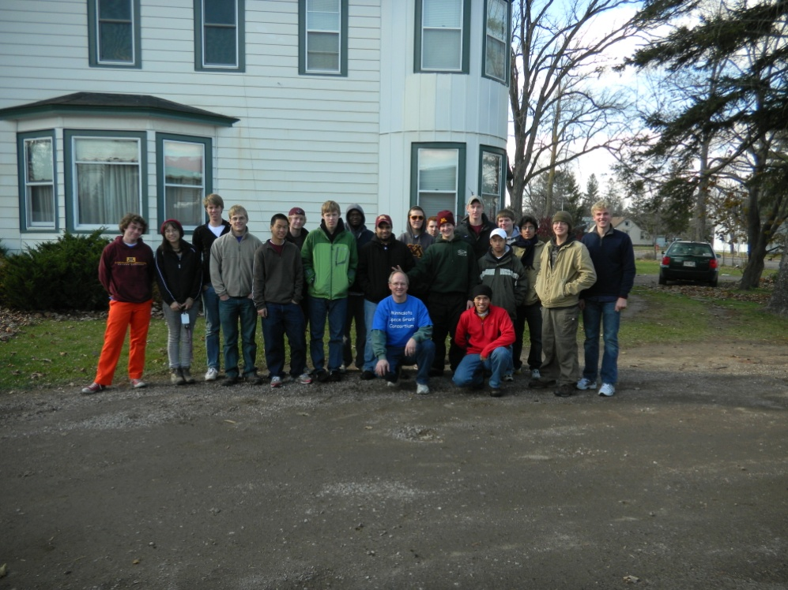

Written by:
Vishnuu Mallik
Connor Chapman
Jaymond Huynh
Mark Flage
Jenew Yang

Report Date: 7th December 2010
Revision C

Table of Contents

0. Team Assignments.........................................................................3

- Introduction……………………………………………………...5

- Mission Overview……………………………………………….6

- Payload Design………………………………………………….7

- Project Management…………………………………………….10

- Project Budgets………………………………………………….13

- Payload Photographs…………………………………………….14

- Test Plan and Results……………………………………………17

- Expected Science Results……………………………...………...22

- Launch and Recovery……………………………………………25

- Result and Analysis…………………………...…………………29

- Conclusions and Lessons Learned………….………………...…46

- Citations and Acknowledgements………..……………………...48

- Appendix: Program Listings…………....…………………...…..49

0.0 Team Project Documentation Writing Assignments

Team Name: Stark Industries

Introduction Mark
Mission Overview Vishnuu
Payload Design Vishnuu
Project Management Connor
Project Budgets Jenew
Payload Photographs Mark
Test Plan and Results Mark
Expected Science Results Jaymond
Launch and Recovery Vishnuu
Results and Analysis Everyone
Conclusions and Lessons Learned Jaymond
Citations and Acknowledgements Connor
Program Listings Jenew

Oral Presentation Assignments

Conceptual Design Review (CDR) Mark and Jenew
Flight Readiness Review (FRR) Connor and Vishnuu

Payload Build Assignments

Overall team lead and ground testing lead Mark
Flight computer (BalloonSat Easy) build Jaymond
Weather station build Connor
Payload box build Vishnuu
Photographer Vishnuu

Programmer (of flight computer(s)) Jenew
Camera and camera experiment Mark
HOBO (payload “health” (internal temp)) Jenew
“Other” science experiment Mark

Launch Day Assignments

Photographer Mark
Prediction/tracking assistant Jenew
Balloon filling and release assistant Vishnuu
Payload/stack handling specialist Jaymond
Recovery specialist (needs to go on chase for sure) Connor

- Introduction

Near-spaceflight, as opposed to spaceflight, is the process of sending a (usually scientific) payload to an altitude that is high enough to qualify as the “near-space” environment. These payloads consist of scientific equipment designed to study the atmosphere, solar radiation, and many other things.
The boundary between near-space and space is difficult to define for several reasons. First of all, even space itself is not a perfect vacuum. The drag induced on the international space station by these molecules is what requires the ISS to occasionally fire booster rockets to avoid re-entry. Second, the atmosphere is constantly sloshing back and forth. The gravitational pull of the moon, as well as uneven heating of the earth’s surface cause this. For the purposes of science, however, the academic community has arbitrarily set the boundary for space at 100 kilometers, or approximately 328,000 feet. The near-space environment, on the other hand, is the area between the middle-upper reaches of the troposphere and the lower levels of space, spanning from around 80,000 to 300,000 feet. Since most near-spacecraft are carried by balloon, the altitude limits of near-spaceflight is around 110,000 feet where the atmosphere becomes too thin to support lighter than air flight. Some interesting properties of near space include the extremely thin atmosphere, which has a density of approximately 1% of sea level, as well as the brutal cold experienced around 60,000 feet, where temperatures can be as low as -70 degrees F.
A near-spacecraft usually consists of one or more payloads lifted by a helium- or hydrogen-filled latex balloon. These balloons are generally from 7 to 15 feet in diameter on the ground and can expand to huge dimensions in near-space, reaching dimensions of 30 feet across and larger. Payloads may contain barometers, hydrometers, cameras, or biology experiments, and the possibilities are only limited by the imagination of the near-space planner.
The payload is safely returned to earth when the balloon bursts and the weight of the payload is transferred to a parachute. Tracking of the falling unit is done in a variety of ways, including GPS and radio transmitters, and recovery can take place anywhere from 50 to 300 miles away from the launch zone, depending on how under- or over-loaded the balloon is and the intensity and altitude of the jet stream.

2.0 Mission Overview

The primary objectives of our mission include the measurement of relative humidity, atmospheric pressure and temperature in different parts of the atmosphere. Our creative experiment is the infrared camera, which shall take pictures of the atmosphere along with the normal camera and will prove that light reveals more than visible light alone. Considering the fact that our balloon will eventually attain a maximum altitude of about 90,000 feet, we have to design our payload box such that the components inside can withstand extreme temperature ranges. For that purpose we have a heater in our payload box, which will keep all the other equipment warm. We also decided to have our payload box black so that it absorbs some heat from the sun. Our payload box has been assembled so as to withstand a harsh landing and ensure the safe and sound functioning of our equipment.
To measure the relative humidity, atmospheric pressure and temperature, our payload box is equipped with a HOBO data logger and weather station. A flight computer will process the data and save it. Once our payload is recovered, we can analyze the data on the computer and study the graphs so as to learn the temperature, relative humidity and pressure fluctuations and patterns in different parts of the atmosphere. Our cameras will take pictures after a certain interval. We shall analyze these pictures together for our creative experiment.

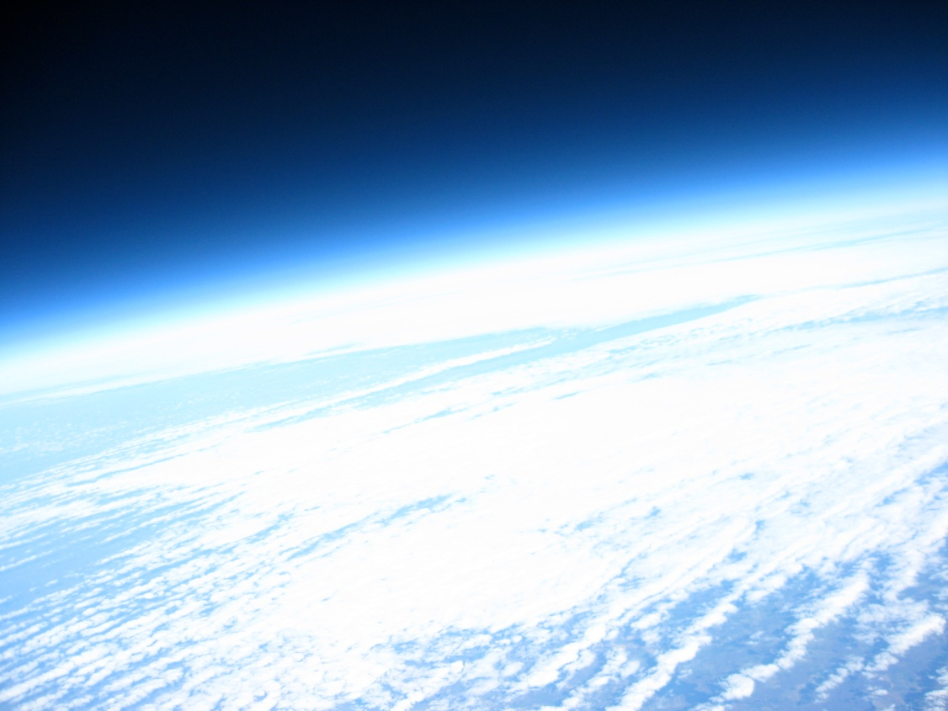

Picture 1: A magnificent view of the Earth taken by the visible light camera

3.0 Payload Design

Ultimately, our payload’s design has a simple goal: carry out a scientific experiment using an apparatus that is able to prevent the experiment from falling or freezing to failure. In our experiment, we want to measure temperature inside and outside the capsule, relative humidity, and pressure. We also want to compare recorded infrared radiation from the earth to visible light.
To measure temperature, relative humidity, and pressure, we will have a tiny thermometer, relative humidity sensor, and pressuresensor attached to our flight computer, which will record the data in a format that we can use later. To analyze the infrared radiation coming from the earth and sun, we will use a pair of cameras taking photos side by side, with the left camera shooting in near infrared, and the right camera observing the visible spectrum. The capsule itself must be large enough to handle all the equipment inside, but cannot be so large as to disrupt the rest of the “stack.” We have to prepare our payload to handle intense cold and violent shaking as the balloon and parachute are affected by the wind. The thermometer and cameras require access to the outside, yet we cannot allow cold drafts to come in. To handle these problems, there are several design ramifications we consider during the payload’s construction.
To keep the components warm at high altitudes, we will need a heater inside the box. The Stark team chose to supplement this heater by building the capsule out of a purely black material, providing warmth to the electronics even when the air in the upper stratosphere is too thin to conduct heat from the heater to the equipment. Our technology must be tightly strapped into place. This will prevent items inside from bouncing against each other, causing damage. Finally, our unit will be uniquely wider than most, since we have to accommodate two cameras sitting next to each other. We have three separate systems in the box: the weather system, the camera system, and the heating system.
The weather system consists of the HOBO, BalloonSATeasy(BSE) and flight computer. The weather equipment shares a common circuit board as well as a connection to the flight computer. The weather equipment is dependent on the flight computer. Our camera system is comprised of two separate cameras. We need both cameras to compare the differences between visible and infrared radiation from the earth and sun. All of the equipment will depend on the heater to keep the chemical reactions in the batteries generating electricity and the experiment going.The construction of the payload box was done before any markings were made. When it was put together, holes needed to be cut for two Canon Powershot A570IS cameras. After thinking about the cameras, the group had a new obstacle to deal with. Since the box was hot glued together, it made it much more difficult to see where the camera lens would come out on the box. The entire payload box is covered with black foam.

Construction Material
•3-ply poster board
•Black insulating foam
•Hot glue
•Epoxy glue
•Velcro
•Packaging tape
•Rigging strings, Key rings, Zip ties

Components
•Flight computer
•Batteries for flight computer and heater
•HOBO
•Weather Station
•Cameras (Normal and Infrared)
Infrared camera- a normal camera was taken and its infrared filter was removed so that it would capture the infrared spectrum.

Arrangement of components and their connections
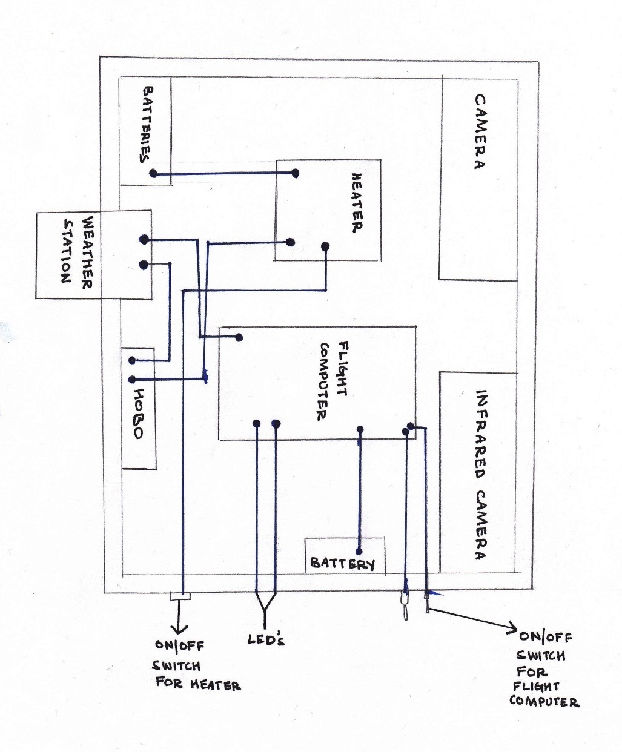

4.0 Project Management

ORGANIZATION CHART

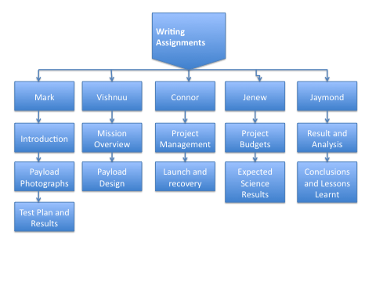
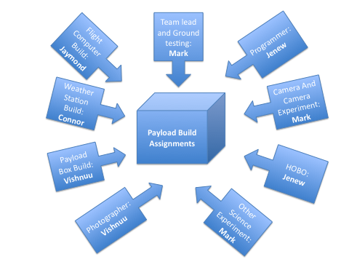
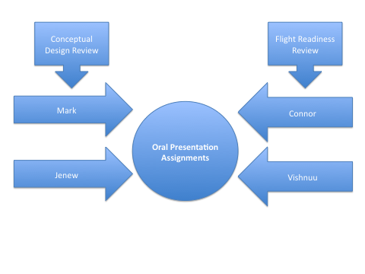

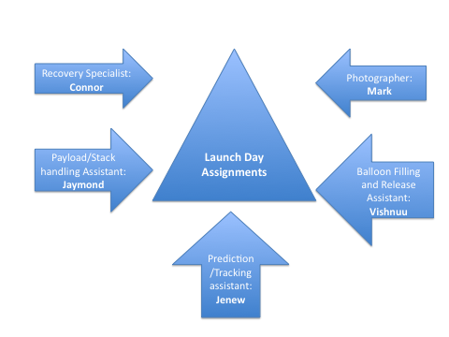

SCHEDULE

Date | Month | Task
5 | October | Conceptual Design Reviews; Began Payload Construction
6 | October | Stark meeting
12 | October | Class time to work on construction, integration, and testing
13 | October | Stark meeting
19 | October | Class time to work on Flight Readiness Review, Assemble and test by next week
21 | October | Completed and tested payload box

27 | October | Stark meeting
28 | October | Attached infrared camera to box. Weighed the box and turned it in.
30 | October | Launch day
2 | November | Data extraction and analysis in class
3 | November | Stark meeting
7 | November | Worked on team project documentation
16 | November | Work on final team presentation in class
17 | November | Stark team meeting
23 | November | Final team presentation
30 | November | Discussed re-entry of landing systems, Worked on a balloon mission to Venus
7 | December | Final team documentation due; Class time to work on mission to Venus and mission summary poster and laptop exhibit
14 | December | Public discussion; Course evaluation; Wrap up

5.0 Project Budgets

Component | Price | Mass
Foam Core/Black liner | 7.00 $ | 0.180 kg
Tubing, Rigging strings, key rings, zip ties, glue, tape | 5.00 $ | 0.050 kg
Heater circuit | 5.00 $ | 0.027 kg
3 pack 9 volt battery for heater | 6.00 $ | 0.130 kg
Weather station | 40.00 $ | 0.015 kg
BalloonSat Easy | 30.00 $ | 0.033 kg
Battery for flight computer | 2.00 $ | 0.046 kg
Canon A570 IS still camera | 166.00 $ | 0.223 kg
Canon A570 IS still camera(hacked for infrared capability) | 166.00 $ | 0.223 kg
HOBO system | 168.00 $ | 0.068 kg
Total | 595.00 $ | 0.995 kg

We expected the mass to be .995 kg, but the actual mass came out to be 1.2 kg.

The most obvious reason for this difference in predicted and actual mass would be due to the fact that our payload box was a bit bigger than the average size, and hence required more material to build.

6.0 Payload Photographs

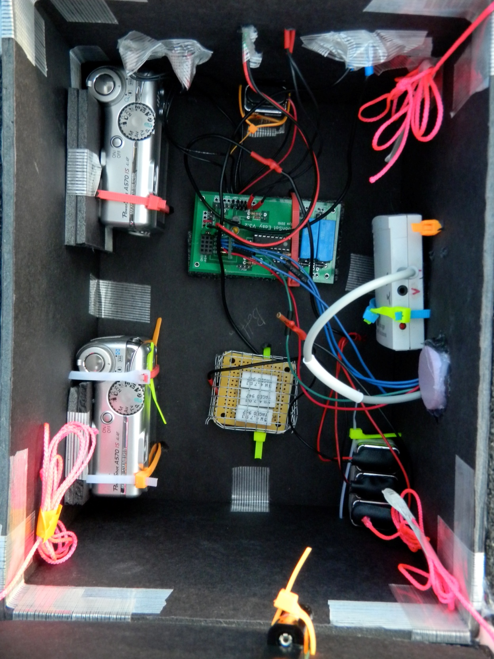

Picture 2: Payload with all components attached, just before launch

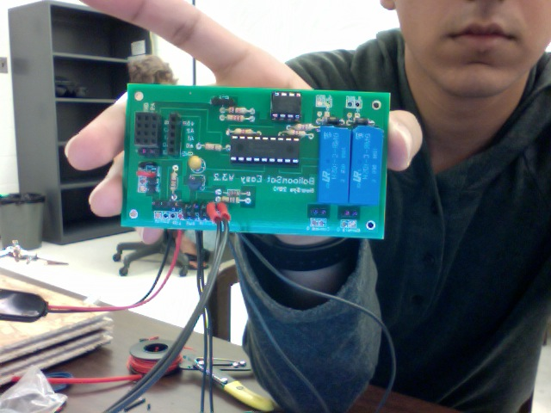

Picture 3: Vishnuu working on the flight computer

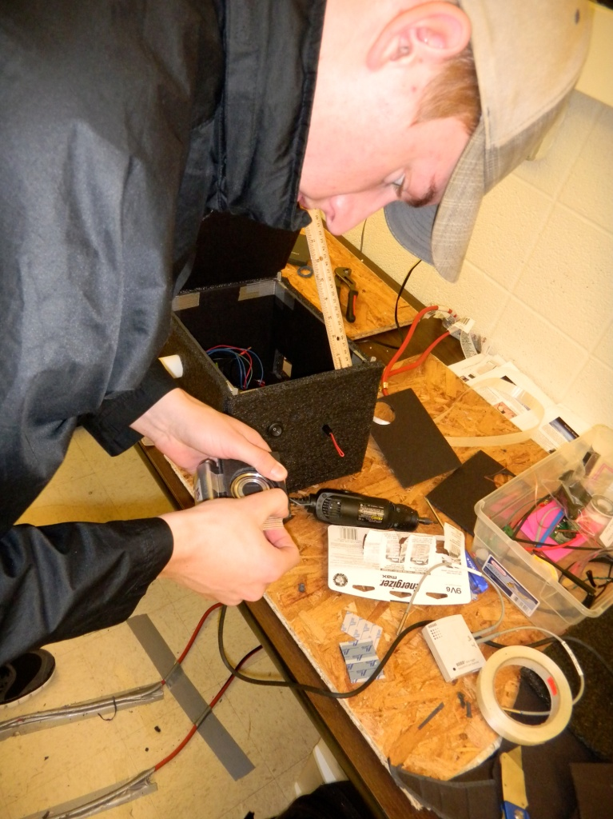

Picture 4: Connor putting everything together

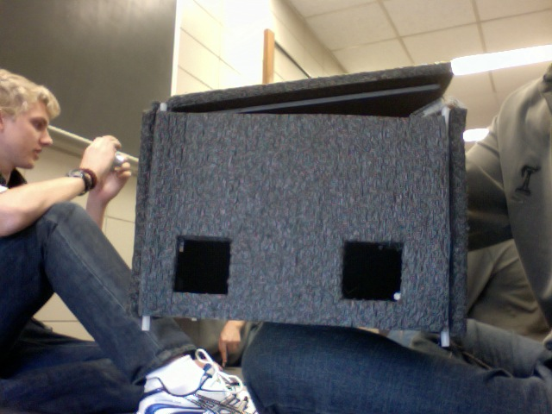

Picture 5: Spaces for the cameras(Payload under construction)

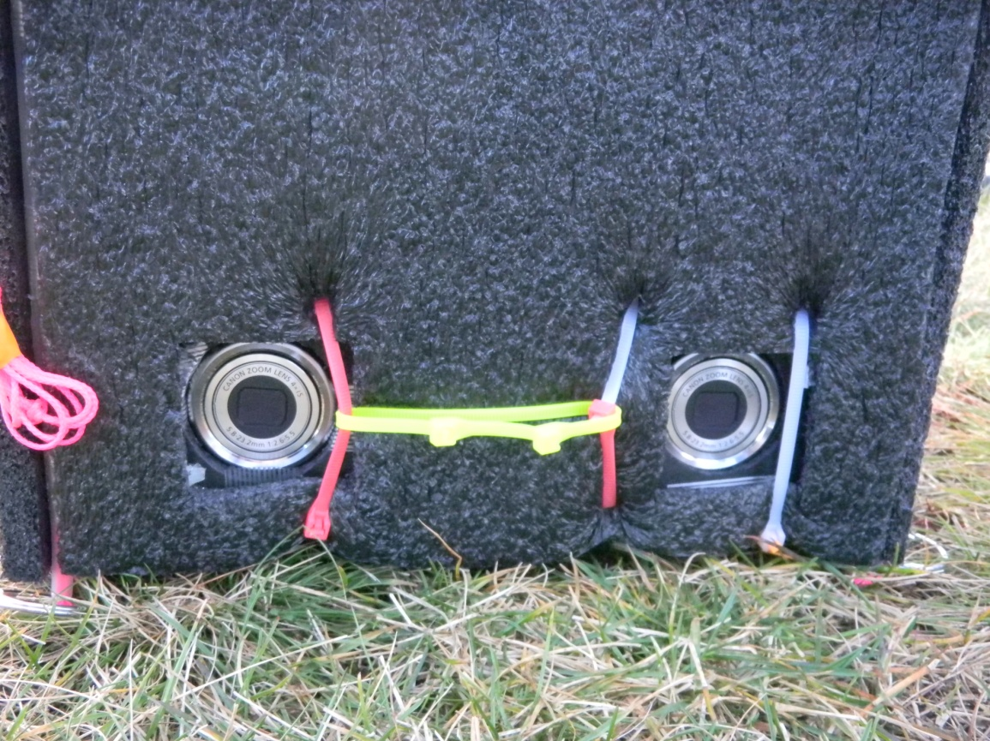

Picture 6: Cameras in place, just before the launch

7.0 Test Plan and Results

The parts in the Stark Industries capsule include a heater, weather station, flight computer, infrared camera, visible light camera, batteries, and protective capsule. We will test our heater by switching it on and seeing if it warms up. The data from the weather station will be analyzed after the box has been cold soaked to ensure that it records data in a reproducible and accurate format. The flight computer will be examined to see that it properly obtains and stores the data from the weather station. We will take photos with our infrared camera and see if they turn out well. The visible light camera will be tested in the same way. We will not be testing the batteries for each unit, as high-quality lithium batteries from a reputable manufacturer are incredibly reliable. Our capsule will be thrown down a flight of stairs with 2lb of sand inside: if the unit survives, it will be approved for flight. Testing of the entire unit will require more effort.
During test 1, the parts will first be assembled. After being put into flight configuration, we will place the capsule in a dark closet and set up a timer inside the closet, orienting the timer so that the cameras are able to photograph the changing of the face of the clock. After 15 minutes, the unit will be moved out into a dorm room where the unit will be placed in a sunny window, enabling us to check the performance of the equipment as well as the temperature change from the dark to the sunny window. After 15 minutes in the sun, the capsule will be opened and the data examined. If the camera passes this test, we will replicate the experiment, changing only the variable that the unit will be encased in a laboratory freezer for the first 15 minutes instead of a dark closet. The freezer will be chilled to -50 Celsius or as low a temperature as possible. If the capsule continues to operate during this time, we will judge the test a success and approve the unit for flight.

Test Plan Steps:

1.Structural strength test will be done first. This will involve filling the box with two pounds of sand and dropping it from a height of 24 feet.

2. Test heater by installing batteries and waiting until heater warms up. Test will be successful if heater becomes hot.

3. Test weather station and flight computer by assembling and recording 5 minutes of data in two environments: a damp towel and the freezer. If weather station records data and flight computer reports data, we will consider it a success.

4. The cameras will be tested twice: once outside and once inside the box. The outside test will consist of an activation of the camera software and examination of the photos the cameras take on a computer.

5. The cameras will also be tested a second time, when they are inside the box and placed in the freezer. We will activate the software and place the box in the freezer as outlined in the following steps.

6. The entire unit will be tested in non-rigorous conditions first, by placing in a dark closet for 15 minutes and then in a sunny window for 15 minutes. All the equipment will be activated before the test begins. At the end, we will examine the data and see if it is consistent and reasonable. If so, we will move on to test step 6.

7. For the final test, we will activate all the equipment and seal the unit. The unit will be cold soaked in a dry ice chamber. If the equipment continues to work throughout the test, we will examine the data. If it is acceptable and reasonable, the capsule will be approved for launch.

Test Results:

- The box laughed off the structural strength test.

- The weather station and flight computer recorded data.

- The cameras worked well under all the required conditions and took photographs after the required interval.

Because of time constraints, we were limited in our ability to perform extensive testing on the capsule. Therefore, we stayed with the original testing regimen of cold soaking and a vibration test (“yank” testing). We omitted the relative humidity “wet towel” test, and only tested the cameras once. We also omitted the non-rigorous overall system test. We believed that the relative humidity test was unnecessary since the relative humidity sensor reacted in a predictable way in the cold-soak test, negating the need for further testing. We chose not to test the cameras separately since they worked well during the cold-soak tests and after shutter-interval programming adjustments in the lab.
The infrared camera was left out of the original tests since it was not yet ready to fly. Since the infrared camera was not materially different from the visible-light camera, and the visible-light camera was in the cold-soak test, we believed it was reasonable to extrapolate the successful performance of the visible-light camera onto the infrared camera. Since the individual components of the capsule worked perfectly in rigorous conditions, we concluded that they would continue to perform well throughout the flight and therefore would not require an overall system test. We were convinced that the successful performance of the capsule during the cold-soak test negated the need for any further testing.

The following graphs provide information collected from the capsule during the cold-soak tests. Since the capsule was completely black inside, no visible-light photos are available from the test.

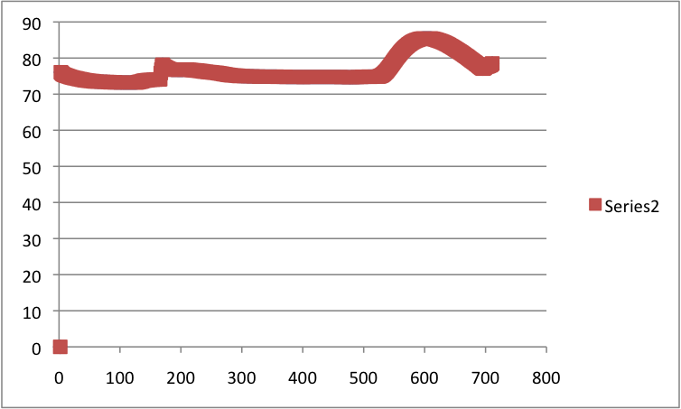
Graph 1: Internal Temperature vs. Time. Shows how the heater's temperature did not significantly change in the capsule during the cold soak test

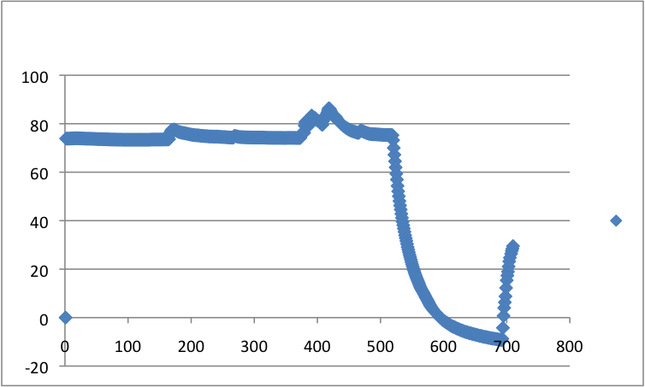
Graph 2: Outside Temperature vs. time. This graph shows the reaction of the weather station’s temperature sensor as taken from outside the box. As expected, this data expresses a straight line as the capsule sat at room temperature before testing and a dramatic drop in temperature once the team placed the capsule in the freezer.

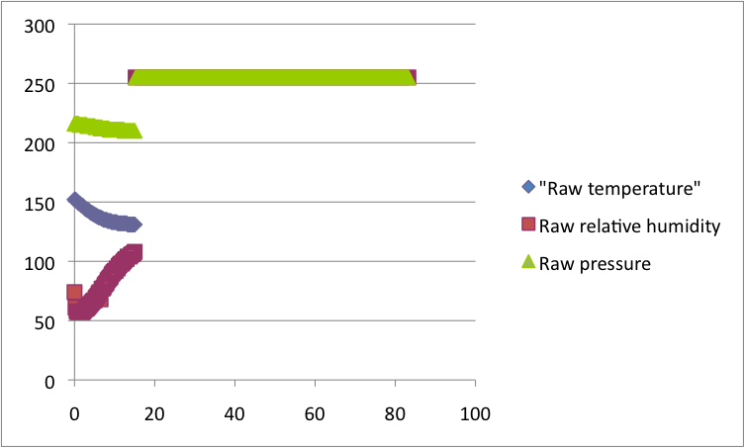
Graph 3: Raw data vs. time. Shows a combination of all the data sensors. They are showing changes over time as would be normally expected under the conditions. We see that all the values jump to 256 after about 15 minutes. This marks the end of the experiment as the flight computer reprograms itself.

Adjustments made after testing:

- The position of the weather station was changed. This was done primarily to seal the box of better and avoid air from getting in.

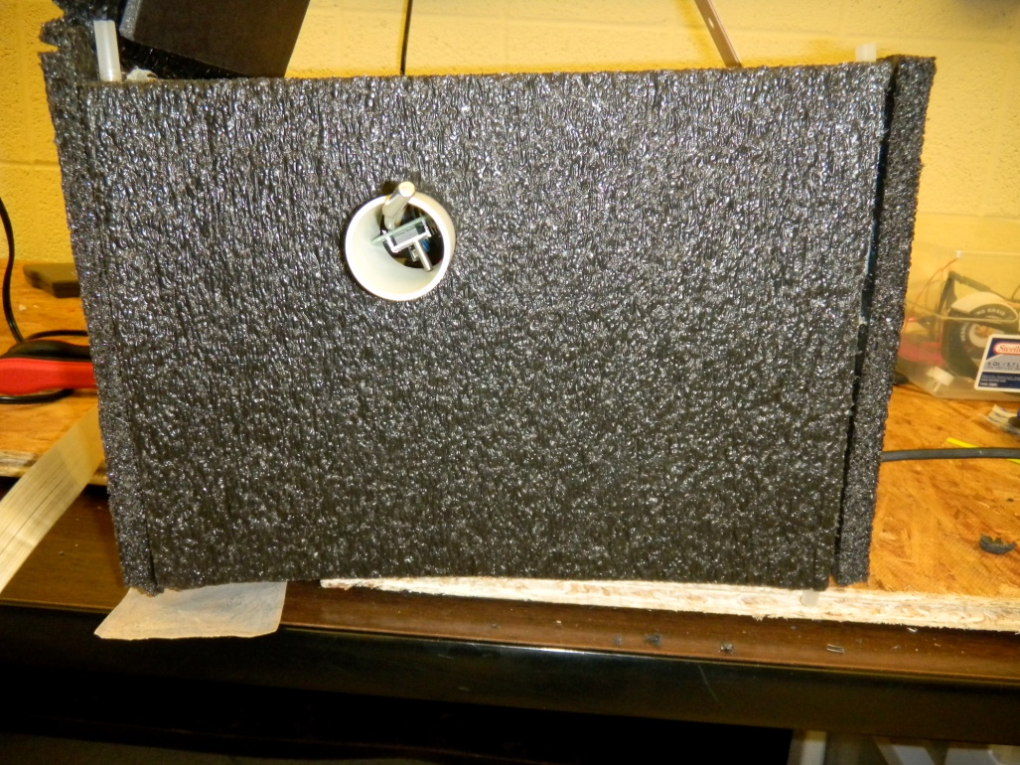

Picture 7: Initial position of the weather station

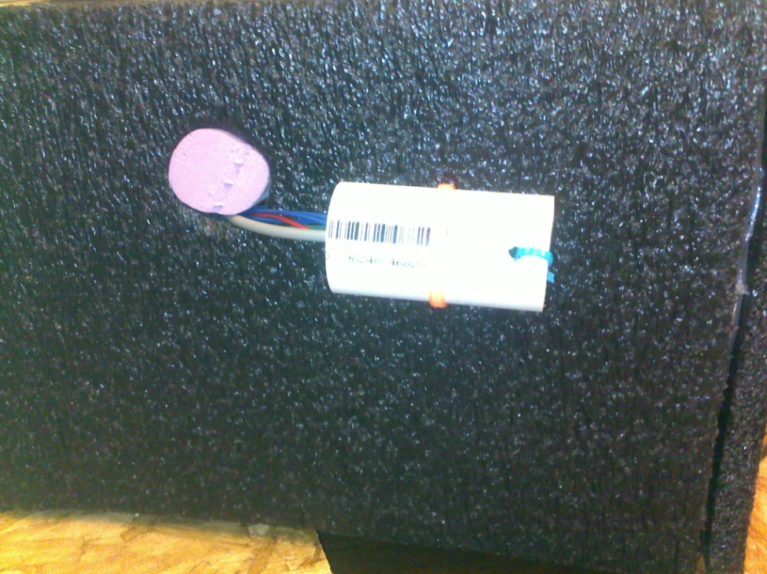

Picture 8: Final position of the weather station

8.0 Expected Science Results

Stark Industries’ members made several experimental predictions about the conditions of “near space” after collecting data from previous weather balloon launches, and reading articles about “near space” written by Paul Verhage. Paul Verhage had graphs in his articles showing the same trends that previous weather balloons experienced. In part one of Paul Verhages’s article on near space, he showed certain trends in the temperature, humidity and pressure when ascending up into the atmosphere. Paul describes that the ascending process into the atmosphere would be relatively peaceful, but the descent would be turbulent. Because of the violent descent and the harsh conditions, the payload box was tested to ensure that it would be able to protect the enclosed components against the cold environment Paul Verhage illustrated. Another source of information about the conditions that were to be expected was the data collected form weather balloons that were launched in the previous years. These weather balloons were equipped with HOBO’s that documented that the atmosphere got cooler as the balloon traveled through the troposphere and then it got warmer as it continues into the stratosphere. Stark Industries believed that it was going to get below negative fifty degrees Fahrenheit and then slowly increase once the balloon went past sixty thousand feet. In contrast with temperature, the pressure that will be experience will steadily decrease. The changes in pressure and temperature could also depend on the season since the warm or cold air masses that the weather balloon will travel through will affect how high the payload will go.
To measure relative humidity at different altitudes, a HOBO will be placed in the payload and will be calibrated to have a “zero” point for pressure, humidity and temperature. The HOBO will most likely display the same trends that Paul Verhage and previous weather balloon experiment reported.
The Stark Industries’ trademark experiment will be to modify a 7.1 mega-pixel Cannon Powershot A570IS to capture some of the ambient Infrared Radiation that is being emitted from the Earth’s surface. This Cannon Powershot camera will be taking picture at the same time as that of an unmodified camera of the same model. The expectations that we have will be that the modified camera will reveal more about condition of the atmosphere than a normal camera. This can be confirmed by comparing the still images of the unmodified camera with the images of the camera that will be able to detect Infrared Radiation

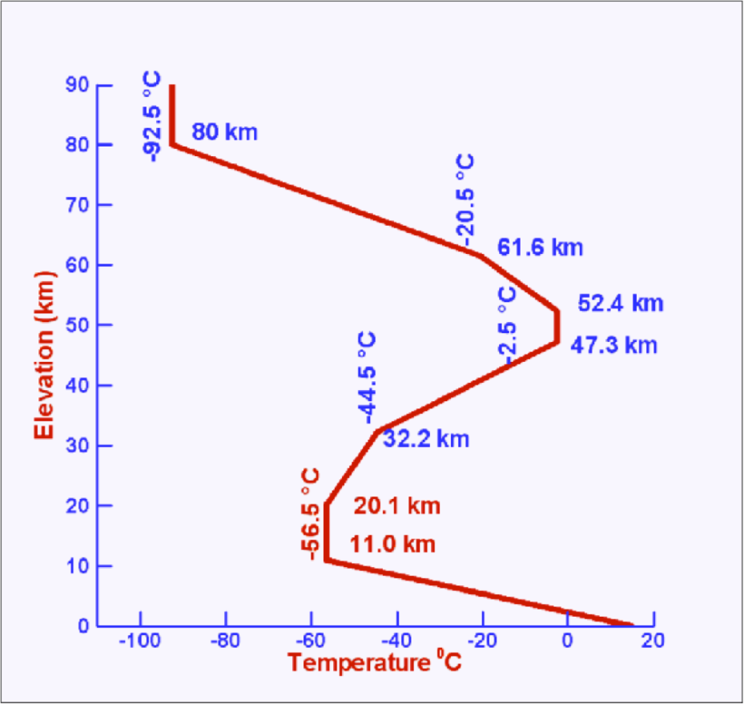
Graph 4: Variation of temperature with increase in altitude. Note how it decreases till 10km, and then stays constant before rising till about 32 km

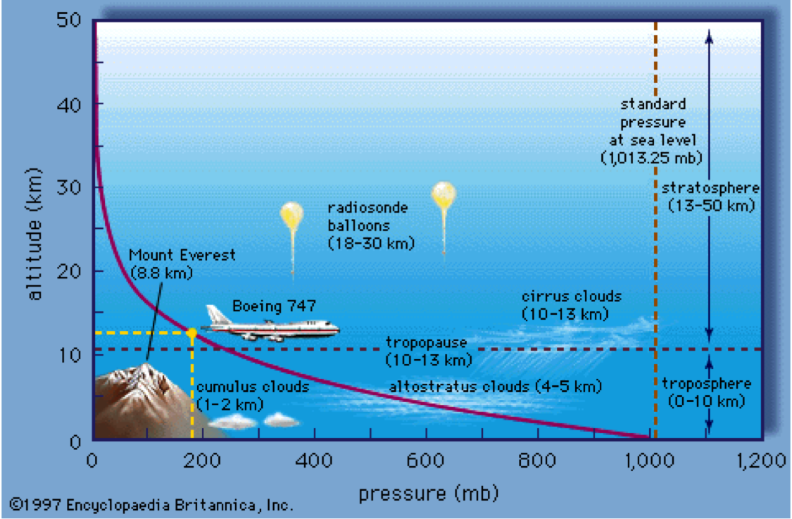
Graph 5: Variation of pressure with altitude. Pressure decrease with an increase in altitude and at 90,000 feet (27.4 km) is 56 times less than that at sea level.

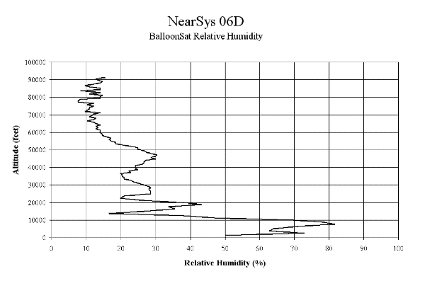
Graph 6: Relative velocity shows indefinite trends. This is due to the presence of moisture rich cloud layers at different altitudes in the atmosphere, and then gaps of dry air.

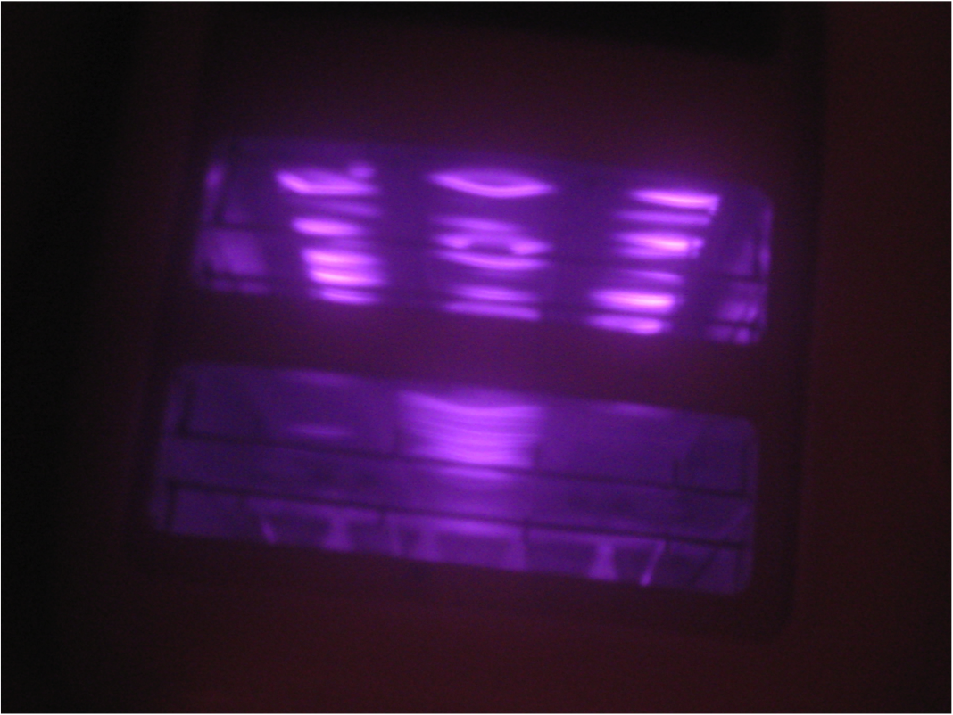
Picture 9: Photograph of a hot toaster taken by our infrared camera. Note the hot elements in the toaster reflect a relatively large amount of infrared light. (Photo courtesy: Seth Frick)

9.0 Launch and Recovery
Finally, themuch-awaited day of the launch was here. The launch was scheduled for the 30th of October at about 9:00 am and we were to leave the University at around 6:00 am. We went a bit of schedule and left at 7:00 am, accompanied by Dr. Flaten and the teaching assistants for the class. It took us about two hours to reach the launch site, which was a school ground in Pierz, 80 miles Northwest of Minneapolis. It was a cold, sunny morning, with clear skies and no wind.
We were all assigned specific tasks for the launch day. The pre launch set up required us to lay a plastic sheet on the ground, on which the balloon would be filled and handled. This was to assure that the balloon surface did not come in contact with any sharp objects on the ground, which could be capable of puncturing the latex. All those handling the balloon were also required to wear plastic gloves. Four cylinders full of helium ensured some backup incase things did not work out as planned and we burst a balloon while filling it up. Filling the balloon is a tricky operation as the balloon must be refrained from swaying and only the required amount of helium has to be filled in. This is determined by how fast we want the balloon to ascent and the mass of our payloads, including the parachute, Stratocaster and radio. We wanted an ascent rate of 1000ft per minute, so we filled our balloon with just enough helium to easily lift all the payloads and other equipment tied to it.
Before the launch, all the payload boxes were attached to one another and to the balloon by means of rigging strings. We ensured that all our components were in place and switched on our cameras, flight computer and heater before sealing the box. We were fortunate that it wasn’t windy as it is a challenge to keep the balloon stable while filling and the launch becomes tough due to the balloon swaying due to the wind. Even then, we took the necessary precautions while launching the balloon, and let it rise slowly, holding the payload boxes and letting them into the air one by one. Within a matter of a minute, our balloon along with the payloads was a tiny spec in the sky.
After the launch, we packed all our equipment and headed off to Barron, Wisconsin, which is 76 miles Northeast of Minneapolis. This was our predicted landing site, based on GPS calculations. Preferably, we wanted to land on a farm so that we did not have to deal with taking the payload off a tree or maybe even a lake! Since we did not have a Zigbee radio in our payload box, we did not receive any data during the flight. As we were on our way to recover the balloon, we learnt that it had offshoot its destination by about 45 miles and landed in an area covered with trees at Holcombe, Wisconsin. Much to our disappointment, we could not go to recover our payload due to shortage of time. The payload was recovered by one of our teaching assistants, Philip. According to Philip, the parachute along with all the payload boxes was stuck in a tree, right side up. The recovery wasn’t much of a hassle and required just yanking the payloads from the tree.
We got to see the condition of our payload box two days later in class. The payload box was in perfect condition, with no visible damage and everything was intact and working. Only the Infrared camera had an error and was out of focus.

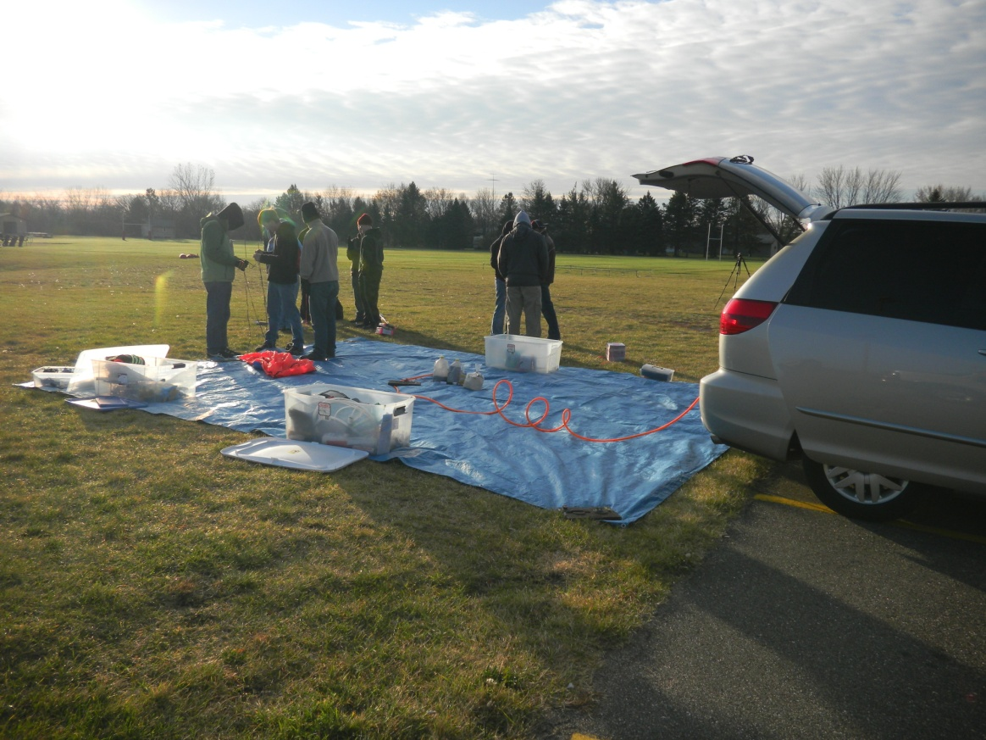

Picture 10: Students preparing for launch at the launch site

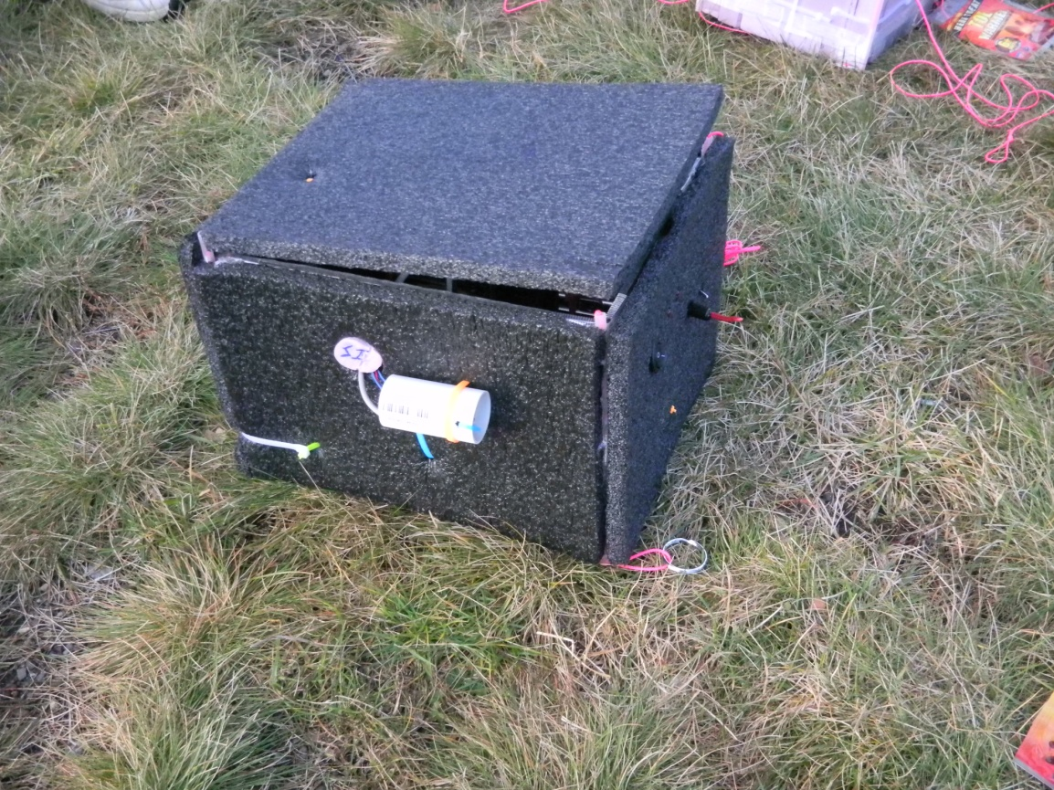

Picture 11: Our payload box, before it was sealed for launch

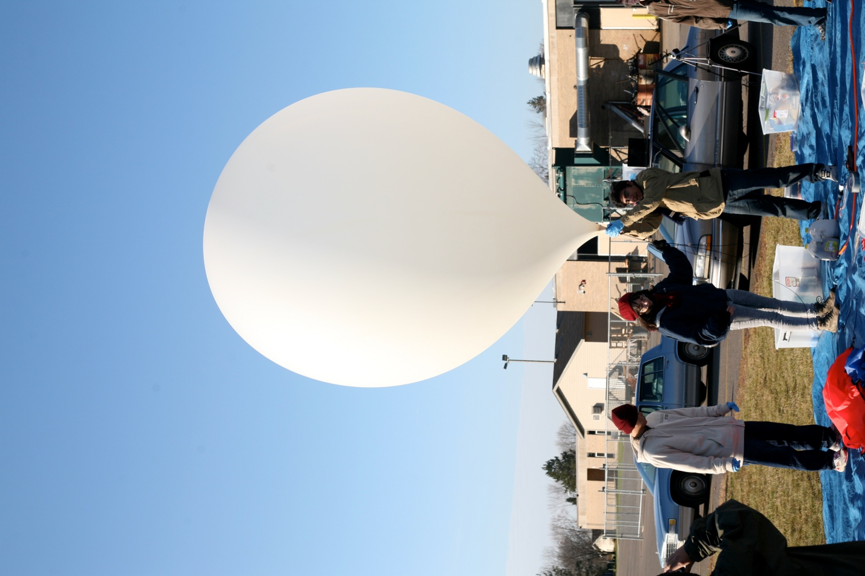

Picture 12: This was how big our balloon got before the launch

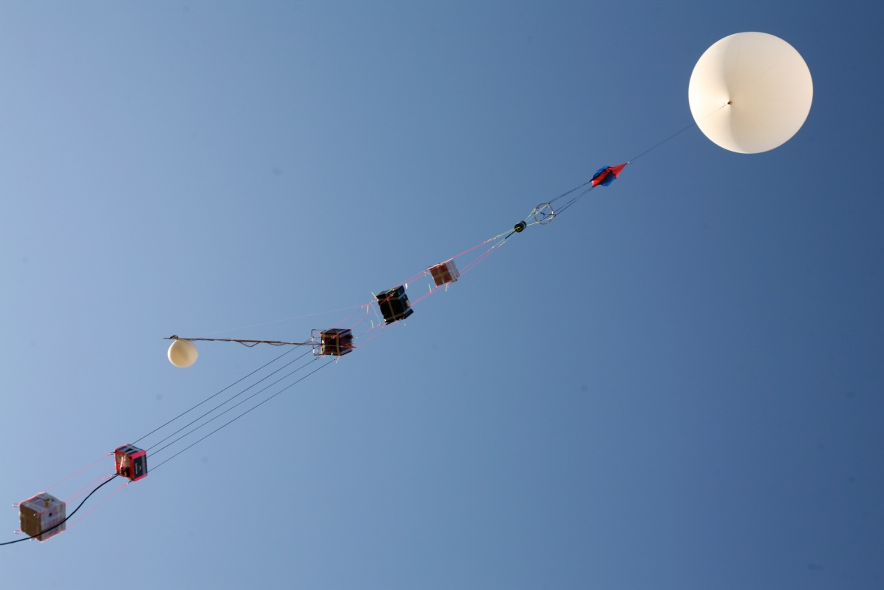

Picture 13: Up and Away! This picture was taken seconds after the launch.

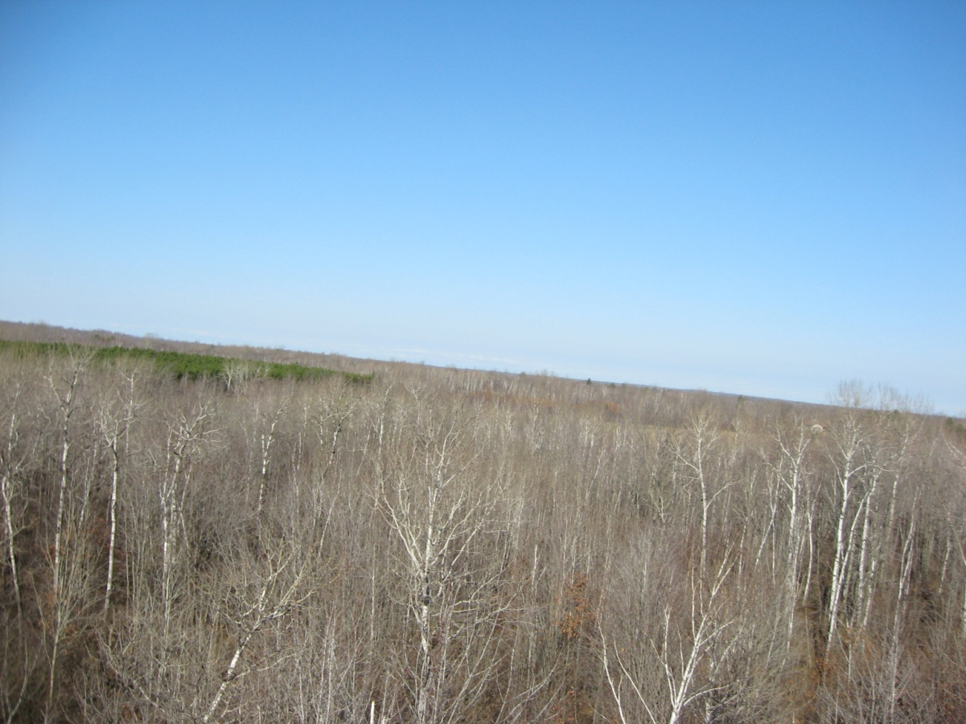
Picture 14: The landing site. Picture taken from the visible light camera seconds before touchdown.

10.0 Results and Analysis

Following the recovery and after we finally got to see our payload, we extracted the data from the flight computer and HOBO so as to analyze it. This was the moment of truth for our entire project, as we would come to know whether or not our mission was a success and if our predictions agreed with the experimental results.
To our relief, the flight computer and HOBO had recorded data and both our cameras had taken wonderful pictures. We shall now discuss our experimental results and analysis.

Time of flight

Our HOBO and Balloon SatEasy(BSE) recorded the altitude our balloon reached before it burst. According to our instruments, the altitude at launch was 1223.4 ft above sea level, and the balloon burst at 90,859.5 feet above sea level (HOBO data), at which point the balloon was an hour and fifty-two minutes into flight. (We launched at 10:05 am and the balloon burst at 11:57 am). We landed at a site, which was 1304.57 feet above sea level at 12:31pm. So the total time of light was one hundred and forty six minutes.

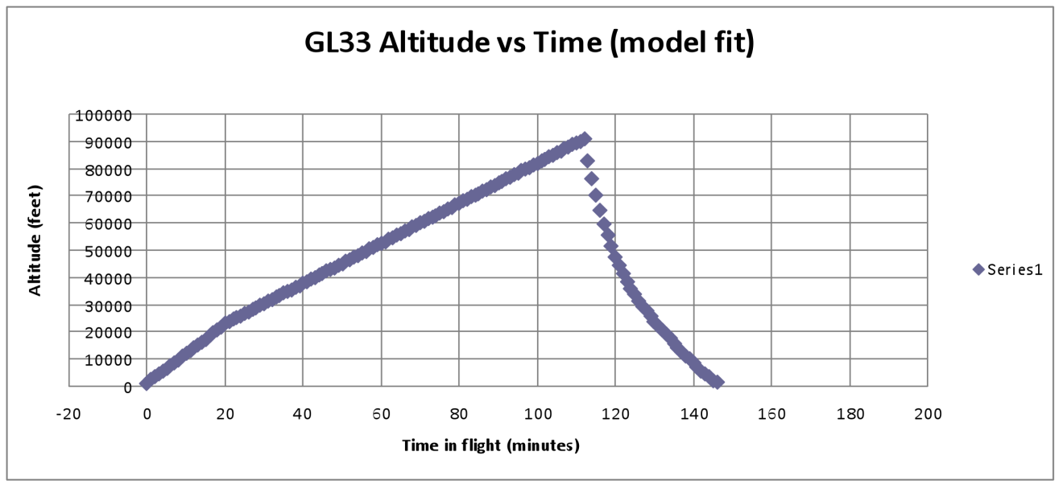
Pressure
Graph 7: Altitude vs. Time

Our prediction that pressure decreases with altitude was based on the fact that the density of air decreases with an increase in altitude, and so the molecules of air are farther apart than they are at sea level. There is a direct relationship between pressure and density. Our BSE recorded the pressure at the launch site to be 981.9883 millibars, at an altitude of 1223.4 feet above sea level. Our balloon burst at 90,859.5 feet above sea level, at which instance the pressure recorded, was -12.8604 millibars. Pressure cannot be a negative value, which tells us that there was a slight error with our BSE as far as pressure at this altitude was concerned. The last positive recorded value of pressure was 1.978millibars at about 85,000 feet, which is still inaccurate as at that altitude, pressure should be above 25 millibars. After giving it a lot of though, our group figured that this inaccuracy could be due to calibration error in the instrument, or due to the air being to thin, accompanied with the fact that the payload may have experienced free fall after the balloon burst.

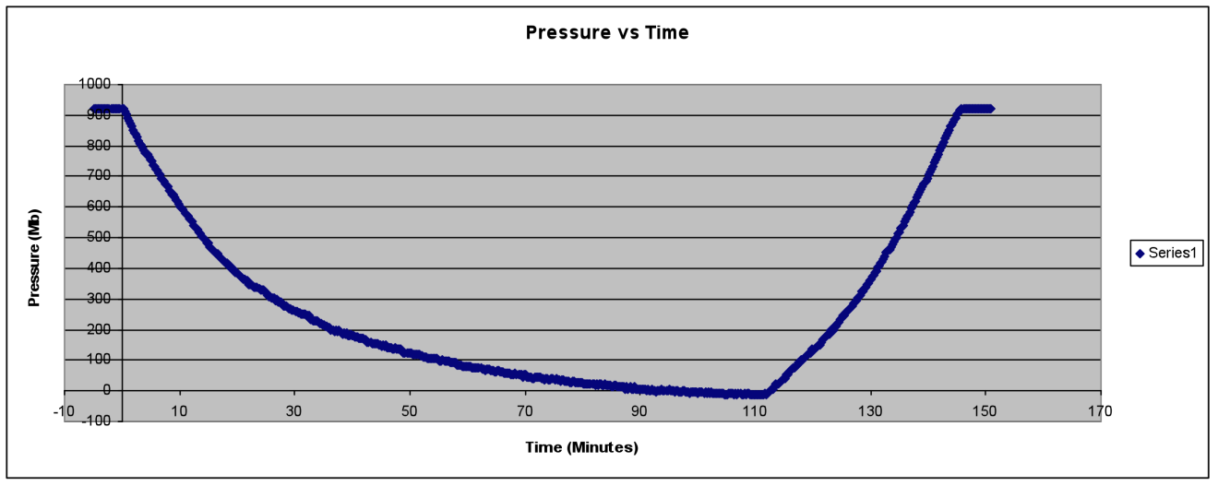
Graph 8: Pressure vs. Altitude
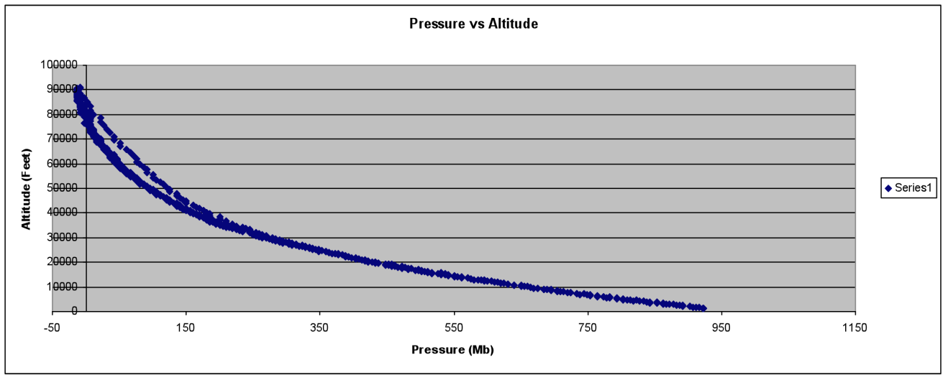
After observing the trend in the graphs, we found that the pressure decreased with an increase in altitude. This trend agreed with our prediction.
Graph 9: Altitude vs. Pressure

Relative Humidity

Relative humidity showed a rather irregular pattern. This was expected, as cloud layers in the atmosphere are areas of high humidity, due to the concentration of water molecules, while in the rest of the atmosphere; relative humidity decreases with an increase an altitude.

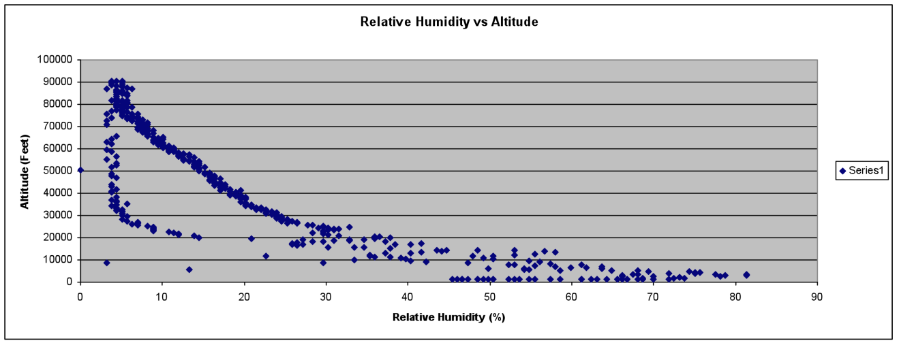
Graph 10: Relative Humidity vs. Altitude( Taken from BSE)
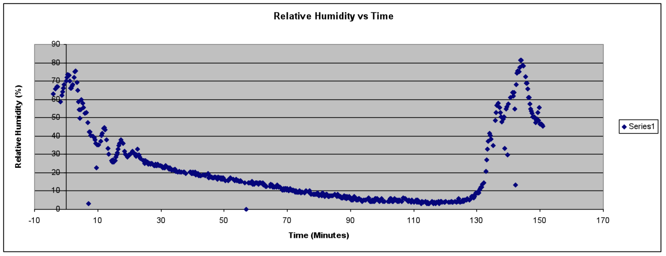
Graph 11: Relative Humidity vs. Time (BSE Data)
The ‘lag’ in relative humidity observed in the graphs indicate that the air circulation kept the instruments dry and that our payload box carried a sample of dry air downward with it, or trapped dry air.
Considerable spikes in relative humidity occurred between 15,000 and 20,00 feet, when the balloon traveled through layers of cloud, due to which there were sudden increases in relative humidity.

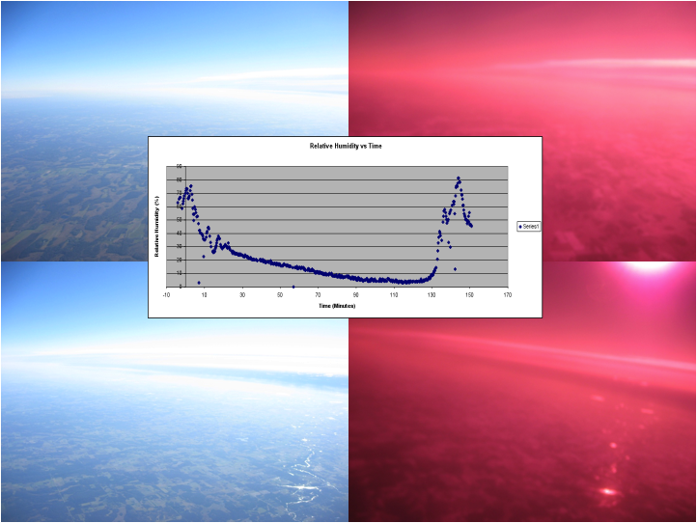
Picture 15: These pictures were taken when the payload was going through a thin layer of clouds, due to which relative humidity increased

Temperature

As we had expected, the temperature decreased from 38.273 degrees Fahrenheit at launch to -46.631 degree Fahrenheit at 34,839 feet, after which the average external temperature increased till 90,122.4 feet where it reached a high of 40.064 degree Fahrenheit (HOBO data). After the balloon burst, the temperature decreased to a low of -64.212 degree Fahrenheit at about 55,329 feet and then increased till the time we landed. Surprisingly, during ascent, the temperature at about 55,000 feet was around -22 degree Fahrenheit. This led us to observe the general trend in our Temperature vs. Altitude graphs and think about factors that could have caused such a drastic difference.

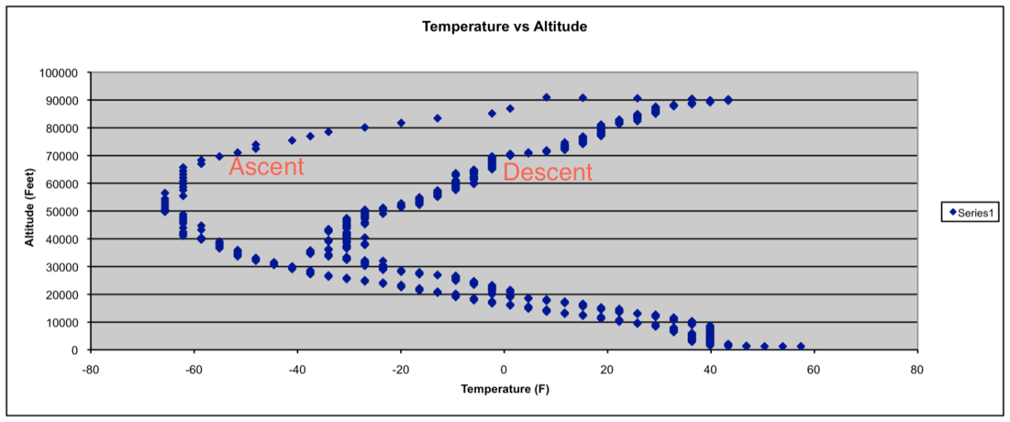
Graph 12: Temperature vs. Altitude. Note that the temperature variation during the descent is faster than that during the ascent.

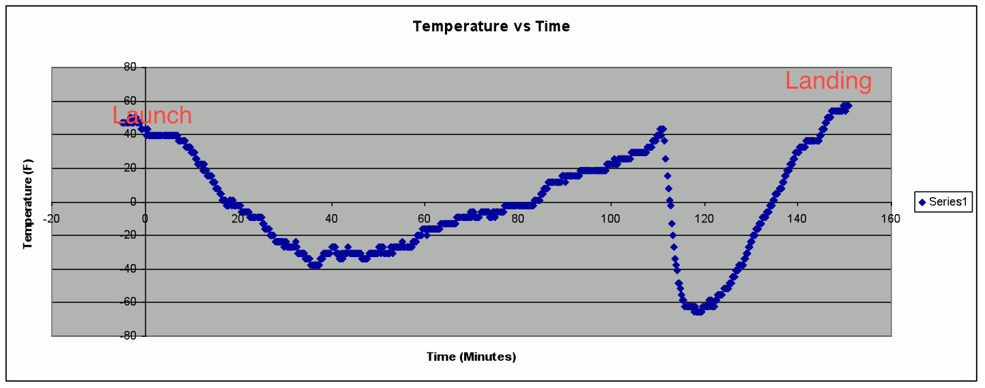

Graph 13: Temperature vs. Time

Graph 11 indicated that the temperature variation during the descent was much more drastic than that during ascent, especially the decrease in temperature. Our team thought about the wind chill factor, as the box descended at a much faster rate than it ascended. An important fact, which we thought about, was that in still air, the air next to the capsule would be a local hot spot as it is slightly warmer than the atmosphere. This would have been the case during the ascent. On the other hand during descent, the payload is in a state of freefall. The airflow of freefall replaces the local hot spot with new air. This keeps the temperature difference (and therefore heat loss) to a maximum. The increased parachute effectiveness at low altitudes reduces this effect.

Creative Science Experiment

Stark Industries creative science experiment involved comparing the pictures from an infrared camera with those of the visible light camera and attempting to see how different ground features and the atmosphere absorbed or reflected infrared light.
Since the sensitivity of infrared cameras is more than those of visible light cameras, they can capture a spectrum beyond the visible light spectrum, which is captured by normal cameras.

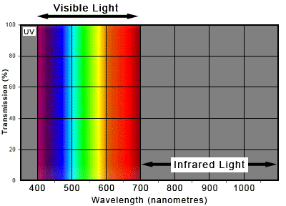

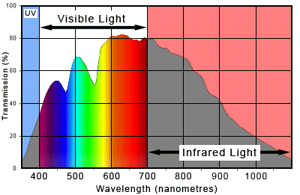

Infrared light has a longer wavelength than visible light, due to which cameras tend to be sensitive to infrared light. To avoid this, manufacturers install filters in all cameras to hamper the infrared light from reaching the sensor. On the other hand, when a visible light-blocking filter is added, only infrared light is captured.
The camera we used for our scientific experiment had its infrared light filter removed, but there was no filter for visible light. Moreover, since infrared light has a longer wavelength, the camera was thrown slightly out of focus with the adjustment. So our camera was essential a ‘Near Infrared camera’, but we managed to work with it and come up with some interesting conclusions.

Infrared light and water bodies

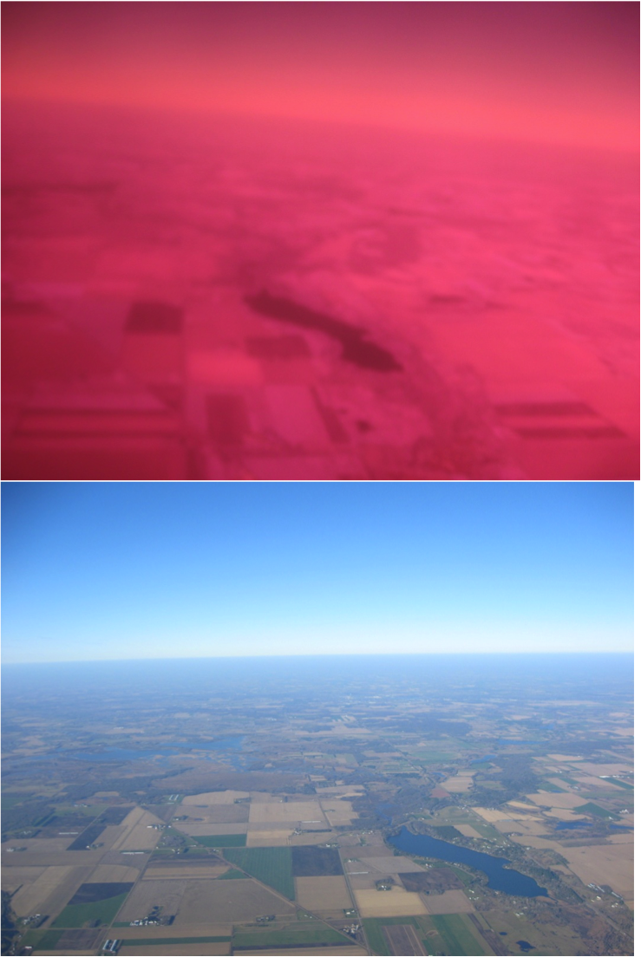
In the above pictures we notice the near complete absorption of infrared light by the lake and the considerable absorption by freshly tilled soil.

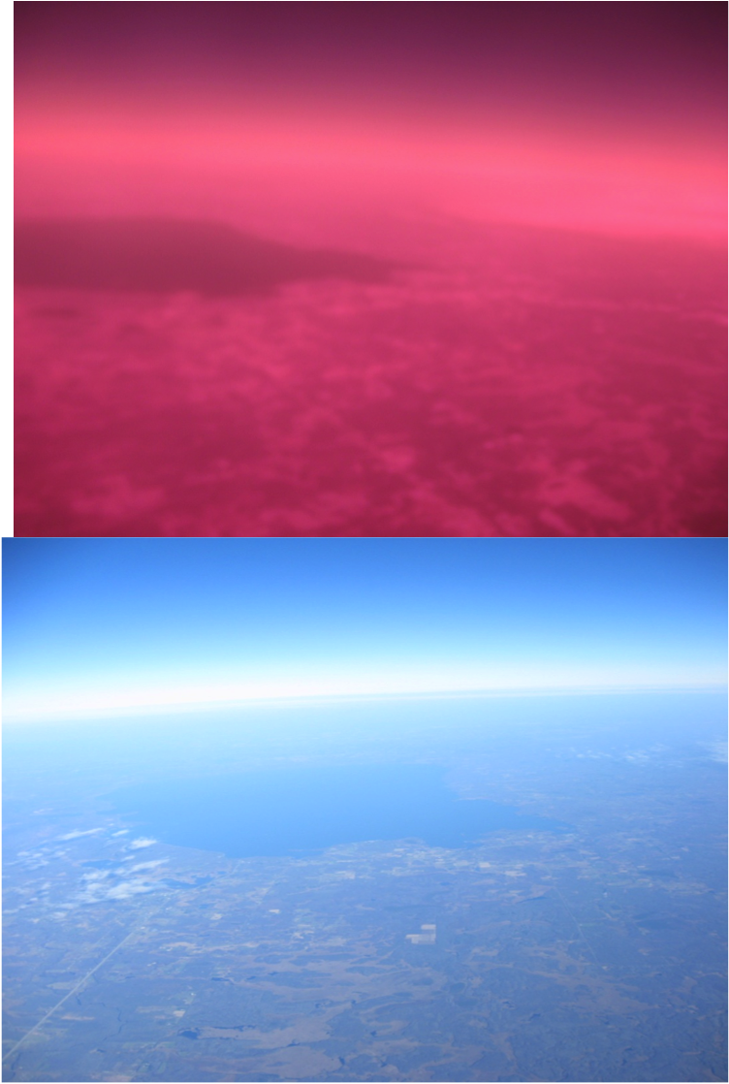
Seen in these photos is Mille Lacs Lake.
We can say that bodies of water absorb a large amount of IR radiation.

Infrared light and green plants

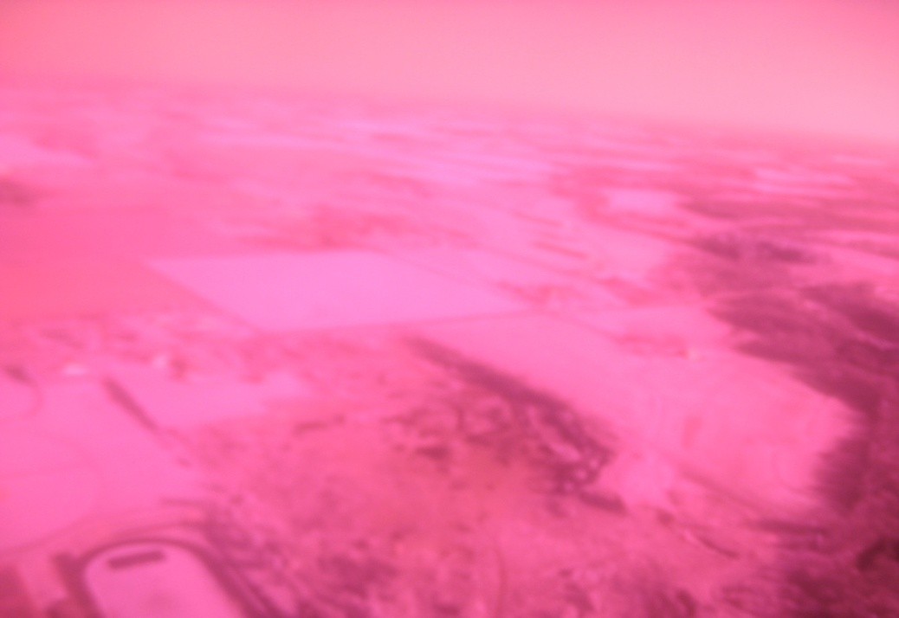
Plants contain chlorophyll, a green pigment that assists them in photosynthesis. Notice the football field in the lower left hand corner of the photo. From this we learn that chlorophyll strongly reflects IR.

Suspended water particles and Infrared Light

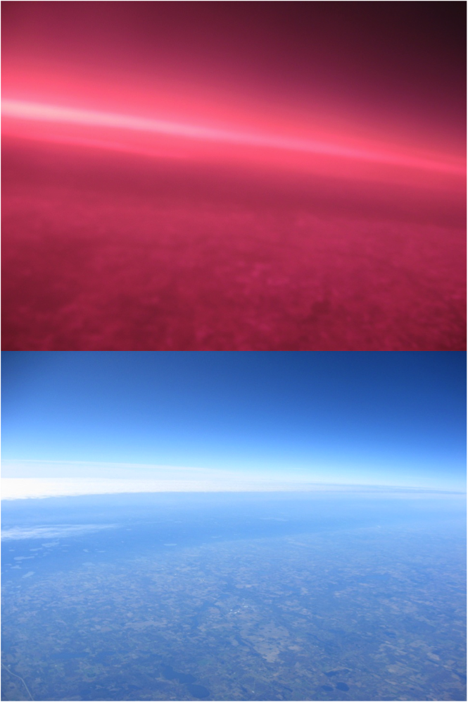
From the above photographs, we see how a large amount of IR light is reflected back to space by cloud cover.

Seeing through ‘Haze’

In these photos, Mille Lacs Lake is clearly visible in IR but hard to make out in visible light because of the light reflection off the clouds.
This supports our prediction that infrared light can reveal more than visible light alone.

Infrared Reflections

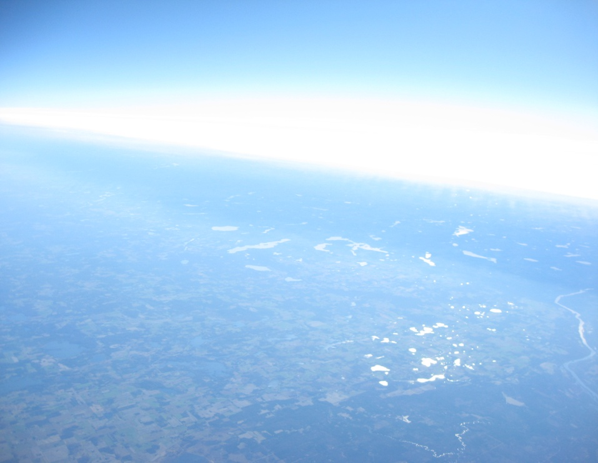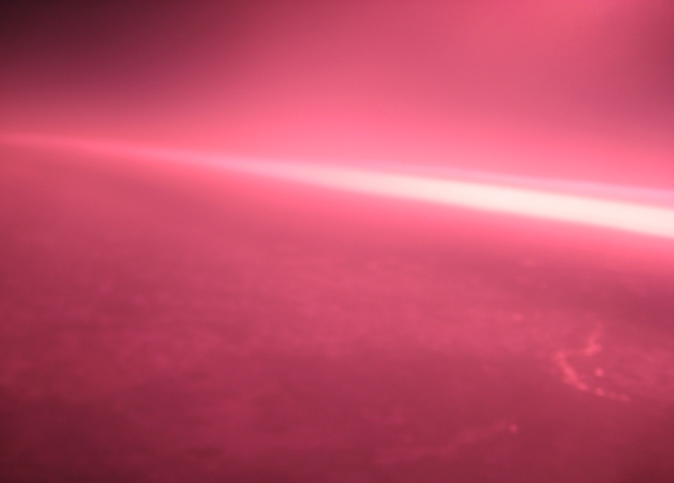
Infrared reflects off water liquid water just like visible light, but to a much lesser extent.
In the above photographs, notice the greater ability of IR light to penetrate a cloud layer, as indicated by the apparent thinness of the clouds when viewed in IR.

Infrared Penetration

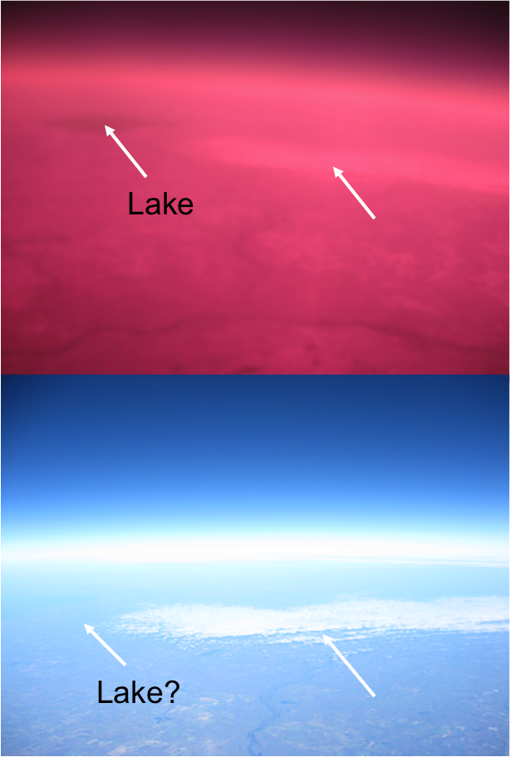
By this point in the flight, Mille Lacs Lake is completely invisible to the naked eye, although IR light gets through just fine.
This shows that IR penetrates the atmosphere better than visible light.

Infrared Light Intensity

In the above photographs, IR casts a sharper shadow than visible light. This may be because there is less IR than visible light available to the sensor.

Right Before Burst

These photographs are from 88,000 feet. Notice the lack of “glow” of IR off the upper reaches of the atmosphere.
This supports our expectations about IR penetrating the atmosphere deeper than visible light.

Reasons for penetration

The reasons for the penetration of infrared light over visible light are due to two interesting phenomenon,Rayleighscattering and the Mie Theory.
Rayleigh scattering is the scattering of light by particles much smaller than its wavelength. Since infrared light has a larger wavelength than visible light, there are more particles that have smaller wavelength than it and thus it is scattered in a different manner.
Mie theory is the theory and math describing scattering of light by particles that are near in size to the wavelength of light. It is similar to Rayleigh scattering except it governs light wavelengths that are near in size to the scattering particle.

Experiments that didn’t work

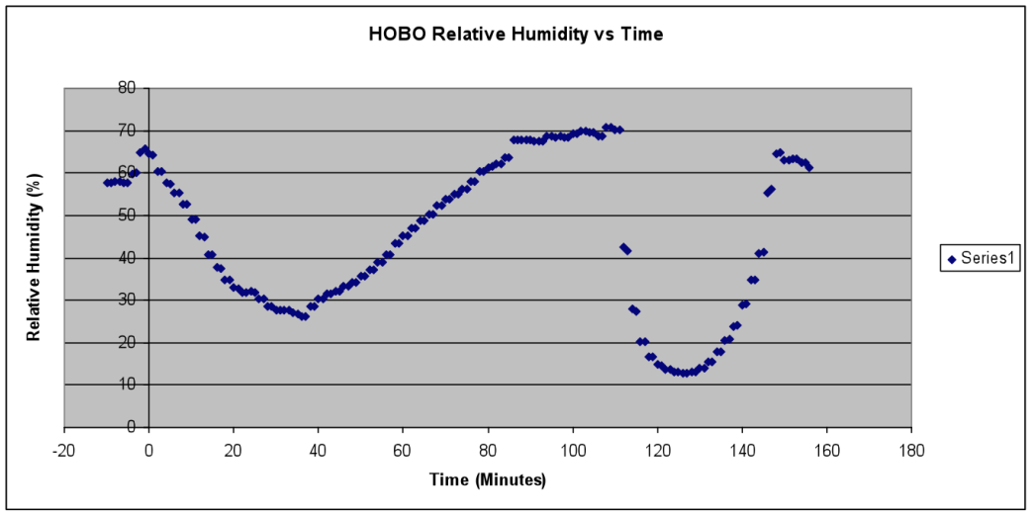
Graph 14: HOBO relative humidity vs. time

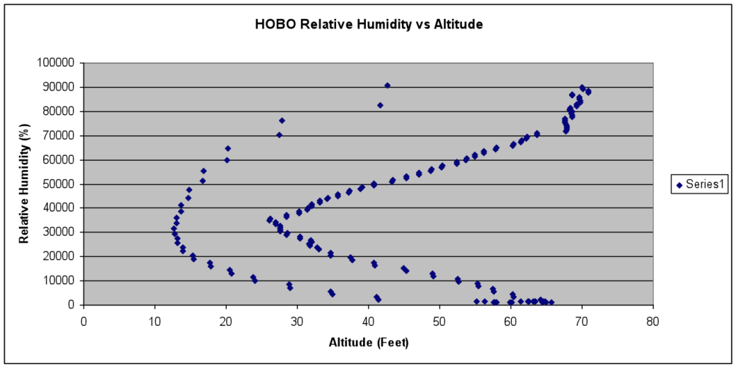
Graph 15: HOBO relative humidity vs. altitude

Our HOBO relative humidity data was rather unexpected and showed unusual trend with considerable lags in data accumulation. We compared this data with team Hindenburg’s HOBO relative humidity data too, and found that even their data was not meeting expectations.

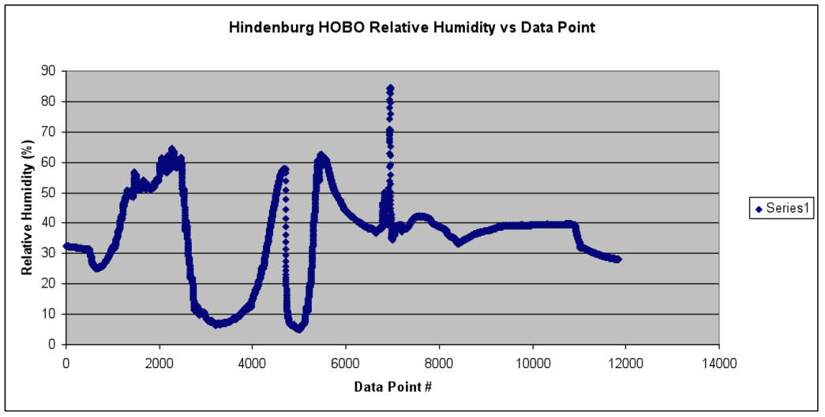

Graph 16: Team Hindenburg's HOBO relative humidity data, showing a rather unusual trend

11.0 Conclusions and Lessons Learned

When the project was assigned, many of the new team members had no previous experience with any soldering. If the group were going to do this project again we would first start with quickly soldering the weather station and BSE board together. We would make sure that all the parts would be soldered correctly so that we would not have to unsolder like the first time. The time we save on not unsoldering could be used for creating a better design for the layout of the payload. The layout that was used the first time was simple, but put together without the best planning. For example, a hole was made for the weather station to be mounted on the side of the box. Instead of using the hole for the weather station, the group changed its mind and decided to mount the weather station on the by strapping the weather station on the side of the payload box. The payload box was left with a gaping hole on the side that needed to be patched up by hot gluing a foam disk to cover the hole. This might have made the payload more susceptible to becoming cold in near space conditions.
With more efficient use of time, the group would have had more time to make a scale to better analyze the near-infrared photos that were taken. Because some areas of the photo had been darker in the infrared photos, it could indicate that the area was emitting more infrared radiation. Comparing photos taken of objects whose temperature and infrared radiation were known could make a scale. A legend could then be made to estimate the temperature and amount of infrared radiation present in the atmosphere. Although the infrared photos could have been analyzed better, there was a major component that needed to be perfected in order for the project to turn out better.
The infrared photos had a different color than the photos that captured visible light. Thus two cameras were used to capture near- infrared and visible light. The synchronization of the cameras was essential to the group designed experiment. On the launch day, the cameras seemed to be synchronized, but the time intervals that the cameras took pictures at gradually drifted apart. This was quite disheartening since the cameras appeared to be working when the balloon was launched. Without synchronized pictures, it was much more difficult to compare visible light photos with the near-infrared photos. Since the photos were not completely synchronized, it was also more difficult to figure out and assign a time stamp to each photo. However, the payload and its components came together to work in some awkward fashion. The results that were achieved could have turned out better, but considering the amount of time that was allotted; the instruments gave us the results we expected.
As far as our experiments were concerned, we can conclude based on our analysis that
- External temperature in the atmosphere follows a decreasing trend till about 35,000 feet above sea level, and then increases till about 90,000 feet.
- Atmospheric pressure decreases with an increase in altitude above sea level.
- Relative humidity follows an irregular pattern with an increase in altitude above sea level. It increases in areas where cloud layers are found, and decreases with altitude in the rest of the places in the atmosphere up to about 90,000 feet.
- Infrared light can reveal some distinct features in the atmosphere and on the earth’s surface, such as water bodies.

Words of Wisdom
- Find multiple ways to contacting group members.
- If you cannot think of any ideas, write a list of the first things that come to your mind. From the list, pick the ones that you like the best.
- Doing things now is better than doing them later
- Hot glue is really hot!

12.0 Citations and Acknowledgements

We received help from several people throughout the process of our payload. Construction. Seth helped the most, where he turned a camera into one of infrared capabilities for us by tweaking the lens. He also helped us get into lab and also to understand our “other” science experiment (the infrared camera). Cait also helped us with understanding the cameras and getting them programmed to our desired settings. Kyle got our weather station and HOBO programmed and ready to work, and he made sure it processed the way it needed to. All of the former AEM1905 students helped us out tremendously and we really appreciate it. For our final presentation we got our relative humidity data from team Hindenburg because ours was not correct.
Special thanks must be given to our professor, Dr. Flaten, who helped us through every phase of our project and was a major source of knowledge and information.

Internet Sources

- http://www.parallax.com/tabid/567/Default.aspx (Date Accessed: 6thNovember 2010)

- Graph 4 taken from: http://www.mdp.eng.cam.ac.uk/web/library/enginfo/aerothermaldvdonly/aero/atmos/atmos.html (20th November 2010)

- Graph 5 was taken from:http://fiziknota.blogspot.com/2008/04/atmospheric-pressure-and-altitude.html (20th November 2010)

- Graph 6 was taken from: http://www.sas.org/tcs/weeklyIssues_2007/2007-12-07/project1/index.jpg (Date accessed: 6th December 2010)

- http://www.engineeringtoolbox.com/air-altitude-pressure-d_462.html(Date accessed: 20th November 2010)

- http://en.wikipedia.org/wiki/Cloud (Date accessed: 20th November 2010)

13.0 Appendix: Program Listings

“30 sec code” for Canon PowerShot A570 IS still cameras.

rem Interval shooting
rem For Canon A570IS
rem CAMERA MUST BE IN AV (aperture priority mode)

rem For 3 hour MNSGC flight photo every 30 seconds

@title MNSGC Intervals
@param a Shoot count
@default a 360
@param b Interval (Minutes)
@default b 0
@param c Interval (Seconds)
@default c 30

d=1000

rem reset camera
sleep d
click "menu"
sleep d
click "right"
sleep d
click "up"
sleep d
click "set"
sleep d
click "right"
sleep d
click "set"
sleep 3000

rem set menu values
sleep d
click "menu"
sleep d
click "down"
sleep d
click "down"
sleep d

rem Digital Zoom off
click "right"
sleep d
click "down"
sleep d
click "down"
sleep d

rem Red-Eye off
click "right"
sleep d
click "down"
sleep d

rem Safety FE off
click "right"
sleep d
click "down"
sleep d

rem set MF-Point Zoom off
click "right"
sleep d
click "down"
sleep d

rem Safety MF off
click "right"
sleep d
click "down"
sleep d

rem AF-assist Beam Off
click "right"
sleep d
click "down"
sleep d

rem Review off
click "left"
sleep d
click "down"
sleep d
click "down"
sleep d

rem IS Mode = Shoot Only
click "right"
sleep d
click "menu"
sleep d

rem set apeture to 2.5 by overkill
for n=1 to 10
sleep d
click "left"
next n

rem select manual focus
sleep d
click "down"
sleep d
click "down"
sleep d
click "down"

rem set focus to infinity
for n=1 to 10
sleep d
click "right"
next n

t=b*60000+c*1000
if a<2 then let a=10
if t<1000 then let t=1000

print "Total time:", t*a/60000; "min", t*a%60000/1000; "sec"

sleep 3000

click "display"
click "display"

shoot
for n=2 to a
sleep t
shoot
next n

end

We used two still cameras for our project. We used one that captured visible light and one that captured near infrared light. In both the still cameras we used the same program known as “30 Sec Code” provided by Dr. Flaten on a memory stick to take pictures at intervals of 30 seconds. However for our experiment we had to adjust the program so it would enable both of our still cameras to capture images at 15-second intervals. The program enables each still camera to capture a photo every 15 seconds, but due to the difference in the cameras ability to register each captured image the cameras could not stay in synchronization during the entire flight of the project. While saving an image, one of the cameras would be slower than the other and thus create a little bit of time that was lost between each of the shots and as there were more shots, the cameras would go out of sync, disabling are objective to capture two of the same images in different light patterns, visible and infrared.

' File: FreshmanSeminarFlightCodever3 (used Fall 2010)

symbol record=w0 'This is the section where the variables are declared
symbol index=w1
symbol value=b4

BalloonSat:
symbolMax_ADC = 2 ' maximum adc channel usedstarting with 0
symbolMission_Delay = 15000 ' length of pause in mission loop 15 seconds

Mission_Prep:
i2cslave %10100000,i2cfast,i2cword ' set memory speed to 400 kHz
if pin7 = 1 then Download_Data 'and one word records

flashed: 'this section is the section that waits
high 3 'for commit pin to be pulled
pause 1000 'the flahser is also in this section
low 3 ' it flashes at a specific rate
pause 1000
if pin7=0 then flashed

Mission: ' will change pattern of flashing when data is being taken

gosub Analog ' collect analog voltages
write 0,record ' store the number of records collected
gosubOn_Flash ' pause.....

goto Mission ' ....before starting all over

Analog:
for index = 0 to Max_ADC ' loop for number of analog voltages to record
readadcindex,value ' get next adc value
gosubRecord_Data ' go store the value
next ' until last voltage is recorded
return ' return to main mission loop

Record_Data:
if record = 3000 then End_Mission ' check that aren't writing too many records to memory
record = record + 1 ' increment record number
low 0 ' unwrite protect memory
writei2c record,(value) ' write the next record to memory
pause 10 ' wait 10 ms for write
high 0 ' write protect memory
return ' return to the calling calling subroutine

On_Flash:
high 3
pause 1000 'flash twice than a long pause
low 3
pause 500
high 3
pause 1000
low 3
pause 12500
return

Download_Data:
sertxd ( cr,lf)
sertxd (cr,lf)
sertxd ("Welcome to Balloonsat Easy Data Download Routine ",cr,lf)
sertxd ("Data Download will be in 3 seperate interface sections",Cr,lf)
sertxd ("After the data section is completed copy input buffer to a text file",Cr,lf)
sertxd ("Then clear input buffer and replace the commit pin when read back resumes remove commit pin ",Cr,lf)
Sertxd (" Clear the input buffer and replace the commit pin")

gosub flasher

sertxd ("Data section 1 of 3",Cr,lf)

for record = 1 to 1000

readi2c record,(value) ' read the recorded record
sertxd (#value,",") ' serial out the data record
record = record + 1

readi2c record,(value) ' read the recorded record
sertxd (#value,",") ' serial out the data record
record = record +1

readi2c record,(value) ' read the recorded record
sertxd (#value,Cr,lf) ' serial out the data record
next
sertxd ("Data section 1 of 3 Complete",Cr,lf)
gosub flasher

sertxd (Cr,lf)
sertxd ("Data section 2 of 3 ",Cr,lf)

for record = 1000 to 2000

readi2c record,(value) ' read the recorded record
sertxd (#value,",") ' serial out the data record
record = record + 1

readi2c record,(value) ' read the recorded record
sertxd (#value,",") ' serial out the data record
record = record +1

readi2c record,(value) ' read the recorded record
sertxd (#value,Cr,lf) ' serial out the data record

next
sertxd ("Data section 2 of 3 Complete",Cr,lf)
gosub flasher ' waits to replace the commit pin
' than remove commit pin
sertxd (Cr,lf)
sertxd ("Data section 3 of 3 ",Cr,lf)

for record = 1999 to 3000

readi2c record,(value) ' read the recorded record
sertxd (#value,",") ' serial out the data record
record = record + 1

readi2c record,(value) ' read the recorded record
sertxd (#value,",") ' serial out the data record
record = record +1

readi2c record,(value) ' read the recorded record
sertxd (#value,Cr,lf) ' serial out the data record

next
sertxd ("Data section 3 of 3 Complete",Cr,lf)
gosub flasher

sertxd (Cr,lf)
sertxd ("Data Download Complete",Cr,lf) ' until last data record read out
gosubLT_down

LT_down:
high 3 'flash 3 times than pause
Pause 1000 'signifies completed
low 3 ' download data
pause 500
high 3
pause 1000
low 3
pause 500
high 3
pause 1000
low 3
pause 10000
GotoLT_down

flasher:
pause 1000
if pin7=1 then flasher 'waits the for commit pin
return

End_Mission: 'this is if data was recorded during the whole flight
low 3 ' this shows that the memory is full
pause 10000 ' and that the flight computer functioned properly for the flight
high 3
pause 1000
gotoEnd_Mission

'this program has a problem

' it writes the record location to internal memory not to the
' 16 bit 1 word memory chip on the balloonsat easy 2.0 flight computer board
'thereforethe data should exist for any

end ' end of mission

We used a flight computer program code provided by Dr. Flaten to enable our HOBO to record internal temperature, relative humidity, and external temperature. With the help of Philip who programmed the code into the HOBO, our payload was able to bring back data of internal temperature within the payload, external temperature of the atmosphere near space, and relative humidity. To start the recording of data within the HOBO, we created a pull before flight pin, in which we would pull the pin just before letting off the balloon to provide enough time for the HOBO to collect data every 3 seconds for 9 hours.

