University of Minnesota and MN Space Grant Consortium
AEM 1905 Freshman Seminar: Fall 2009
Spaceflight with Ballooning
Team Project Documentation

Team icarus
Written by:
Mike Hill
AJ Knapp
Max Sjöberg
Lucas Chowen
Kyle Marek-Spartz

Report Date: 2009.12.4
Revision C
Table of Contents

- Introduction……………………………………………....…………………….....3
- Mission Overview……………………………………......……………….........….4
- Payload Design………………………………………………………......………..5
  - Functional Block Diagram……………………………..........……………...6
  - Drawing of Payload Layout…………….......……………………………....6
- Project Management……………………………………………………...….........7
  - Schedule…………………………………………………………......………..7
- Project Budgets……………………………………………………………...…….9
- Payload Photographs……………………………………………………….…….10
- Test Plan and Results………………………………………………………..…...14
- Expected Science Results………………………………………………………..15
- Launch and Recovery……………………………………………………………17
- Results and Analysis……………………………………………………………..22
- Conclusions and Lessons Learned……………………………………………….27
- Appendix: Program Listings……………………………………………………..28

1.0 Introduction

To define near spaceflight we use the definition of, the region of earth’s atmosphere ranging between 70,000 and 350,000 feet above sea level. At this altitude we are able to see the curvature of the earth as well as the darkness of outer space. Near space is often used for military surveillance, or more relatable to our class, high altitude balloons, and blimps. This particular part of the atmosphere is above altitudes that commercial airlines fly, and it is below the altitudes of orbiting satellites. Since there is such a large range of the atmosphere that is particularly unused it makes for an ideal location to send these balloons. Near space ballooning was started in the early 1930s. In the last 70 years there have been increasing numbers of experiments that have taken place in near space. Ballooning is the most popular type of experiment. In these experiments, large latex balloons are used to bring attached payloads filled with a variety of things up into the atmosphere until the balloons burst and then return to the ground via a parachute. Filling up a payload can vary from experiment to experiment. Depending on what someone is trying to experiment with determines the equipment used in the payload. The equipment can vary from cameras, to computers, to weather related instruments. In our class we are filling our payloads with a weather station, camera, and compass.

2.0 Mission Overview

In our ballooning mission, we need to accomplish a multitude of tasks for the experiments to be successful. First our package needs to be sturdy enough to survive the rigorous conditions that it will experience as it travels, gaining altitude than rapidly losing it. It will not be a smooth ride, especially the descent and the landing, so the box needs to be able to handle such physical stress. Inside of the package the experiments also need to be sturdy enough to survive the conditions, including the cold along with the rough ride. A heater will provide enough heat so the batteries won’t freeze, and the material that the package is made of will act as an insulator.
On board we will have two experiments in addition to the standard flight computer, HOBO and weather station, which respectively run our experiments, monitor internal temperature, and exterior temperature and pressure. Our optical experiment will be to see if high attitude daytime astronomy is a cost effective and reasonable alternative to current practices. The camera will take photographs of the near-space environment, and will be analyzed to se if a positive conclusion is reached. The other experiment is to use a magnetometer to check if the Earth’s magnetic field changes the farther the balloon moves from the surface of the Earth. A tilt compensation device will be required in order to maintain that the correct data is received.

3.0 Payload Design

The overall payload design we chose as a team consists of a 6”x6”x6” internal dimension box. For the box material we chose to use the sturdy tag board with the black foam lining. Our design required six separate squares of material. For the top and bottom we cut a 7”x7” square and for the sides we cut two 6 13/16”, and two 6 5/8”. We chose to do this so we could alternately overlap each side with each other providing a sturdier wall structure. The black foam was then cut to fit securely inside the box. To seal our box we used the provided epoxy to fit our box, and we used hot glue to fasten the foam to the walls. The limitations of our box came after we put it together, when the internal dimensions didn’t quite reach 6”x6”x6”. Although this will not necessarily affect our overall design, it could make things a bit snug internally. The equipment we are going to be putting in our box consists of: Ultra flip video camera, weather station, flight computer, HOBO, heater, and a magnetometer. All of our components will be run by batteries. We have decided to space out the parts inside the box; basically each side of the box has one part. We plan to fasten the magnetometer to the top of the box to hopefully give us better orientation during flight. Our camera will be positioned in the box to look upward toward the sun, and everything else will run together inside the box. Ultimately the positioning of the equipment in our box will be determined once we preview the setup with everything in place. We may need to move some things around our camera, and away from the heater, or just to better position them to have an organized internal payload.

3.1 Functional Block Diagram

3.2 Drawing(s) of Payload Layout
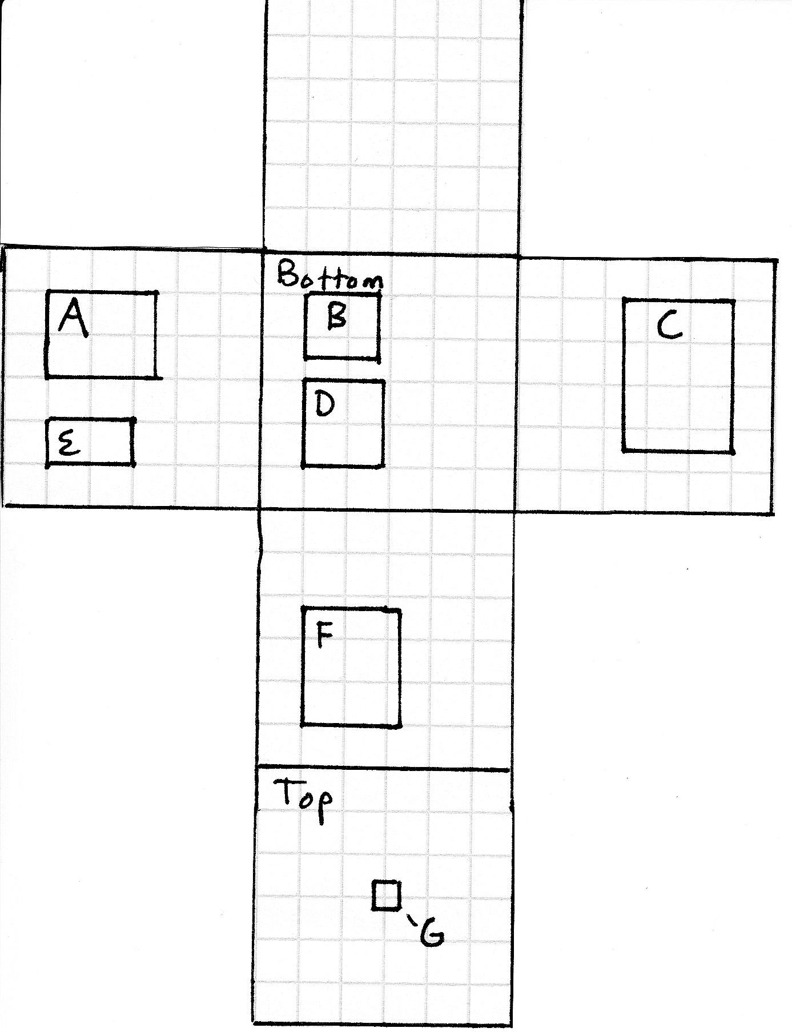

4.0 Project Management
AJ Knapp
- Writing
  - Introduction, Payload Design
- Oral Presentation
  - Flight Readiness Review
- Payload Build
  - Box Build, Camera Experiment
- Launch Day
  - Photographer
Kyle Marek-Spartz
- Writing
  - Project Management, Payload Photos
- Oral Presentation
  - Conceptual Design Review
- Payload Build
  - Photographer, IMU
- Launch Day
  - Prediction/Tracking Assistant
Lucas Chowen
- Writing
  - Mission Overview, Expected Science Results
- Payload Build
  - Weather Station Build, HOBO (Payload “Health” Monitoring)
- Launch Day
  - Balloon Filling and Release assistant
Mike Hill
- Writing
  - Launch and Recovery, Conclusions
- Oral Presentation
  - Conceptual Design Review
- Payload Build
  - Flight Computer, Programmer
- Launch Day
  - Recovery Specialist
Max Sjöberg
- Writing
  - Project Budgets, Test Plan and Results
- Oral Presentations
  - Flight Readiness Review
- Payload Build
  - Team Lead
- Launch Day
  - Payload/Stack Handling Specialist

4.1 Schedule
Sept. 8 - Class
Sept. 15 - Class
Sept. 22 - Class / Movie Night / Heater Construction
Sept. 27 - Make up Movie Night
Sept. 29 - Class / Rev. 0 Due
Sept. 30 - Weather Station Construction
Oct. 1 - Flight Computer Construction
Oct. 4 - Concept Design Review Meeting
Oct. 6 - Class / CDR Due / First Draft SciEng Paper Due / Structure Assembly
Oct. 9 - Editors comments SciEng Due
Oct. 13 - Class / Final Draft SciEng Due
Oct. 16 - Rev. A Due
Oct. 20 - Class / Movie Night
Oct. 23 - Flight Computer Programming / Magnetometer Programming Due
Oct. 24 - Structure Assembly, Pt. 2
Oct. 25 - Testing/Flight Readiness Review Meeting
Oct. 27 - Class / FRR Due
Oct. 29 - Payload Deadline
Oct. 31 - Primary Launch day
Nov. 1 - Secondary Launch day
Nov. 3 - Class / First Draft SciEng2 Paper Due
Nov. 6 - Editors comments SciEng2 Due / Rev. B Due
Nov. 7 - Tertiary Launch day
Nov. 8 - Quartary Launch day
Nov. 10 - Class Final Draft SciEng2 Due
Nov. 17 - Class / Data Analysis Visuals
Nov. 24 - Class / FTP Due
Dec. 1 - Class / Movie Night
Dec. 4 - Rev. C Due
Dec. 8 - Class
Dec. 15 - Class

5.0 Project Budgets
The following lists contain the information of how our mass and money will be allocated within our payload. The original mass budget is an estimate – once we’ve actually completed construction, we shall return and record the actual masses of our components and of the overall payload.

ITEMS | COST (in USD) | MASS (in Kg)
White Foam Core | 9.00 | 0.150
Miscellaneous (tape, etc) | 5.00 | 0.050
Heater Circuit | 5.00 | 0.027
Flight Computer | 30.00 | 0.033
Weather Station | 40.00 | 0.015
Compass Module | 150.00 | 0.015
Flip Video Camera | 170.00 | 0.175
HOBO | 130.00 | 0.048
IMU | 205.00 | unknown
Batteries | 8.00 | 0.196
TOTALS | 751.00 | 0.710 + IMU Mass

6.0 Payload Photographs
Payload w/o components
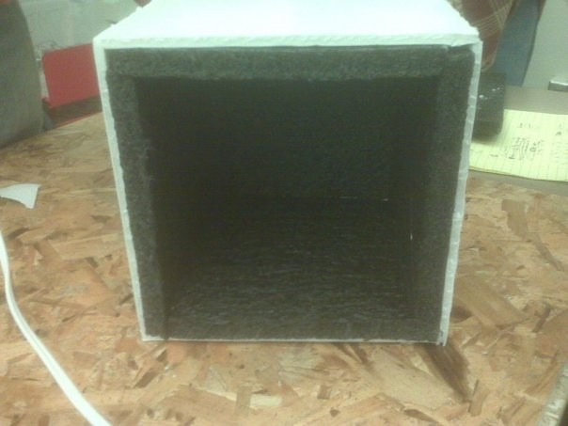
Ties attaching components to payload. Note camera hole in bottom left
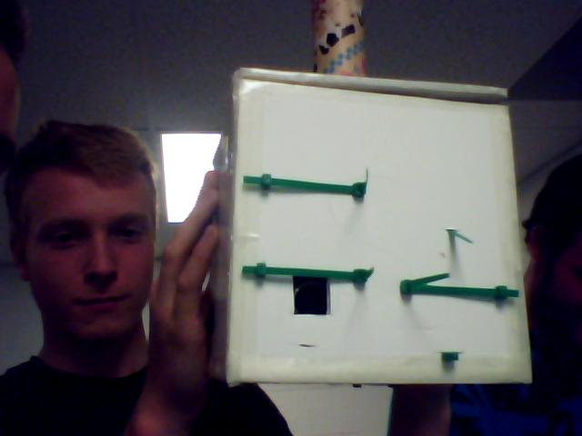
Heater switch
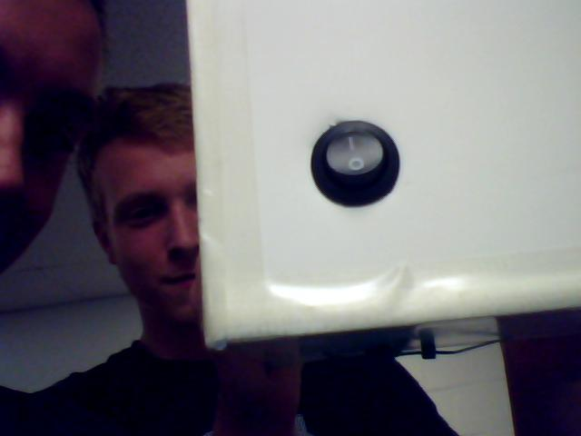

Components in Payload minus IMU
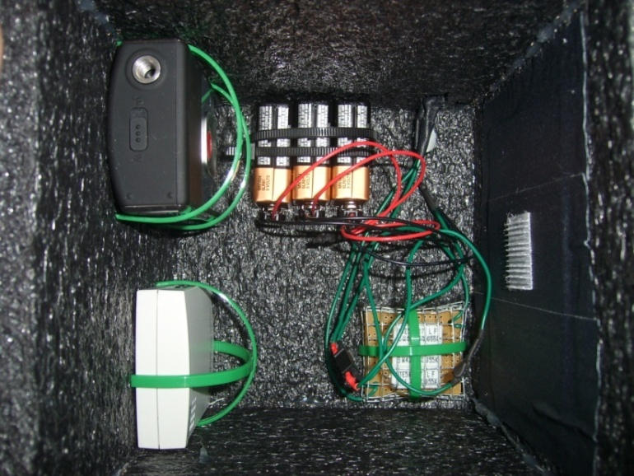
Inertial Measurement Unit
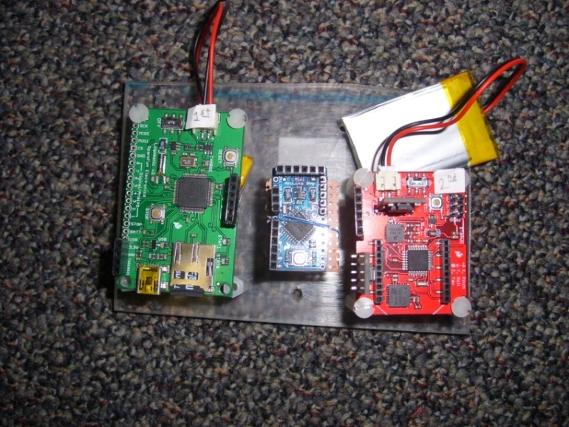
IMU in Payload. Heater in top left.
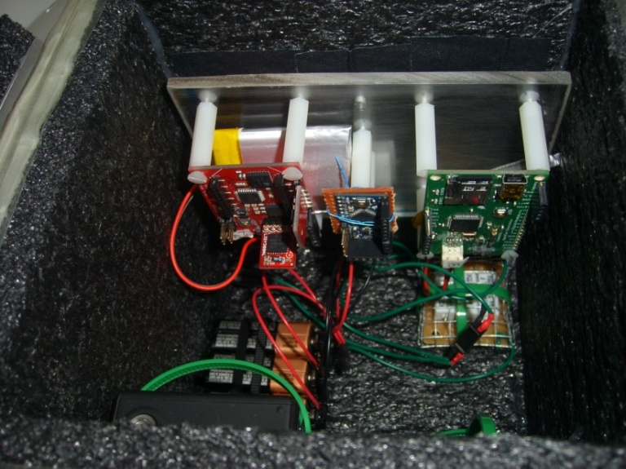
Logo
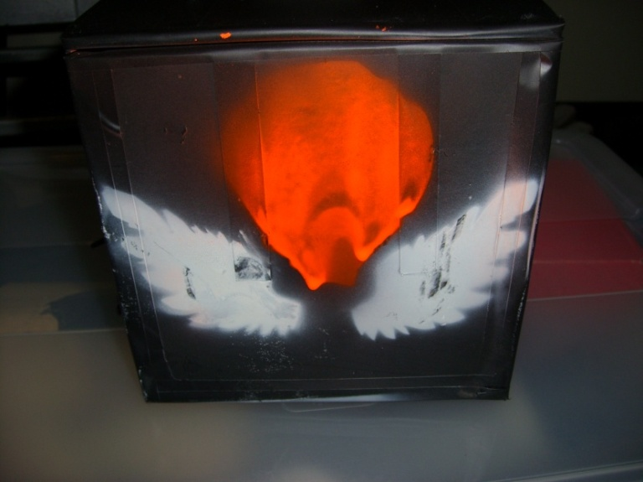
Stenciled skull
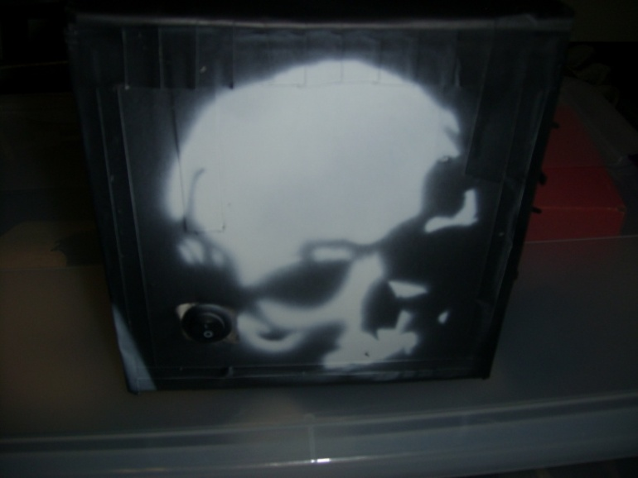
Jack o’ Lantern
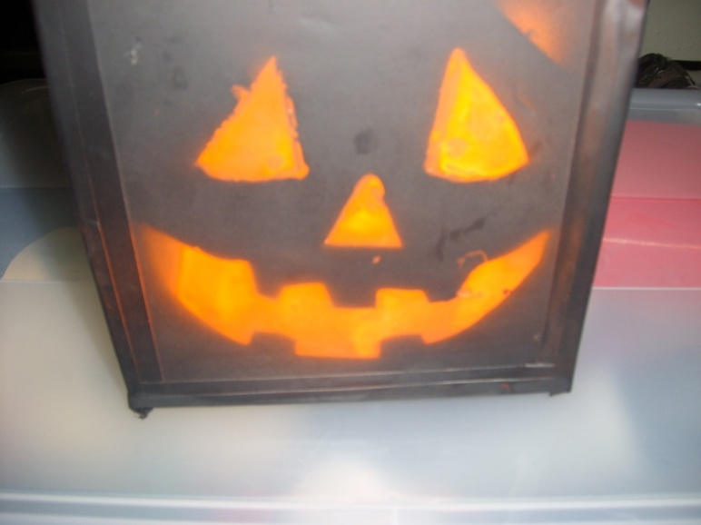
Flight computer and weather station (behind lid)
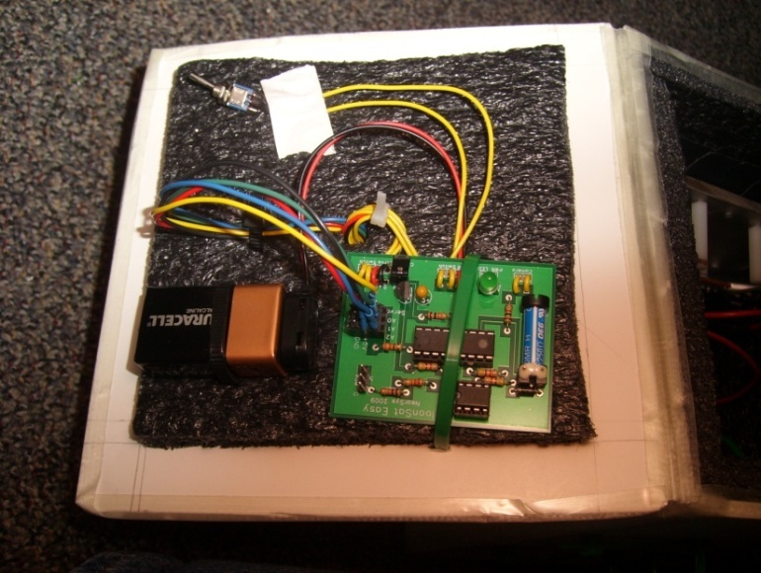
Final flight checks
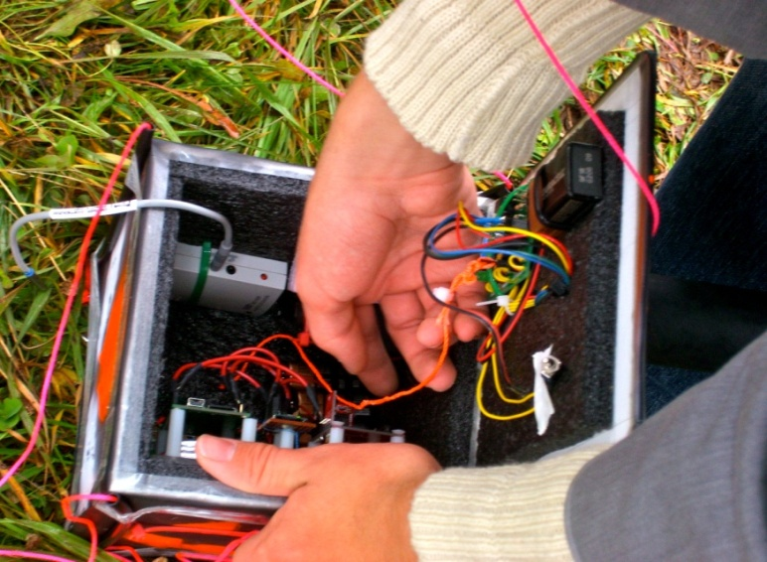
Ready to launch
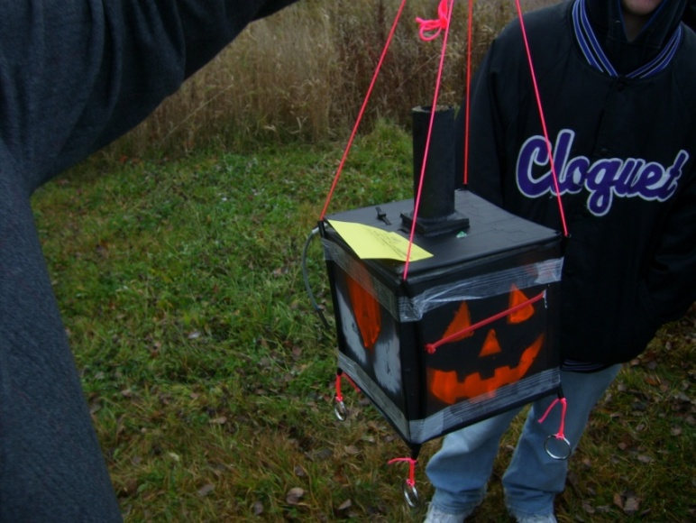

7.0 Test Plan and Results

We shall test our individual parts and our integrated payload to ensure all our systems will work during the actual flight. After this testing, we shall discuss the testing results and describe any adjustments we made due to the results of aforesaid tests. In the case that we do not do a specified test, we shall explain why and why we believe we do not need to.

Below is our team’s test plan for our payload. To begin with, we will test every individual piece of our box, for the cameras to the heater. Some of the parts need to function before hand, or at least function in a way in which we can retrieve any-and-all data. For instance, the IMD (Inertial Measurement Device) we may be borrowing, will need it’s data retrieved, and as of right now, we are not quite sure how that will be done, and those are individual instructional things that we have not put on this list. That list, containing the crucial test procedures to make sure that our payload is as flight ready as it needs to be, is as follows :

- Impact test with dummy weights
- Heater circuit gets hot
- Flight computer no-chip testing
- Weather station initial testing
- Flight computer programmed (for weather station)
- Learn to program and operate video camera
- Learn to operate other experiment
- Make sure that we can retrieve data from the Inertial Measurement Device
- Heater integrated, with battery pack and external switch
- Camera integrated, still can be turned on
- Weather Station integrated, plugged into flight computer
- Flight computer integrated, with 9-volt battery
- HOBO integrated and programmed, ext. sensors (if any)
- Other experiment(s) integrated
- Weather station 10-min day-in-the-life (bench) test
- Cold soak 20-min (completed payload, all running)
- Yank test with real contents

The results of all of these tests came back beyond satisfactory, and our payload retained heat throughout the cold soak, as the structural integrity was good throughout the entire testing process.

8.0 Expected Science Results

With our balloon launch, we fully expect to see changes in temperature, pressure and relative humidity as our balloon ascends into the atmosphere. As the balloon travels through the different layers of the Earth’s atmosphere, it will experience a decrease in temperature to a low of around 60 degrees Celsius, the as it reaches the upmost levels of the atmosphere, will begin to warm up. It will as see a drop in humidity and pressure, as less and less atmospheric gasses are above it and the upper atmosphere is known to be dry, with any moisture being frozen. Change in temperature can most easily be seen in Figure 1, while changes in pressure and humidity can be imagined as a decreasing straight line on a graph.

Specific to our box, we have two other experiments. First we have a camera that is to see if ballooning is a cost effective and feasible alternative to daytime astronomy. We do not expect this to work due to many factors. These include the fact that the package will be hard to control and aim at the sun, the best that can happen is a chance shot of the sun passing the camera lens. Also it will be hard to take a focused shot I n the rough conditions of the upper atmosphere, and the it is never easy to take a photograph of the sun’s corona even regularly. Lastly with this experiment, while balloons are cheap compared to other methods, they are still expensive to the average amateur. Our second experiment is to send a magnetometer into the upper atmosphere to detect any changes in the Earth’s magnetic field we do not expect to see any change, as although the balloon will be traveling far, changes in the magnetic field should be negligible. Although it is a generalized diagram, Figure 1 shows that any serious change in magnetic fields would be farther out in true space, not in the near space that our balloon will fly to.
Figure 1:
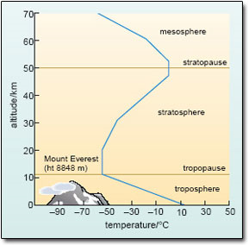
From: http://openlearn.open.ac.uk/file.php/2805/S250_3_008i.jpg

Figure 2:
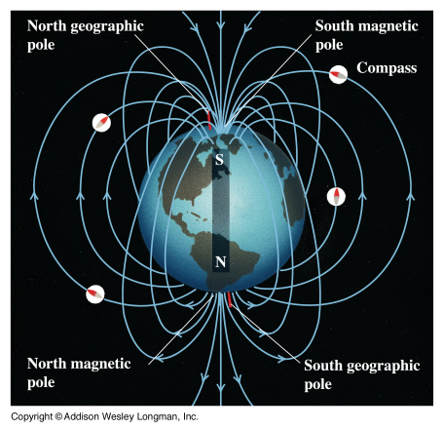
From:
http://www.physics.sjsu.edu/becker/physics51/mag_field.htm

9.0 Launch and Recovery

Launch day for the University of Minnesota spaceflight with ballooning freshmen seminar landed upon Halloween, October 31st 2009. We met in front of Akerman Hall at 6:30 to be shipped off to our launch location. The location of our launch was roughly in the vicinity of Hinckley. Weather conditions were overcast, cold and windy with a little drizzle of snow/rain. Started setting up the equipment and everything around 9:00 am and launched at approximately 10:45 am. Prior to launch teams helped with setting up the payloads on the string and of the filling of the latex balloon with helium. For our payload and team Icarus, with testing of equipment and of the integrity of our box we were ready to do. With some last minute adjustments and the turning on of the flight computer, heater, and IMU we were set. Right before launch we pulled the data trigger and it was up and away from there.

Somewhat immediately after launch, all teams helped pack up everything and got into their designated vans. One going back to Minneapolis, the other was on the chase. Michael Hill was chosen for team Icarus to be on the chase and did so. It took a couple hours of driving, with a little pit stop at McDonalds, to follow the balloons trajectory. The balloon had taken us north of Eau Claire. After some hesitation we found ourselves parked a gravel driveway of some sort next to a small patch of woods. Immediately we heard the siren of the balloon payload. Finally we found the payload roughly 25-30 feet in the air and about 100 yards into the woods. Further investigation showed that the payload was hanging on between two trees. Early attempts of trying to get the payload down failed; shaking the trees, tying a string around a small piece of log and trying to throw it over. We decided to rely on the slingshot, which had a small weight with a string attached to it. Early attempts of this failed also, but with minor adjustments and the magnet of the slingshot being taken out, we eventually go the weight and string to go over the payload. Following this was the endeavor to pull the payload down off of the trees. It took broken branches and some elbow grease, but we got it down without any major damage. With all the teams helping we lugged the payloads out of the woods and back to the line of vehicles. Later we disconnected the boxes and opened to see what was happening inside. For our team, the zombicarus, had minor scratches because of the landing, but everything seemed fine on the outside. Upon opening the box, Michael noticed the IMU was still running, flight computer was still on, and the camera had turned off. With a quick study of the HD video camera, it showed to have roughly an hour and half of footage. When the investigation ended, Michael disconnected all the batteries, turned off the heater and the IMU and was ready to be shipped back to home base for data analysis.

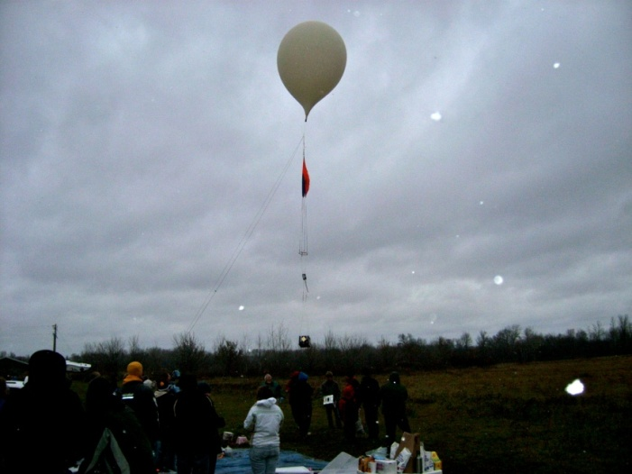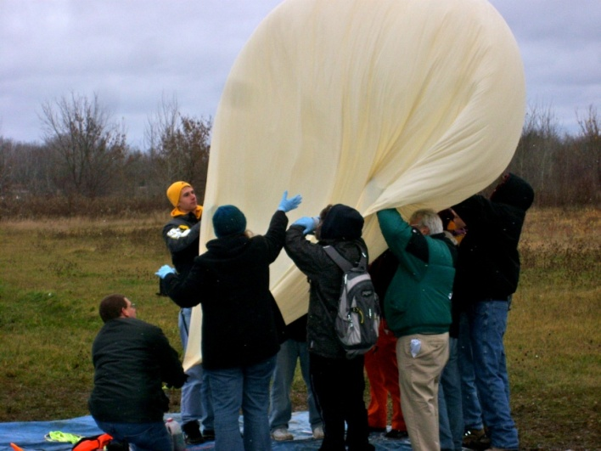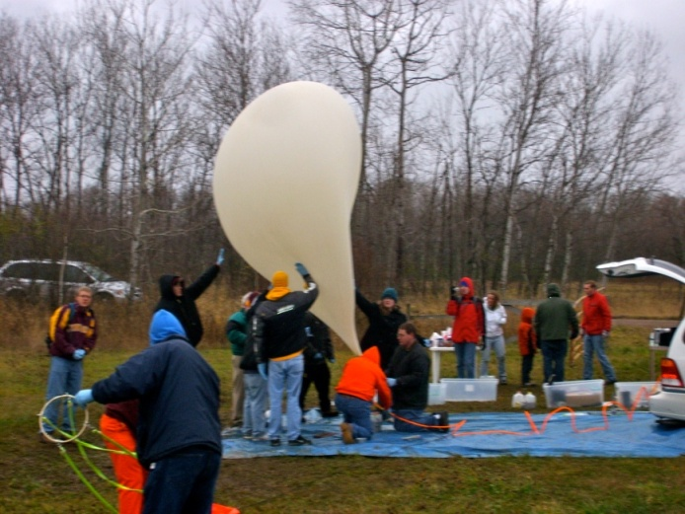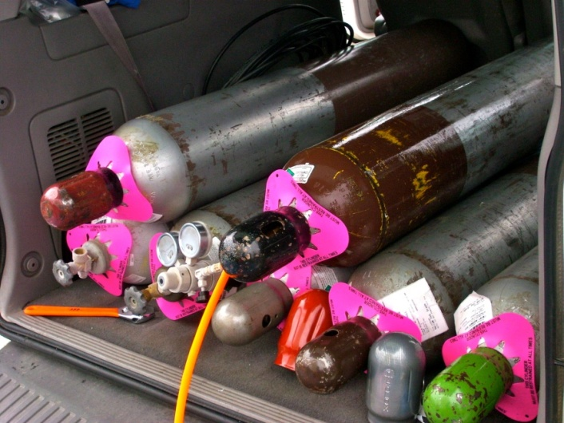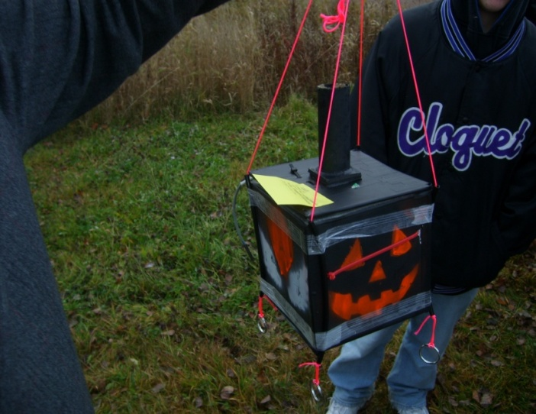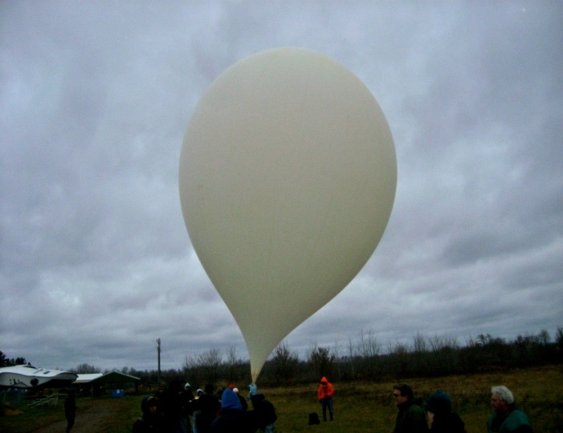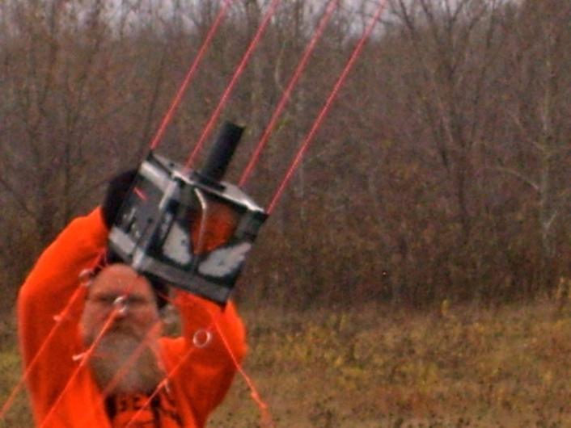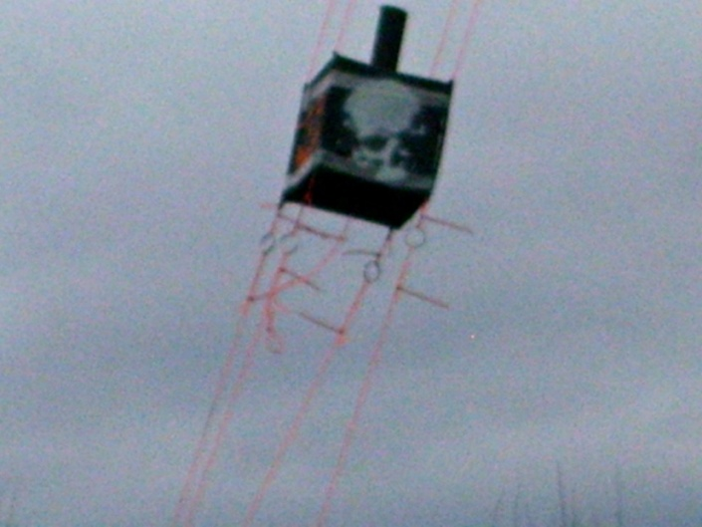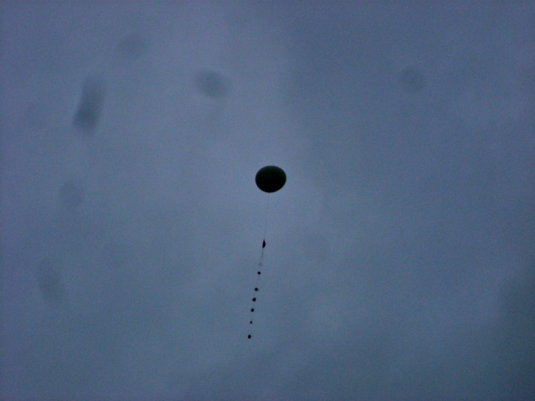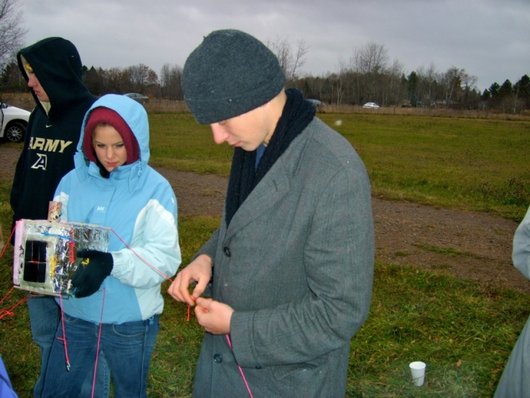
10.0 Results and Analysis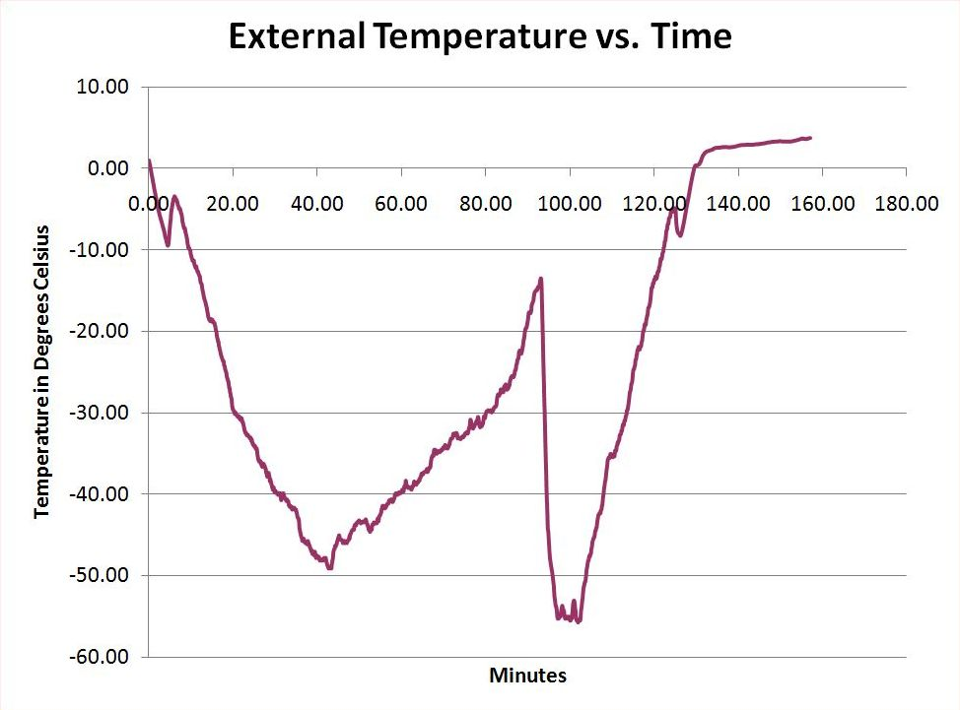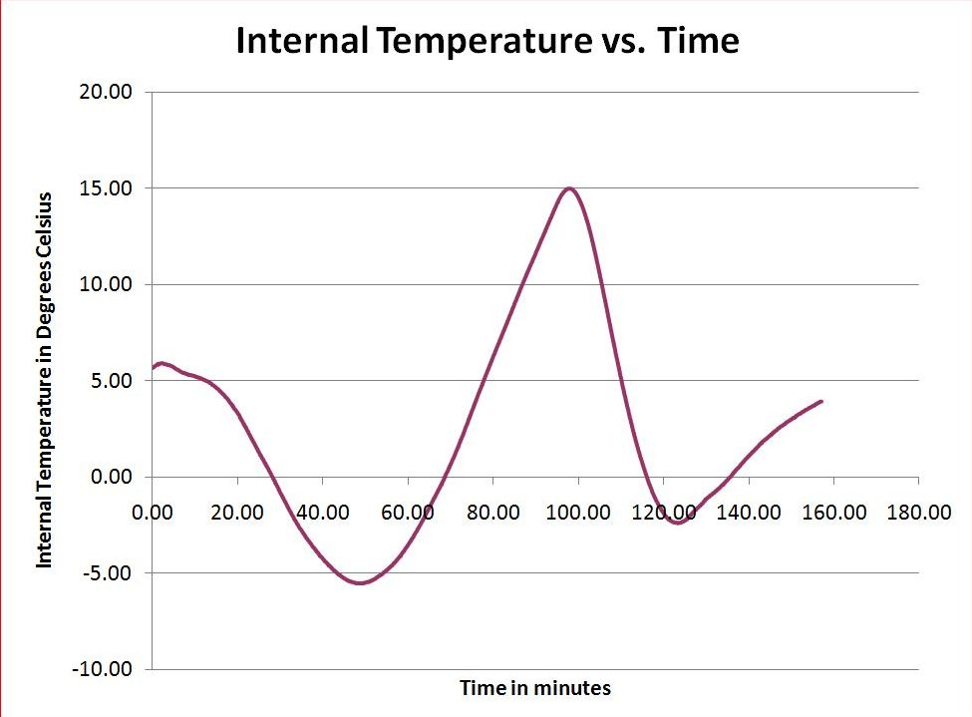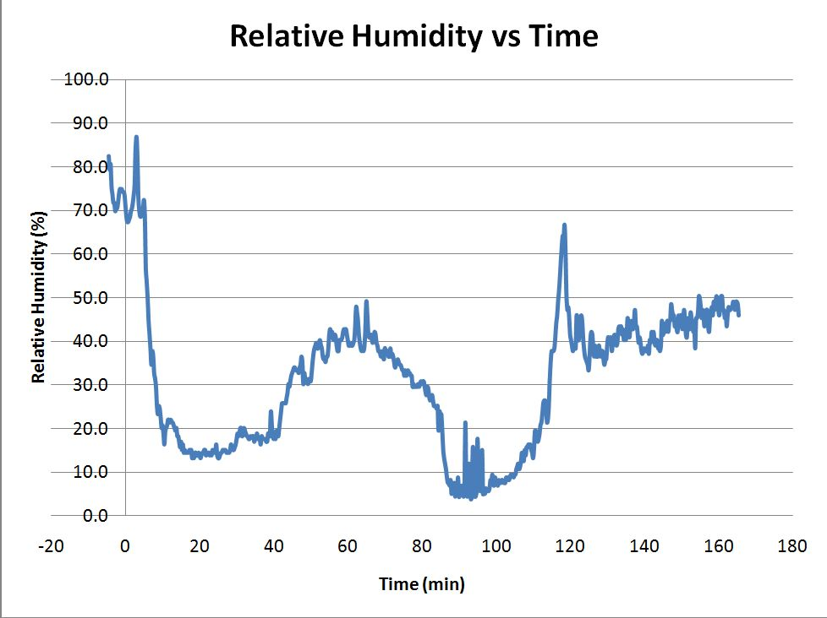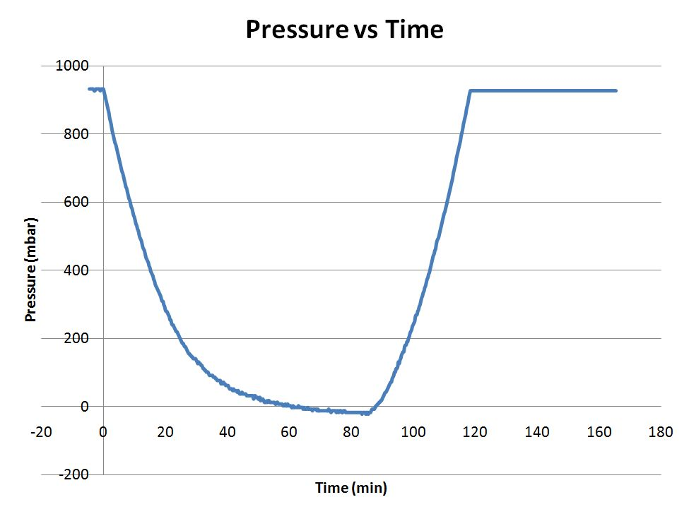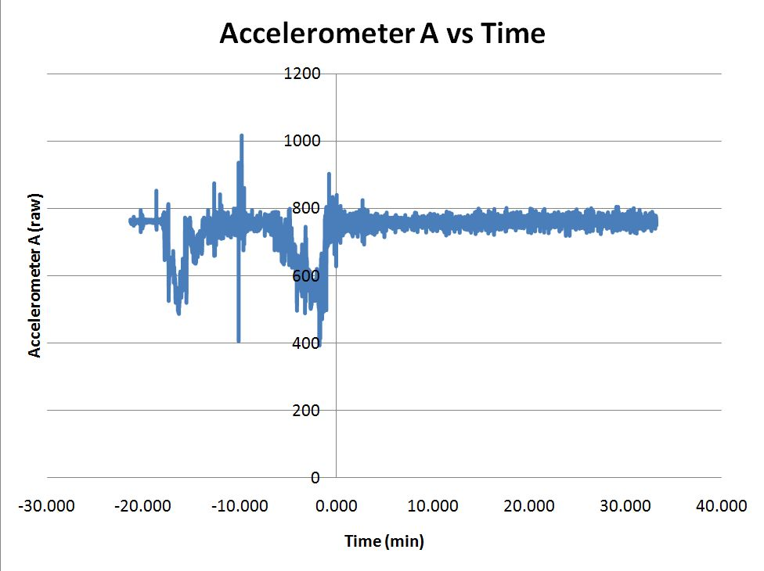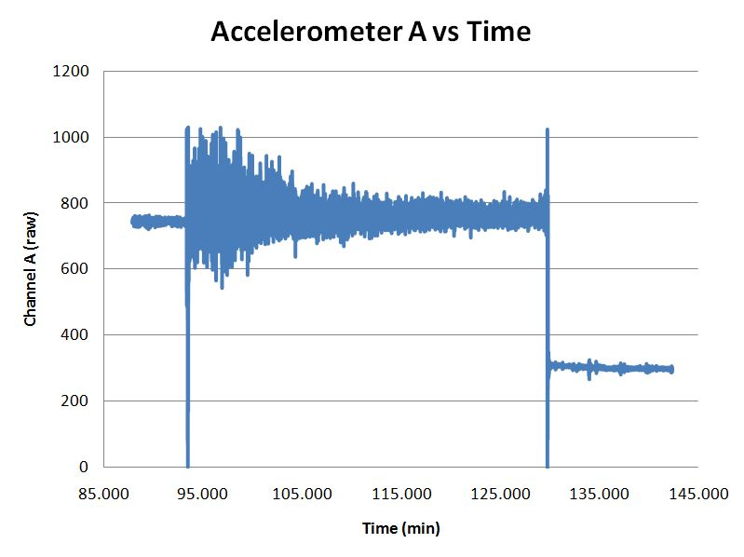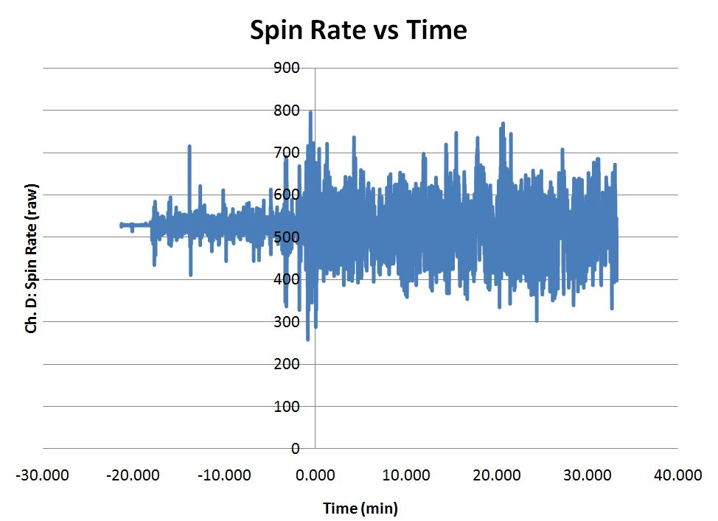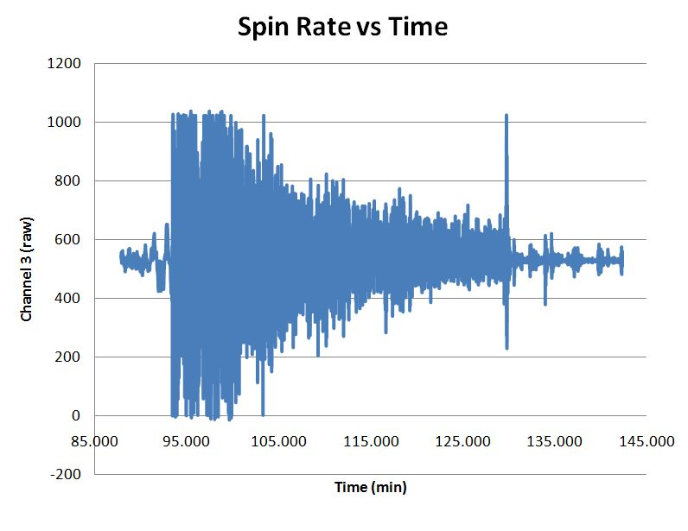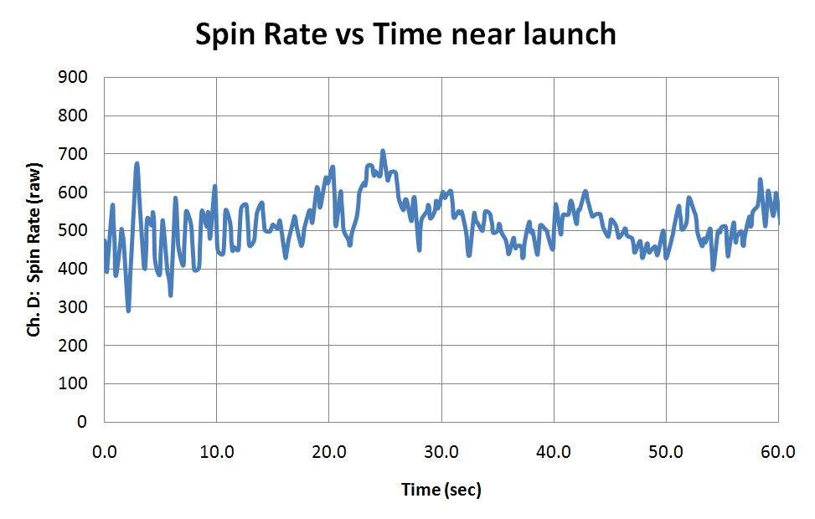
11.0 Conclusions and Lessons Learned

For the external temperature vs. time, the temperature dropped to about -50 degrees Celsius until about the 50 minute mark then the payload entered part of the atmosphere were it started heating up to about -15 degrees Celsius. Burst soon followed and temperature rapidly dropped to its lowest of the flight to -55 degrees Celsius. Relative humidity vs. altitude showed that as altitude increased, humidity decreased to as low at 5% which was around the 80,000 foot mark. Pressure vs. altitude demonstrated that as altitude increased the pressure decreased. For our solar observation the experiment didn’t work as we thought it would and with a better strategy of blocking the sun out would have made it better. The success with our payload was that everything worked at one point or another and functioned how it should have. Plus our design of the box was good and was successful for being our first ballooning space flight.

“Words of Wisdom”
- Don’t drink too much water on the chase; you never know when you are going to stop.
- Think BIG. ALL LIMITS ARE SELF-IMPOSED.
- If you think it might be cold, then it probably will be.

12 Appendix: Program Listings

symbol record=w0 'This is the section where the variables are declared
symbol index=w1
symbol value=b4

BalloonSat:
symbol Max_ADC = 2 ' maximum adc channel used starting with 0
symbol Mission_Delay = 15000 ' length of pause in mission loop

Mission_Prep:
i2cslave %10100000,i2cfast,i2cword ' set memory speed to 400 kHz
if pin7 = 1 then Download_Data 'and one word records

flasher: 'this section is the section that waits
high 3 'for commit pin to be pulled
pause 10000 ‘'the flahser is also in this section
low 3 ' it flashes at a specific rate
pause 1000
if pin7=0 then flasher

Mission: ' will change pattern of flashing when data is being taken
high 3
pause 2000
low 3
gosub Analog ' collect analog voltages
write 0,record ' store the number of records collected
pause Mission_Delay ' pause.....
goto Mission ' ....before starting all over

Analog:
for index = 0 to Max_ADC ' loop for number of analog voltages to record
readadc index,value ' get next adc value
gosub Record_Data ' go store the value
next ' until last voltage is recorded
return ' return to main mission loop

Record_Data:
if record = 2047 then End_Mission ' check that aren't writing too many records to memory
record = record + 1 ' increment record number
low 0 ' unwrite protect memory
writei2c record,(value) ' write the next record to memory
pause 10 ' wait 10 ms for write
high 0 ' write protect memory
return ' return to the calling subroutine

Download_Data:
read 0,record ' get the number of data records recorded in this flight
for index = 1 to record ' until the number of data records
readi2c index,(value) ' read the recorded record
sertxd (#value,",") ' serial out the data record
next ' until last data record read out
goto fail

fail: ' this is what flashing pattern that will occur if the
high 3 'battery dies some time during flight and the computer
pause 1000 ' has restarted and not taken data
low 3
pause 5000
goto fail

End_Mission: 'this is if data was recorded during the whole flight
low 3 ' this shows that the memory is full
pause 1000 ' and that the flight computer functioned properly for the flight
high 3
pause 5000
goto End_Mission

end ' end of mission

