Preliminary Design Review for Minnesota “Group 2” Payload
By: James Flaten, MN Space Grant, flaten@aem.umn.edu
Kyle Marek-Spartz, mare0132@umn.edu
Date: 1/6/2011

Mission Overview

Our mission is three-fold:
Engage and motivate local high-school students, and their teachers, in the space sciences;
Involve younger students in suborbital payload building, including freshmen at the U of MN – Twin Cities as well as students (and teachers) from several local high schools. (Aside: More-advanced college students from MN Space Grant institutions, notably Augsburg College and the U of MN – Twin Cities, are mostly being encouraged to participate in the MinnSpec project instead, though this new project will share canister space with that one, so there will be at least some interaction between the teams.)

Determine the usability of hardware (mostly off-the-shelf, inexpensive, and quite user-friendly) used by the MnSGC High-Altitude Ballooning Team in suborbital applications; Determine whether hardware currently used in ballooning payloads (Verhage flight computers, HOBO data loggers, Flip video cameras, RM-60 Geiger counters, Verhage weather stations) can survive a suborbital launch and function during a suborbital flight (these will probably be turned on in advance of launch, rather than launch-triggered). If they can survive, this may allow future teams to use these simpler user-friendly (albeit less powerful) off-the-shelf components for suborbital payloads.

Collect and analyze science data from the experiments flown;
This is less important because the data being collected is intentionally quite mundane and redundant rather than cutting-edge. There is educational value even if the experiments are unsuccessful. Collect data from basic sensors such as temperature, pressure, relative humidity, cosmic radiation levels, ambient light levels, and acceleration in 3 dimensions, video of visual accelerometer within the canister. We also would like to test passive biological samples (bacteria, brine shrimp, and/or lichens in various stages of their life cycles) to document their ability to survive and their propensity for mutation on such a flight.

Theory and Concepts
Providing educational aerospace opportunities to a wide range of students is a core part of the MnSGC’s mission. Advanced college students in the MnSGC already have the opportunity of working on a suborbital payload with the MinnSpec payload. The additional space allocation allowed us to respond to high school teachers who also expressed interest in becoming involved. The MnSGC High-Altitude Ballooning Team has an established ballooning program, with over 30 launches in the past 4 years. We have experience with off-the-shelf and adapted electronics and a desire to see how far that sort of hardware can be pushed.

Mission Requirements
- Involve students from local high-schools and students new to the suborbital program (i.e. U of MN students not already working on MinnSpec) in experimental design, building, testing, and data analysis
- Determine usability of hardware from our balloon program for suborbital applications
  - Verhage flight computers (BalloonSat Easy, BalloonSat Mini)
  - Basic Stamp computers (BASIC Stamp 1, BASIC Stamp 2)
  - HOBO data loggers (U12-013 data loggers, G logger pendants)
  - Flip video camera
  - Passive biological experiments (bacteria, brine shrimp, lichen)
  - Common weather sensors (Verhage weather station – temperature, pressure, relative humidity)
  - Accelerometers (RockOn-style and 2 home-built designs, one monitored visually and one, based on g-switches, monitored electrically)
  - Geiger counter (Aware Electronics RM-60)
- User’s Guide Compliance

Mechanical System
Number of Plates: We are currently planning on three plates. We may mount some equipment on the bottom of a plate to pare the number of plates down.

Plate Material: We plan to use Lexan/Polycarbonate (or something similar) – has RockOn heritage, is tough, electrically insulating, and transparent – available from McMaster-Carr

Component layout: None of the components we plan to fly are very large so we will be able to place multiple components on each plate. See SolidWorks drawings.

Component spacing: The video camera and RM-60 Geiger counter are the largest components we are using, so they will go on the same plate – plate spacing will allow for at least a 0.5 cm spacing between plates and components above or below. The visual accelerometer chamber will be made from the same acrylic as the plates, and so one or more sides of the chamber could be made using the plate.

Securing components: Plates will be separated by RockOn-type standoffs. For simplicity we are tentatively considering trying to just use zip ties to secure components to the plates, though we might eventually resort to metal brackets as the design evolves and is tested.

Shared Can Logistics: We will be sharing the canister with MinnSpec. Our team members have some overlap with the MinnSpec project and are actively involved with their mission. Structure design for the whole canister will be overseen by the MinnSpec structures subteam. MinnSpec is using the all the ports of the canister.

Mechanical Design remaining: Specifics of the video camera turn-on system (by a high school group, TBD which group). Final SolidWorks design with MinnSpec.

RockSat-C User’s Guide Compliance
—Weight: < 10 lbs, including half of canister itself
—Volume: < 1/2 canister
—C.G: coordinated with MinnSpec to lie within 1” x 1” x 1” of geometric center of canister
—Powered from MinnSpec – shared activation at T-2 min
—Payload will be fully compliant with User’s Guide

Preliminary Mass Estimates: We are aiming for 10 lbs including structures. Our plan is to scale our use of HOBOs and the biological samples based on how much mass remains available after the other components. We will probably have to use ballast to center and raise our mass. This will be worked on closely with the MinnSpec team. Initial mass is 2.61 lbs, however there are other components that have not yet been weighed in. Notably, we are missing the visual accelerometer, the Flip turn on mechanism, and the biological portion of the payload, since these are early in the design phase.

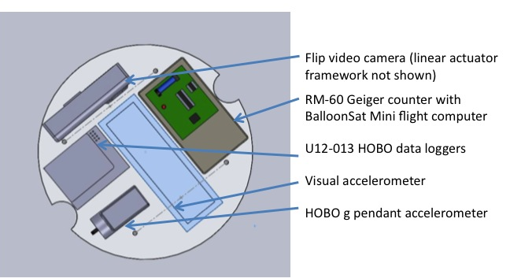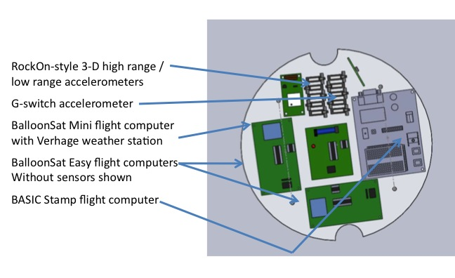
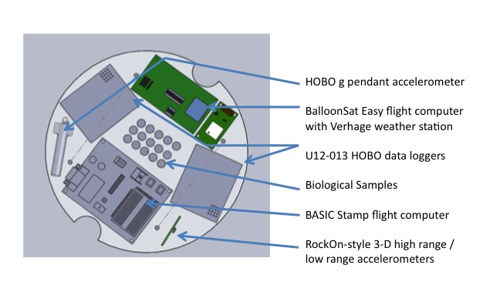

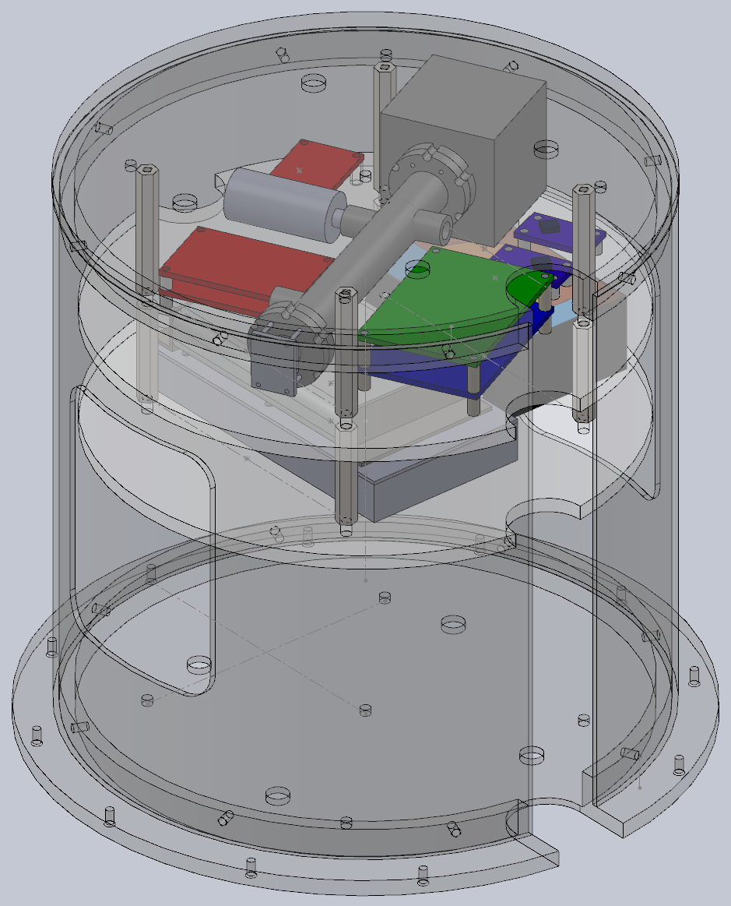
MinnSpec Payload in Canister Our Payload ready for Canister

Note: There were some technical issues integrating the two solid models. Toward the end of break, we should be able to resolve the issues as people return to campus.

Electrical System
Our payload will be sharing power with MinnSpec. We plan to mostly use off the shelf components.

We will have the following sensors:
- Accelerometers:
  - Visual accelerometer, near the Flip camera
  - RockOn accelerometer, 5v, near BalloonSat Mini
  - G-switch bank, 5v, near BalloonSat Mini
  - G-switch Pull before flight pin, near a second BalloonSat
  - HOBO accelerometer, 2.5v, oriented XYZ
- Environmental
  - NearSys Weather Station, 5v, near BalloonSat Easy
  - Internal HOBO Sensors, 2.5v
  - RM-60 Geiger Counter, 5v, near BalloonSat Mini
  - HOBO external sensors (Temperature LM335, Pressure ASDX030A24R, Light Sensor OPT-101) 2.5v, near HOBOs

We plan to fly primarily Verhage flight computers from NearSys: BalloonSat mini, BalloonSat Easy. These are PICAXE-based microcomputers with regulators and ADC’s built in. Power will be supplied by the MNRock/MNSpec power supply. A BalloonSat mini will be monitoring a g-switch with the pull before flight pin, and then turn on a second BalloonSat. We will be monitoring an Aware Electronics RM-60 Geiger Counter with a BalloonSat Mini. A BalloonSat Easy will be monitoring a modified NearSys weather station with a 0-30 psi pressure sensor instead of 0-15 psi. A BalloonSat Easy will also be monitoring our G-Switch bank/Voltage divider circuit. Additionally, we will monitor RockOn Accelerometers using a BalloonSat Mini.

Sample rates will be determined by the high school groups who are building and testing the sensors. We anticipate running the computers much faster than on a balloon mission since the flight is so much shorter, but not so fast so as to run out of memory. It is possible that we will run them fast for the first several minutes – prior to and during the launch – then slower during the duration of the mission so as to conserve memory.

We also plan to fly HOBOs. Due to their design, they will run off of internal power. We have a few ideas for addressing different flight times. One is having multiple HOBOs programmed to run at the primary and secondary flight times. Another thought would be to have a slower HOBO that runs for the 48 hour window of the flight. A third thought is to use the push button to turn on the HOBOs before flight. This could be mechanical or electrical. Our current plan is a hybrid of the first two ideas, having multiple HOBOs with some programmed for the primary flight, some for the secondary flight, and some for the flight window. We would like to use traditional HOBOs, as well as HOBO accelerometers.

The HOBOs will be monitoring their own internal weather stations, but we may use other sensors with them. We are considering using sensors between HOBOs and the BalloonSats. One issue is the HOBOs we use are based on 2.5v sensors. This is TBD by a high school group which will experiment with different sensors and configurations.

Our plan is not to hack the video camera but rather to use servos (probably linear actuators) to literally press the appropriate buttons to turn on the camera in advance of the flight. The servos will be controlled by a Basic Stamp computer. We have not yet decided whether the camera will use its own battery pack or whether we will provide power to the camera from the central power supply. The electrical, mechanical, and software portion of this will be primarily designed and built by a high-school group.

Data resolution is relatively unimportant, except for the HOBO accelerometer, which needs fast data collection.

System interfaces: The only communication between boards is using the relay from one BalloonSat to turn on a second BalloonSat.
BalloonSat Easy Schematic:

High School Program
Participating high school teachers
—Peter Grul (Tentative), Washburn High School, Minneapolis, MN
—Peter Pitman, White Bear Lake High School, White Bear, MN
—Eric Colchin & Colin Denis, Johnson High School, St. Paul, MN

This week we will have a "kick-off" event with students and teachers at Johnson High School in St. Paul and a similar event next week with White Bear Lake High School. Kickoff with Washburn High School TBD. We plan on having weekly meetings or telecons with each school once our semester starts (1/18).

Tasks for schools:
- (all schools) Learn to power sensors (on a breadboard) and monitor their output directly with a digital multimeter. This will require general electric circuits, breadboards, sensors of various sorts, and multimeters.
- (all interested schools) Learn to program HOBO data loggers and use them to monitor sensor output, both in “live mode” and in “delayed-start” mode. Use voltage dividers to bring sensor output into voltage range that HOBO can monitor, if necessary. Learn to off-load data from a HOBO and graph it. This will require HOBO data loggers, HOBO sensors, general DC voltage cables, HOBO software, and Excel spreadsheets.
- (all interested schools) Learn to solder, then build a NearSys BalloonSat Easy flight computer. This will require learn-to-solder kits, BalloonSat Easy kits, soldering irons, and other tools.
- (all schools) Learn to program BalloonSat Easy flight computers (and possibly other computers like BalloonSat minis, BASIC Stamps, etc.) to record sensor values at various rates. Possibly also program computers to use sensor input values and/or timing to make decisions to do things, like activate servos or power up devices. This will require Picaxe chip programming, sensors of various sorts, and servos (for some projects).
- Individual school projects: (Each school will either choose or be assigned one of these. We are currently discussing with the schools how to distribute these tasks)
  - G-switch bank: Design, build, and test/calibrate a g-switch-based accelerometer in which g-switches of various stiffnesses are used to short out resistors in a voltage divider circuit, to monitor acceleration. Record the output with a computer. Possibly help build a centrifuge to test it, at least with steady accelerations, perhaps up to about 20 g’s.
  - Visual accelerometer: Design, build, and test/calibrate a cantilever-based accelerometer in which cantilevers of various stiffnesses are used to indicate acceleration. Monitor the flexing visually with a video camera (See 5.c.). Build a transparent enclosure in which to place it, to protect the rest of the payload in case any parts break during flight. Possibly help build a centrifuge to test it, at least with steady accelerations, perhaps up to about 20 g’s.
  - Camera turn-on: Design, build, and test a light but robust robotic mechanism, controlled by a flight computer, to start a Flip video camera using servos to press the power button and then the record button (used to monitor the accelerometer mentioned in 5.b.). Use an optical sensor to monitor whether or not the camera’s record light comes on and stays on. If the camera does not come on at first, or shuts down during the launch, the program should try to do something about that.

Passive Biological Payload
The biological payload will be designed to just sit there during the flight. However, much work will need to be done both before and after the flight. There are three portions to this payload: The Ames test, consisting of the bacteria Salmonella tymphimurium; A lichen portion, looking for survivability and mutational properties; and brine shrimp, also looking for survivability and mutational properties. These experiments will go into small plastic test tubes with locking tops, designed for centrifuge use (Locking Centrifuge Tubes, 1.5 ml). The test tubes will be placed into aluminum or acrylic block(s) with holes drilled in a hexagonal array to hold the test tubes. A lid will come down on top to hold the tubes in place, as well as to provide a secondary seal, in case of failure.

The Ames test is a common test for carcinogens. A strain of the bacteria Salmonella tymphimurium, will be exposed to cosmic radiation. The bacteria will be inoculated into small test tubes containing a small amount of Histidine. Histidine is needed for bacterial growth. However, if mutation occurs, the bacteria can grow without Histidine. Lead foil will be placed in varying amounts around the tubes to test the effects of this type of shielding. The bacteria will be able to grow during the flight, allowing them to be affected by the cosmic radiation. The bacteria will then be placed on plates without Histidine, and the bacteria that grow have had mutations. Comparing which bacteria grow to which had more shielding will be our primary data analysis. Alex Knutson-Smisek is working on the Ames test portion of the payload.

The lichens will be primarily testing whether they can survive in a high-g and then a low-g environment. Potential applications are manufacturing biofuels in space, or providing food for astronauts. There will be samples of three different types of lichens. For each sample flown, a duplicate sample will remain on the ground for comparison post-flight. Mary Pattison is working on the lichen portion of the payload.

The brine shrimp will be primarily testing survivability. Potential applications are providing food for astronauts, or low-g hydroponics. Different samples will have different life stages of shrimp. Some will have inert stasis shrimp, some young freshly hatched shrimp, and some mature reproducing shrimp. For each sample flown, a duplicate sample will remain on the ground for comparison post-flight. Kyle Marek-Spartz is working on the brine shrimp portion of the payload.

Expected Results
At this time we do not know whether the hardware we hope to fly has been used in suborbital rocketry. Finding out if it can work will be valuable for future teams. New people involved in the project will gain a basic understanding of spacecraft payload building and more appreciation of space science. If the hardware survives the launch, the data we will try to collect data is from the sensors listed previously. We also will collect data post-flight from the biological experiments. Hardware and experiments that collect usable data will be considered for use on future payloads.

Management
Personnel: Professor James Flaten will advise this project and the student team lead is Kyle Marek-Spartz, who is already a member of the MinnRock/MinnSpec project. Other U of MN students have already agreed to help work on this team and will interact with students and at least one teacher from about three local high schools. High school teams will be managed by their teachers. There will also be other U of MN students working on the biological payload.

Organizational Chart:
- U of M Students
  - Biological
    - Mary Pattison (Lichens), Alex Knutson-Smisek (Bacteria), Kyle Marek-Spartz (Brine Shrimp)
  - Programming
    - Anthony Knutson, Chris Schumacher, Seth Frick
  - Structures
    - Jules Feldhacker, Monique Hladun
- High-Schools
  - Student Liaisons
    - Cait Mantych (Ballooning Team Lead), Philip Hansen (Ballooning Team Programmer), Alex Ngure (White Bear Lake graduate, Ballooning Team)
  - Peter Grul (tentative), Washburn High School, Minneapolis, MN
  - Peter Pitman, White Bear Lake High School, White Bear, MN
  - Eric Colchin, Johnson High School, St. Paul, MN
- U of MN faculty advisor: Dr. James Flaten
- Consultant: Bryce Schaefer (MinnSpec team lead)

Schedule:
2011.01.06 | PDR Due  Kick off Meeting with Johnson High School
2011.01.07 | Final Down Select—Flights Awarded
2011.01.13 | Kick off Meeting with White Bear Lake High School
2011.01.18 | Spring Semester begins  Regular Team Meetings commence  Regular High School Meetings commence
2011.01.21 | Critical Design Review (CDR) Due
2011.01.24 | Critical Design Review (CDR) Teleconference
2011.01.31 | RockSat Payload Canisters Sent to Customers
2011.02.07 | Online Progress Report 3 Due
2011.02.14 | Individual Subsystem Testing Reports Due
2011.02.21 | Individual Subsystem Testing Reports Teleconference
2011.02.28 | Online Progress Report 4 Due
2011.03.28 | Payload Subsystem Integration and Testing Report Due
2011.04.02 | Balloon Test Flight with MinnSpec and Ballooning Team  High School projects are due
2011.04.04 | Payload Subsystem Integration and Testing Report Teleconference
2011.04.08 | Final Installment Due
2011.04.11 | Weekly Teleconference 1
2011.04.18 | Weekly Teleconference 2, First Full Mission Simulation Test Report Due
2011.04.25 | Weekly Teleconference 3(FMSTR)
2011.05.02 | Weekly Teleconference 4
2011.05.09 | Weekly Teleconference 5
2011.05.16 | Weekly Teleconference 6
2011.05.20 | Second Full Mission Simulation Test Report Due
2011.05.23 | Weekly Teleconference 7 (FMSTR 2)
2011.05.30 | Weekly Teleconference 7
2011.06.03 | Launch Readiness Review (LRR) Teleconference
2011.06.06 | Weekly Teleconference 8 (LRR)
2011.06.10 | Weekly Teleconference 9
2011.06.16 | Visual Inspections at Refuge Inn
2011.06.17 | Integration/Vibration at Wallops
2011.06.22 | Presentations to next year’s RockSat
2011.06.23 | Launch Day

Materials: Since we are using off-the-shelf items, many of which we already have and all of which are easy to purchase, we do not anticipate delays in procuring materials. To keep the complexity low we anticipate laying out external circuits on breadboards and possibly even flying them that way, rather than making printed circuit boards.

Budget: Group 2’s equipment (up to $1000) will be funded by the Minnesota Space Grant Consortium (MnSGC). We already own much of our equipment as part of our high-altitude ballooning program. Extras we may need will be easy to acquire at relatively low-cost and we already know what vendors to use.
Description | Details | Source | Quantity | Price
Video Camera | Flip Video | PureDigital | 1 | 100.00
Datalogger | HOBO U12-013 | Onset Electronics | 4 | 110.00
Datalogger | HOBO G-pendant Accel. | Onset Electronics | 2 | 72.00
RockOn Accel. | ADXL103CE, ADXL203CE | Digi-Key | 2 set | 20.00
Computer | BalloonSat Easy 3.2 | NearSys Systems | 3 | 40.00
Computer | BalloonSat Mini | NearSys Systems | 2 | 30.00
Geiger Counter | RM-60 | Aware Electronics | 1 | 150.00
Weather Station | Weather Station | NearSys Systems | 2 | 50.00
Computer | Basic Stamp Kit | Parallax Inc. | 2 | 100.00
Brine Shrimp Eggs | SF Bay Brine Shrimp Eggs | Amazon.com | 4 | 2.95
Brine Shrimp Food | OSI Artemia Brine Food 6 gm | Amazon.com | 10 | 1.77
Centrifuge Tubes | Eppendorf Safe-Lock 1.5ml | Cole-Parmer | 500 | 45.00

Component list:

Action Items/Questions:
Establish regular meeting times for both the high school meetings as well as the team meetings.

Have we heard for sure that we can use pre-programmed HOBO data loggers and/or batteries for the Flip video camera?

Have we heard for sure that we can use an RM-60 Geiger counter on the flight? Beyond conformal coating, is there anything else we need to do?

