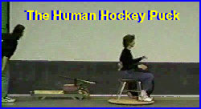
XXXXMaterials XXXConstruction XXXDiagram
Build your own hovercraft and power it with a standard shop vacuum. Demonstrate the ability of air to reduce friction by gliding students down the hall on the Human Hockey Puck. You can also demonstrate the lifting ability of compressed air, we have had as many as four students ride the craft at one time.
Click here to see the Human Hockey Puck in action.
Materials:

1. 4 x 8 sheet of 3/8 inch plywood&emdash;good on one side. Have the lumber store split into two 4 x 4 Pieces.
2. 6 x 6 foot square of 6 mill visqueen (heavy plastic). Obtained from hardware or lumber store.
3. 50&emdash;5/8 inch round head screw.
4. 3&emdash;metal washers to be used with the 5/8 inch screws
5. 1- 1/4 inch carriage bolt 1 and 3/4 inch long and nut
6. 2 metal washers to fit the carriage bolt
7. One plastic coffee can lid (approximately 5 inches in diameter)
8. Staple gun (desk type will also work)
9. Two pieces of 3.4 wood 4" x 4" (Oak Works well).
10. Duct tape
11. One shop vac
12. Scrap wood to build a stool (optional)
Construction:
1. With a saber saw, cut a disc out of each plywood sheet. The top disc should have a diameter of 48 inches. Theo other disc should be cut to a diameter of 47 inches. If the bottom disc is cut a little smaller, the overhang of the top disc will protect the rolled edge of the visqueen covering on the bottom disc when the craft is stored on its edge.
2. The bottom disc must have the edges of the plywood sanded round to protect the visqueen covering. I used a router to shape both the top and bottom edge of the plywood disc. I lightly sanded the edge to give it a smooth surface. I also routed and smoothed the edges of the top disc to prevent splintering or slivers.
3. Drill a 1/4 inch hole in the center of both discs.
4. Drill a 1/4 inch hole in one of the 4 x 4 inch wood blocks.
5. Temporarily bolt the two discs together and drill a hole large enough to receive the end of the plastic hose of the shop vac. This hole should be located halfway between the center of the disc and the outer edge. This hole must go through both discs and should provide a rather tight fit for the shop vac hope (if needed, tape can be used on the end of the shop vac hose to take up any sloppy play). Also drill the same size hole in one of the 4 x 4 inch wood blocks.
6. Tightly cover the bottom surface of the smaller disc with the visqueen, folding it over the top and staple in place as shown in the diagram.
7. Poke a hole in the visqueen where the bolt will go through and reinforce this area with duct tape. I covered about a six inch square area in the center of the visqueen.
8. Bolt the top piece of plywood and the bottom disc together as shown in the diagram. Be sure to insert the bolt through the washer and plastic coffee can lid first then through the two discs and wooden block. Secure with a washer and nut.
9. Screw the edges of the discs together using 5/8 inch round head screws spaced about 3 inches apart. These screws should help form a tight seal and prevent air leakage.
10. Screw the coffee can lid firmly in place using three 5/8 inch screws and washer.
11. Cut several air holes in the visqueen. I made a cutting tool out of an old piece of shower curtain rod. It has a diameter of about 1 inch and it is made of thin brass so I was able to sharpen a cutting edge with a round file. This worked well because it made a nice clean hole. A large cork baring tool could also be used to cut nice clean holes in the plastic. The pattern shown in the diagram is the one I used, and it worked well. You may want to experiment with your own pattern.
11. I made a stool tall enough to fit over the shop vac. The students could sit in the center when riding the hovercraft.
12. Good luck and happy hovering.
Diagram
Click here to download a printable PDF of the diagram. (Adober Acrobat Reader is required. See www.adobe.com for a free copy.)
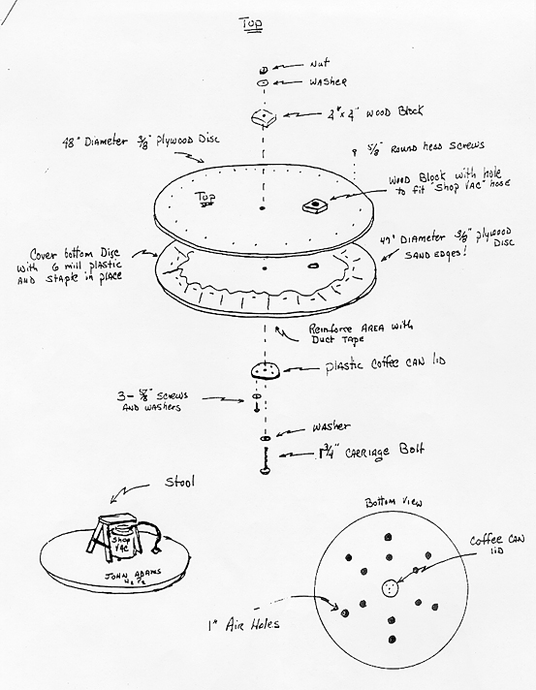

Hovercraft instructions by:
David Arlander
John Adams Science Department
The John Adams H2 P: The Human Hockey Puck

