High-Altitude Ballooning
for Middle and High Schools

Teacher Overview

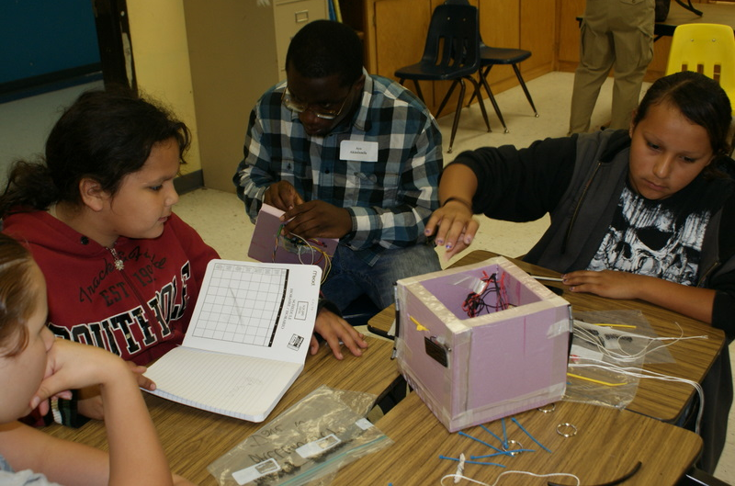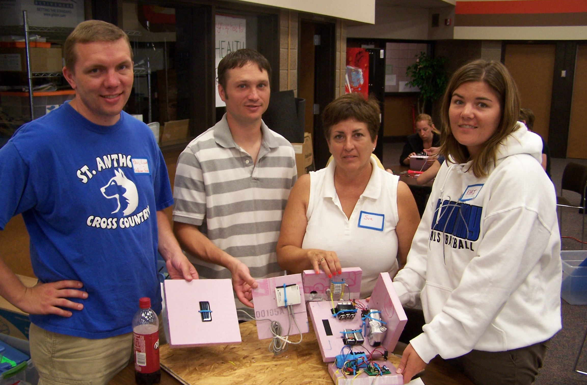

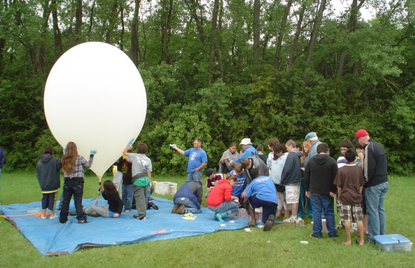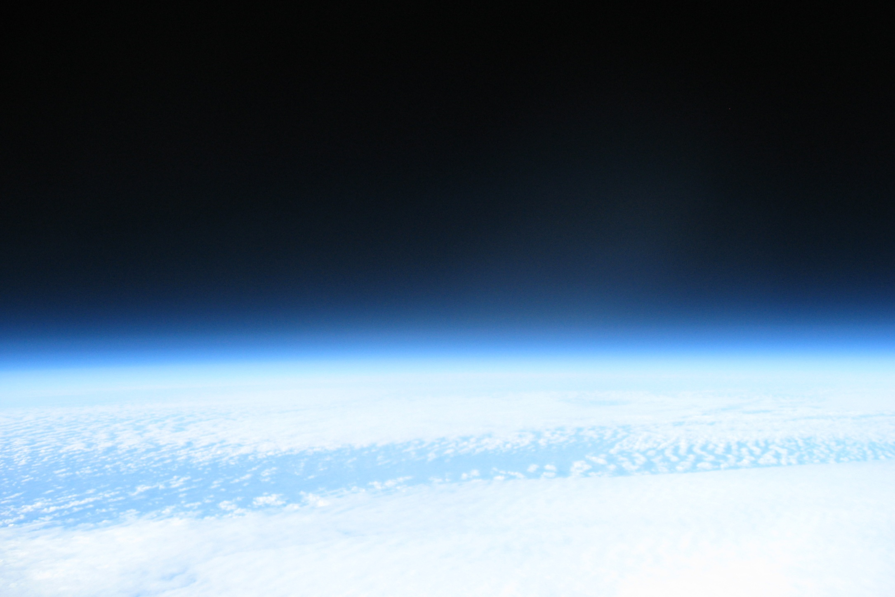

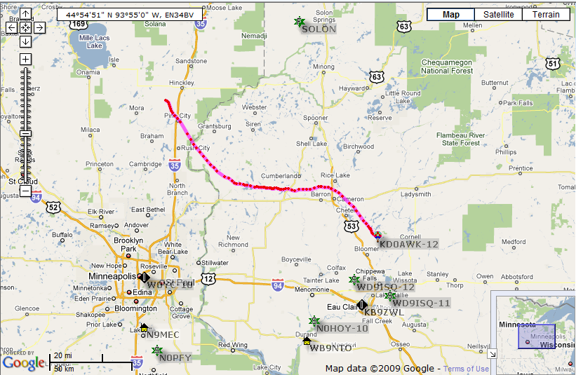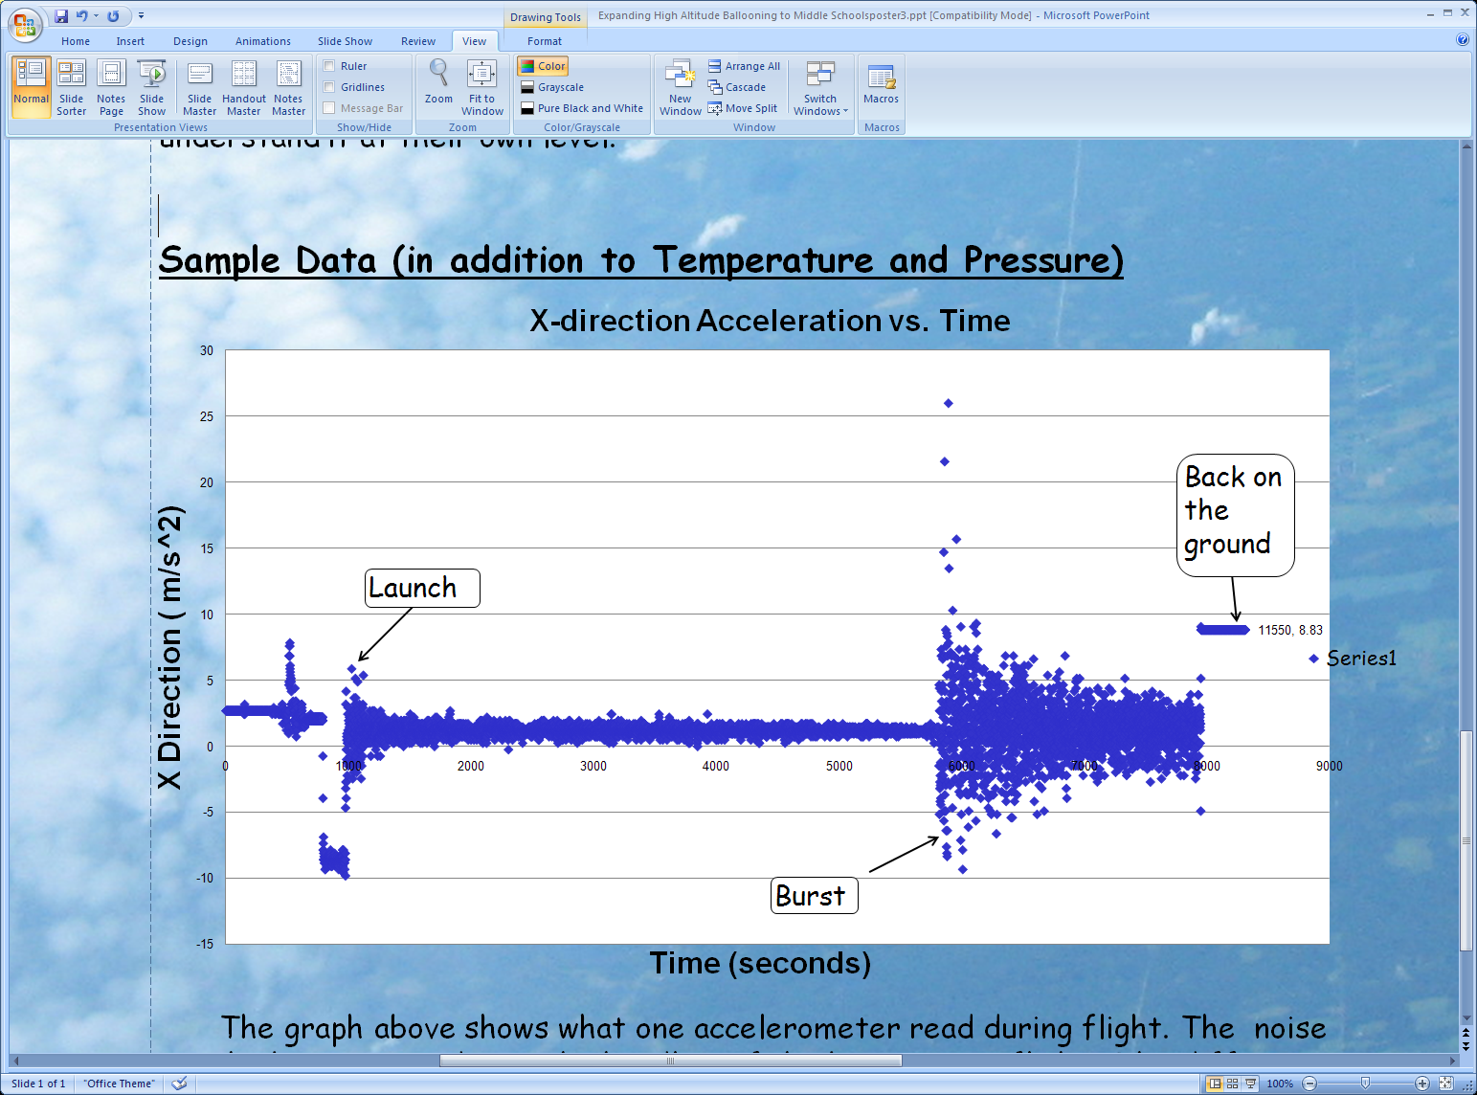

James Flaten, Ph.D.
MN Space Grant Consortium
University of Minnesota
flaten@aem.umn.edu
Index

Prologue…………………………………………………………………………………………...3
Introduction to Near-Space-Flight with Weather Balloons…………………………………….....4
Designing, Building, and Testing a Near-Space Payload………………………………………...5
Monitoring the Near-Space Mission………………………………………………………………8
Analyzing the Data………………………………………………………………………………10
Epilogue……………………………………………………………………………………….…12
Prologue

The purpose of this document is to broadly explain what the MN Space Grant’s high-altitude ballooning initiative for pre-college schools is (and is not) and to suggest ways in which teachers might take advantage of this opportunity to participate in a genuine, hands-on, local space program (albeit an amateur one) with their students.

The program is:
- a chance to learn about outer space and near-space
- a chance to pose science/engineering questions to test in near-space
- a chance to design, build, and test a near-spacecraft (within certain parameters) to collect data to answer the question(s) posed above
- a chance to monitor the flight of the near-spacecraft during a near-space mission
- a chance to analyze the data collected to answer the question(s) posed above

The program is not designed to:
- dictate exactly how much of a high-altitude ballooning experience students get, nor exactly how many students are involved in what parts of the process
- have lots of students come out to the balloon launches – instead, video of launches will be streamed over the internet and may be monitored at the school, either in real time or replayed after the fact
- provide multiple payloads and multiple flights to each school – the program offers to fly just one payload per school for each of two calendar years
- prepare teachers and/or school districts to be able to do their own launches – instead, launches will be provided by the MN Space Grant during the program and advice will be offered after that about how to make ballooning activities sustainable for schools that wish to continue to offer this opportunity to their students

As suggested by the Index, the steps one might go through to involve students in high-altitude ballooning include:
- learning some basics about outer space, near-space, spaceflight, and spacecraft
- posing science/engineering questions(s) then designing, building, and testing a near-spacecraft (AKA a payload) to collect data to answer the question(s)
- monitoring flight of the payload to near-space, either in person or watching live (or re-played) video and data streamed over the internet
- analyzing the data from the payload so as to answer the question(s)

This overview briefly touches upon each of these steps, to guide and motivate the development of specific curricular activities about various topics for various age groups. Curricular activities written by the MN Space Grant ballooning team, advised by Professor Flaten, and by the teachers participating in the program will be posted, to flesh out and expand upon some of the ideas presented here. Potential standards-alignments are discussed, with more details to be found in specific curricular activities.
Introduction to Near-Space-Flight with Weather Balloons

Students will be unfamiliar with “near-space” so (after giving them pre-instruction surveys) be sure to take time for a motivational introduction to near-space, near-spacecraft, and missions to near-space using weather balloons. This might be preceded by a discussion of and/or activities related to more-familiar “outer space” and NASA spacecraft and exploration missions around the Solar System.

Unlike some of the later steps, this introduction to spacecraft and spaceflight can probably be delivered relatively easily to all your students. Emphasis should be placed on the following main points:

- Outer space (and near-space) environments are similar to one another but quite different from the environment where we live, at the base of the atmosphere. In general, both outer space and near-space are very toxic environments: pressure is lower (or zero), radiation is higher (not protected by the atmosphere), temperature is often much colder (but some layers of the atmosphere are warm), sunlight is more intense, and the sky looks black even in the daytime (above the blue “glow” of the atmosphere due to scattered light).
- Spacecraft need to be able to operate in this toxic environment (often passing through very cold layers of atmosphere are the biggest obstacle) and must be rugged enough to survive re-entry (tough for near-space flight with post-burst chaos; even tougher for outer space flight with re-entry heating).
- Using weather balloons to reach near-space is much less expensive than using rockets to reach outer space, but the challenges one must deal with when designing and building science payloads for missions to both regions are quite similar. This is what makes near-space missions so worthwhile for educational purposes.

When introducing high-altitude ballooning, consider showing videos of launches plus still photos, videos, and/or data from other balloon flights. Consider showing a sample payload too, just try not to let seeing one limit the creativity of your students. If you have a specific kick-off date for this unit, consider inviting Dr. Flaten and/or members of the ballooning team out to speak to your class(es). Photos and stories from your ballooning workshop experiences might be even more meaningful. This opportunity is exceptional and unique – your students are going to send science experiments higher than any people will ever go (except astronauts)! Play it up!

There are high-altitude ballooning groups around the country (though not many people do it here in Minnesota), so you can learn more by looking for web sites from various ballooning groups. (The MN Space Grant Ballooning Team at the U of MN doesn’t have much of a public web presence (yet).) Paul Verhage writes a fairly non-technical column called “Near Space” in the electronics hobbyist magazine “Nuts and Volts”. Several of his early columns, in which he makes a case for amateur spaceflight are at http://www.parallax.com/tabid/567/Default.aspx. Pay particular attention his first 3 articles for Nuts and Volts, published in February, March, and April 2004.
Designing, Building, and Testing a Near-Space Payload

The primary hands-on part of high-altitude ballooning is actually building the payload that flies. One of the first questions to be addressed is “Who exactly gets to build the payload (considering the fact that we don’t have contents for multiple payload boxes and we only get to fly one anyway)?” There is no one-size-fits-all answer to that question and answers are likely to vary from school to school. Some of the steps below could be done by multiple groups of students working in parallel (or successively) on multiple payloads (or at least on payload models). The easiest solution, though not necessarily the most satisfying one, may be to have a relatively small group of (hand-picked?) students design, build, and test the actual flight payload box, with other students contributing mostly to preliminary design and payload testing (perhaps) the monitoring the flight and data analysis (for sure).

Thoughtful design must come before actual building, both science (experiment) design and engineering (payload structure) design. Due to the limited and unfamiliar nature of the payload box contents, it may be best to demonstrate/discuss all the possible sensors before having student try to pose science questions and then try to design science experiments to answer those questions. Contents might include a weather station (temperature sensor, pressure sensor, relative humidity sensor) with a flight computer on which to store data, a HOBO (measures internal temperature, plus two generic voltage inputs from things like temperature sensors and/or solar panels), a still or video camera (can take photos looking out or up or down (or in more than one direction simultaneously using mirrors!); also, some experiments may call for taking photos through a filter of some sort), accelerometers (measure vibration in 3-D), and Geiger counters (measure cosmic radiation). Voltage-type data can be sent to the ground during the flight using a zigbee radio telemetry system and an interface board – leave space for that in the payload box if you want to use one. Also remember that altitude, latitude, and longitude data will also be available during and after the flight, from the GPS tracking boxes on the stack – your students don’t have to measure those.

Once one or more science experiments have been chosen and the required sensors have been selected (note that you might not be able to fly all the sensors you have due to weight limitations) a payload box needs to be designed and built to hold the sensors and allow them to function in flight. Designing and building the payload shell is a good opportunity to apply the engineering design cycle. Give the students as much creative latitude as you are able at this point in the process and be sure to allow them time to test, evaluate, and improve upon their early designs – nothing ever works right the first time! Recommend, but perhaps don’t insist upon, materials that have worked well historically such as tough Styrofoam, foam-core, black insulation, epoxy, strapping tape, etc. Decisions will need to be made regarding payload wall material, payload shape and size, interior component layout (paying close attention to which components need to be connected together), etc. The overall weight limit (2 pounds before rigging) is likely to be a major limiting factor. Actual rigging is usually done externally so might be dealt with only after the payload itself is completed. Since rigging integrity is critical to a successful flight, expect the ballooning team to look over your efforts very critically and possibly try to improve upon them.

It may be useful to make models of components (possibly out of Styrofoam or card stock) and have students practice arrange them in a payload-sized box in various ways (possibly using Velcro or double-stick tape), to help them find a solution to what is essentially a 3-D spatial puzzle of how to make things fit. Payloads will need to be compact, yet large enough to contain all the desired sensors in locations where they can still be reached to turn them on and off. Some components, especially flight computers and HOBOs and still cameras, need to be programmed – make sure the design allows for access for programming cables, SD cards, etc. Going through a “flat-sat” stage while building the payload will allow more people to work on it simultaneously than if it is folded into a box early on (see photos on the front cover) – just be sure the contents don’t interfere with one another when the sides are finally folded up! When the design is complete and all components are in their final places, use zip ties to affix them in place – Velcro isn’t strong enough for the violent motion during post-burst chaos!

Although some ballooning groups depend solely on the thermal insulating properties of their payload walls to keep their components warm, we believe in active heating using resistive heaters. (Painting the outside of the payload black is also a good idea!) Building heaters gives you an opportunity to talk to your students about circuits and, if you want, to teach them to solder. (If you decide to teach them how to solder, consider having them learn by assembling a flasher circuit – see handout.) “Snap-together” heaters are another option: more work to make and a bit more expensive, but they allow you to teach the same lesson about circuits, not have to deal with students soldering, and they can also be taken apart and reassembled by others (allowing you to get more students involved). Our team’s preference is to teach using snap-together heaters but to actually fly with hard-wired heaters. (Go figure!) If you really want to challenge your students, have them solder together a BalloonSat Easy flight computer and/or a weather station rather than just using them off the shelf.

Some payload testing, though not necessarily all, will occur after the payload is essentially complete. The purpose of testing is to ensure that the payload will function without failure during the entire near-space mission, so students need to learn what to expect regarding the near-space environment and also regarding the balloon flight itself so that they know what to test. In general, testing involves subjecting the payload to conditions similar to those it will experience while in flight, to make sure that it doesn’t fail. Some aspects of the near-space environment, like pressures near zero and high radiation levels, are challenging (even dangerous) to attempt to reproduce on the ground – hence some things will remain untested and students will need to depend on the experience from previous flights with similar payloads as evidence that their payload will survive these conditions. On the other hand, most payload failures can be traced back to structural breakage (often during post-burst chaos) and/or electrical failure (often due to batteries getting too cold), so structural testing and thermal testing are particularly important and are both fairly easy to accomplish.

To test the structural integrity of the payload shell we recommend loading it with weights (not necessarily the actual valuable flight contents) then dropping it onto a hard surface from a height of a few feet and also rolling it down a flight of stairs. Such tests reproduce, approximately, the sort of impact the shell should be able to survive when it lands. Once the rigging is installed we recommend a “yank” test, with real flight contents strapped in place, in which the payload is yanked around as hard as possible by the rigging (though not slammed against anything). This approximates post-burst chaos. Nothing should come loose or break inside the payload or on the rigging.

Thermal testing can be done by exposing the (sealed and operating) payload to the coldest environment you can produce (preferably well below freezing) for about 30 minutes. A HOBO can be used to monitor the internal temperature and external temperature during this test, just like during a real flight. If the payload is completed during the winter, one might try to test it outside during a very cold day (or night). A standard freezer is another option, though we prefer using a chamber containing dry ice and can lend one out (if you can come up with a local source of dry ice). Measures of success might be (a) if the payload stays warmer with the heater running than without (would require two tests) and, much more importantly (b) nothing shuts off due to the exposure to the cold environment during the 30 minute test. If you can test the payload in a -30° to -40° F environment and keep the internal temperature above freezing for 30 minutes, consider that a success. If your payload goes below freezing it might still work during a flight, but trying to improve the thermal insulation would be worth trying.

Another important part of testing has to do with learning how to operate the cameras and how to program the computers and the HOBO to take the data you want when you want it (and also learning how to get the data back after the flight). Separate instructions will be provided for each of these items, as well as direct assistance from the ballooning team (possibly as late as the day of the flight), but don’t hesitate to assign at least some students to each sensor so that they can learn how it works and how to download and interpret the data it produces (see Data Analysis section of this document).

Once the payload is completed, tested, and fully operational (i.e. completely programmed, fresh batteries, memory cards on camera cleared, etc) it will need to be delivered to the U of MN for a final check-out and weigh-in. As you organize your schedule, please aim for having the payload done at least 1 week before the flight date. This might allow someone from the ballooning team to actually come out to your site to pick it up and to talk to your students a bit, rather than just having you drop it off or mail it to the U of MN.
Monitoring the Near-Space Mission

Regardless of exactly who builds the payload, monitoring the near-space mission can be quite engaging and we encourage you to involve all the students who will be doing data analysis (at least) in this aspect of the project. As mentioned earlier, our intent is to stream video of the launch and data during the flight to the web so that schools do not feel obligated to deal with the cost and logistical challenges of transporting large groups of students to the launch and/or taking them on the “chase.” Monitoring spaceflights remotely is actually very realistic – NASA does it all the time with their control rooms (sometimes in a completely different state from the actual launch site).

Important notes about potentially attending launches in person: Launches always take place at least an hour drive from the Twin Cities, sometimes more. Launch sites are usually selected only a day or two in advance, based on weather predictions. Chases can take multiple hours and can be unpredictable, especially if the payloads land in an area that is hard to approach by car or on foot. Because of all these issues, we recommend that you do not plan to bring many (if any!) students out to the launch, fun though that might be, and we strongly discourage taking any students along on the chase. If you elect to bring students out you will need to be 100% responsible for their transportation and their behavior on site, so be sure your adult-to-student ratio is reasonable.

In the days prior to the flight one important task, which can involve lots of different people, is predicting where the balloon will go based on evolving weather prediction models. Details of how to do this are written up as a separate activity. The purpose of the exercise is not only determine where the flight is likely to go, based on input parameters (launch date and time, ascent rate, burst altitude, descent rate) but also to anticipate where it will land if the parameters are not met (launch time delay, incorrect ascent rate, early burst, etc.). In general one can launch from almost anywhere, but there are parts of Minnesota (and Wisconsin) that we really prefer not to land in, so another part of flight predictions is to try moving the launch location around so as to “aim for” a specific landing zone. This activity can lead to lots of discussion about weather, predictions, mapping, topography, etc. and a final decision about where to fly – again, this is just like debates at NASA about what to aim for when they send landers to the Moon or to Mars.

On the flight day there will be significant activities at the launch site and possibly some vehicles sent out in advance to the expected landing zone (and some of the launch vehicles will probably chase the balloon as it flies as well, though we have only a finite number of in-vehicle tracking systems). Tracking data from the balloon (latitude, longitude, and altitude) is transmitted using APRS (ham radio) format under a specific ham radio call sign, as well as using 900 MHz (“Stratostar”) radio transmitters. The Stratostar system also can be used to send down sensor data, in the form of raw voltages, from on-board experiments. Photos and certain other types of data are only logged on-board and are not accessible till after the payloads are recovered.

Assuming you are not out at the launch site, here are the basic options for monitoring the flight. More details are provided with a separate curricular activity discussing setting up a “control room” and generating graphs of data while the flight is in progress.
- We will stream video from the launch site (stack assembly, balloon inflation, balloon release) to the internet on the web sites http:///www.justin.tv/mn_space_grant and http://www.justin.tv/mn_space_grant2 . There is often somewhat of a delay (up to 30 minutes!) between our generating the stream and it appearing on-line, so this should be described as nearly in real time. Interestingly enough, this is quite realistic for NASA missions exploring distant planets because their radio transmissions take a while to reach the Earth. This video will be archived on the web site so can be viewed later if you elect not to monitor it while the fligh is actually taking place. Unfortunately this delay makes it hard to plan exactly when to watch from your school – if a flight is planned for 10 a.m., for example, and even goes off on time you might not be able to see it on the web till 10:30 a.m. or so.
- Once the balloon is in flight its APRS transmissions will be picked up by ham radio repeaters on the ground and dumped directly to the internet, so tracking data from the flight can be monitored in real time at web sites like aprs.fi. We will tell you which ham radio call sign you need to monitor. Notice that since this data is not delayed, it might be confusing to simultaneously watch this plus the video steaming information mentioned above (and below) – maybe choose to do just one or the other.
- Stratostar data transmissions will be picked up by radios in our vehicles, but they are not dumped directly on the internet. We will stream Stratostar data transmissions to the internet using mobile broadband equipment from the launch site (should be able to monitor the balloon till it goes over the horizon – full ascent, descent down all the way down to a few thousand feet in altitude). Like the video streaming mentioned above, there may be somewhat of a delay before this data appears, but the good news is that it can also be played back later.
- If there is reasonable internet coverage in the landing zone it is possible that we will be able to stream additional video of the chase, landing, and/or actual recovery. But don’t count on this! We’ll definitely take video from both the launch and recovery zones, to distribute after the fact.
- We may also be able to keep in touch with you by cell phone (to some degree) during the flights, though we are pretty busy using our cell phones to keep in touch between chase vehicles and with the FAA, so don’t expect notifications too often. We can, at minimum, let you know how things are going with finding and recovering the payload once it lands (but if it lands where there is no cell phone coverage, even that might have to wait till we are back on the road driving home).
Analyzing the Data

Data analysis has the potential to be the most educational part of this experience for the largest number of students, especially at schools where just a small group of students build the actual payload. However there is a lot of data and some of it is a bit abstract so, like everything else, this part of the project needs to be approached carefully. Hopefully the students doing the analysis will at least have some familiarity with the payload box from which it came, whether or not they were directly involved in building it. This may give them a sense of ownership in the data as well as help with the abstractness issues.

The most engaging data is likely to be the photographic data, taken by still cameras and/or video cameras on the stack. We plan to have the payloads that fly together share their photos (and all their data, for that matter) so students will get to look at more photos than just those taken by their own camera. “Look-up” cameras capture the sky above (changes color dramatically) and the balloon (watch it expand then ultimately burst, watch the parachute in action), “look-out” cameras capture the view to the horizon (see layers of the atmosphere, watch the sky turn black, start to see the curvature of the earth), and “look-down” cameras may show best just how high the balloon actually goes (as well as taking interesting pictures of people and the ground just after launch and just before landing). We recommend giving students adequate time to view and talk about photographic data before working on sensor data. One issue that is likely to come up will be “How high was the balloon when this photo was taken?” which can lead neatly into a discussion of altitude versus time and time-in-flight (t) (as opposed to time since camera-turn-on (T) or real (clock) time).

Central to data analysis, though not collected in the student-built payload itself, is “tracking data” both from the APRS record on the internet and the Stratostar transmitter. This data contains altitude, latitude, longitude, and the real (clock) time. From latitude and longitude one can plot where the balloon flew, superimposed on a map – indeed, this was done automatically by the tracking software during the flight, so the students may not need to do it for themselves. If you are ambitious, you can make 3-D maps of the trajectory then “fly around” them with Goggle Earth. Combining the altitude with the time stamps allows one to generate altitude versus time graphs, showing the balloon ascending at one (possibly two) nearly-linear rates, bursting at some maximum altitude, then descending at a decreasing rate as the parachute slows its fall. Instructions are provided about how to generate altitude versus time graphs, and even how to fit the data on them, for Stratostar data (quite easy) and for APRS data (data needs “scrubbing” first, so this is more labor intensive). Rather than having your students work with all the tracking data from scratch, consider having them generate an altitude versus time graph perhaps once every 5 minutes during the actual flight – believe me, even that will keep them busy – then just look at altitude versus time graphs produced by the ballooning team on your behalf after the flight.

Instructions are also provided for downloading then analyzing data from science sensors and we recommend the teacher trying the analysis before even deciding how much, if any, to have the students do. In general the Stratostar data record is easier to work with, but much more voluminous, than the BalloonSat Easy data record. HOBO data is quite easy to work with as well. For example, once the data is in a spreadsheet (separate columns for time (T) and corresponding sensor voltage readings) students might be engaged in (1) plotting raw data versus time to identify certain features like launch, burst, and landing, then subtract off the launch time to generate a time-in-flight column (t), (2) converting raw data into better units (requires using the equation-feature in Excel and knowing calibration information – we’ll help with that), (3) replotting data with nice units versus time-in-flight (t), and possibly (4) generating an altitude column to go along with time-in-flight (t) so that students can plot data versus altitude (more meaningful from a science perspective than data versus time).

Regardless of exactly who generates the graphs – the ballooning team plans to produce a full set of graphs for every flight, so you can actually get away with not having your students do any of them if you like – an important data analysis skill is looking at the graphs and understanding what they imply about the atmosphere (or whatever the experiment is studying). For example, students should be able to see that pressure decreases steadily with increasing altitude, whereas temperature goes down for a while but then starts to climb again as the balloon passes out of the troposphere into the stratosphere (i.e. into the ozone layer). If cosmic radiation data is collected, students should notice that radiation levels in the upper atmosphere are much higher than those on ground level, but that the radiation doesn’t actually start to go up until you are a ways into the flight. Near the peak of the flight the radiation values might actually level off, telling them something about the protective nature of the atmosphere. If acceleration data is collected, students should notice that the ascent is quite gentle but that the descent is very rough. After landing things get quiet again, of course, until those pesky people show up and start bumping things around. ☺

Once the students have examined and discussed the graphs, don’t forget to have them return to their original science questions to see if (a) they can answer their questions and (b) if they now have new questions which they can imagine answering using additional missions to near-space. If it is practical, consider giving students the opportunity to share what they have learned with others who were not involved in the project, like to different students at your school and/or to parents or other adults at a community event of some sort (like a public Science Fair). School flights are tentatively scheduled for mid-to-late May each spring, so data analysis from the flight may end up being one of the capstone activities of your school year.

Last, but not least, once the students are finished with their activities please remember to give them the post-instruction surveys, to help assess the impact of the program and to generate feedback so that it can be refined and improved.
Epilogue

Remember that the purposes of this program, as stated in the Prologue, are to motivate students and give them
- a chance to learn about outer space and near-space
- a chance to pose science/engineering questions to test in near-space
- a chance to design, build, and test a near-spacecraft (within certain parameters) to collect data to answer the question(s) posed above
- a chance to monitor the flight of the near-spacecraft during a near-space mission
- a chance to analyze the data collected to answer the question(s) posed above

Challenges abound, many of them centered around how best to engage students considering the constraints of limited time to devote to this project, limited equipment with which to build payloads, and the limited number of flights. However past experiences with student suggest to us that there is exceptional potential in high-altitude ballooning activities to engage and motivate students with hands-on work on real spacecraft, making this worth the effort (even if it doesn’t strongly impact all your students).

As discussed in the workshop and in the Prologue, to make this program sustainable would require, among other things, identifying launch providers for the future and/or learning to do balloon launches yourself. This program currently deals primarily with payload-building, not balloon launching and tracking. However that is something that can be taught, and the MN Space Grant is willing to help as need be.

“Launch-for-hire” providers are coming on-line in several places around the country and may be quite reliable within a year or two, willing to fly payloads (probably in another state) for about $200 per pound. To get involved in launching your own balloons, one-time expenses like basic tracking equipment costs about $1000 whereas fancy tracking equipment like a Stratostar system is closer to $10,000. (These costs do not include laptop computers for tracking.) Flight consumables like weather balloons, helium, and batteries cost on the order of $400 per flight (not including paying mileage of the vehicles involved). Payload contents like those distributed in the workshop cost about $500 per payload, but can be reused. One can fly three or four 2-pound payloads per balloon stack with a 1200-gram or 1500-gram balloon, in addition to tracking radio payloads (required). To start up a ballooning program you will also need some individuals willing to earn ham radio licenses and familiarize themselves with FAA regulations, as well as to learn how to handle balloons and pressurized helium tanks (not hard). Local ham radio clubs may be willing to pitch in with tracking, but not necessarily with handling and launching the balloons.

