AEM 1905 – Spaceflight with Ballooning 10/27/09
Using Baltrac (balloon track) on-line to predict the flight of a high-altitude balloon

Team Name:

Predictor Name(s):

On the internet search “Balloon Track On-line” to find the NearSpaceVentures flight prediction input page. Enter the following data exactly as it appears below, then hit Submit. (Note – once we are within 84 hours of the launch time you can start to use the 3-hourly GFS model, which is more accurate.)

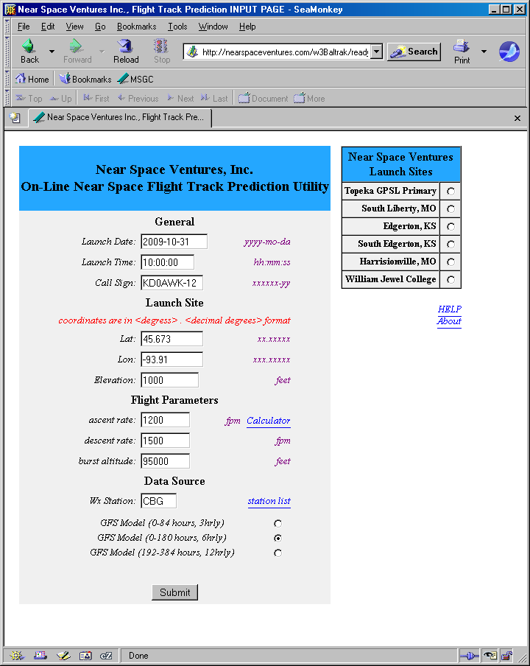
On the next page pull down the time/date menu and select Oct. 31, 2009 at 18 UTC (Universal Time AKA Zulu Time). Notice that the program gets the time for the prediction from this screen, not from the time you entered in the first screen, so selecting the right time here is critical. Then type in the code it shows and select Get Profile.

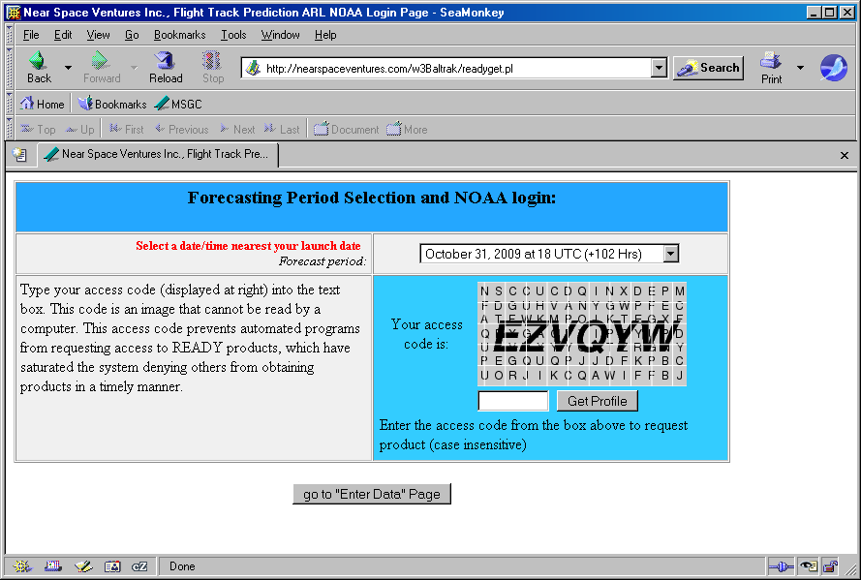

On the next screen, select all the data from the left window and copy it into the right window. Then press Submit.

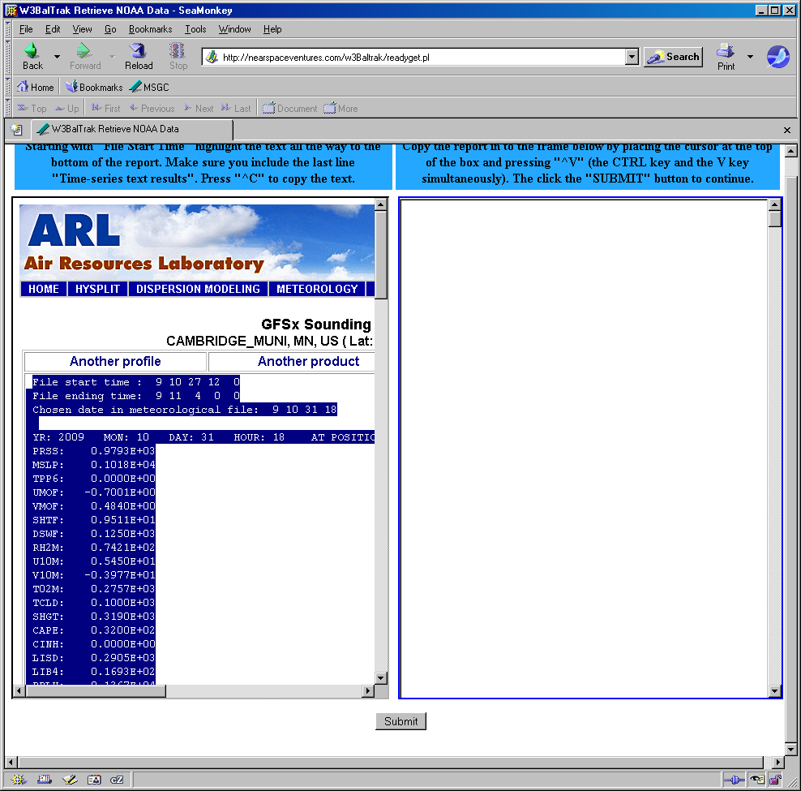

For output format, choose Plot Track on Google Maps.

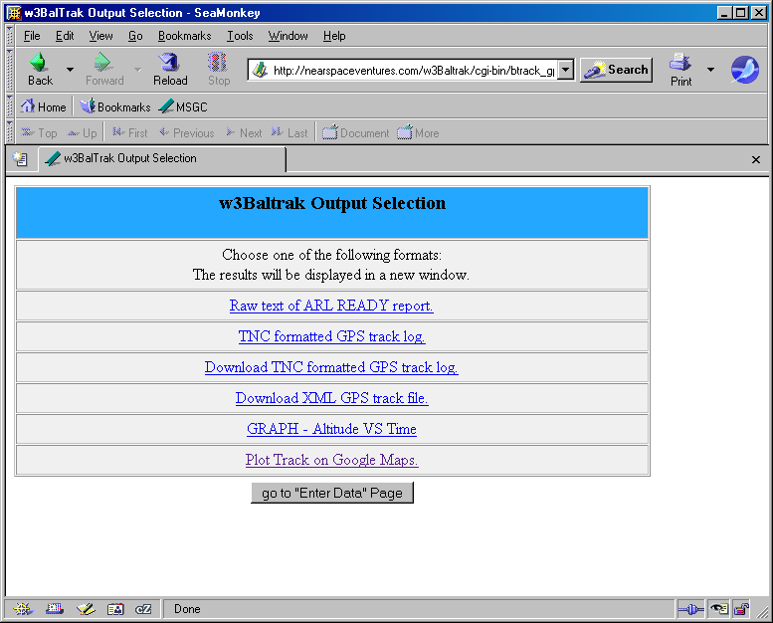

Now you can see the predicted track, from launch through 10,000 ft, 30,000 ft, 60,000 ft, 90,000 ft, burst “B”, and touchdown “T”. You can zoom in and out and also select maps or else satellite photographs of the areas. The rings around the touchdown indicate 5 mile and 10 mile radius circles. Depending on exactly when you do this activity, the predictions may have been updated so the map might not appear like the one below. If you don’t get zoom bars or the menu across the top, try reloading the page.

Here is a “Map”.

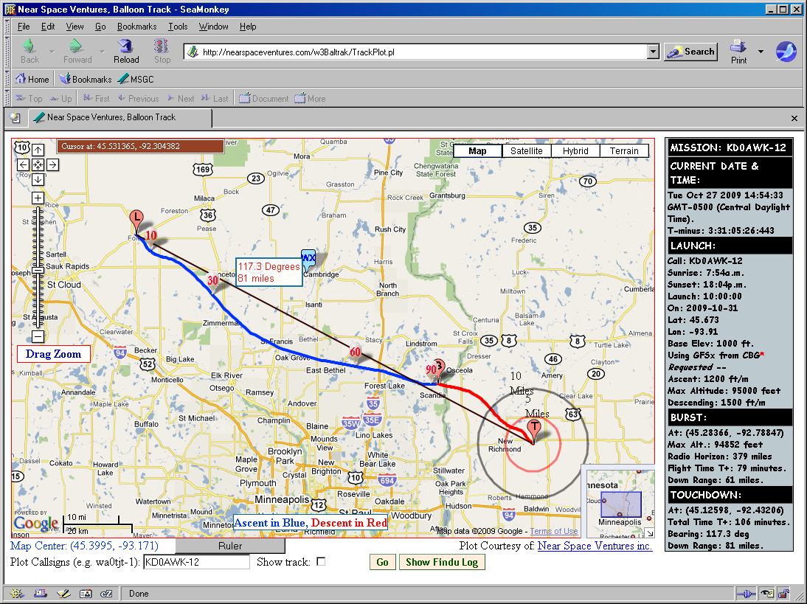

Here is a “Hybrid” (map and satellite image superimposed) – shows landing terrain better.

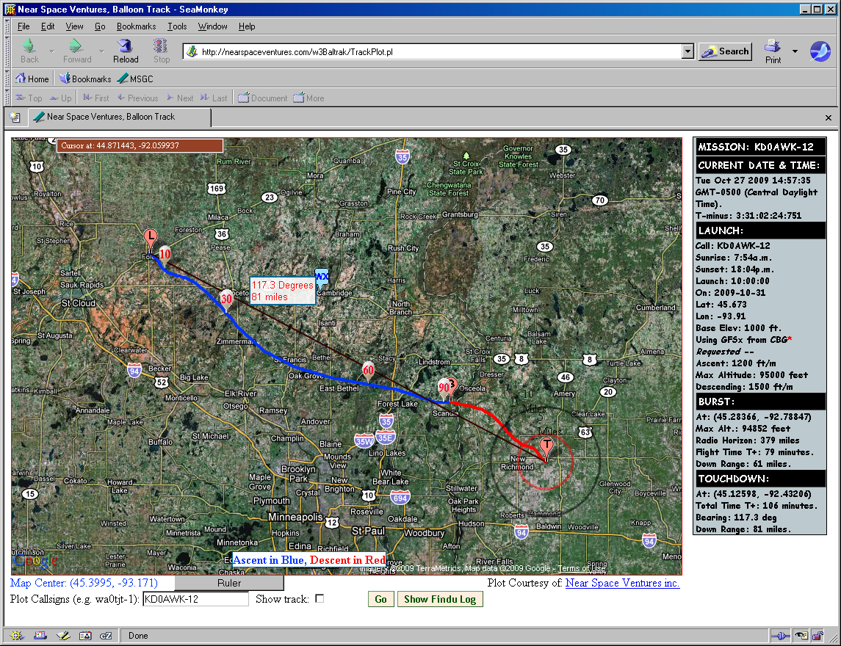

It is usually worth playing with the input parameters of the first page, just to see how the landing location changes if the ascent rate is off or if the burst altitude is off.

- Notice where the balloon lands with the original input parameters (1200 ft/min ascent rate) (burst at 95,000 ft). Print out that map.
- Redo the prediction to document the effect of ascending as slow as 1000 ft/min and as fast as 1400 ft/min, keeping the burst altitude at 95,000 ft.
- Redo the prediction to document the effect of bursting as low as 85,000 ft and as high as 105,000 ft, using the original 1200 ft/min ascent rate.
- On the printed map, mark a “landing ellipse” inside of which you believe the balloon will land, even if the ascent rate is off by up to 200 ft/min and/or the burst altitude is off by as much as 10,000 ft.
- Switch the view to Hybrid or Satellite to see what sort of terrain exists in the landing zone (you may want to zoom in). Dark means water, deep green means trees, light green or brown means farm fields. Do you recommend moving the launch location to improve the landing zone and, if so, in which direction and by how far? Defend your proposal by explaining where it is likely to land instead.

