High Altitude Ballooning - Building a Basic Payload Box (v3, Oct. 27, 2010)
Lead author: Peter Grimm, South View Middle School, Edina

This activity gives students the opportunity to construct a payload box that will take several experiments into near space (approximately 80,000 to 90,000 feet), and back to earth. While the steps to build a payload box (hereafter referred to as a "box" only) are relatively straightforward, there are several educational opportunities in the process of designing the box, as well as many Minnesota Science Standards that can be addressed during this process.

BOX MATERIALS:

The first step is selecting the materials for building the box. Instructors can have students investigate what materials make the most effective box - "effective" in terms of how well the box protects the internal components (cameras, HOBO computer, etc.) from the temperature extremes of near space flight. Materials that are typically used to build the boxes include either a) 1" thick pink Styrofoam insulation, or b) a combination of 1/4 inch "foam core" posterboard and 1/2" black foam insulation. The following standards can be addressed as students investigate this aspect of box construction:

1. The Nature of Science and Engineering | 2. The Practice of Engineering | 2. Engineering design is the process of devising products, processes and systems that address a need, capitalize on an opportunity, or solve a specific problem. | 6.1.2.2.1 | Apply and document an engineering design process that includes identifying criteria and constraints, making representations, testing and evaluation, and refining the design as needed to construct a product or system to solve a problem. For example: Investigate how energy changes from one form to another by designing and constructing a simple roller coaster for a marble.

For 6.1.2.2.1, teachers can have students experiment around box design. Students could create a small box made from either the 1 inch "pink" foam or the combination of poster board and black foam. For the poster board/black foam combo, students can experiment with either having the black foam on the outside/poster board inside, or black foam inside/poster board outside. Temperature change could be measured when the box is moved from room temperature to inside a freezer, or a container with dry ice, or from room temperature to an "incubator" box with high wattage light bulbs. This sort of experiment could also be used to meet the following standard:

2. Physical Science | 3. Energy | 2. Energy can be transformed within a system or transferred to other systems or the environment. | 6.2.3.2.3 | Describe how heat energy is transferred in conduction, convection and radiation.

After the class has settled on the materials to be used on the box, it is time to begin construction on the actual payload box. The first step is to cut the materials for the sides of the box (using a hot wire cutter if using Styrofoam or a utility knife if using posterboard), and for the top and bottom of the box. The finished box needs to have 6"x6" interior dimensions for each side panel, as well as 6"x6" dimensions for the interior of the top and bottom panels. Depending on the material chosen, see the following diagrams for cutting out panels:

"PINK" 1" THICK STYROFOAM BOX WALLS

4 box sides should be cut one of the following ways:
Option 1:
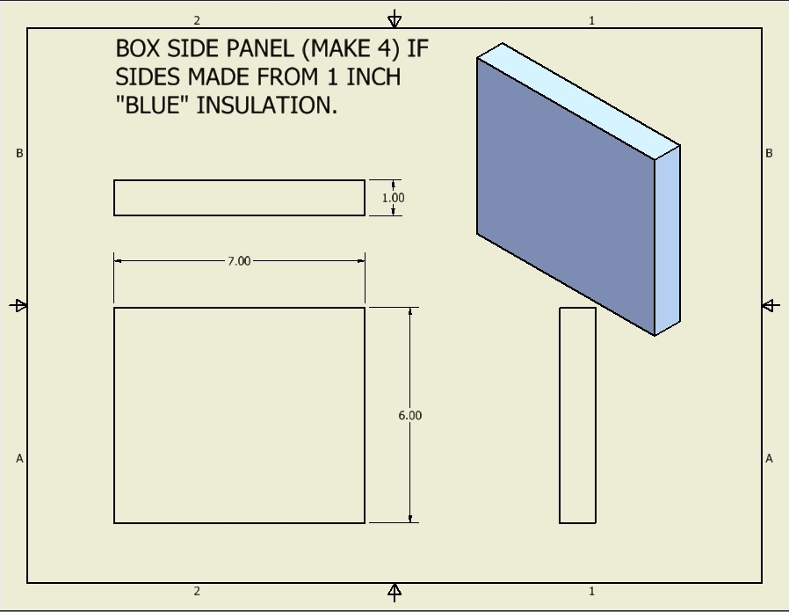

Option 2:
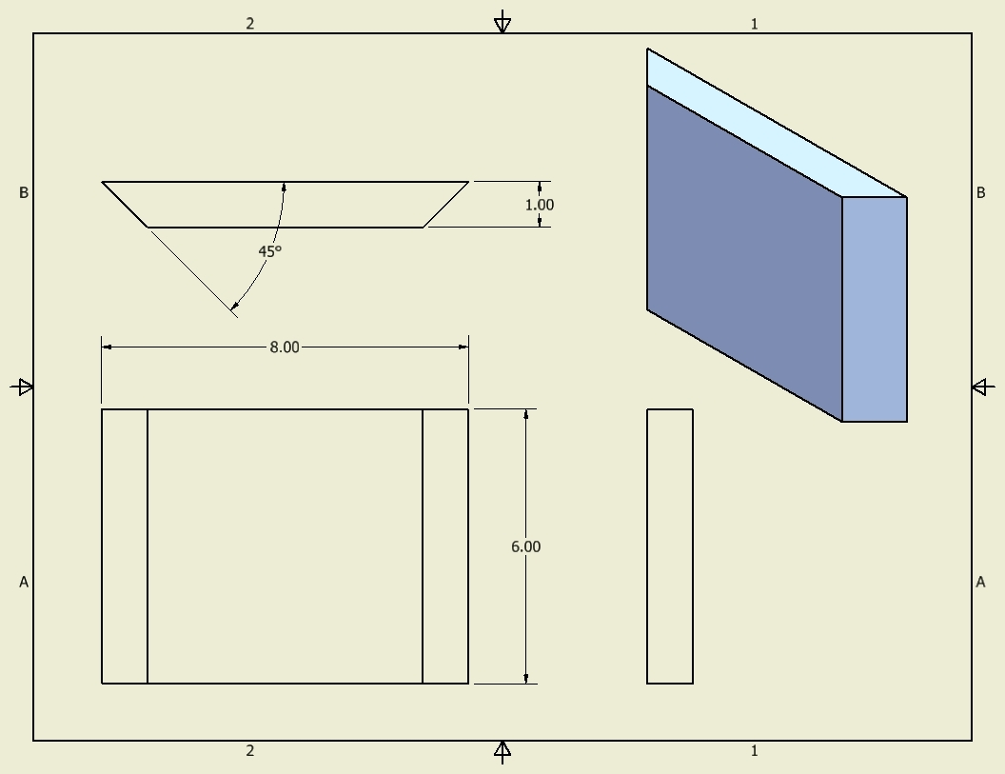

You will then need to cut two plate that measures 8" x 8" for the top and bottom of the box. Upon completion (DON'T ASSEMBLE YET!), your finished box will go together like this:
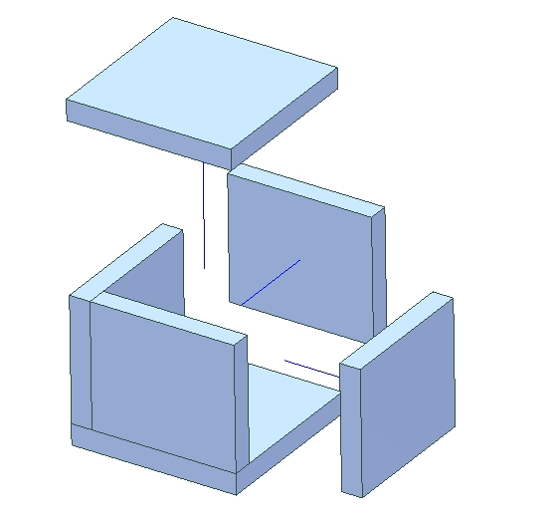
Straight side box - note how 1 edge of each side panel matches up with the corresponding edge of the base plate, and that the other edge overlaps the adjacent side panel - therefore, there will be a 1" portion of each side panel where no equipment can be fastened. The top and bottom panels cover the box completely, leaving a 6"x6" interior surface on all sides to which equipment can be fastened.

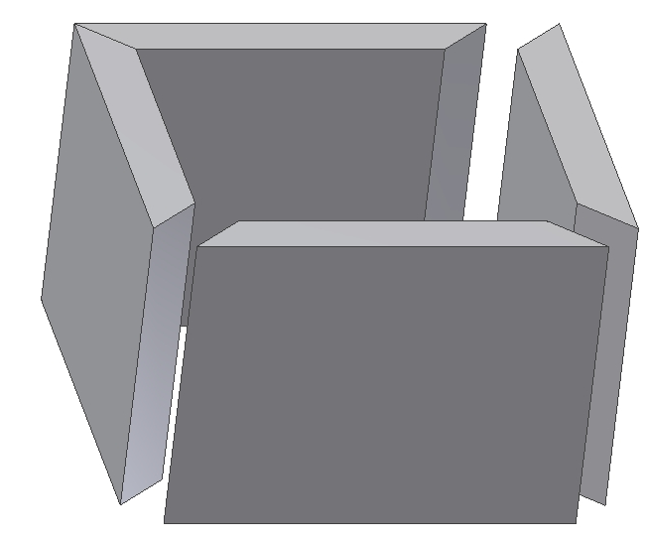
Should you choose to cut the edges of the side panels at a 45° angle, the panels will be assembled like the diagram on the left, with the top and bottom panels covering the side panels completely.

There is no right answer here - the straight sides are simpler to cut, and the tapered sides make it a bit more obvious where payload can be attached.

FOAM CORE/BLACK INSULATION BOX WALLS

If your box is to be constructed from a combination of "foam core" and black insulation, you will need to cut the foam core and black insulation at different sizes, depending on whether your students decide to put the black foam internal or external to the box. The foam core is about 1/4" thickness, and the foam about 1/2". Cut your foam so that interior sides are 6"x6" when complete.

COMPONENT LAYOUT - BOX PLANNING

The next step is to plan the layout of the components within box. You need to consider the following:

1. Plan your layout so that one of the box panels will serve as the "door" into the box. This will be the panel that is fastened last - right before flight - after turning on items like your camera, which cannot be started from the outside of the sealed box.

2. Make a plan for which components will be attached to which panels. You need to consider the following as you plan this:

- What direction will the camera face? (still or video cameras can face up, sideways, or down towards earth – it depends on what you want to watch) Make a hole in the appropriate panel for the camera, making sure it has a clear view (but also doesn’t let in too much cold air). If using a still camera notice that the lens when it is turned on.

- You need to be able to turn on your camera and other components while they are mounted in the box with all other components - make sure no other components or wires block your access to necessary power switches, buttons to start filming, etc.

- Plan for the "pull before flight" pin on computers and an external switch to turn on heaters. These will be holes that are punched through the sides of your box. You will also want to ensure that you can see any LED lights that indicate function (Flip camera "on" light, HOBO computer LED indicating various functions, etc.).

CREATE A MOCK UP OF YOUR BOX

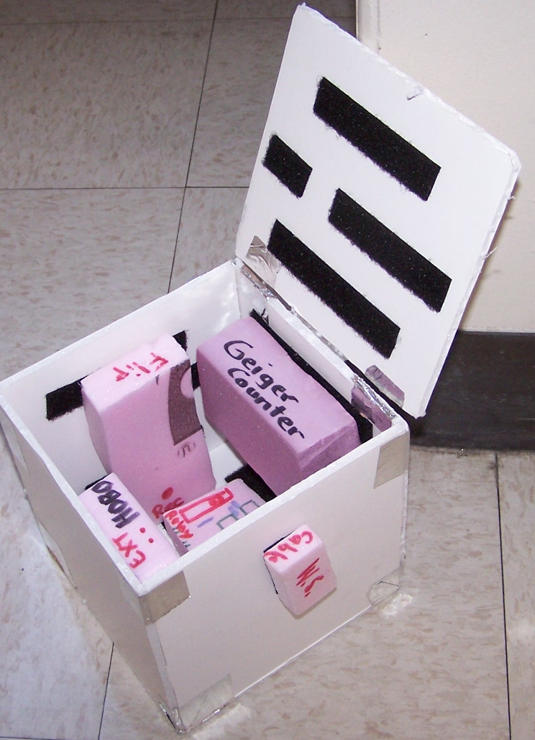
One option you might consider is making a cheap mock up of your design by cutting out Styrofoam representations of your components (try to match the size of the actual components as closely as possible) with a hot wire cutter, cutting box sides out of foam core, and practicing the layout of your box with these components first. This will reduce the chance of damaging components while experimenting with your layout, and is potentially a real time saver, as you can change the layout of components much faster in this way. This may also allow more students to get involved in 3-D payload layout design, since you can build many mock-ups but may only have one set of actual flight hardware.

THE "FLAT-SAT" STAGE

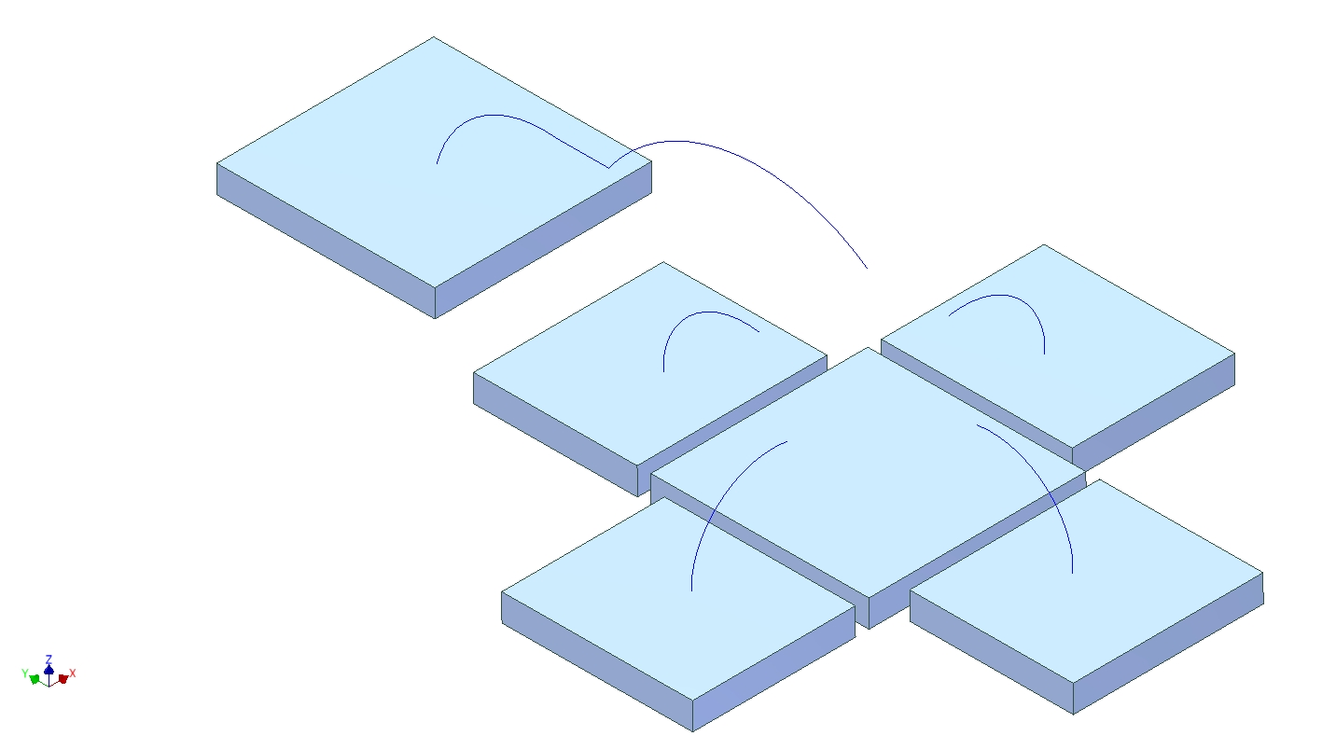
You will want to figure out the layout for all of your components before cutting any holes in your box for the cameral lens, LEDs, and other wires. A good way to test your layout is using a "flat-sat" model. This is where you lay out all of the sides and base like this:

Placing all of your sides in this manner, you can experiment with the
layout of components by tacking them to the sides with velcro. By lightly taping the outer bottom edge of each box side to the base, you can gently rotate the sides into place, to examine the fit of components to each other. As you discover interference, you can lay the sides back down, and rearrange components to ensure proper placement and fit. Modifying the location of components is much easier when constructing your box in this manner, verses assembling the box completely, and trying to lay out components inside the cramped space of the finished box. Going through a flat-sat stage may also allow more students to be involved, since different people might work on different sides at the same time but once you have an actual box only one person can reach into it at once.
Once you are sure of the organization and layout of the box, you can also poke holes in appropriate locations so that you can secure the components with zip ties. The velcro tacking holds the components in place for the purpose of getting things laid out correctly, but zip ties are necessary to secure components for the rather bumpy ride ahead.

THE CAMERA HOLE

When you know for sure where the camera will be located, you need to cut a hole for the lens. The hole should taper out from the lens, so as not to block the "view" of the camera. After cutting the hole, you should tack the camera to the side and test to ensure that the camera has an unobstructed view of the outside world. Be careful not to cut the hole too large, as you want to maintain as tight of a seal as possible around the camera to minimize the amount of VERY COLD air that can enter the box and cause malfunction of the camera and other components.

FINAL ASSEMBLY

At this point you should be clear on where all of the components will be mounted in your box, and in fact you should have velcro on the box walls and components. You'll now want to assemble the box together, using strapping tape to secure all box panels together. DON'T FORGET TO LEAVE A "DOOR PANEL" taped on only one edge (either the top or one of the sides of the box) so that you can turn all components on and ensure that everything is functioning before finally sealing the box up for flight. After assembling the box, you will need to tape rigging tubes vertically (according to how the box should be oriented in flight) on the 4 corners of the box. Ensure that the rigging tubes do not interfere with the door.

Once the box is assembled, and components are in place with velcro.

<more to be added here>

Here are some examples of finished box interiors. Note that these examples also show finished assemblies of the various box construction methods.
