Setting up a “Control Center” to monitor a near-space flight and making plots in real time.

To monitor a near-space flight via the internet, log on to the following web sites. (Check these out in advance to make sure your school doesn’t restrict your access.)

Live tracking (shows progress of balloon on a map in real time – need to know call sign): http://aprs.fi

Stratostar tracking and sensor data and/or video feed (up to 30 minute delay from real time, archived so you can also watch later):
http:///www.justin.tv/mn_space_grant

Video feed and/or Stratostar tracking and sensor data (up to 30 minute delay from real time, archived so you can also watch later):
http://www.justin.tv/mn_space_grant2

Note: Because of the delay it might be frustrating/confusing to monitor both the aprs site and the justin.tv channels at the same time – perhaps select just one. If you aren’t able to monitor the flight while it is actually in progress, or hope to monitor it with several different groups of students at different times, use the archives on the justin.tv channels rather than that aprs data.

To make this activity more engaging, we recommend that you have students generate graphs of some of the data (manually) as it arrives. With the aprs data all you have available is altitude versus time. If you watch the Stratostar data feed closely you can pick out individual sensor values which can also be graphed versus time, though that data will require calibration interpretation. Side note: aprs altitude data is transmitted in feet whereas Stratostar altitude comes down in meters.

Here is how you might proceed to monitor altitude versus time from the aprs.fi web site.
- In advance, generate a table with realistic altitude (in feet) and time-in-flight t (every 5 minutes). Make sure the altitude goes up to 100,000 ft and the time goes to 140 minutes. Leave the clock time T column blank for now.

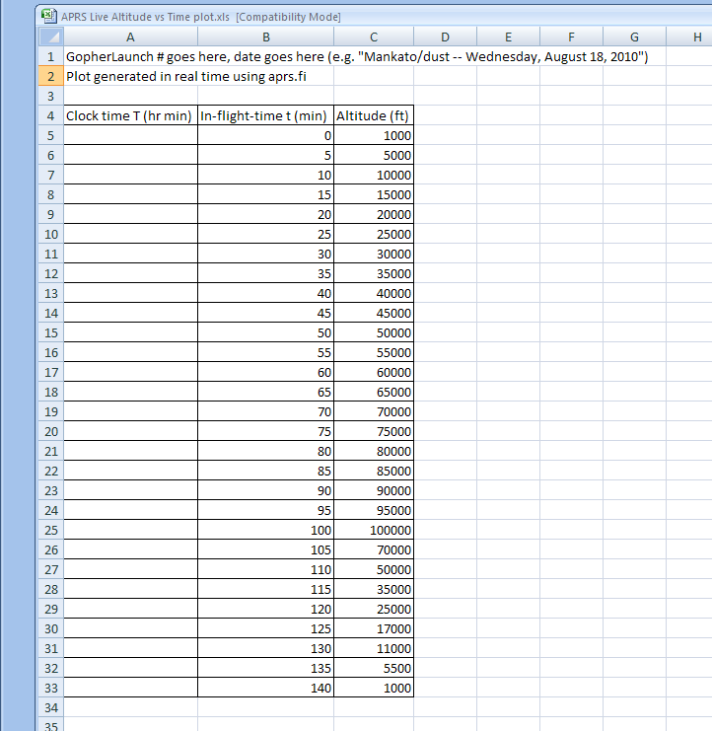
- Graph the fake data (altitude vertically, time horizontally) then format the vertical axis to have a fixed maximum and minimum (0 to 100,000 feet) and format the horizontal axis to have a fixed maximum and minimum (0 to 140 minutes).

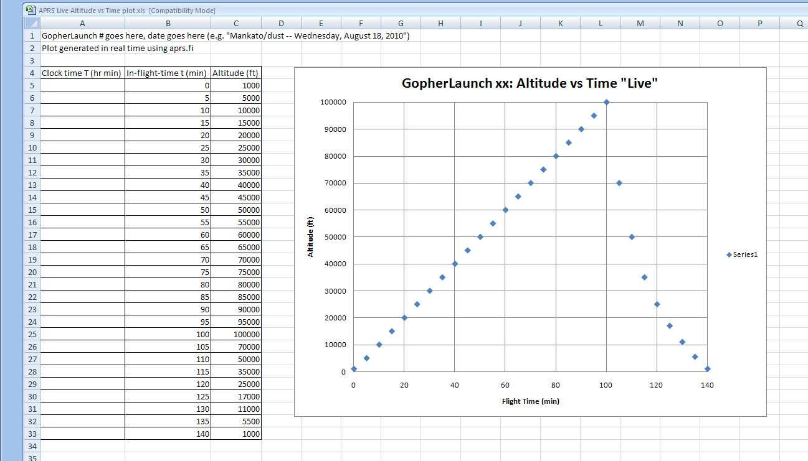

- Leave the time values in place (0, 5, 10, etc.) but replace the fake altitude values with zeroes. Now the graph will appear flat but it is ready for entry of actual altitude data (every 5 minutes).
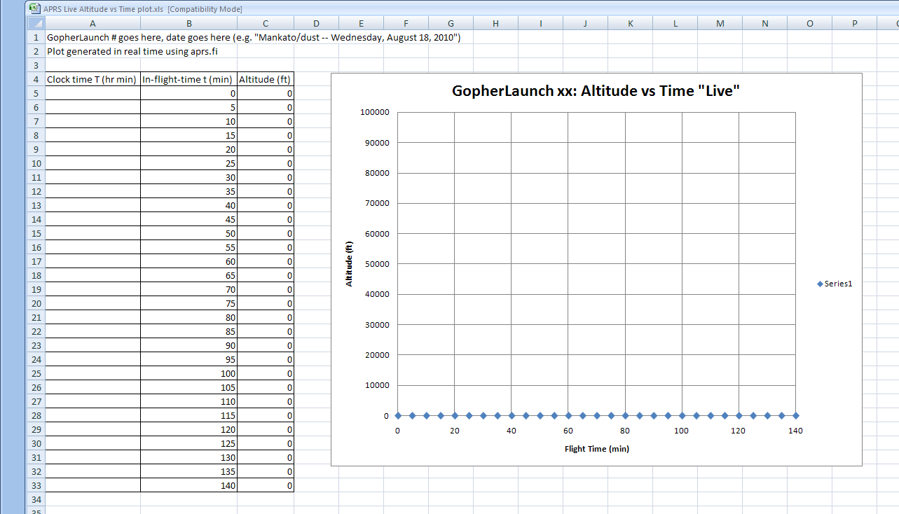

- When the flight takes place, find out (by calling the launch team) their initial altitude and the exact time they release the balloon. Put the launch altitude in the first altitude box and the launch time (hour min format e.g. 10:07) in the first T box. (Notice that point now properly graphed – a low but non-zero altitude, measured above sea level; much of Minnesota is at about 1000 feet above sea level.) Then go down and fill in the rest of the T-boxes, adding 5 minutes to each one (e.g. 10:12, 10:17, 10:22, etc.).
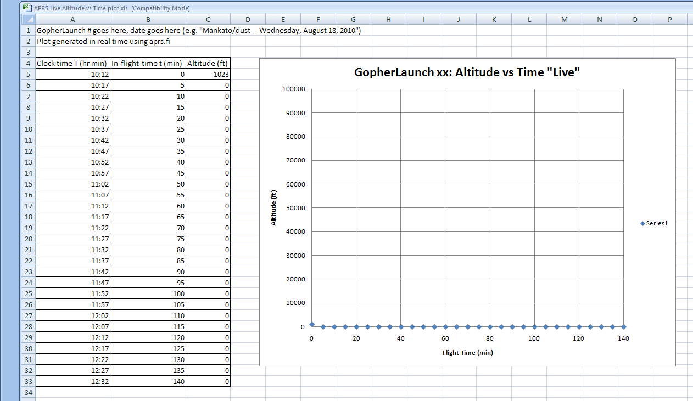

- Once in flight you’ll see altitude data updates on the map on aprs.fi every 30 or 60 seconds. Every time T passes a new 5-minute mark, enter the altitude in the right box and watch the graph grow in real time. If you get behind, or if there is any data missing, follow the “Raw Packets” link on aprs.fi to see an archived data table. Altitude will be the “A =” data but times may be given in GMT (AKA Universal Time) rather than CST. If cannot get data on a 5-minute mark you can enter data from a different time – just adjust the times t and T which goes along with it. For example, in the data shown below (real data from a real flight up through 105 minutes) adjustments needed to be made at times t = 31, 47, 51, 91, and 97 minutes.
