Testing Near-Space Payloads

Lead author: Caitlin Mantych
Last modified: May 6, 2011

Before you fly your payloads into Near Space, you should test the container and its instruments in simulated conditions that are like those in Near-Space. So what are Near-Space conditions?

- Very Low Pressure Environment: at 80,000-120,000 ft, where your payload will be carried to, there is very little atmosphere and the atmospheric pressure drops from about 15 psi, at ground level, to near zero. (Zero pressure would indicate full vacuum – AKA outer space.)

- Frigid Temperatures: your payload will experience temperatures as low as -60 to -80 degrees Celsius, especially around 40,000 to 60,000 ft on the way both up and down. Temperatures at the peak of the flight, in the ozone layer of the Stratosphere, aren’t quite as cold.

- Increased Cosmic Radiation: the atmosphere protects us from most cosmic radiation from outer space, but as your payload ascends the amount of radiation it experiences will increase dramatically and can be harmful to some parts of your payload.

- Increased Electromagnetic (Solar/Light) Radiation: the atmosphere is transparent to visible and radio light, but stops most ultraviolet, infrared, and other types of light from the Sun. The payload will be exposed to “full sunlight” in the upper parts of the atmosphere which and can be harmful to some things.

Also note that your payload will be subjected to very strong forces throughout its flight. On the way up and down, it may pass through the “jet stream” where horizontal winds can reach speeds over 100 miles per hour. Even worse, just after the balloon bursts your payload will tumble violently for thousands of feet until the air becomes dense enough for the parachute to slow and stabilize its decent. In addition, the payload may have a hard landing likely in a field, tree, or body of water. Extraction of payloads from trees in particular can also be tough on them, especially on the rigging. You must design and test your payload to withstand all of the conditions it will experience.

Here are some tests you might want to consider (though if you built a payload following recommended designs you might be bold enough to skip these tests and depend on past results as a measure of your success). Testing, especially thermal and structural, can really help you to improve your chances of a successful balloon flight. Happy testing!

Thermal Testing (AKA “Cold Soak”) (Recommended)

The purpose of this test is to simulate the low temperatures of Near-Space. You will need access to a low temperature environment, the colder the better! Outdoors in winter can work, as can a deep freeze, but a refrigerator or an ice-cooled cooler isn’t cold enough to really stress your payload. In general you want your payload to experience as low a temperature as possible for 30 to 60 minutes with electronic components running, heater running, and a HOBO to monitor both the external and the internal temperature.

The U of M ballooning team uses a dry-ice-cooled thermal testing chamber that can maintain about -20 degrees C. The container is a cube 2-ft on a side made of 2-inch thick Styrofoam and covered with Mylar. Inside, two large wire mesh pockets are attached to the walls to hold pieces of dry ice (cold source). In addition, there is a metal basket placed upside down on the bottom of the box, under which you can place dry ice and on top of which you can place your payload. Two small fans inside the box help circulate the cold air. You can use a HOBO attached to the chamber to monitor the temperature inside the chamber (outside the payload) is on during a test. Keep the chamber sealed and the fans running during the test. Opening the lid and/or adding a warm payload into the chamber can bump the temperature up a lot, at least for 10 minutes or so.

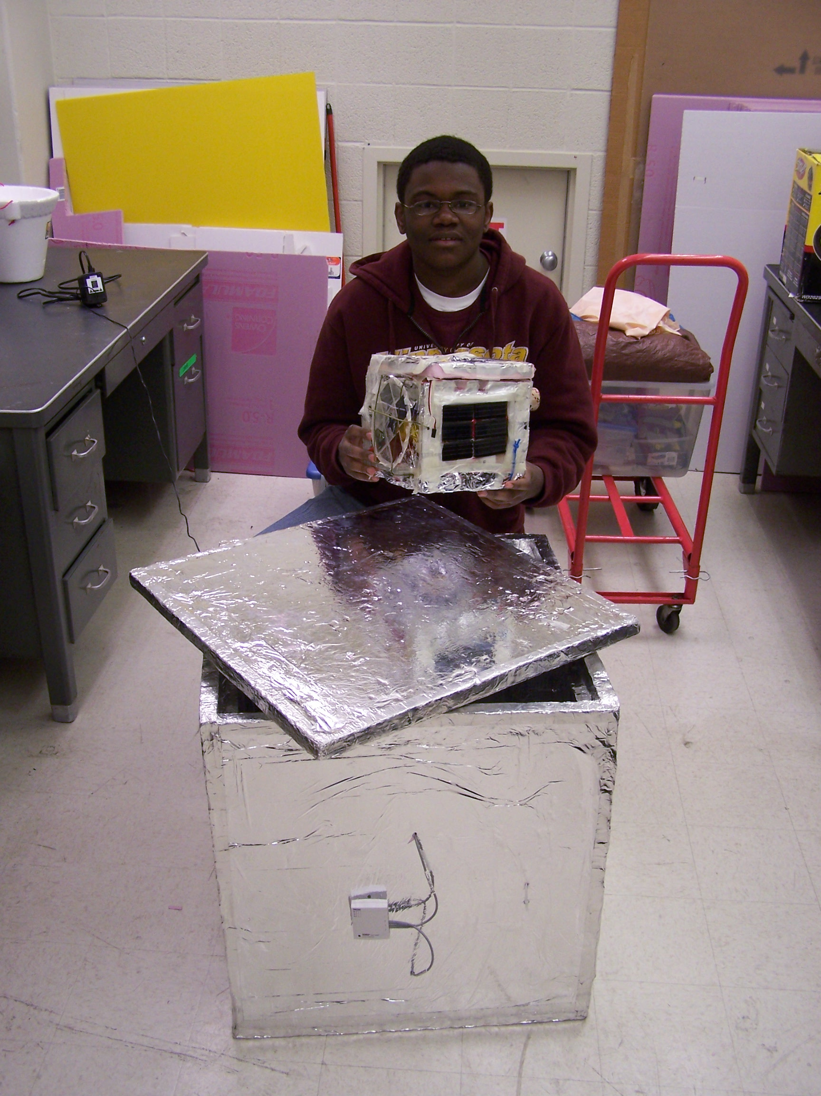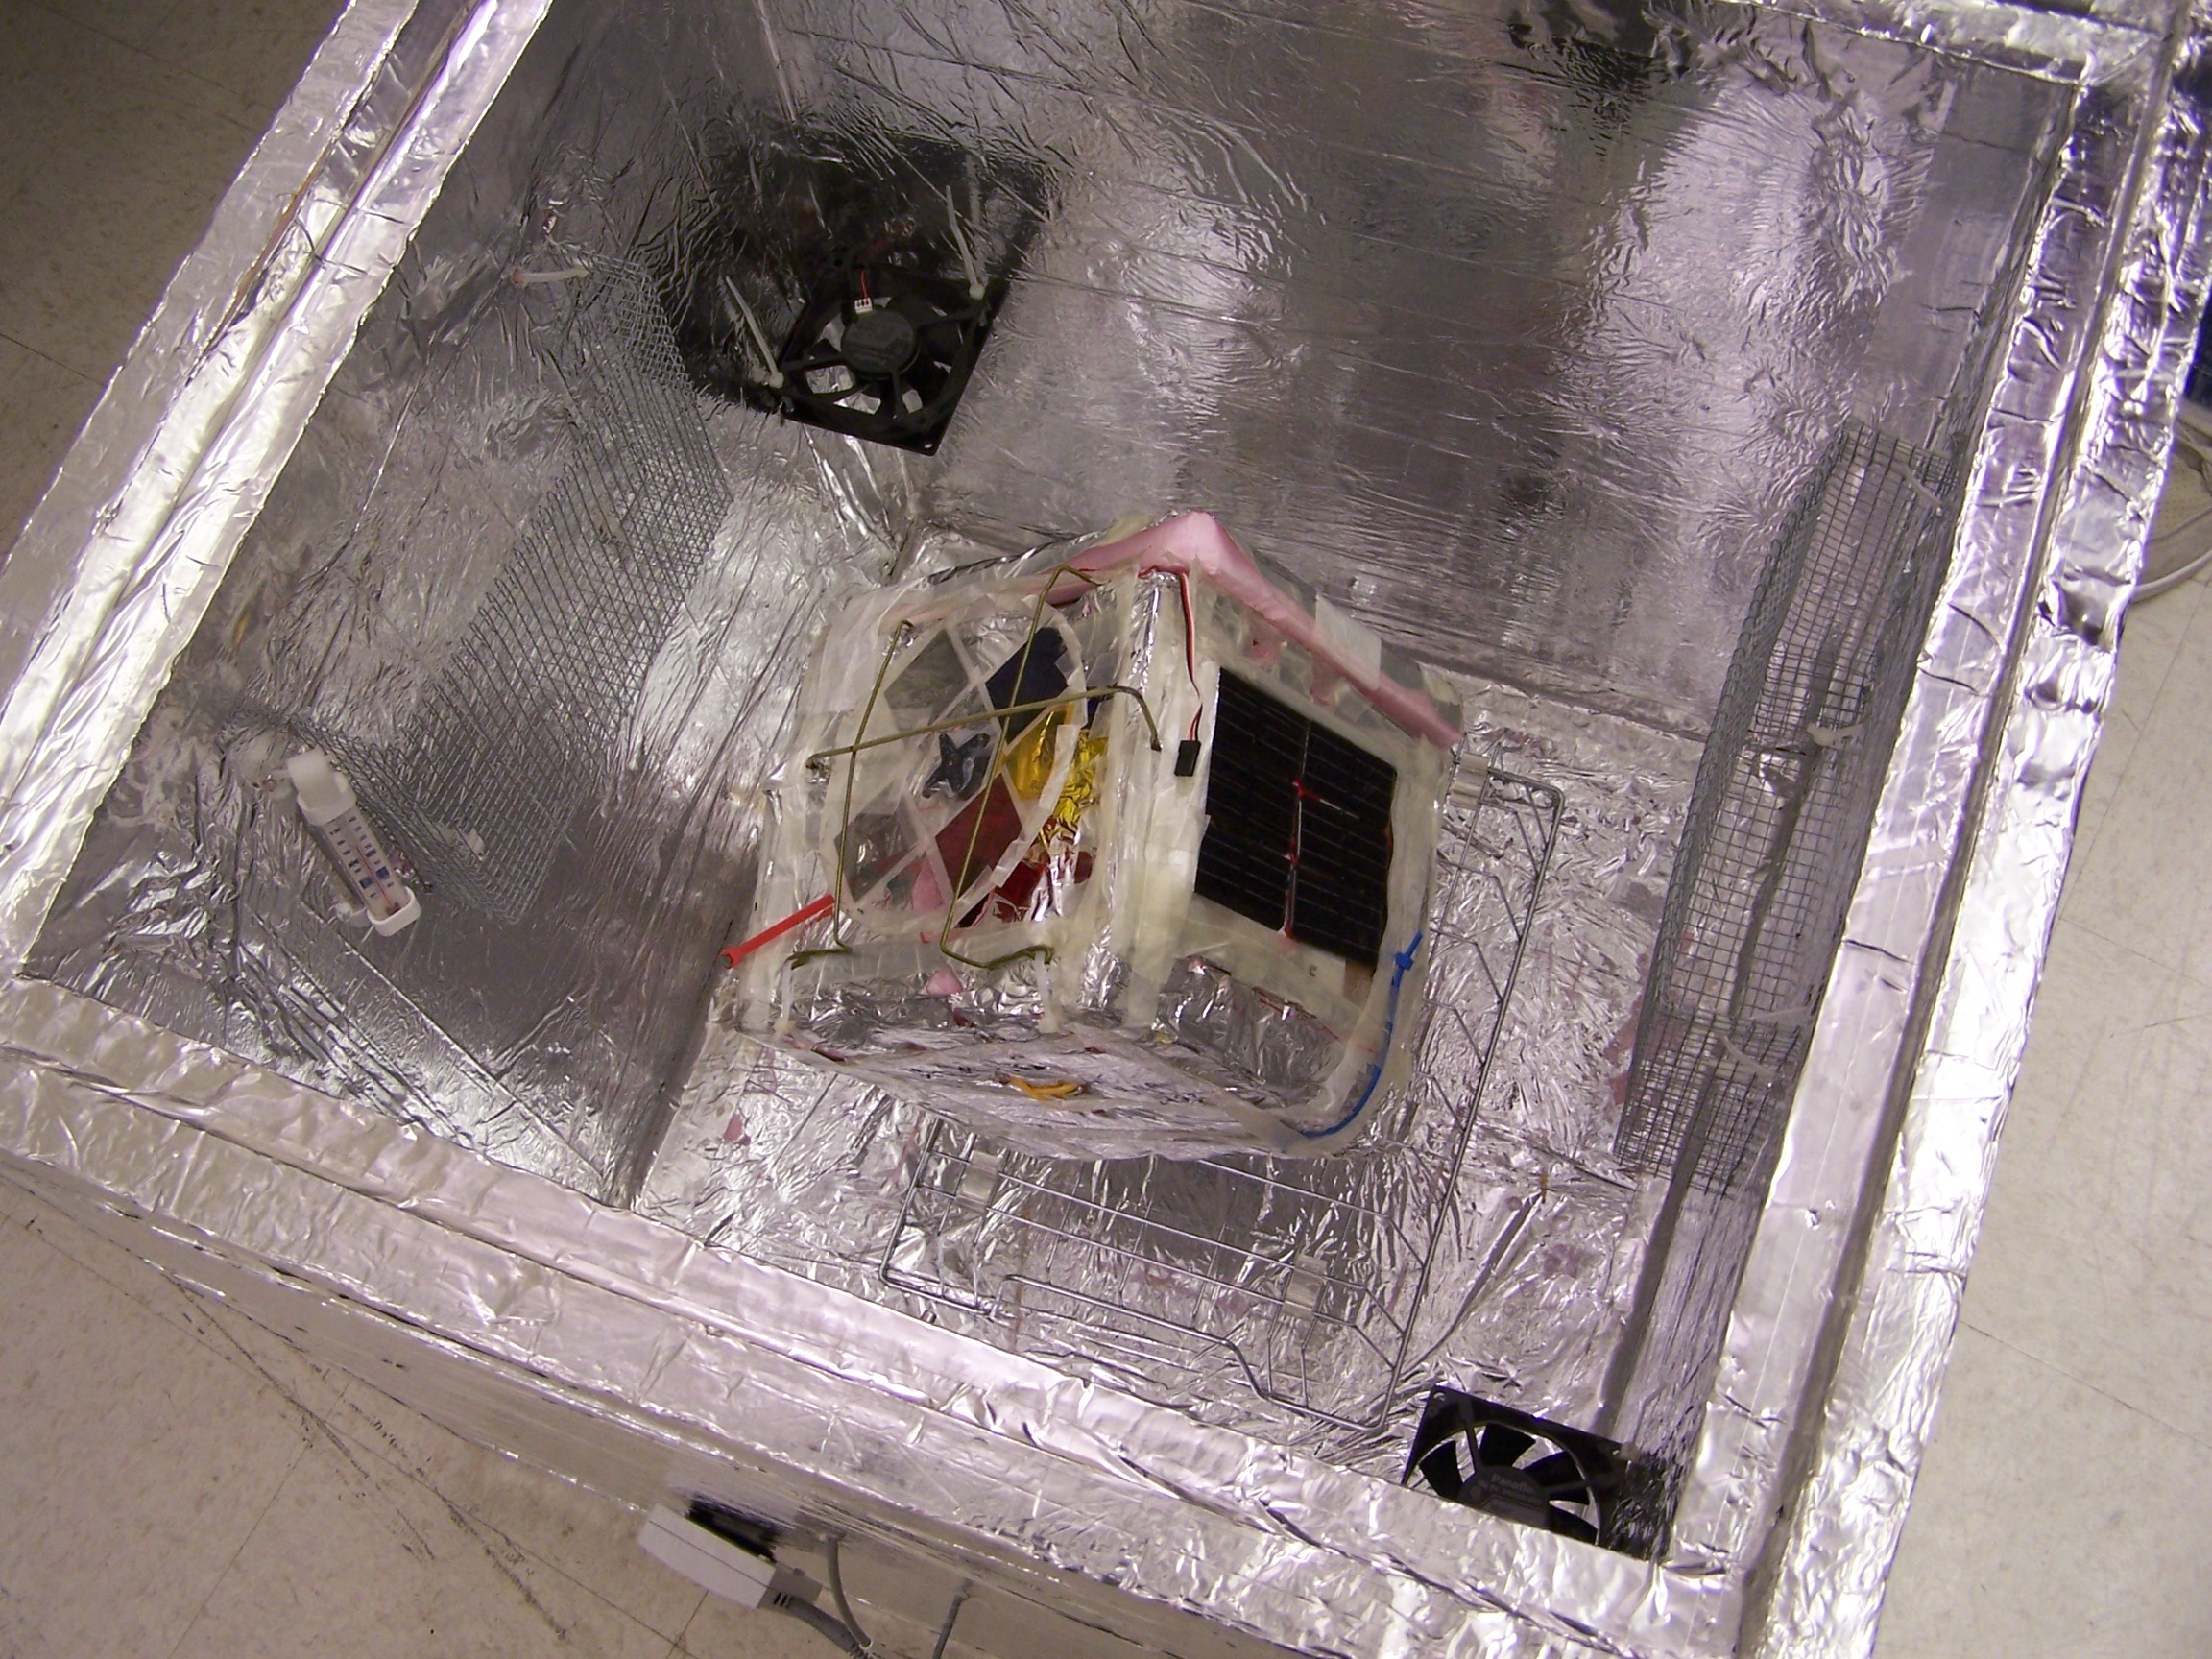
Thermal test chamber Payload in thermal test chamber (not cooled).

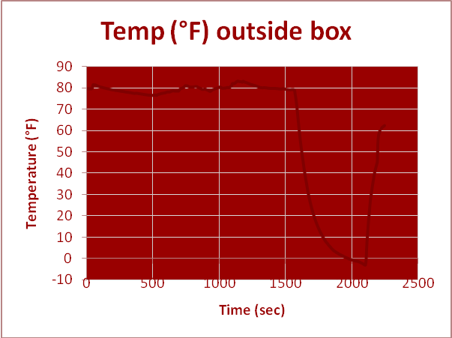
Data from a cold soak – only lasted about 10 min.

Whether you build a test chamber, borrow ours, or use a deep freeze, it is important to make sure that all components of your payload continue to function even when the exterior temperature gets very low. Pay particular attention to things that do not “like” operating in the cold: batteries, electronics, sensors, moving parts, and sensitive or fragile components. For biological experiments, make sure that organisms will not die from the cold soak (unless that is part of your study).

Cosmic Radiation Exposure Testing (Optional)

The increased exposure to cosmic radiation in Near-Space can affect some materials, sensitive electronics/sensors, and any live organisms that you send up. We list radiation exposure testing as optional because it is difficult and somewhat dangerous to try to reproduce the radiation environment in the upper atmosphere, and experience suggests that excess exposure for just a couple of hours (the duration of a typical balloon flight) isn’t problematic for the materials and electronics we use (and generally less unhealthy for living organisms than low temperatures and low pressures).

However if you have access to radioactive sources, know how to handle them safely, and really want to expose your components to increased radiation levels, proceed with caution. In general, educate yourself about the type and strength of your radioactive source(s) and take appropriate precautions when handling sources to avoid unsafe exposure to yourself. Never allow young children to handle radioactive sources. Radiation exposure is known to cause cancer, though our bodies are fairly good at dealing with low levels of radiation in our natural environment. Store your radioactive source(s) in a safe and well-marked container away from children when not in use.

There are a variety of radioactive sources you can find in familiar products, including a small americium source found in smoke detectors, thorium in some camping lantern mantles, and/or radioactive uranium oxide in the red-orange glaze that used to be used on Fiesta dinnerware. Have a Geiger counter handy to measure the radiation produced by the source you have. Understand what kind of radiation your source is producing: alpha particles can only go about 2-3 inches in air and cannot penetrate even thin things like paper or tin foil, so if using an alpha source you must put the source very close to the component being tested. Balloon flights usually last about 2 ½ hours, so that is the longest time we would recommend for exposure when doing radiation testing.

UV (ultraviolet) Light “Solar Radiation” Testing (Optional)

Another type of “radiation”, not to be confused with “cosmic radiation” or emissions from radioactive sources, is “electromagnetic radiation” (also known as light). Light comes in many forms, distinguished by wavelength (or frequency), with long wavelength (low frequency) light being called “radio waves” and short wavelength (high frequency) light being called “x-rays”. “Visible light” which we can perceive with our eyes lies between those two extremes.

The Sun emits light of a wide variety of wavelengths, but only visible light and radio light passes through the atmosphere and reaches the ground. (Aside – the reason some layers of the atmosphere, like the ozone layer, are warm is because they absorb the energy of some wavelengths of sunlight rather than letting them pass through.) As your payload ascends into the upper atmosphere it will get above the protection of the air and hence get exposed to more and more electromagnetic radiation. Ultraviolet (UV) light in particular can damage certain materials. For example, the latex of weather balloons will degrade when it is exposed to UV radiation. Hence old balloons and/or ones exposed to UV rays for extended periods of time may probably burst prematurely from the UV damage. Our (fresh) balloons should ascend to their peak and pop due to overstretching before they suffer significant degradation from UV light.

UV radiation testing, which we have not done historically, requires purchasing a UV light source and shining it on payload components. Some florescent light bulbs (“black light” bulbs) are billed as having high UV content. One can purchase UV-sensitive beads that change color under UV light to verify that you have indeed produced a high UV environment. Beware of getting too much UV exposure to your skin (it causes sunburn) or to your eyes.

Structural Testing (Highly Recommended)

During a balloon flight payloads are subjected to some very violent shaking, especially during post-burst “chaos” and also when they strike the ground. The purpose of structural testing is to make sure nothing breaks or comes loose within the payload during these parts of the flight.

This test is a simple yet vital. (Your students will love it!) First, give the payload a good shake after you’ve secured everything down. Does everything remain in place? Working properly? No battery disconnections or toggled switches/buttons? Next, close the box and grab the strings (rigging) that you attached to the payload box. Swing the box around, give the strings a sharp yank (we call this a “yank test”) and make sure that nothing disconnects. (Don’t slam the box against anything, please.)

Finally, do an “impact test”. Take the sealed box and roll it down one flight of stairs. If it survives, and is still properly functioning, your payload has a good chance of surviving the flight and landing forces.

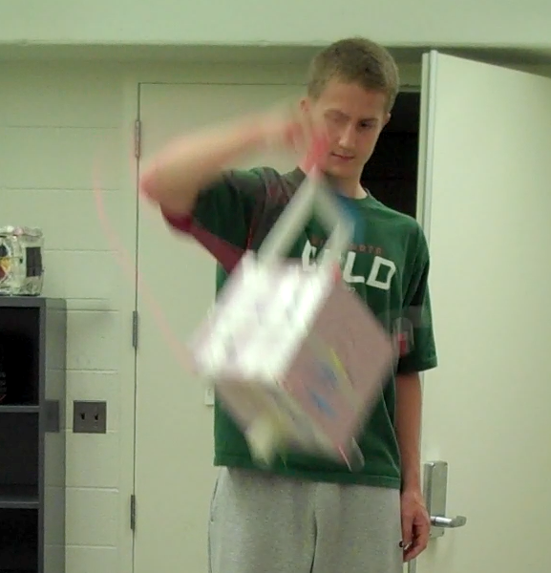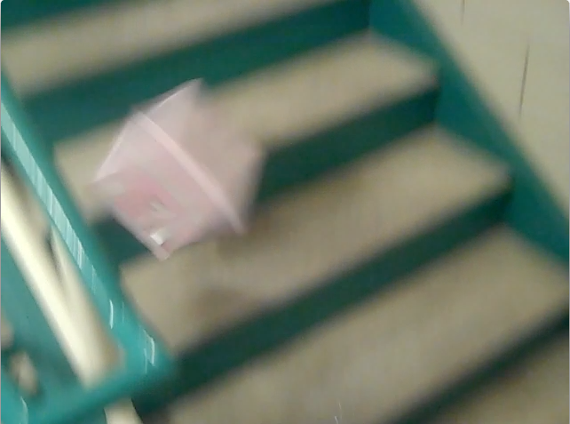
“Yank test” “Impact test”

Near-Vacuum (Low-Pressure) Test (Optional)

The components we recommend for ballooning flights all operate fine in near-vacuum conditions, so you don’t really have to do a low-pressure test unless you are trying something new that you have reason to believe will give trouble. Some objects you might consider flying, especially additional balloons or sealed bags (of potato chips), are expected to expand then ultimately burst during a flight, so you don’t want to destroy them in a low-pressure test in advance.

If you want to do a low-pressure test, we recommend finding a facility that already has a vacuum chamber, since they are an expensive and can by bulky. A full-size payload may not fit into a vacuum chamber, so you may need to test components individually. Whenever possible have the component actually running during the test – the purpose is to ensure that it both survives and operates under near-vacuum conditions. Pay special attention to sealed containers, fluids that might boil under low-pressure, and other pressure-sensitive components/sensors. Be careful not to let anything fail catastrophically inside a vacuum system – that could damage the vacuum pump itself.

Note: We recently purchased a vacuum system for our ballooning program but haven’t assembled it ye t (as of May 2011), so we are unable to assist with low-pressure testing at this time. Maybe next year…

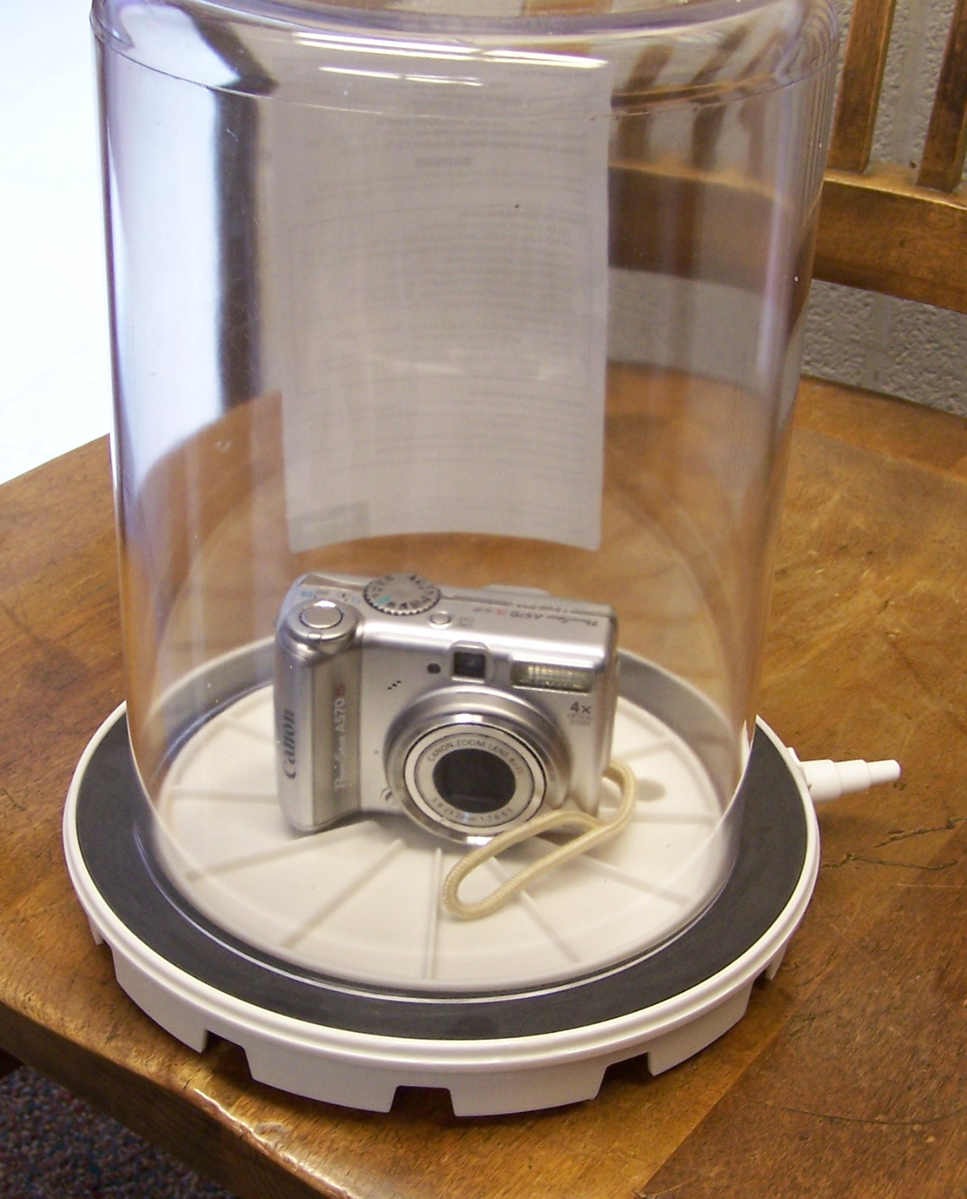
Camera in a vacuum bell jar (not evacuated).

