University of Minnesota and MN Space Grant Consortium

AEM 1905 Freshman Seminar: Fall 2009
Spaceflight with Ballooning
Team Project Documentation

The Roaches
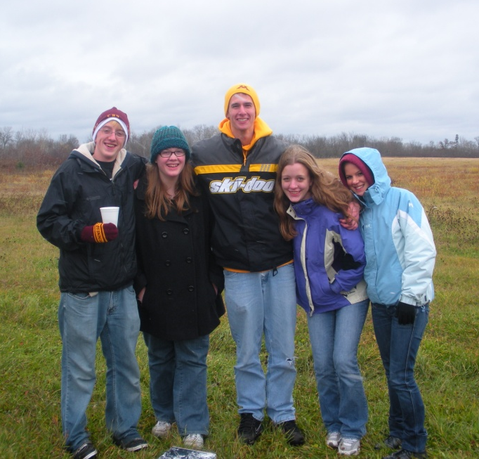

Written by:
Kelsea Schaefer, Patrick Price, Granger Marsden, Kelley Fike, Tamara Grosskopf

Report Date: 11/6/09
Revision B
Table of Contents

- Team Assignments…………………………………………………….…………….3
- Introduction………………………………………………………………….………4
- Mission Overview………………………………………………………….………..4
- Payload Design………………………………………………………………………5
- Project Management…………………………………………………………………10
- Project Budgets………………………………………………………………………12
- Payload Photographs………...………………..……………………………………..13
7.0 Test Plan and Results………………………………………………………………...15
8.0 Expected Science Results…………………………………………………………….17
9.0 Launch and Recovery………………………………………………………………...20
10.0 Results and Analysis………………………………………………………………….25
11.0 Conclusions and Lessons Learned…………………………………………………....31
12.0 Appendix……………………………………………………………………………..31

0.0 Team Project Documentation Writing Assignments

Introduction Patrick
Mission Overview Kelsea
Payload Design Granger
Project Management Kelsea
Project Budgets Tamara
Payload Photographs Tamara
Test Plan and Results Granger
Expected Science Results Patrick
Launch and Recovery Kelley
Results and Analysis All
Conclusions and Lessons Learned Kelley

Oral Presentation Assignments

Conceptual Design Review (CDR) Granger Tamara
Flight Readiness Review (FRR) Patrick Kelsea

Payload Build Assignments

Overall team lead and ground-testing lead Kelsea

Flight computer (BalloonSat Easy) build Patrick
Weather station build Kelley
Payload box build Granger
Photographer Tamara

Programmer (of flight computer(s)) Granger
Camera and camera experiment Tamara
HOBO (payload “health” (internal temp)) Kelley
“Other” science experiment Patrick

Launch Day Assignments

Photographer Tamara
Prediction/tracking assistant Kelley
Balloon filling and release assistant Patrick
Payload/stack handling specialist Granger
Recovery specialist (needs to go on chase for sure) Kelsea

1.0 Introduction

Exploring new frontiers has always been a priority of mankind. Space is the one of the few frontiers that has not been explored extensively by humans. The main reason for this is the price of space travel. Rocketry is extremely expensive. In addition, we can only gather so much information from the cheaper alternative of exploration and space research, astronomy. What if there was a cheap way to experience approximately the same conditions of space without spending millions of dollars to do so? Near spaceflight allows individuals to do exactly this. Near space has approximately the same conditions as outer space. However, unlike missions into outer space, there is no need to use rockets or space-rated materials to travel there.

Near space flight is relatively cheap when compared to rocketry, and can be done with materials that you can buy at most hardware stores. Instead of using rocket boosters, a weather balloon filled with helium is used. Such balloons cost hundreds, rather than hundreds of thousands, of dollars. Professional telemetry stations are replaced with amateur radio and Global Positioning Systems used to track the spacecraft throughout its flight.

The launch vehicle consists of a helium filled weather balloon. The balloon that will be used in this launch is a 1200 gram balloon that can lift our payload, which weighs about twelve pounds, up to 90,000 feet. The normal near space spacecraft consists of an outer shell, tracking equipment, and miscellaneous experiments.

The “poor man’s spaceflight,” as near spaceflight is sometimes referred to, is a great way for people who are interested in exploring space to have hands on experience in building an amateur spacecraft without having to raise the immense amount of money necessary for spaceflight into outer space.

2.0 Mission Overview

Generally stated, our team’s mission is to successfully launch a payload into near space and maintain both the structural integrity of the box and the various systems contained within it. The box our payload is contained in must be strong enough to withstand the winds at higher altitudes and the relatively rough landing upon descent. In addition, the box must be insulated enough to protect the elements inside it from the extreme conditions of near space, namely the low temperature and pressure, and possibly radiation. In order to maintain a functional temperature inside the box, two heaters, one powered by three nine volt batteries and one powered an array of six solar panels attached to the outside, will be placed inside the box. Keeping the box relatively warm is essential to keeping the flight computer, HOBO data loggers, camera, and other components fully functional throughout the duration of the flight.

In addition to simply keeping the components inside the box functional and keeping the box intact, our team’s mission is to collect data from two main experiments. First, we will determine changes in the visibility of the layers of the atmosphere through at least three different filters (polarizing, diffraction, and color filters, with at least one unfiltered area on the filter wheel to serve as the control). We expect to find that the layers of the atmosphere are more visible through a filter than when recorded with a “naked” lens. Second, we plan to record the amount of energy a single solar panel (separate from those connected to our second heater) can absorb at different altitudes. We expect to find that the solar panels are able to absorb more energy at higher altitudes due to the lower interference from Earth’s atmosphere (and therefore further exposure to the sun). Other environmental factors to consider for this experiment include the effect of lower pressure and temperature on solar panel efficiency. Furthermore, the heater powered by the solar panel array will be attached to a HOBO temperature probe to monitor whether it is functional during flight.

3.0 Payload Design

Our design requires a rotating filter wheel, along with a video camera to record as many shots as possible. It also requires a servo motor to run the filer wheel. One solar panel will be linked to a HOBO voltage probe and covered in Mylar to measure if there is an increase in charge generated by the solar panel in the upper atmosphere. There will be a solar panel array consisting of six separate solar panels to run a heater. A HOBO temperature probe will be attached to this heater to see if a heater can be run by the six solar panels. The box must be sturdy and insulated, and it also must have at least 1 battery powered heater to keep the electrical components from failing. If we wish to measure conditions of “near space”, a weather station that interfaces with a flight computer is also necessary.

The largest limitation of the payload is its weight. It has to weigh just around 2 pounds. Some of our other limitations include camera memory and battery life, limited payload area, and the “violence” outside of the box. We would like to mount a filter wheel outside of the box, but if the conditions are too violent, it could be torn off mid-flight. This is why there will be a “capture plate” made of wire to hold the filter wheel to the box if it does become detached.

In our payload, the computer is the brain of the spacecraft. It takes in data from the weather station and it controls the servo motor; which is crucial to our experiment. The other essential data logging piece of equipment would be the HOBO. It will measure charge from our two solar panels, and it will keep track of the “health” of the interior of the payload. Our camera has a long record time and should be able to capture what we need it to; and it runs on its own batteries. We are going to run two heaters. One will run off of a 3 pack of nine volt batteries, and the other will run off of an array of 6 solar panels. The panels are light and we had extras, so we decided that it would be beneficial to have another heater so our electronics run less of a risk of being damaged. For a complete web of interaction, see the flowchart below.

rts/Equipment List
Parts for Payload | Quantity
Pink Styrofoam | 6 pieces of 8x8 foam
Tubing, rigging strings, key rings, zip ties, glue, tape, Mylar, paint, emergency blanket for insulation | N/A
Heater circuit | 2
3-pack 9-volt battery for heater | 1
Weather station | 1
BalloonSat Easy flight computer | 1
9-volt battery for flight computer | 1
Flip Ultra HD Camera | 1
HOBO data logger for interior "health” | 1
Servo Motor and Batteries for Servo Motor | 1
Small solar panels | 6
HOBO voltage probe | 1
HOBO temperature probe | 1

Flowchart of System Interface*
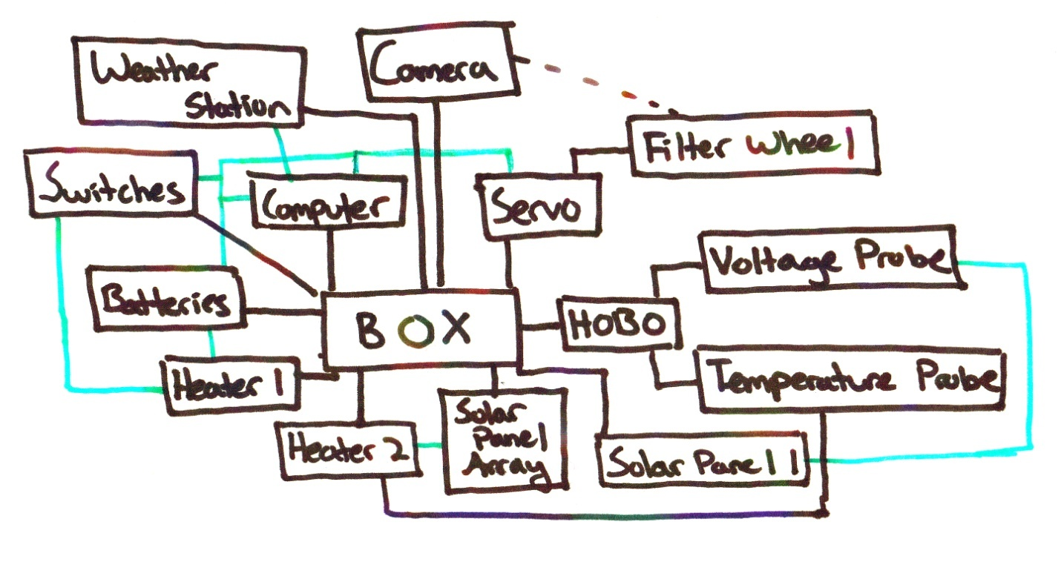

Diagrams and Payload Layout
Fig 1: general box, filter wheel, and solar panel shape
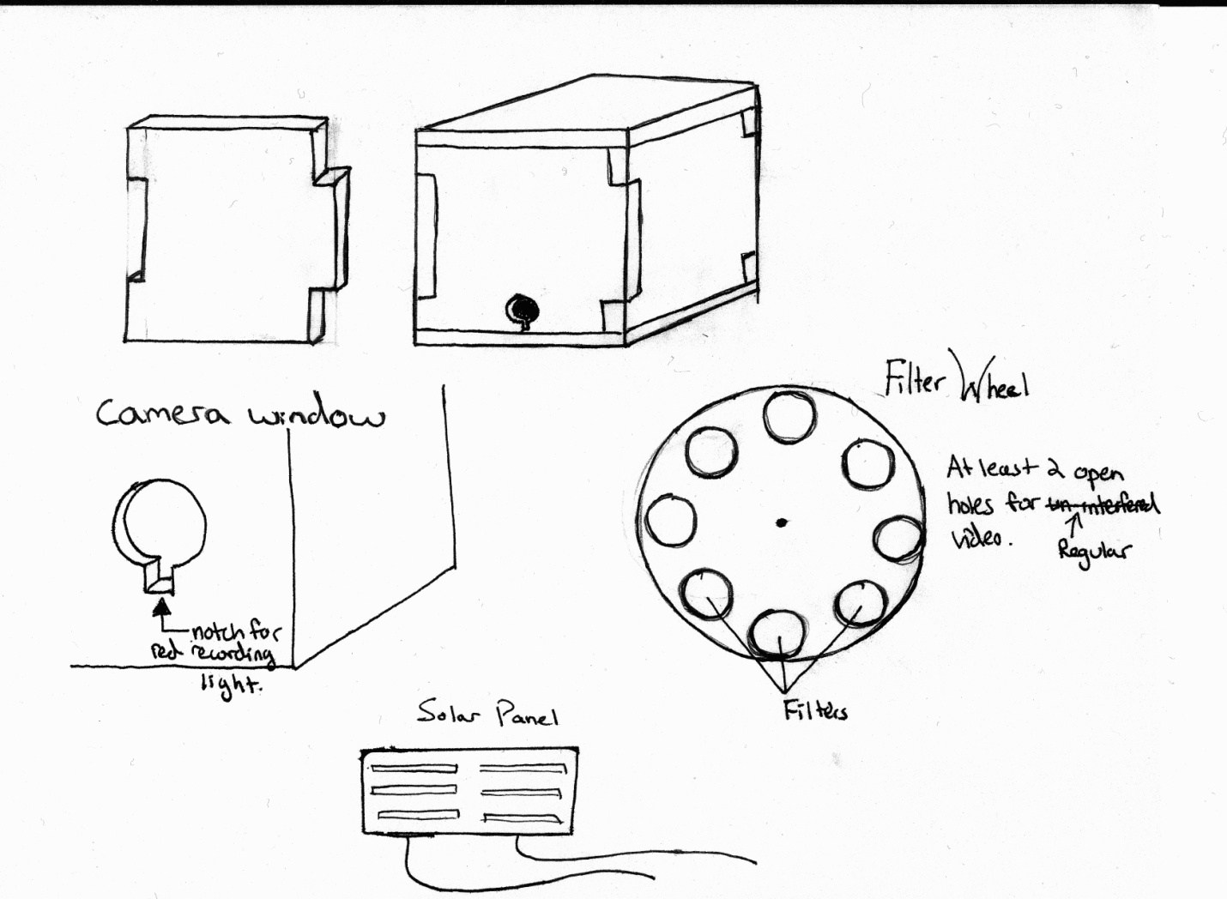
NOTE Filters changed shape to square panels

Fig 2: outside design of box with interlocking pieces, filter wheel, and solar panel array
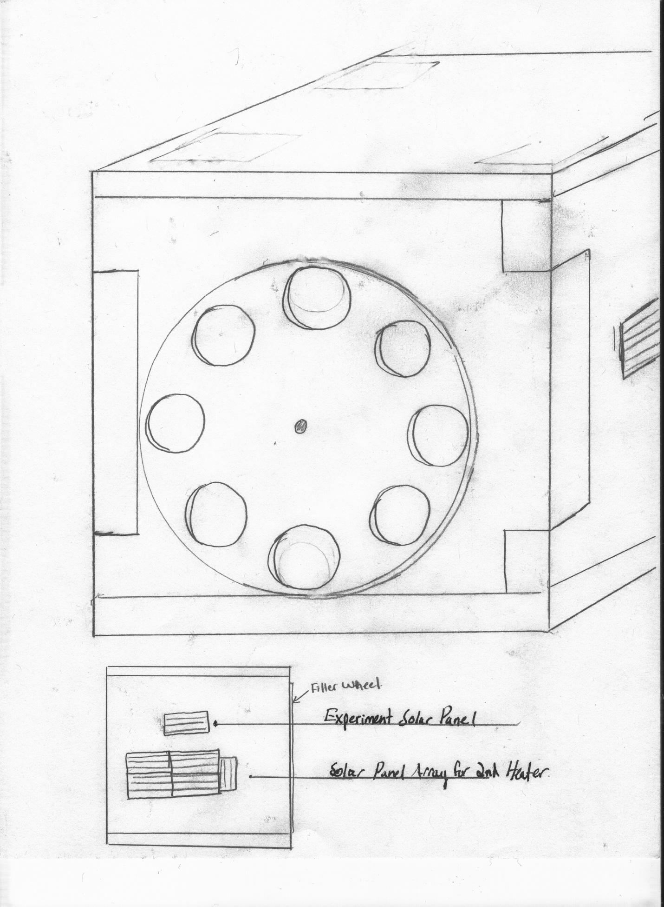
Capture Plate for Filter wheel, constructed of wire.
Fig 3: the interior layout of the box, see list below for part identification
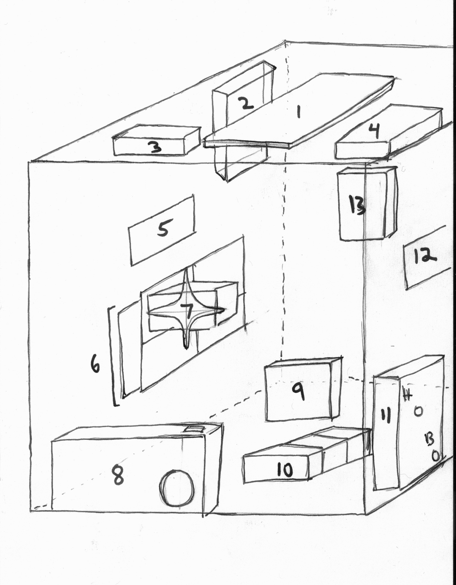

Labeling Chart for Fig 3:
- EasySat Flight Computer
- Heater Circuit powered by solar panels
- 9V battery for flight computer
- AAA battery pack for servo
- Experiment solar panel #1
- Solar panel array for heater (2)(NOTE: Location has changed to where #12 was in original diagram)
- Servo Motor
- Flip Ultra HD Video Camera
- Heater powered by 3 9v batteries
- HOBO with temperature and voltage probes attached
- 3 9v batteries for heater (9)
- Experiment solar panel #2 (NOTE: This has been removed from our current design)
- Weather station

4.0 Project Management

Payload Build Assignments

Launch Day Assignments

Team Project Documentation Writing Assignments

Schedule
Due Date | Tasks to be Performed
September 15 | Preliminary payload planning
September 22 | Learn to solder, begin building heater circuit
September 29 | Begin building weather station and flight computer
October 6 | First Conceptual Design Review, begin payload body construction, final confirmation of experiments
October 13 | Further construction and integration, mechanical testing of parts, final decision on camera usage
October 16 | Team Project Documentation, Revision A, due
October 20 | Begin Flight Readiness Review, data collection “day in the life” testing, continue construction, integration, and testing of payload
October 27 | Prediction software, launch logistics, tracking, recovery logistics,  Finalization of payload during class, weigh-in/turn-in of payload if it is finished
October 29 | Final deadline for weigh-in/turn-in of payload (by noon)
October 31 | Launch
November | Analyze data recovered from flight

5.0 Project Budgets

Budget Chart
Object | Cost ($) | Mass (kg)
Pink Styrofoam | 8.00 | 0.150
Tubing, rigging strings, key rings, zip ties, glue, tape, Mylar | 5.00 | 0.050
2 Heater circuit | 10.00 | 0.054
3-pack 9-volt battery for heater | 6.00 | 0.150
Weather station | 40.00 | 0.015
BalloonSat Easy flight computer | 30.00 | 0.033
9-volt battery for flight computer | 2.00 | 0.046
Flip Ultra video camera | 170.00 | 0.175
HOBO data logger for interior "health" | 130.00 | 0.048
7 small solar panels | 56.00 | 0.056
1 HOBO voltage probe | 9.00 | 0.010
1 HOBO temperature probe | 29.00 | 0.010
Filter wheel and servo | 15.00 | 0.150
Total Cost ($) | 510.00
Estimated Total Mass (kg) | 0.947
Actual Total Mass (kg) | 1.067

6.0 Payload Photographs

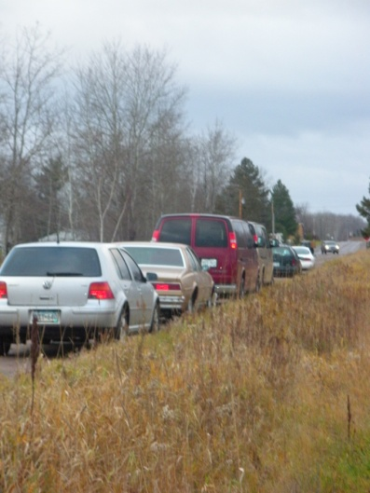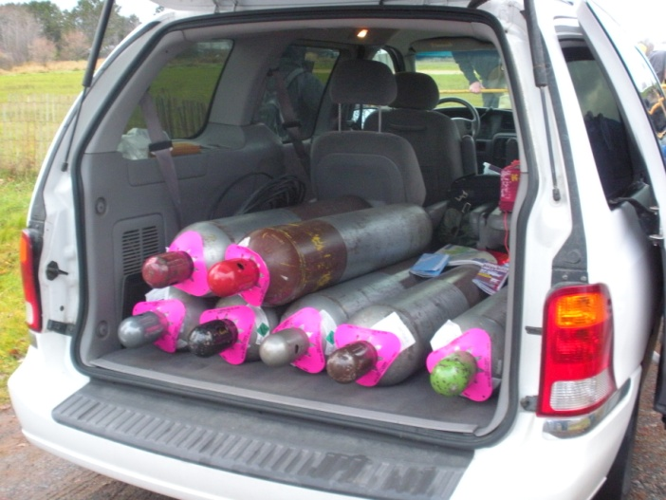
Arrival at the launch site Helium tanks in the back of one van

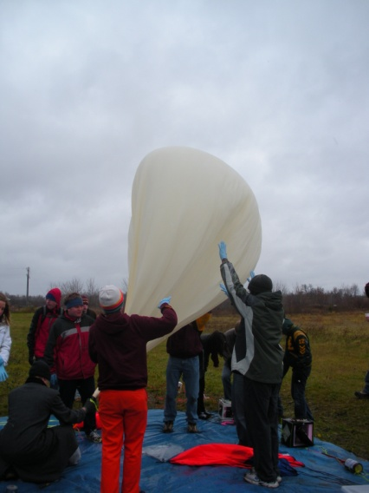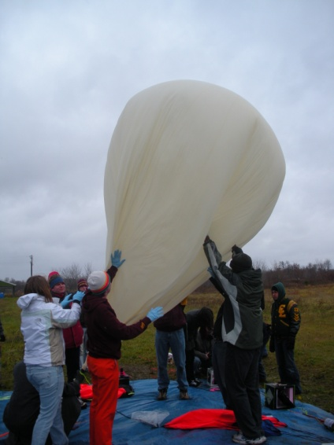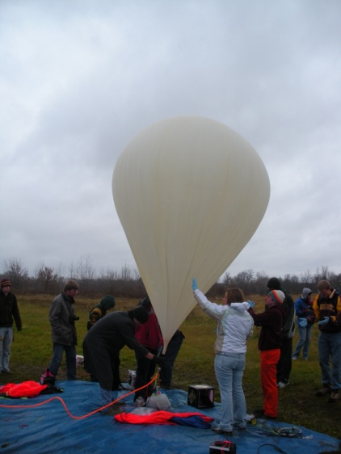
Inflating the weather balloon

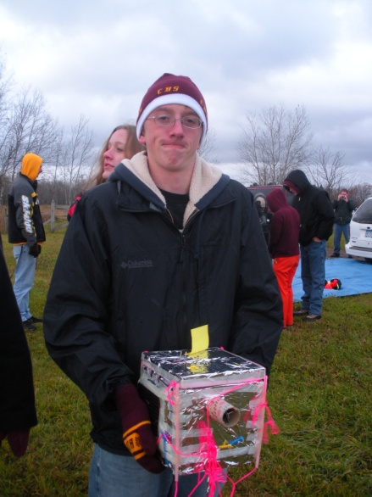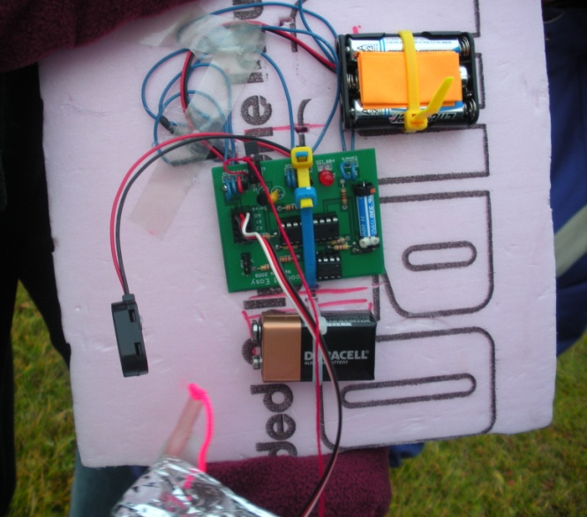
Our finished payload Lid of our finished payload

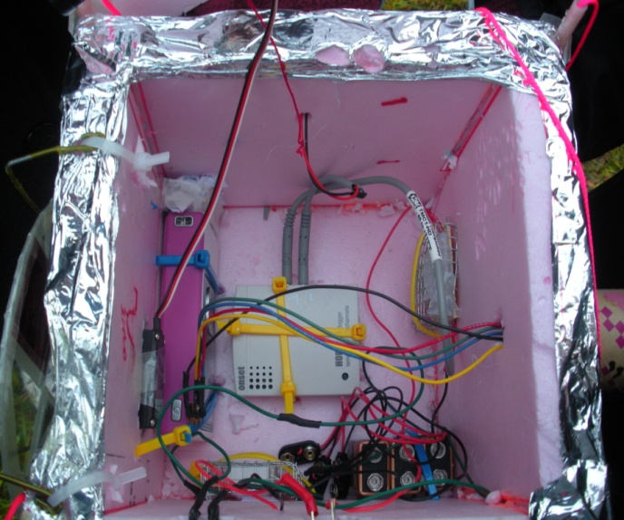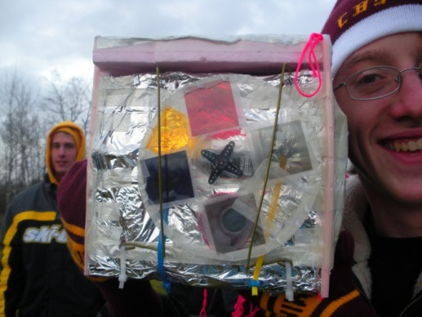
Inside of our finished payload Finished filter wheel

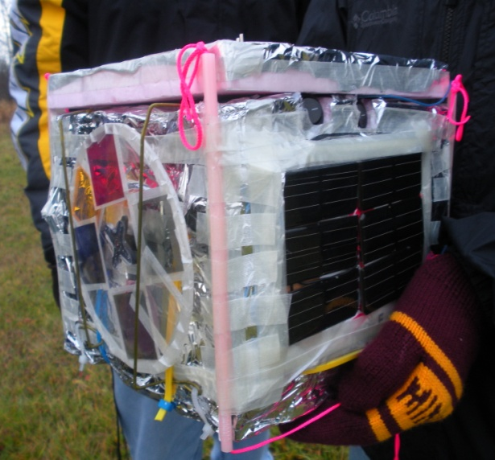
Filter wheel and solar panels
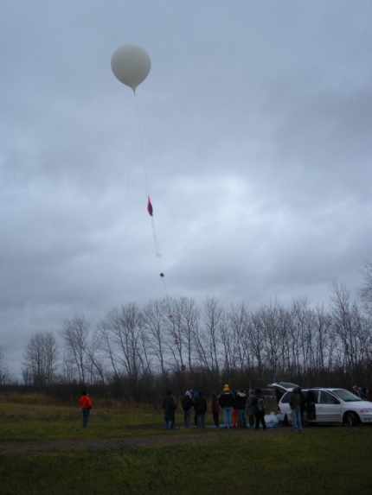
Ready…set…go! Launching the balloon.

7.0 Test Plan and Results

Below is a compilation of the various tests that need to be passed before we are able to launch. The tests that have been completed and passed as of this date have results included.

Payload Body- After payload body is constructed; it will be tossed down a flight of stairs when it has .85 kg in it for impact testing.
Result: The payload body was not damaged and it maintained its structural integrity.

Flight Computer- The flight computer will be tested by hooking up a 9v battery and then making sure current flows through the entire circuit. Also, once it is programmed, we will try collecting some data with the weather station to make sure the flight computer logs the data properly.
Result: The computer functioned normally during the cold soak. However, because the servo program was not programmed into it yet, we could not tell how the servo would react to the low temperatures.

Weather Station- The weather station will be connected to the flight computer. We will then collect sample data on the ground and make sure that the weather station is transmitting properly. The weather station will be run in the cold soak to make sure it functions at low temperatures.
Result: The weather station collected data both in normal conditions and in the cold soak.

Flip Video Camera- The camera will be turned on and sample videos will be taken and transferred to the computer to make sure the files work and that the camera records properly. The camera will also be run in the cold soak to make sure it functions in low temperatures.
Results: The camera recorded and transferred the videos well. The camera also functioned during our cold soak test.

Heater Circuit- The Heater circuit powered by batteries will be plugged in and left for a while. It will then be checked to make sure it gets hot. The same will go for the solar panel powered one. If the solar panels cannot generate enough heat then the second heater will not be included.
Result: The heater circuit attached to the battery reached a desirable heat.
The solar panel powered heater did generate current, but it did not generate enough heat on the ground. However, it will be kept in the box because of the high levels of radiation in the upper atmosphere could provide much more power.

Servo Motor- the servo motor will be plugged into the flight computer to make sure that it is operating properly and rotating at the speed which we want it to. The motor will also be run during the cold soak test to see if it can withstand the low temperatures.
Result: The servo motor (after being programmed) rotated at a good capture speed, allowing the camera to record on each filter for a little more than five seconds or so. However it was not programmed in time for the cold soak test, so we could not determine how it would run at low temperatures.

Filter Wheel- the filter wheel will be attached to the servo motor. We will make sure that connections are stable and that the camera can see through the various filters properly. Everything must line up in this stage of testing; it is crucial to our experiment.
Result: The filter wheel allowed for excellent visibility through all of the filters, and the connection was relatively strong. The size of the filters was also perfect for viewing. We decided that the filter wheel should definitely be circular, to allow for a capture plate to be attached; in case the filter wheel came disconnected during the flight.

HOBO, voltage probe, and temperature probe- We will put the HOBO through a series of trial experiments, testing controlled temperature and voltage to make sure that all the sensors are functioning properly, and that the HOBO is logging data correctly.
Result: The hobo and its probes logged data correctly both on the ground and in the cold soak. There were no issues with any part of the HOBO.

Solar Panels- Each of the solar panels will be attached to the multi-meter and exposed to sunlight to make sure that they are outputting a charge. The final array will also be tested for a charge.
Result: Each of the individual solar panels was outputting a charge. They also output a charge when they were wired into the array.

Integrated Payload- After all parts are integrated into the payload shell, we will run tests at low temperatures (cold soak) and at standard temperatures to make sure that all the systems function properly together. (This includes insulation around the box.) We will also do a “yank” test to test the strength of our riggings.
Result: The payload worked well as a system, and it functioned during the cold soak. The rigging passed the yank test, and everything was very secure inside the box. All of the different components operated very well together.

8.0 Expected Science Results

Expected Science Results
Our near-spacecraft is expected to travel up to about 90,000 feet. To put this number into perspective most commercial airliners fly at approximately 30,000 feet and outer space begins at about 270,000 feet. Below is a picture taken from the February 2004 “Nuts and Volts” that shows the altitude of the layers of the atmosphere and the height at which some objects can be found.

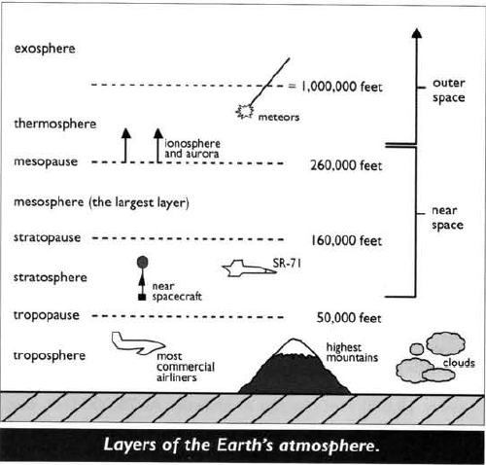
In our near-spacecraft we are running multiple experiments. One of our experiments is a weather station which will record the temperature, relative humidity, and pressure outside of the box. We attached our weather station inside a tube and attached it to the outside of the box. The weather station was placed inside of the tube so that our temperature readings would not be corrupted if the sun was shining directly on it.

Due to our prior readings and research of what we expect to happen we believe that as the altitude increases the temperature will decrease for about half the flight, then increase for the remainder of the flight. Here is a graph from the February 2004 “Nuts and Volts” article that helped us make this prediction. This graph has been proved to be true due to multiple near-space flights by different balloonists.

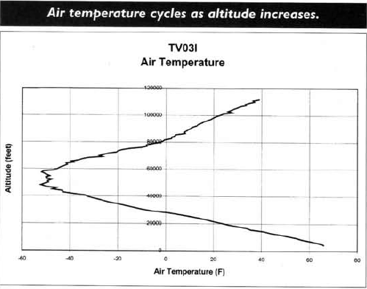
For the relative humidity, we believe that the humidity will decrease as altitude increases. The graph below shows the relative humidity versus altitude. Our payload is only expected to go up to about fifteen miles, and as you can see, the humidity is decreasing in that region.
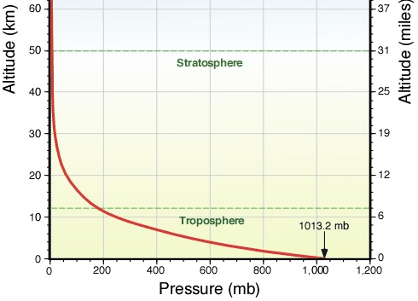
Also contained in the February 2004 “Nuts and Volts” article is a pressure versus altitude graph. This graph shows that as altitude increases, pressure decreases.
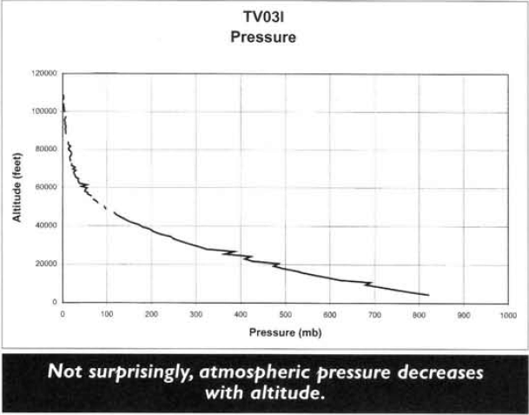
Another experiment we plan to perform is to see if we can use a solar panel array to power an additional heater in our box. We created the array out of six small solar panels and wired them together, then connecting them to a second heater circuit. Attached to the additional heater is a temperature probe so that it is possible to determine if any heat was being produced by this heater. The expected results are that the heater will output the same amount of heat from when the balloon is released until it passes through the cloud cover. After the balloon passes through the cloud cover, the solar panels are expected to have more light available to transfer into heat energy therefore increasing the heat output of the heater. At a certain point we believe that the solar panels will reach their maximum output so the heat output will remain the same until the burst of the balloon. In addition to the solar panel array powering the heater, we have included a single solar panel attached to a voltage probe to monitor its output. We expect the output of this solar panel to increase due to increased exposure to solar energy until it reaches its maximum output. To ensure that all of our data is measureable, we have covered the solar panel with Mylar to lessen the impact of the sun on the panel.

Altitude (Ft)
Heat Output (*F)

Our final experiment is taking video through different filters to determine which filter allows us to see the different layers of the atmosphere the best. We have a filter wheel attached to a servo motor, which rotates the filter wheel, allowing our video camera to capture images through the different filters. On our filter wheel we have blue, yellow, and red color filters along with two polarizing lenses, one diffraction filter, and one blank filter used as a control. We believe that we will be able to see the different layers of the atmosphere through one of the filters better than we would with the naked lens of the camera. It is difficult to test this prediction because we would need to reach a high altitude to see the layers of the atmosphere.

Works Cited
Verhage, Paul. “Near Space Part I.” Nuts and Volts. February 2004: Pg. 65-66.

9.0 Launch and Recovery

After nearly two months of planning, preparations, and building, we were finally ready to launch our payload. Our (approximately) 7”x7”x8” pink Styrofoam box was built; all the electronics were integrated, all the wires were connected and ready to go. We had tested all the parts by doing many experiments during the building process. We had also prepared the experiments and made sure they worked. We could only test to a certain extent the solar-powered heater; the sun was not strong enough on the ground the few days before the flight, so we could only test to make sure a current would run through the wires going between the solar panel array and the heater. All the other experiments were fairly easy to test and prepare, however, so we felt pretty confident on the day of the launch that they would work exactly the way we wanted them to.

We launched our payload on October 31, 2009. It was very cold and windy that day in the Twin Cities. We left campus at about 6:45 in the morning, and drove for approximately two hours until we reached Brook Park, MN. Brook Park is approximately eighty-five miles north of the Twin Cities. When we got to the launch site, we discovered that it was even windier and it was snowing. The wind was somewhat unwelcome; calm conditions would have been better for the filling and launching of the balloons. We unpacked the vans and helped prepare for the launch of the Continuing Education class balloon; we did this by stabilizing the balloon while it was filled, waiting for the launch, and guiding the package into the sky.

While the Continuing Education class worked on preparing their payloads for launch, we worked on preparing our payload for launch. We added another capture strap (a wire hanger we bent and stuck into the Styrofoam of the body of our payload) for our filter wheel, just in case it fell off its setting on the servo (like it did). We also had to unravel the strings that held our payload to the rest of the stack, as they had become tangled in the days between the yank test and launch day. After our box was physically ready for launch, we placed it on the ground in stack order.

After the Continuing Education balloon was launched, we began preparations for our launch. We turned on our video camera, our battery-operated heater, our flight computer, and the servo motor for our filter wheel. These were the electrical preparations. We made sure all the components were securely zip tied in. We also had to tape the lid of the payload on to our box to keep all the components in the package. In addition, we had to write our contact number on the payload; this was important in case we did not find it that day (we needed to get it back in case someone else found it).

While the electrical preparations were being made, several of us were helping prepare the actual balloon. Due to the relatively high winds, we had to stabilize the balloon so it would not hit the ground and get punctured by something sharp on the ground. This was very difficult to do; especially once the balloon was close to being filled (to where we wanted it to be filled) since the wind was pulling so much on its large surface area.

Our official launch time was 11:45 am. We were pretty much right on time with this schedule. We released the balloon by letting go of the launch lines and guiding the stack up into the air, making sure the lines did not get too tangled before the balloon rose out of our reach. We watched the balloon rise as much as we could before it disappeared into the clouds.

We had to keep the FAA apprised of what was going on with both balloons during the flight. We had a weight restriction on each of the payloads because if the total package was over a certain weight, the FAA would need several months advance notice. At constant time intervals, someone would call the FAA and tell them what we knew about the package. This was very important for the FAA because if they did not know what was going on with our package, it could cause major problems with the flight patterns for that day.

After the balloon was launched, we piled back into the van to track the payloads to their ultimate landing spot. Approximately twelve members of our class went on the chase and recovery. We used ham radio to track the package during its flight. We could see as the balloon rose to approximately 112,000 feet. This is the altitude where it burst. We did lose contact with the balloon part of the way through the transmission, but since we had more than one computer tracking the package, we did not lose contact completely.

The balloon fell back to the ground quite quickly, which is to be expected of this kind of experiment. We predicted the package to land near Menomonie, Wisconsin. We left the launch site and drove “behind” it to its landing place north and east of Bloomer, Wisconsin near the Chippewa Moraine State recreation area. The whole flight was approximately two hours long, from release to landing.

When we got to the area where we knew the package had landed, we discovered that the surrounding terrain was mostly forest. This was slightly unsettling, only because it meant we may have to pull the package out of a tree. We got out of the van and followed the siren’s noise to locate the package. It was found clinging to three different trees about thirty feet in the air. We tried for several minutes to get it down by shaking the trees that it was lodged in. Eventually, we gave up on that and tried other methods of retrieving the package. The one that finally worked was using a slingshot to throw a lead weight over the strings that held the package together and pulling the payload down.

After the package was recovered from the tree, we checked for any damage. We discovered that our filter wheel had fallen off the servo but was caught in the capture straps. The camera had stopped working and the servo had stopped spinning. These were the things we discovered before we left the wooded area. After we got the package out of the forest, we opened the box and assessed the damage done to the inside of the box. One of the batteries was unhooked, but that probably did not have much of an effect on how the electronics worked. We also took the camera out of the box and found out how little of the flight we captured due to an unknown malfunction; we got about forty minutes of video, when we should have gotten at least an hour and a half. It was also noted that the solar-powered heater was still warm when we opened the box, which alerted us that the solar experiment had worked, at least to some extent.

Launch day turned out to be a very long but rewarding day in many ways. Even though we had to wake up early on a Saturday and spend most of the day in a van chasing the balloon, we got to send a high-altitude balloon to near space and recover data from several experiments that we designed and built. This was very rewarding for us since we are only freshmen in college and it is probably the first time many of us have ever done something like this.

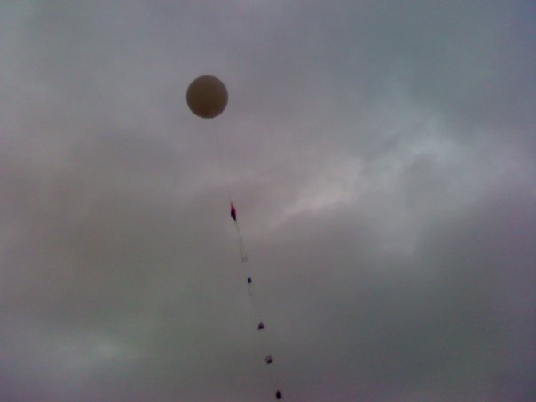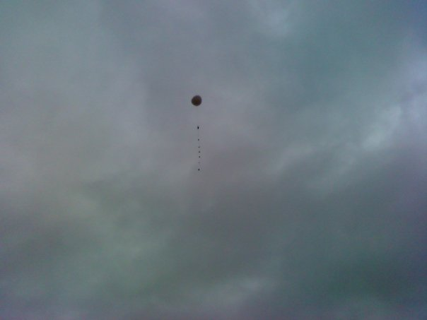
The balloon shortly after release.

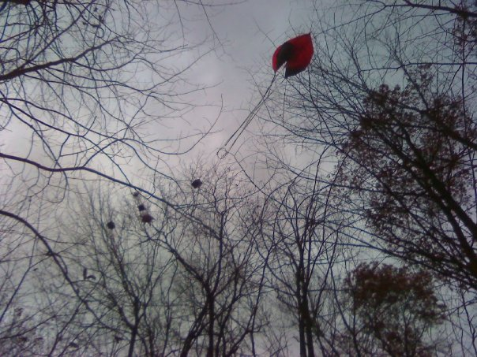
The package stuck in the trees near the Chippewa Moraine State Recreation Area.
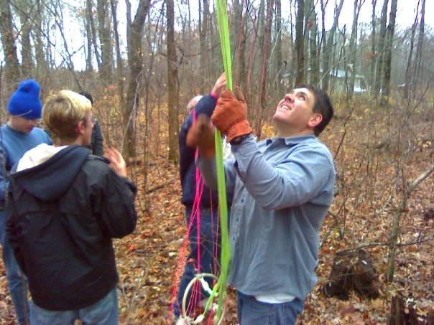
Pulling the package out of the trees.
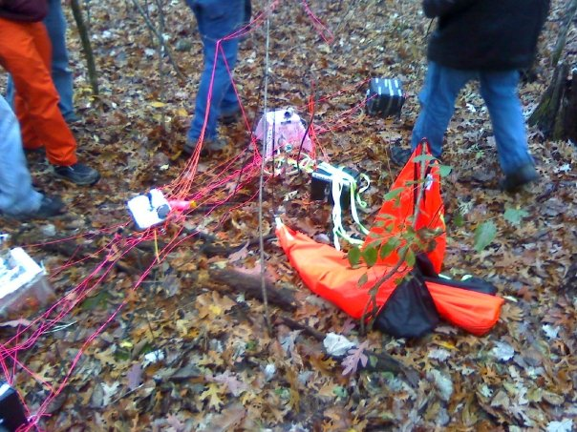
Assessing damage once the package was on the ground.

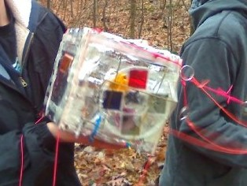
The package after we untangled it from the tree and the other payloads. The filter wheel is detached and the camera was no longer on.

10.0 Results and Analysis

Altitude vs. Time

As the balloon ascends, there are two different ascent rates, the first being approximately 1300 feet per minute and the second being approximately 1100 feet per minute, starting about thirty minutes after release. At burst, the data gathered becomes more sporadic as the balloon descends.

Ground Track Map
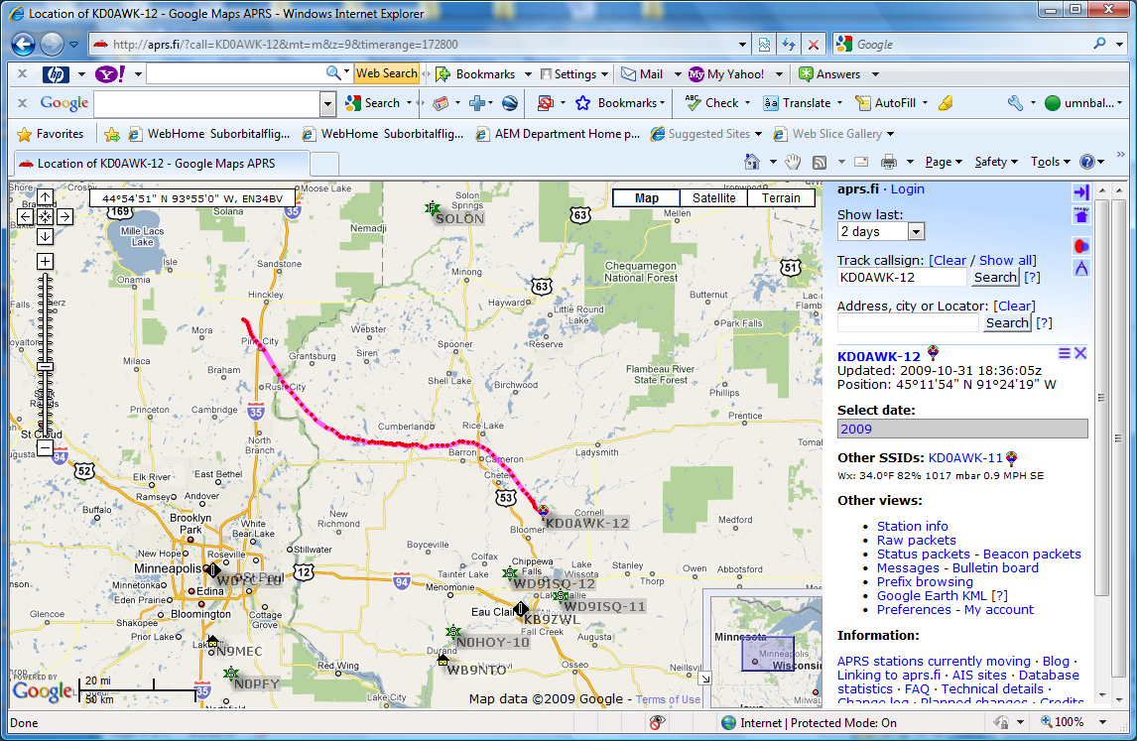
The balloon was launched on October 31st, 2009 from Hinckley, MN around 10:45 a.m. It was recovered northeast of Eau Claire, WI, near Chippewa Falls, WI, on the same day a few hours later.

Our temperature probe did not function properly during the flight. This is why our graph is distorted. We believe that our temperature sensor did not function correctly because of a fault during the construction of the weather station.

Above is Team Icarus’ Pressure vs. Time graph. It shows that as the flight went on, the pressure decreased, until burst at which it then increased again. The graph shows that the pressure went below zero, which is not possible. We think that this is due to a calibration error.

The relative humidity vs. time graph shown above is from team Icarus. Our humidity sensor did not function correctly so we had to use another team’s graph. The graph shows that initially the humidity decreased and then about midway through the flight it increased. This increase in pressure is not what we thought would happen. We believed that there would be an increase, but not one this large. At the end of the flight, the humidity increased back to approximately what it was at the beginning of the flight.

The internal temperature of our payload went as low as -30 degrees Celsius; the payload was supposed to be kept above freezing temperatures (above 0 degrees Celsius) in order to ensure the function of the payload’s components. The points where temperature increases are when the heater is turned on at 0 seconds, when the payload reached the tropopause at approximately 10000 seconds, and on ground temperatures for the rest of the graph.

As altitude increased the voltage from our solar panel increased. Two factors may have influenced the voltage output. First, altitude, causing more exposure to sunlight, may have been responsible. Second, lower temperature, which causes solar panels to function at a higher level, may have influenced it. The temperature relationship can be seen by comparing the voltage graph above to the internal temperature graph before it. The two seem to be directly opposite to one another, showing a relationship between the two variables.

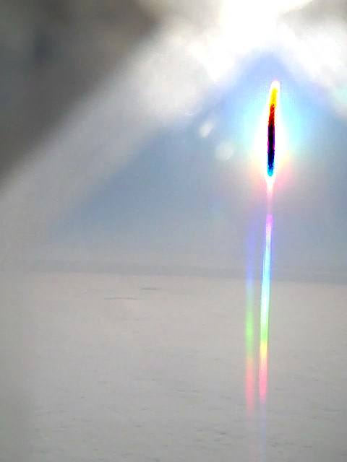

Above Left: Shot through diffraction grating, you can clearly see the full spectrum of light at this altitude
Above Right: This is a picture with a half clear (left) and half polarized (right) shot from 35,000 feet.
Lower Left: This is an image through the yellow filter of the horizon. The gradient color of the clouds is slightly more distinct through this filter; however, the difference is not great.
Lower Right: This is a picture taken through the red color filter. This filter was poor at capturing distinct images of the cloud layering.
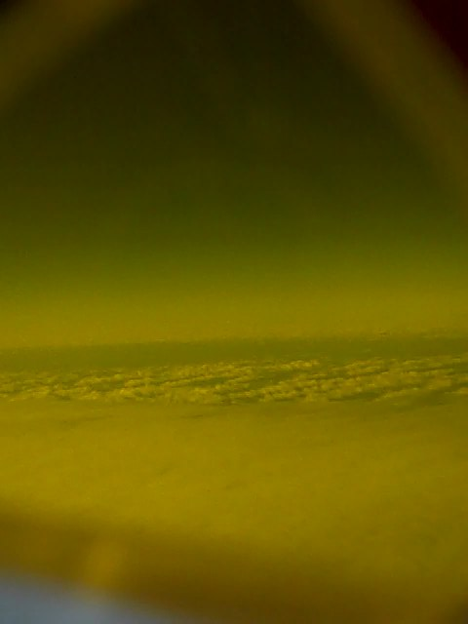
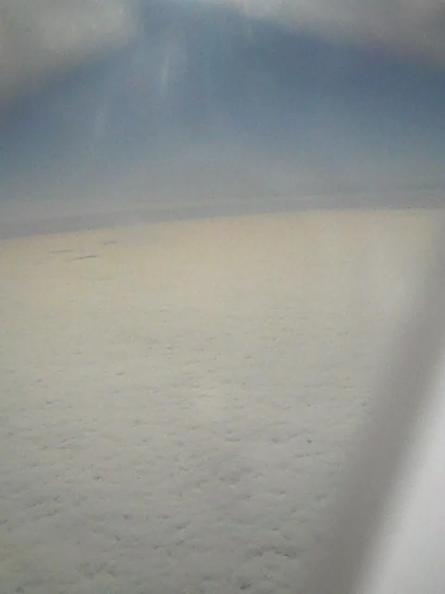

Above Left: This Picture was taken after the payload had risen above the clod layer. It is taken through a polarizer, and some curvature can be seen. The polarizer cuts down on brightness, and the cloud “sea” is more visible.
Above Right: This is another picture through a polarizing filter. It shows the color gradient (from light to dark) of the sky. The layers are not quite visible; however this shot was taken close to the time the camera shut off, which was at about 38,000 feet.

Pictures Conclusion

We did not gain the necessary photos of the layers of the atmosphere because our camera turned off early due to unknown complications. However, we were able to see what filters worked the best for taking pictures on the way up. The diffraction spectrum captured the spectrum beautifully. The clear filter provided crisp photos of the sky and how its color changes. However, the polarizer provided the clearest photos. It eliminated unnecessary light that was coming in and gave us a well-contrasted image. The yellow filter gave a better “contrasted” image; however, it also produced a lower resolution image. The red and blue filters (blue is not given here) did not provide much of an image at all. All that could be determined from these filters was the horizon line.

11.0 Conclusions and Lessons Learned

As a team, we learned many things about near-spaceflight and ballooning, but also about teamwork, science and engineering. We discovered that it is very important to meet every week for a couple of hours at the least to get some work done on the payload and the science experiments. We also learned along the way that what was originally planned might not work out the way we wanted it to. Our original plan was to send cockroaches up to near space in our payload, but when it became obvious that we would not be able to do this experiment, we had to come up with other ideas that interested us. We became flexible and learned to accept changes to our original plans and even plans that we worked with through the month and a half to have to complete this project. We learned how to work as a team to finish the payload and all its components.

If we could do this project again, we would do many things differently. We would likely start with a smaller box for our payload, because we ended up cutting approximately two inches off the top of our payload. We might also figure out a way to make our box more space-efficient, meaning we would probably find a different way to lay out all the pieces and wires in the payload so we could use a smaller design. We would also insulate our payload better so the interior of the box does not get (hopefully) as cold as it did. We would also test more before we launch and troubleshoot any issues that come up on launch day. In conjunction with testing more and troubleshooting, we would come up with quick fixes to the common problems that might occur on the day of the launch; we could bring extra batteries and other supplies, maybe even a second camera if budget allowed (just in case the camera dies before the flight). In addition, we would reduce our payload weight, if possible. Perhaps this could be done by reducing the size of the box, using lighter materials for our filter wheel, cutting out the solar panel array, since the second heater seemed to not do much for our payload. We could also remove the second HOBO probe, since we would not need it for the internal temperature; this would reduce the weight significantly. We would also change the way we attach the filter wheel to our payload. We would probably use screws to hold the filter wheel to the servo, rather than the hot glue we used; this would make the filter wheel more likely to stay on the payload. These are the changes we would make if we could do this project for a second time.

Lessons Learned
- Make sure you mix the epoxy thoroughly before you put your payload together.
- Meet at least once a week, even if only two members can make it.
- Get things done sooner rather than later; don’t put things off until the last minute.
- Spray adhesive eats Styrofoam, even if you don’t spray it directly on the foam.
- Make sure you get a decent amount of sleep the night before the flight.

12.0 Appendix: Program Listings

'servo flight code for gopher launch 22

symbol record=w0 ' variable declarations
symbol index=w1
symbol value=b4

BalloonSat:
symbol Max_ADC = 2 ' maximum adc channel used

Mission_Prep:
i2cslave %10100000,i2cfast,i2cword ' set memory speed to 400 kHz and one word records
if pin7 = 1 then Download_Data ' if no commit pin read out memory

flasher:
low 3 ' this is adapted fligth code
pause 2000 'change rotation pattern when
servo 3,75 ‘ initialise serv 'commit pin pulled
servopos 3,75 'move servo to one end
pause 200 'wait .2 seconnds wait for commit pin to be pulled
if pin7=0 then flasher

Mission:
gosub Servos 'goto the servos subroutine 3 time 15 second pause
gosub Servos
gosub Servos
gosub Analog ' collect analog voltages
write 0,record ' store the number of records collected....
goto Mission ' ....before starting all over

Servos:
low 3 ' this is the rotate servo subroutine
pause 4925 'it will pause 5 seconds
servo 3,75 'initialise servo
servopos 3,75 'move servo to one end
pause 75 ‘
wait 2 seconds
low 3
return ' go to main mission loop

Analog:
for index = 0 to Max_ADC ' loop for number of analog voltages to record
readadc index,value ' get next adc value
gosub Record_Data ' go store the value
next ' until last voltage is recorded
return ' return to main mission loop

Record_Data:
if record = 2047 then End_Mission ' check that aren't writing too many records to memory
record = record + 1 ' increment record number
low 0 ' unwrite protect memory
writei2c record,(value) ' write the next record to memory
pause 10 ' wait 10 ms for write
high 0 ' write protect memory
return ' return to the calling calling subroutine

Download_Data:
read 0,record ' get the number of data records recorded in this flight
for index = 1 to record ' until the number of data records
readi2c index,(value) ' read the recorded record
sertxd (#value,",") ' serial out the data record
next ' until last data record read out

End_Mission:
end ' end of mission

Above are the programs for the flight computer and servo used in flight. Also included is the code that ran the weather station. The servo program turned the servo periodically in order to maximize the time spent under each type of filter. The flight computer program was used to collect data from the weather station in five second intervals.

