University of Minnesota and MN Space Grant Consortium

AEM 1905 Freshman Seminar: Fall 2011
Spaceflight with Ballooning
Team Project Documentation

Team Icarus
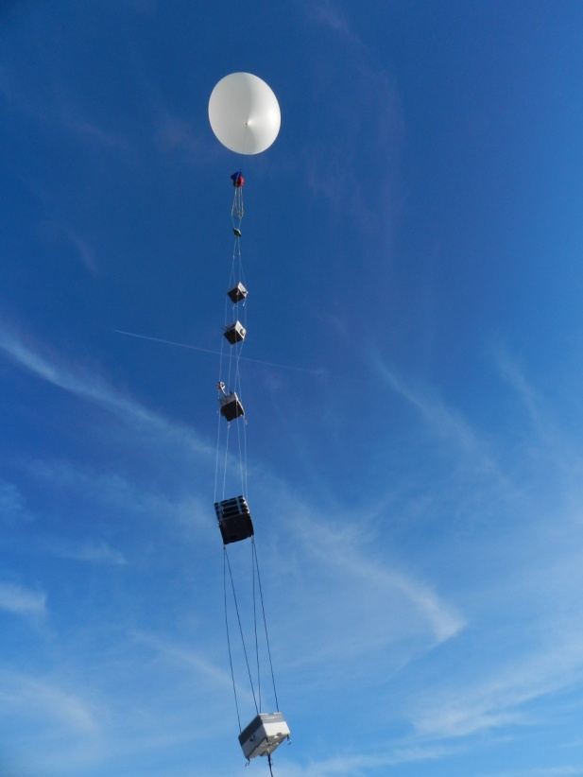
Written by:
Nick Barnes
Sean Grogan
Henry McCabe
Ethan Kapler

Revision C: 12/2/2011

Table of Contents (update page numbers as document evolves)

- Team Assignments………………………………………………………………..3
- Introduction…………………………………………………………………………..5
- Mission Overview…………………………………………………………………….6
- Payload Design………………………………………………………………………..7
- Project Management…………………………………………………………………..9
- Project Budgets……………………………………………………………………….10
- Payload Photographs………………………………………………………………….11
- Test Plan and Results………………………………………………………………….12
- Expected Science Results……………………………………………………………..13
- Launch and Recovery…………………………………………………………………14
- Results and Analysis…………………………………………………………………..15
- Conclusions and Lessons Learned…………………………………………………….16
- Appendix: Program Listings…………………………………………………………..17

0.0 Team Project Documentation Writing Assignments

Team Name Team Icarus

Assign one lead author to each section except for Results and Analysis (that needs to be worked on by everyone!). Each person should be the lead author on two sections. Notice that the sections vary widely in length and complexity. (Rev 0)

Introduction Henry
Mission Overview Ethan
Payload Design Sean
Project Management Ethan
Project Budgets Nick
Payload Photographs Nick
Test Plan and Results Sean
Expected Science Results Ethan
Launch and Recovery Sean
Results and Analysis Nick
Conclusions and Lessons Learned Henry

Oral Presentation Assignments
Assign two team members to help make slides for each of the first two oral presentations. All group members need to pitch in when working on the final oral presentation. (Rev 0)

Conceptual Design Review (CDR) Sean Nick
Flight Readiness Review (FRR) Henry Ethan

Payload Build Assignments
Assign one person to be the overall “team lead” (AKA “team contact”). Their job is to keep tabs on the whole project and keep the teaching staff informed as need be, to organize team meetings, to make sure everything gets done in a timely manner, and once the build is complete to be in charge of ground testing. Assign each of the other four team members to “lead” one item in the first 4 tasks and one item in the last 4 tasks listed below. (Rev 0)

Overall team lead and ground-testing lead Nick

Flight computer (BalloonSat Easy) build Sean
Weather station build Ethan
Payload box build Nick
Photographer Henry

Programmer (of flight computer(s)) Sean
Camera and camera experiment Henry
HOBO (payload “health” (internal temp)) Ethan
“Other” science experiment Ethan

Launch Day Assignments
Assign each team member a specific responsibility for launch day. (Rev 0)

Photographer Henry
Prediction/tracking assistant Nick
Balloon filling and release assistant Sean
Payload/stack handling specialist Ethan
Recovery specialist (needs to go on chase for sure) Nick

1.0 Introduction

Near-space is defined by Paul Verhage in his February 2004 column in Nuts & Volts as the region of the atmosphere from approximately 75,000 ft. to approximately 330,000 ft. Near-space reaches 99% vacuum, it can get down to -90° F at 75,000 ft. (after which it rises to around 20° F), and the view of earth is much the same as outer-space. Since travel to near-space is much more attainable and affordable than travel to outer-space with little trade off in the conditions between the two, it is a great region in which to do research that can apply to outer-space flight.

The main vehicle used to reach near-space is a high altitude balloon, often filled with helium. Attached to the balloon is a string of payloads which carry the various experiments to be performed. An average near-spaceflight involving a high altitude balloon lasts about three hours and reaches a height between 90,000 ft. and 100,000 ft. As the near-spacecraft ascends, the balloon increases in size with the drop in pressure and eventually bursts, causing the near-spacecraft to fall back towards Earth. Attached just below the balloon in the string of payloads is a pre-deployed parachute which expands as the air begins to become denser, eventually bringing the near-spacecraft to a relatively gentle landing. Upon landing, the payloads are tracked and recovered and the payloads are ready to be analyzed.

During the flight, a number of experiments can be performed. Many times these experiments involve confirming predetermined scientific notions about near-space environmental conditions or testing of possible systems to one day actually send into outer-space. Both types of experiments are important to building the knowledge base about spaceflight in a relatively cheap and easy manner. For example, one could send up a several Geiger counters with different shielding materials to test which would be best to send on a manned spaceflight in order to shield the astronauts from the increased cosmic radiation as they escape the shielding of earth’s atmosphere.

Near-spaceflight is a wonderful hobby that is fun, accessible, rewarding, and useful. It gives everyone the chance to do their own experiments in an environment very similar to outer-space and for those results to have a real impact on current and future spaceflight. It is also much cheaper than actual spaceflight with little trade-off in terms of the quality of the experiments. In conclusion, near-spaceflight is the perfect medium for anyone interested in spaceflight who does not have the budget of a nationally funded space program.

2.0 Mission Overview

Our payload has to be able to withstand a very harsh environment. It has to be able to properly function at temperatures of negative sixty degrees and below. We will test this ability by temporarily placing our payload and equipment into an environment where the temperature is regulated by dry ice, and seeing if all of our equipment can still function properly. We plan to keep our temperature warm enough in our payload through insulation and a small heater made out of resistors. Also we are using black foam on the outside of our box so that it will absorb more heat from the sun’s radiation. Our payload also has to be able to withstand the jerking of takeoff and flight, as well as the post-burst chaos that will take place after the balloon bursts. Finally, it has to pass our test of throwing it down a flight of stairs. This is meant to simulate the impact of landing. If not landing, then it has to be able to withstand the impact of falling if it lands in a tree and we have to cut it down. This may mean a drop of around fifty feet or more, so our crash tests are very important. If our equipment can’t survive the drop, then our data may not either.
Our first experiment that we plan to perform is taking pictures of the sun’s corona. We will do this using a mounted camera on a turntable, with servos to move the camera in the sun’s direction. We placed three photo sensors around the camera to determine the sun’s position, and then programmed the flight computer to turn it to face the strongest source of light. We placed a black stripe, the width of the sun, over the camera lens so that we would only have to deal with left and right movement because trying to adjust up and down as well would be much more difficult to accomplish. We hoped to gain some visual knowledge of what the sun’s corona looks like from the upper atmosphere, before a lot of its radiation is dissipated. This is a very difficult task to accomplish, but it would yield very interesting results
Our secondary experiment to the first is mounting a stationary video camera with a partially blocked lens at an angle of 30 degrees and allowing it to rotate with the payload. By doing this we can back up our first experiment. Although this may not get as good of data, we know that eventually it will cover all but a portion of the sun and allow us to hopefully see a small piece of the corona as the sun starts to peek out from behind it.
Our final experiment was to analyze the results of team “up up and away” and use them to observe a relationship between altitude and radiation, as well as the shielding capabilities of tin foil. We will do this by comparing the values of the shielded counter to those of the unshielded, using the time to plot counts against altitude.
These were the goals that we set out to accomplish on this flight. Later on we will see how well each project went, as well as what could have been improved.

3.0 Payload Design

Requirements and limitations:
The primary objective of this flight is to take pictures of the suns corona; therefore we need some specialty equipment. We are required to have a systems monitor to keep track of what the systems are doing, and should one fail, we will know what the cause of that failure was. Another requirement is that we be able to track the sun, which is a very tricky feat because if ones off by even the slightest amount, the entire trip could be a futile one. Because of this need for precision, and the need to track where the sun is, we will be using photo diodes to track how much light is being emitted and in which direction, based off of this information, we will be able to correct the rotational mechanism to point in the direction of the sun. Some of our limitations are the fact that time is very limited and the deadlines come very fast, which means some items on the ‘dream list’ will not be feasible this trip, namely another axis of stabilization.

Parts/Equipment:
- Hobo
- Heater
- Heater battery
- Accelerometer
- BSE flight computer
- BSE battery
- Camera (Flip)
- Turntable
- Acrylic dome
- Styrofoam
- Mounting hardware.

Design: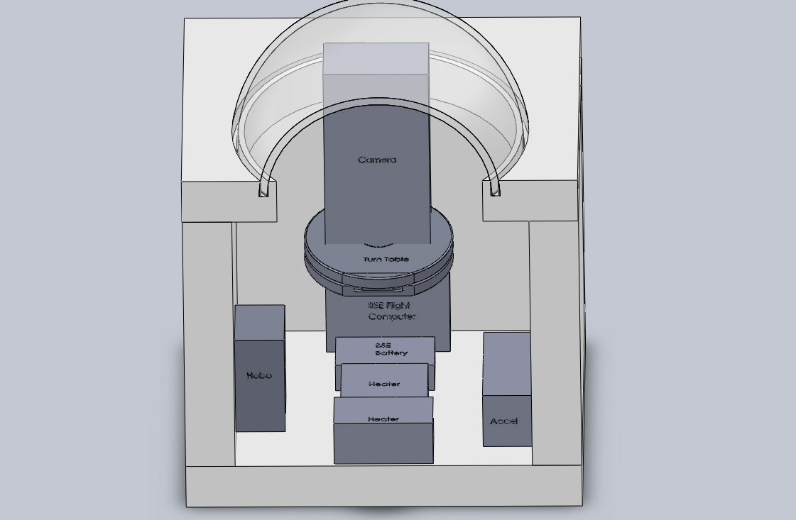

Test plan

Testing:
Our goal in testing is to make sure that the components we are producing will be able to withstand the violent path back to earth. Our box, which is our primary means of protecting our payload, will be tested by loading the box down with sand and tossing it down a flight of stairs. The next major component to test is the electronics of the payload. This gets tested by checking to see if they communicate as expected and if they operate in a vacuum. Following the test for electronics, we will then test the added in mechanical components in a vacuum and make sure that they will function properly. As the final test we will double check to make sure that everything is functioning as a whole and do a final once over before we launch the payload.

Test plan as list:

- Toss box down stairs
- Test electrical circuits
- Check electronics communication
- Check mechanical components
- Operate mechanical components in vacuum if possible
- Final once over, operate the box as if it were in flight.
- Check over just before flight of payload.

4.0 Project Management

Project schedule
- Sept 27: CDR proposal due
- Oct 4: Build Session
- Oct 5: Essay A1 due
- Oct 6: Essay A1 peer review due
- Oct 11: Check out of various systems
- Oct 12: A1 final draft due
- Oct 14: Rev A due
- Oct 18: Flight Readiness review
- Oct 25: Flight Predictions
- Oct 27: Payload due
- Oct 29: Payload Launch Day
- Nov 1- Dec 13: Analysis of data and continue on essay and revisions

Out-of-Class
- Oct 4: Build session
- Weeks of Oct 3- Oct 17: Build sessions according to individual availability.
- Weeks of Oct 3- Oct 17: Weekly group check-ins to discuss progress, difficulties and what needs to be done/ improved on.
- Week of Nov 28: Collaborate on Revision C, prepare presentation for Venus landing
- Week of Dec 5: Reassemble payload for show and tell day, prepare big presentation for Venus landing
- Put all data and photographs onto a CD for Doctor Flate
Org Chart

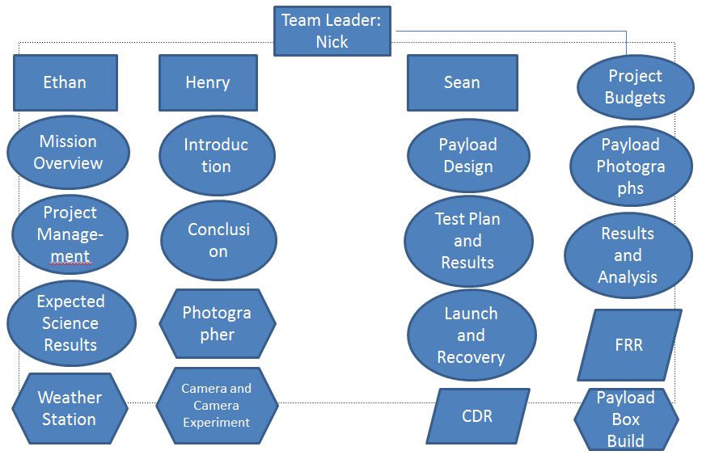

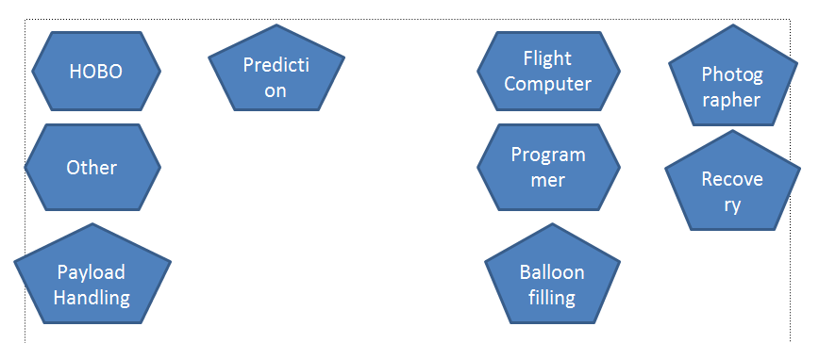

5.0 Project Budgets

Mass Budget:
- Servos: .04lb
- Adapter: >.04lb
- Camera Mount: >.06lb
- Camera: .386lb
- Nuts/Washers: > .06lb
- Hobo Logger: .11lb
- Heater: .05lb
- Heater Battery: .33lb
- Accelerometer: .037lb
- Zigbee: .28lb
- Video Camera: .38 lbs
- Structure: >.32lb
- TOTAL: 2.343 lbs
We are .343 lbs over the limit even after eliminating the extra Geiger counter.

Actual Mass
- Heater: .05lb
- Heater Battery: .33lb
- BSE Flight Computer: .072lb
- BSE Battery: .10lb
- Structure: >.32
- Servos: .04lb
- Flip Camera: .386lb
- Hobo Logger: .11lb
- Servos: .04lb
- Acrylic Dome:.38lbs
- Turntable:.28lbs
- Vivatar camera:.61lbs
- Total:2.718 lbs
- Difference between Revision B: Heavier by .375 lbs

Money Budget:
- Heater- $5
- Heater Battery- $6
- BalloonSat Easy Flight Computer- $50
- BSE Battery- $2
- FLIP Camera- $140
- HOBO Data Logger-$130
- Servo-$18
- Acrylic Dome-$12
- Turntable-$4
- Vivatar camera-$50
- Total:$420
- Difference between Revision B: $500

6.0 Payload Photographs

The inside of the finished payload box. The blue camera is mounted on a white box that houses our BSE and servo, which would turn the camera towards the sun. The box pivots on top of the turntable underneath it and is turned by the servo in the box. Under the self is the rest of our components.

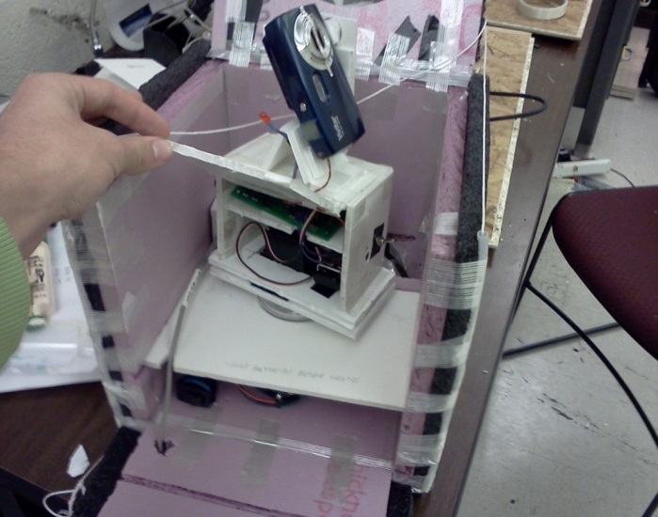

The inside of the box that the camera rests on. The top component is our BSE flight computer. On the bottom we have a 9V battery and a battery pack with 3 AA batteries. In front of the battery pack is the servo.
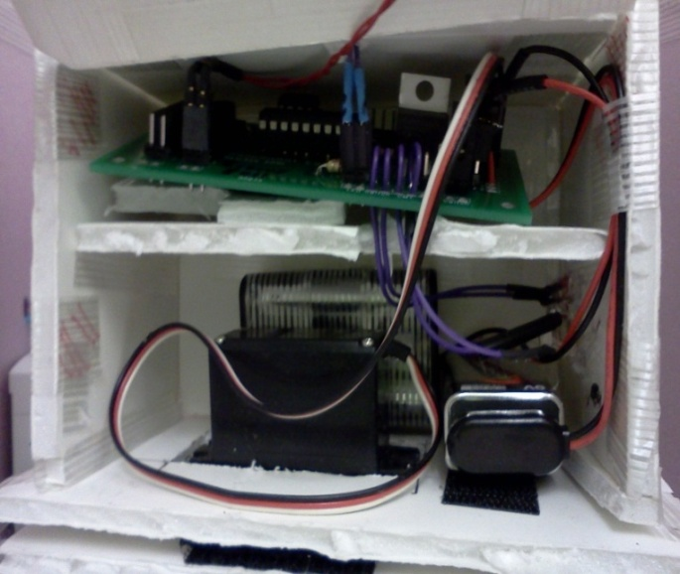

A view of under the shelf. In the middle is the heater with the heater switch in the front left. Behind the heater switch is our Hobo (hard to see in this picture) which has the wire running outside to measure the external temperature. On the right is our Flip video camera angled at thirty degrees so it has a better view of the sun.
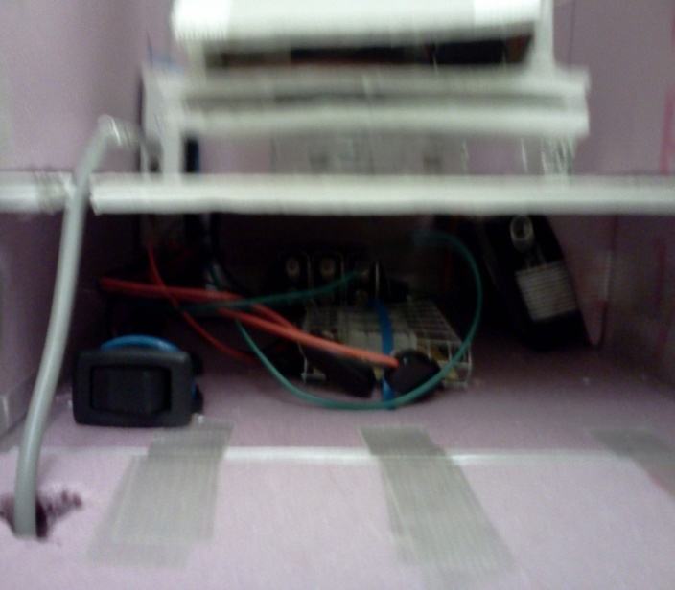

The payload box after it is all closed up. The blue still camera is in the acrylic dome and free to pivot. The Flip video can be seen through the hole in the side.
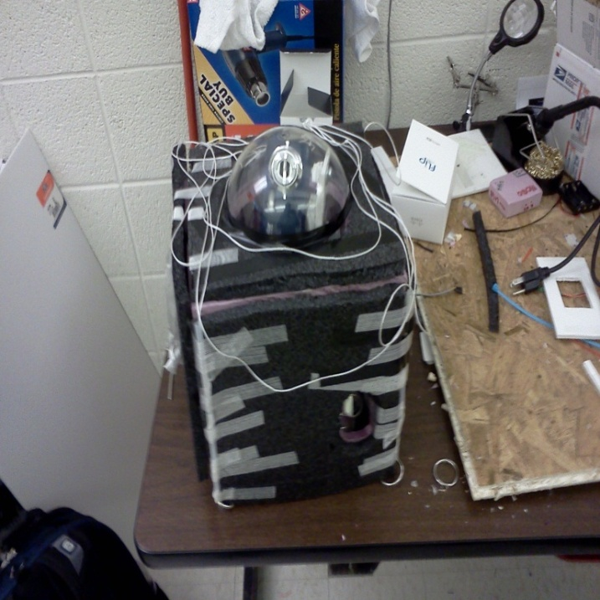

A view of our payload without the shelf in it. The heater is seen in the middle with the Hobo to the left and the Flip video camera to the right. The battery pack in the back is for the heater. The clear section in the top of our payload is a clear dome so the camera can see outside.
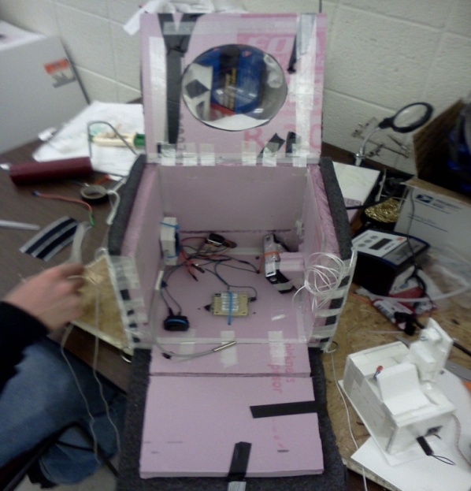

A top view of the payload with the top and side open. The bottom left component is the Hobo. Again the Flip is in the upper left and in the center is the camera mounted on the white inner box.

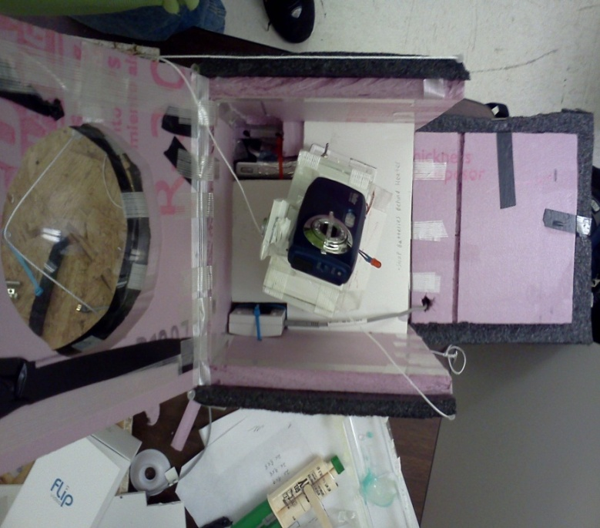

7.0 Test Plan and Results

Plan

-manually filter through individual photographs and pick out successful eclipses
-watch the video and mark times of potential eclipsing
-compare radiation versus altitude data between the ground, the unshielded counter, and the shielded counter and try to identify differences and correlations
-test the capabilities of a program to direct a camera to look at the sun

Results

Pre--flight
Modifications were made to the design prior to launch, some were to increase the likelihood of success (i.e. another flight computer), and others were to make other previously installed items fit (i.e. changing battery locations). In terms of modifications made because of a failed test, non were made in particular. We were not able to perform a drop test with the dome on the payload, but we were confident enough with the acrylic dome that we did not need to do a test on it. Acrylic is a very impact and scratch resistant material which lead us to believe that the dome should survive impact from virtually any angle or direction. Our BSE Flight computer was tested and hooked up to a camera, weather station, and servo. The BSE was also connected to a pc and a diagnostic test was done through the computer and all systems were nominal. Our servo went through a diagnostic test and passed it. Our heater also managed to successfully regulate our internal temperature of our payload during our cold test.

Post-flight
Our final results were less than planned. Our camera stopped taking pictures after 18 pictures, so we have no data from the mounted camera from the flight, although through the audio on the flip video camera he can hear that the servo continued to direct the camera (possibly toward the sun) throughout the entire flight. The results from our video camera were much better though. It recorded the entire flight, and got at least a few of the instances that we were hoping for where just a small speck of the sun was peeking out from behind the partial cover on the camera lens. We have not yet examined the results from the Geiger counters flown on the payload of “up up and away” but as far as we know the counters took the data that they were expected to. It may be difficult to coordinate these with altitude though because of the failure of the positioning systems during the flight.

8.0 Expected science results

For the mounted camera experiment, we hope to see more clarity of pictures as we get higher in the atmosphere. The farther into the atmosphere you go, the unabsorbed radiation from the sun is left. We expected to see better clarity of the sun’s radiation because it would be less dissipated than at the surface of the earth. We did not expect perfection from this experiment because of its complexity. It is dependent on a lot of factors and we weren’t able to test it nearly as much as we had hoped. We expected to get a few good photos, if from nothing else then just from random alignment of our camera and the sun. What we actually expected to see in the pictures were the gases in the corona that encompass the sun, for they are normally not visible because the sun is too blinding when looked at.
Our secondary experiment was a less precise version of the first, but we knew that it would yield results. Given that the camera was tilted at the right angle to view the sun, every time that the payload made a revoltion, there would be a frame where the sun just barely peeked out from the tape that was placed over the camera lens. The video still frames are not as high of quality as the camera shots, but this experiment would at least ensure that we got results.
For the Geiger counter experiment, we expect to see radiation levels increase significantly with altitude. We expect minimal difference between the tin foil shielded counter and the non- shielded counter because of the minimal abilities of tin foil as well as the lack of certain particles (such as alpha particles) in this part of the atmosphere.
For temperature, we expect to see temperature drop linearly until around 50,000 feet of altitude (stratosphere), then level off for around 5,000-10,000, and then steadily increase with altitude. We expected the minimum temperature to be roughly negative 40 to negative 60 degrees farenheit, although the atmosphere’s temperature varies greatly with the seasons and with geographic location.

Temperature vs. Altitude Graph
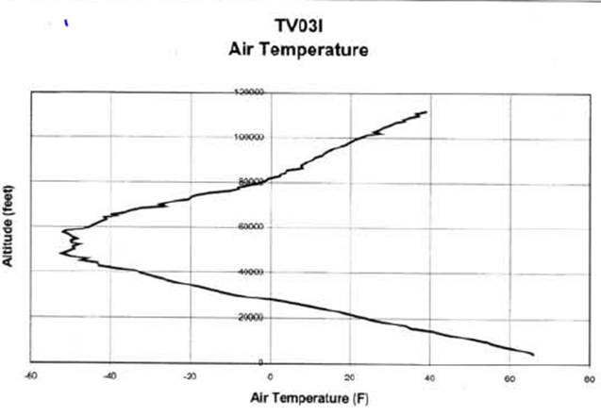
Ref: Paul Verhage Nuts and Volts article February 2004

We expect the pressure to steadily and linearly decrease until around 45,000 feet, and then asymptotically approach 0 millibars after that. As we can see from this graph, the pressure is already below 100 millibars at around 50,000 feet, and by the end of the flight it is extremely low compared to the original, which is around 800 millibars at ground level.

Pressure vs. Altitude graph
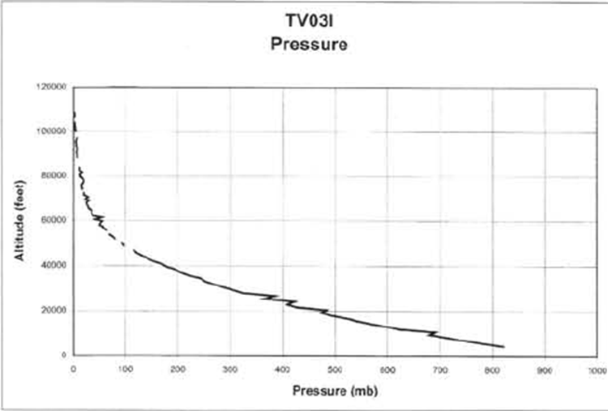
Ref: Paul Verhage Nuts and Volts article February 2004
9.0 Launch and Recovery

Launch: The launch and recovery of the payload occurred on October 29th, 2011. The balloon was launched from Gustavus Adolphus, in St. Peter Minnesota. Prior to launch, the payload was inspected to ensure that no wires or plugs were loose. Following the inspection of the payload, the payload was turned on, this consisted of turning on the flight computer which controlled how the servos interpreted data from the light sensing diodes. After the flight computer was turned on the servo power was enabled so that the servo could rotate when commanded to by the computer. The only step left was securing the payload by putting multiple strips of tape around the payload. The Icarus payload was then attached to the rest of the launch vehicles and finally attached to the already inflated balloon. During lunch, the payloads were carefully released one by one as to not tangle up the lines holding the payloads together. Once released, it was off to tracking.

Tracking: After launch we proceeded to tracking, tracking consists of getting signal, and following that signal until the payload is recovered. Once released, the load could be tracked using Global Positioning Satellites (GPS). One chase vehicle was sent out immediately following the launch while the other vehicles stayed behind to launch another balloon. During the course of tracking, not only were the tracking teams following the GPS signal, but they were also matching up how close the balloon was following the predicted paths. Unfortunately however, because of a turbulent ascension all communication was lost with the payloads, so using where the first balloon fell, and what information was gathered before communication was lost, we were able to create a search radius to determine where the balloon was. This leads to recovery.

Recovery: Recovery took some time because of the loss of signal with the tracking devices. After finding the second balloon, the actual location of landing was compared to that of the predicted model, and after some modifications, a search radius was made that was roughly 10 miles. Following the search of the area, there was one optimistic ping, but it was never found out what it was. Of the initial four search vehicles, three of them returned to campus while the fourth stayed out to search for the payload. After about a half an hour, the payload was discovered in Hollandale Minnesota. The payload was spotted in a plowed corn field that had been tilled. Upon arriving at the landing site, the payloads where still attached to the main parachute, and the buzzer was still sounding. On the Icarus payload, the servo was still moving, this could be determined because the servo makes a distinct sound when it rotates. The flip and Vivatar cameras were both out of battery by the time they were reached. After retrieval, the payloads were turned off and the video and sensor data was analyzed.

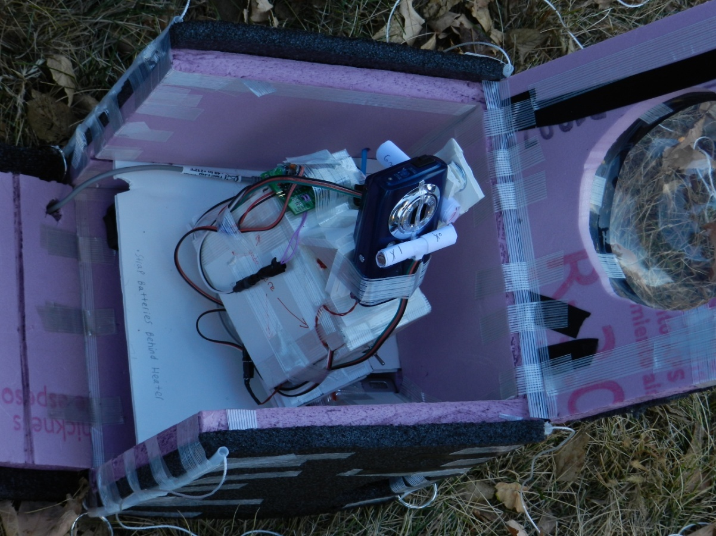
Above: The Icarus payload before being finally taped up and attached to the balloon.

Below: The balloon with attached payloads ready for launch.
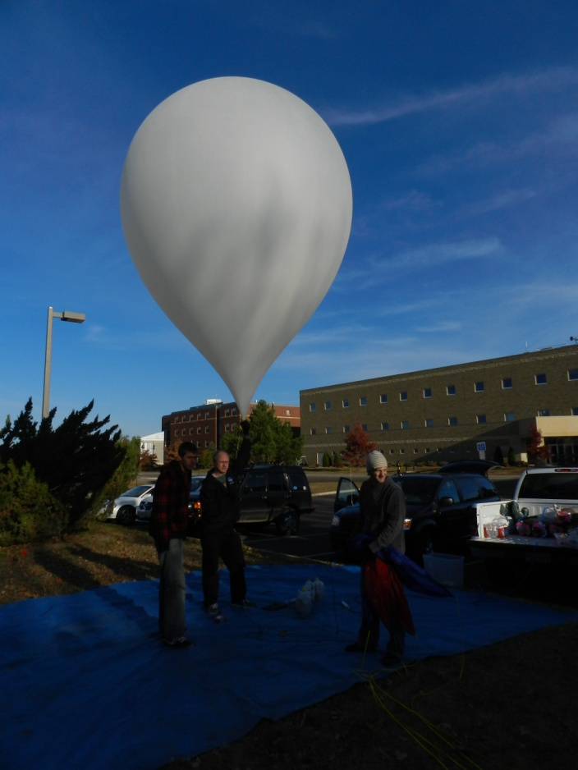

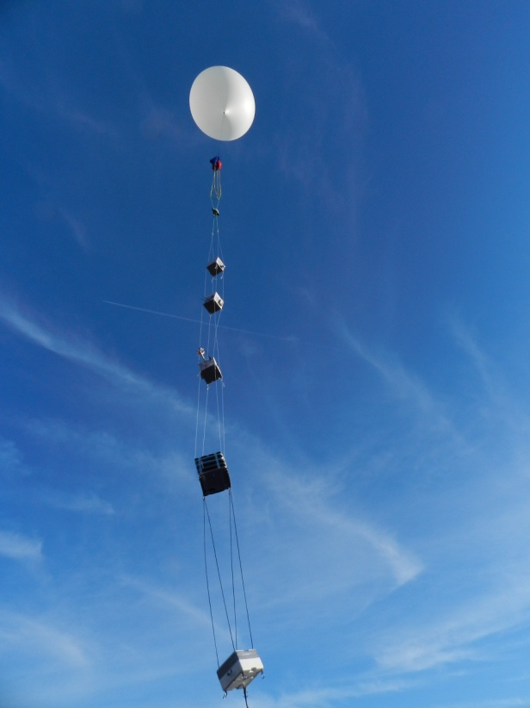
Above: The balloon being launched, roughly 1 min into flight.

Below: The payload as it was discovered, notice the truck in the far background.
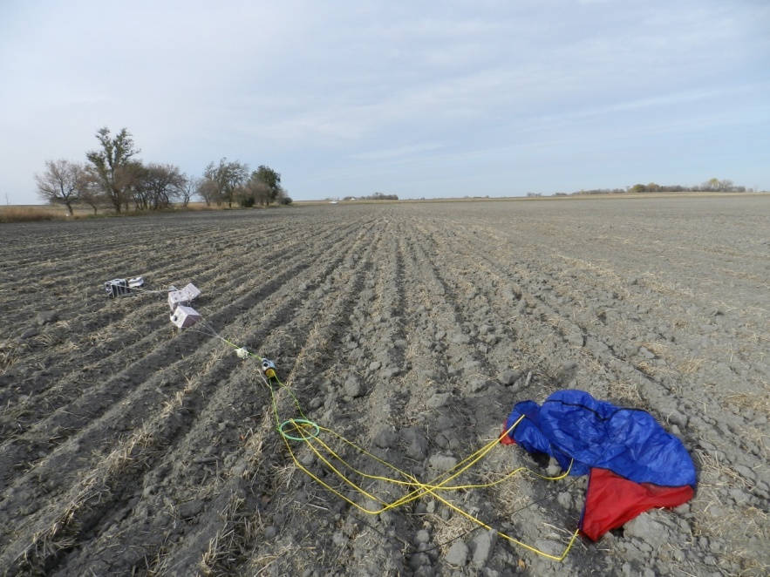
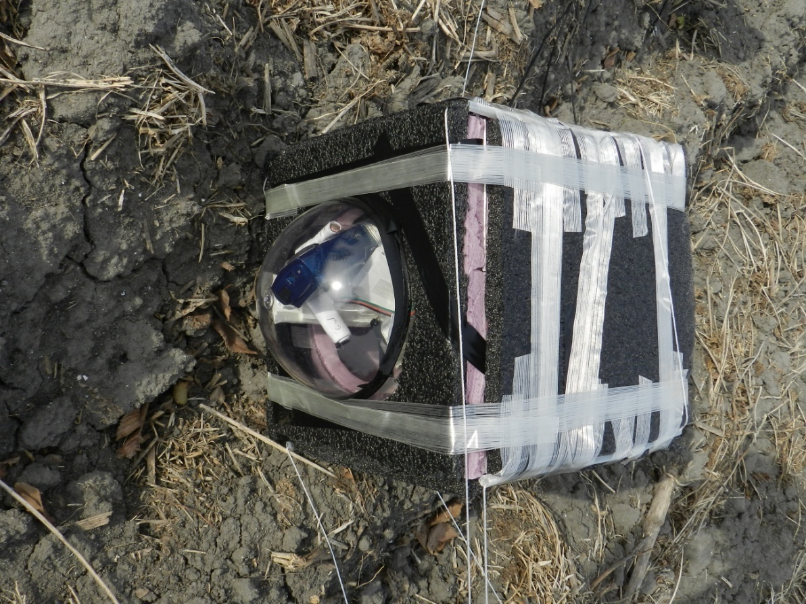
Above: The Icarus payload as it was upon discovery.

Below: Sean Grogan with the payloads just before bringing them back to the University of Minnesota
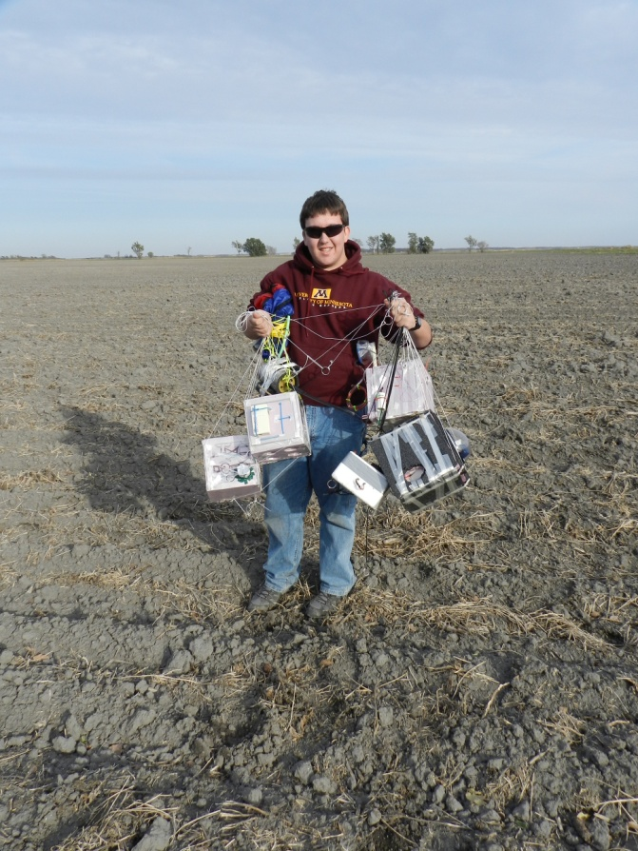
10.0 Results and Analysis

The internal temperature decreases until the balloon reaches chaos (besides the dip in the graph showing where the stratosphere began.) Once the balloon pops, the internal temperature increases until it reaches the ground and then settles around 70°F. The lowest temperature that the inside of our payload got to was about -8°F. Our heater worked but not the best it could have.

The relative humidity seemed to people kind of sporadic. From T=0, the humidity decreased to about 5% but then jumped up to 22% and back down to 0%. This is when the balloon popped. Once the balloon popped, the humidity started to increase until almost 100%. After the peak, the humidity decreased drastically and settled at around 10%.

The external temperature followed the same trend as the internal temperature just colder. The external temperature decreased until it reached the stratosphere, and reached about -70°F. Once the stratosphere was reached, the temperature began to increase and then decrease to -70°F again. During descent, the temperature rose until it settled at 50°F. The reason this is lower than the internal temperature even though it was on the ground is because the heater was on. This shows that our heater did work.

This is another graph showing temperature that is similar to the graph previously shown.

This graph shows that as the balloon traveled through the troposphere the temperature decreased steadily. As the balloon reached the stratosphere and got closer and closer to chaos, the temperature began to rise again.

This graph is very similar to the graph shown earlier. The humidity increased and then decreased during the ascent. Right before the balloon popped, humidity was increased to a peak. After chaos the humidity continuously decreased until it reached the ground.

As seen, the humidity decreased until the balloon was about 20000ft above sea level. The humidity then increased until about 40000ft and then started to decrease until the balloon reached its maximum altitude.

The pressure decreased until chaos and then increased until the balloon reached the ground.

This is the simplest graph collected. As the altitude increases, the pressure decreases.

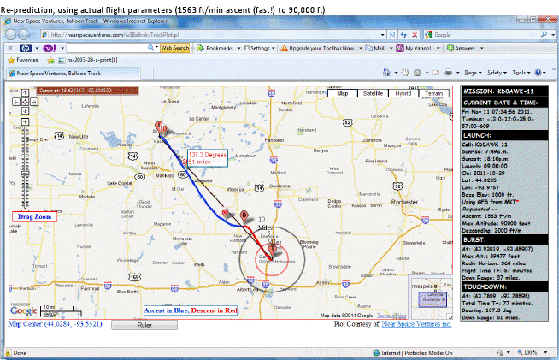
Above: The above picture is the predicted flight path of the balloon, showing launch in St. Peter Mn, and landing in Hollandale Mn.
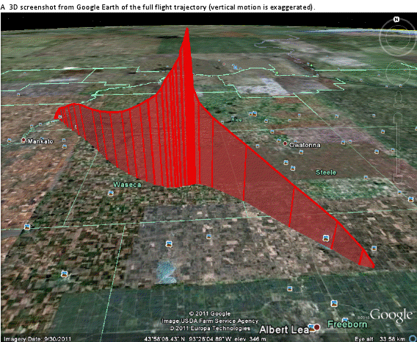
Above: The above image is a 3 dimensional image of the flight that the balloon took

Overall Analysis:

- Launch was approximated at 7.25 minutes into data.
- We can estimate that landing was around 92 minutes into flight from data

11.0 Conclusions

Our two main experiments were the sun tracking experiment and the imaging of the suns corona experiment. We learned from the sun tracking experiment that it was plausible to use a servo in conjunction with light-sensing diodes to point a camera towards the sun. Evidence that this system worked came from the second flight, during which the camera took many promising pictures of the sun. Unfortunately, it turns out that the photos taken of the sun did not actually show the corona. What we at first hoped would be the suns corona turned out to actually be a glare off of condensation in our acrylic dome. We learned from this result that the chances our setup had of capturing a picture of the sun’s corona was much lower than we had originally thought. The NASA project which inspired this experiment, SOHO, is a satellite high in earth’s orbit with very stable positioning systems and a very accurate shielding mechanism that can just shield the whole sun and therefore make the corona very visible. Our system was limited to one plane of rotation with the acrylic dome between it and the sun, inhibiting the clarity of any pictures taken. In addition, our shielding method was simply a thin piece of tape over the lens of the camera. Although we did have promising results, we decided that our equipment was most likely too simple to have a very good chance of actually capturing a picture of the suns corona.

Some changes we would make would be to the camera programming, the type of servo we used, and the setup of the camera. One of the problems we had involving taking pictures of the suns corona was that we could not keep up with rotation of the stack. Our servo and sun tracking programs worked well, but since it would only correct every few seconds, it was not always perfectly aligned with the sun since the stack would rotate in that time. Therefore, we would switch the servo we used for a continuously running servo, so that it would constantly be turning and trying to point at the sun while the stack rotates. We would also then adjust the program for the camera to sense when the camera is pointing at the sun and only take pictures at those points instead of every three seconds. Although this would be another possible source of failure, it would also make processing the pictures much easier since we could then consider every picture taken to be a possible photo of the suns corona. We would not have to sift through a large portion of “empty” photos looking for the few that captured the sun. As far as the setup of the camera is concerned, our problems came from glare off of condensation inside the acrylic dome. The reason that we chose to put a dome on our payload was so that we would have better thermal insulation than if we just left a hole in the top of our box, but this also compromised the experiment. The only alternative would be to find some way to keep moisture out of our box, or find another system of insulation that would still allow the camera its full range of motion without a dome. Since it would be very hard to keep moisture out, we would most likely need to think of another way to deal with condensation or do without the dome.

Words of Wisdom:
- Make sure you know which way is off/on for your heater switch. You don’t want to accidently turn your heater off just before flight.
- Pick an experiment that interests you. It will make the entire class a lot more interesting and enjoyable.
- Don’t be afraid to try something new. Even failure is a valid result.
- You can never have enough tape.

12.0 Appendix: Program Listings
The following code is for the BalloonSat Easy flight computer, this is telling the servo which rotates at one hundred and eighty degrees, to turn in the direction of the highest value. This value comes from the light sensing diodes on the camera body.

Icarus 2011 flight code for BalloonSat Easy to monitor 3 photodetectors and run servo (180 degree only) to point toward the Sun – subroutine to fire the hot-wired camera has been moved to a different computer’s code

'Constants
symbol ch_a=0 ' perpendicular to the sun
symbol ch_b=1 ' pointed at the sun
symbol k1=2
symbol k2=1
symbol c0=127
symbol c1=150
symbol Servo_Pin=3
'End Constants

'variables
symbol x_diff =b0
symbol x0 =b1
symbol x1 =b2
symbol position = b6
symbol pos_start=b7
symbol n = b8
'end variable declarations
start_up:
servo Servo_Pin,150
pause 100

main:
do
readadc Ch_b,x1
if x1<100 then main
readadc ch_a,x0 'test to see what direction the sun is\
if x0>130 then rot_to_x1 'based of ambiant brightness to the
if x0<125 then rot_to_x0 'directional bias
goto stay_there
loop
goto stay_there

rot_to_x1:
readadc ch_a,x0 ' rough location of the sun
x_diff = x0-c0 'scale change function
if x0<125 then rot_to_x0 ' ensures right direction
pos_start =140 + k2*x_diff 'pick a starting location based off of
n=0
x0=0
do
readadc ch_b,x1 ' fine postion algorithm
x_diff = x1-x0 ' deduces position using the
if x_diff<5 then stay_there ' minimum resistance change
position=pos_start+n ' from the original magnitude
servopos Servo_Pin,position ' reposition servo
pause 100
n=n+1 'ensures not out of range
x0=x1 'stack operations for difference
loop while n<20
goto stay_there

rot_to_x0:
readadc ch_a,x0 ' rough location of the sun
x_diff=c0-x0 'scale change function
'the ambiant brightness to generate a
if x0>130 then rot_to_x1
pos_start =160 - k2*x_diff 'pick a starting location based off of
n=0
x0=0
do
readadc ch_b,x1 ' fine postion algorithm
x_diff = x1-x0 ' deduces position using the
if x_diff<5 then stay_there ' minimum resistance change
position=pos_start-n ' from the original magnitude
servopos Servo_Pin,position ' reposition servo
pause 100
n=n+1 'ensures not out of range
x0=x1 'stack operations for difference
loop while n<20
goto stay_there

stay_there:

gosub camera
pause 1000
goto main

camera:

return

Endmission:
end

The following code is that which belongs with the camera. This code tells the camera to fire every five seconds regardless of if the target object is in view of the camera.

Icarus 2011 flight code for BalloonSat mini to take photos on the hot-wired camera every 5 seconds (regardless of the pointing direction)

main:
do
high 2
pause 100
low 2
pause 5000
loop

