University of Minnesota and MN Space Grant Consortium

AEM 1905 Freshman Seminar: Fall 2008
Introduction to Spaceflight with Ballooning
Team Project Documentation

Team Sweetness
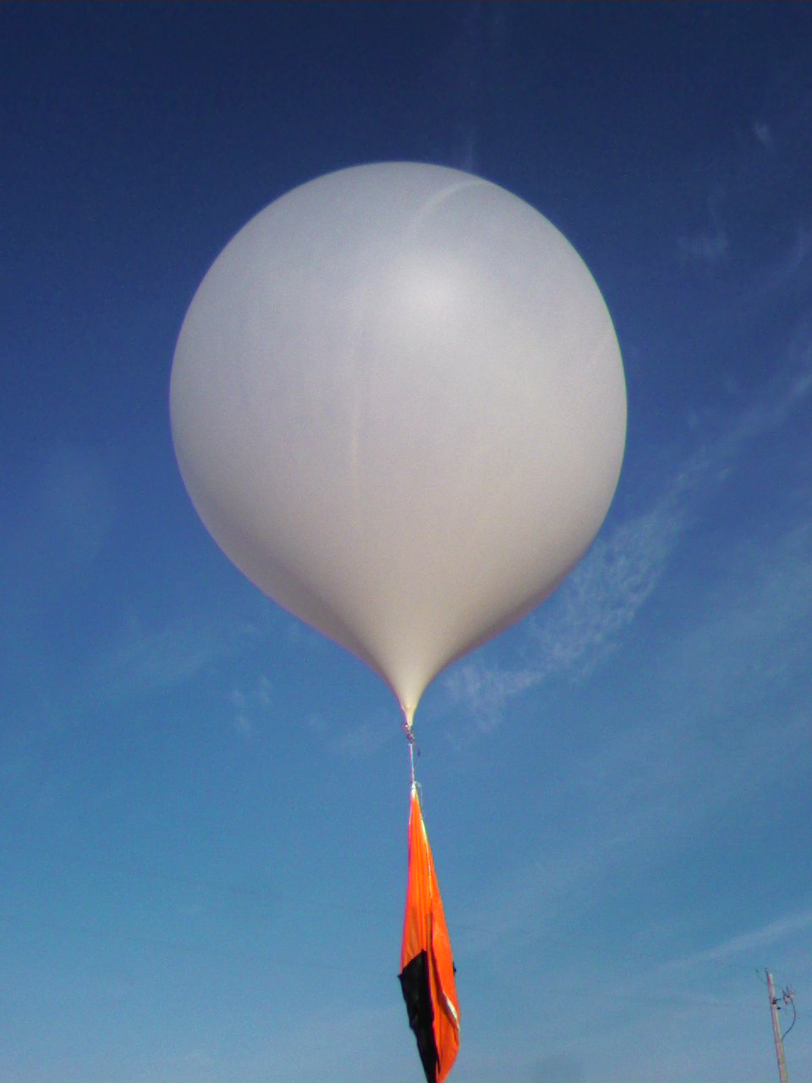

Written by:
Scott Luisi, Trent Quick, Tom Valkenburg, Abe Fark, Jack Szmazda

- Introduction

Space is the final frontier, but not everyone can get into space even in this modern day and age. However, there is an alternative; near space is the upper atmosphere, but it is more than that. This place is just like space in many crucial ways, and it doesn’t cost much to get there; you don’t even need a rocket to reach it.
Going to near space over outer space has many financial and time related benefits. In near space the temperature reaches negative 90 degrees Fahrenheit and due to the altitude you are at it has almost no pressure. These two factors are very important even to NASA scientists because they test materials that will go into real spacecraft in near space.
Getting back to what near space is, this area is defined as being between the altitudes of 75,000 feet and 330,000 feet. The lower bound is based the environment that forms at that altitude and 330,000 feet is the international boundary for outer space. The atmosphere will reach pressures of as little as 1% compared to sea level at only 100,000 feet. An odd occurrence in near space is the fluctuations in temperature. As one would think the temperature does initially go down to as low as -60 degrees or even -90 degrees, but after an object penetrates this cold the temperature slowly begins to go back up to close to 20 degrees Fahrenheit or warmer. This phenomena occurs because of the ozone content in the stratosphere, but after you reach that area of warmth the temperature once again begins to steadily drop and continues to do so until the end of near space.
Overall near space is a fantastic place for the everyday wannabe astronaut. You can get there cheaply and efficiently. The effects are the most similar to those of outer space that you can find on the earth naturally, and you can send up almost any experiment you want. It is a wonderful opportunity to learn and it provides a creative outlet to the everyday person.
2. Mission Overview:
Our mission plan begins by building a stable, insulating container in order to deal with the demanding characteristics of the upper atmosphere. Effects that include declined functionality due to extreme cold as well as the vicious nature of descent and landing. In order to overcome these difficulties our box has two-layer insulation; foam core surrounding foam. The box also contains a battery powered heating circuit that serves to warm the interior of the box throughout the flight. During the descent our box will be attached to a parachute for when it reaches the denser troposphere and it will be attached by strong lightweight ropes in order to stay together in what will more or less be freefall through the stratosphere.
The box itself will contain our experiments and data recording tools. Inside of the box there will be a BASIC stamp II flight computer, which controls the instruments; a HOBO, which records measurements; a camera, which will be taking pictures through various lenses; and the lenses themselves, which will be rotating constantly on a wheel driven by a servo motor. On the outside of the box there will be a weather station, which will take pressure and temperature readings. Also, on the outside of the box solar panels will be mounted which will in turn be attached to the HOBO in order to record voltage measurements.
On our flight our main focus will be on two of our experiments; the camera and the solar panels. As mentioned before our camera will be taking pictures throughout the flight through various lenses. The lenses we have chosen are 2x magnification UV filters, 4x magnification UV filters, and an empty slot so we can reference our filtered pictures to regular ones. Through this experiment we are hoping to discover what the earth looks like through eyes other than our own. Our second important experiment has to do with the voltage output of solar panels. For this experiment we will be placing two solar panels on one side of the box, but one panel will be covered with a Fresnel lens. With this experiment we are trying to see whether focusing the sun's rays onto a solar panel will affect its output. As a side note the experiment will also be able to determine whether or not the solar panels that we are using will work in near space.
Despite the fact that we are focusing on two experiments our box will also be carrying various pressure and temperature sensor. Outside of the box there will be a weather station which will take numerous pressure readings as we go up as well and temperature readings. This information will be useful in determining the functionality of our solar panels. The HOBO unit inside of our box will also be measure temperature, but it will be recording the temperature inside the balloon to see how our box stood against the cold. Lastly onboard there will be a GPS which will track altitude and location. The altitude measurement is for perspective on data and the tracking function is so we can find our balloon after flight completion.

3. Payload Design:
Throughout this project there were many requirements and limitation that had to be considered in order for our team to be able to successfully fly our payload. Our design requirements consisted of rules such as the full payload, which is our box as well as the box’s of the three other groups and two GPS packages, can only weigh twelve pounds. This twelve pounds would include every one of the necessary components in order to fly and to complete our experiment. Our team’s limit is 2.5 lb. These components include our camera, onboard computer, heater, lenses, payload box, temperature and pressure sensor, battery pack (for computer and heater), power switch, the solar panels, and the HOBO data recorder. All of these components are entirely necessary for our payload to fly and function properly. In addition to the rule of only weighing twelve pounds, we had to ensure safety of not only the team but that of others as well. Some of these limitation included having the load being able to be seen by a pilot of an airplane from a far enough distance away so that it can be avoided. A requirement that we had to follow was that we had to perform a specific experiment while in flight. As a team we decided to go through with two experiments. In one of the experiment we needed to use a camera and multiple forms of lenses, and on the other we needed to use two solar panels and attach them on the outside of the box. These are just of a few of the major requirements and limitations that were needed in order to complete our experiment successfully.
Parts & Equipment List:
Filter Wheel and servo
Camera
BASIC stamp flight computer
Weather station
HOBO
Solar Panels- uncovered
Voltage Panels
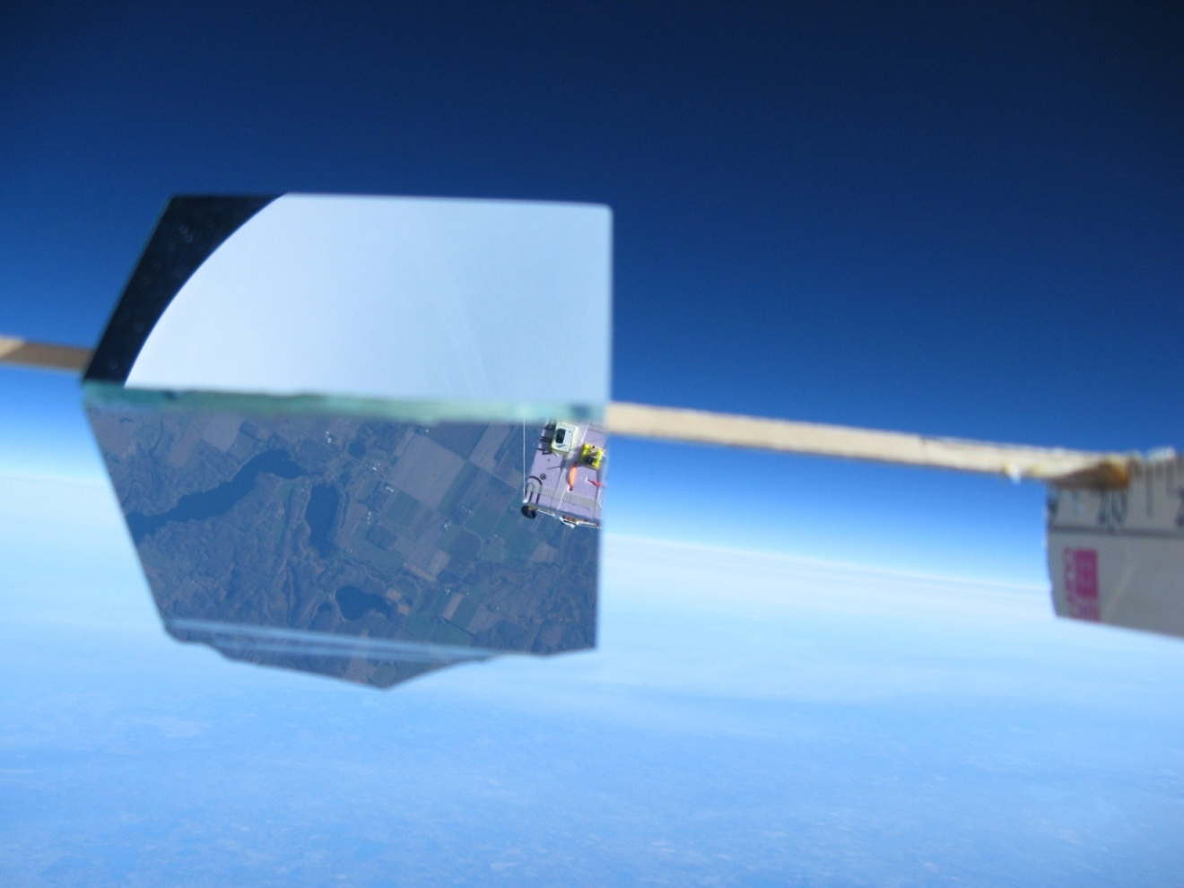

Block Diagrams of Our Payload
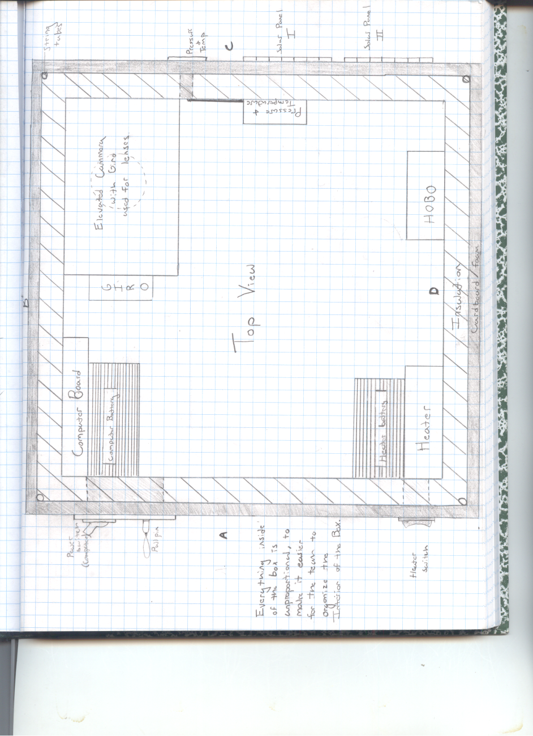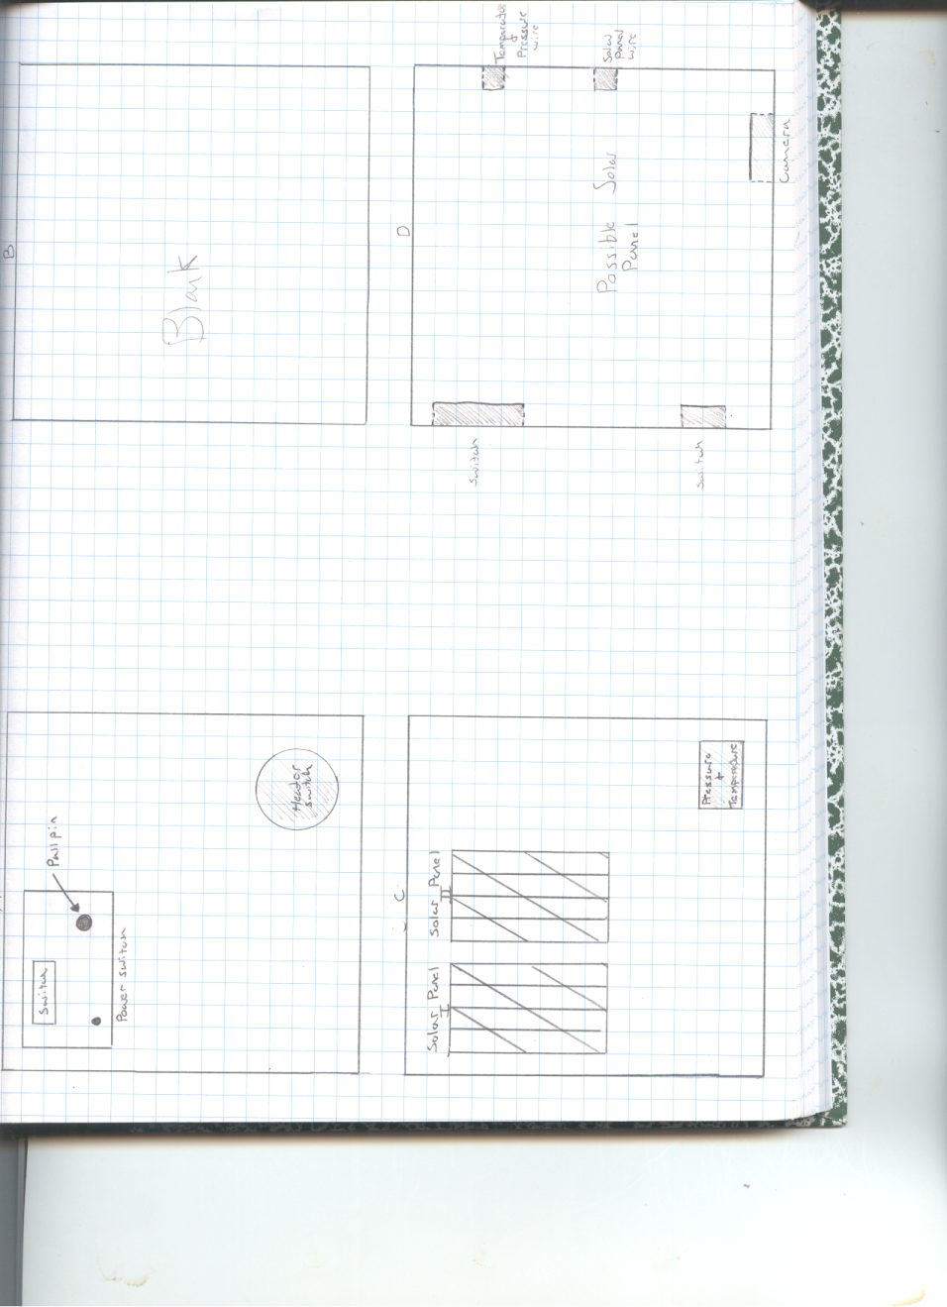
Anticipated internal diagram of our box as viewed from the top
This diagram shows the four horizontal sides of our box
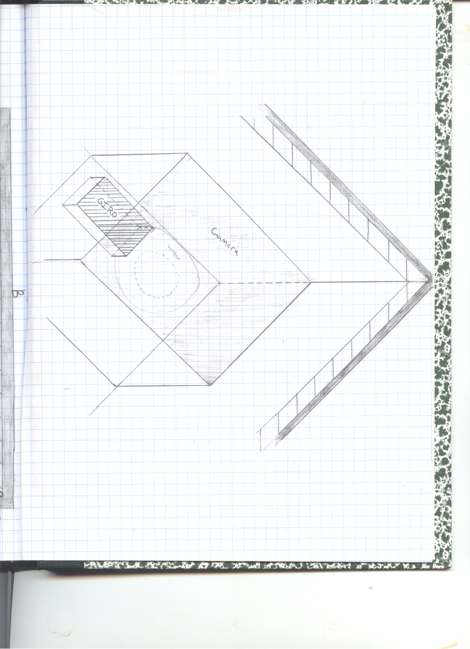

4. Project Management-
 | Building | Building | Building | Building | Testing | Callibration | Data | Project | Oral
 | Shell | Int Elec | Lens | Servo | All | Offsets | Analysis | Document | Presentations
Abe Fark | x | x | x |  | x | x | x | x | x
Jack Szmanda | x | x |  | x | x |  |  | x | x
Scott Luisi |  | x | x | x |  |  | x | x | x
Tom VanValkenburg | x | x |  | x | x |  | x | x | x
Trent Quick | x | x |  | x | x |  | x | x | x

5. Project Budgets-
Project Schedule
October 23 - finish capsule, test electronics
October 31 - have any non-working electronics fixed, programming, cold test,
launch ready
October 1 or 2 - launch (weather dependent)
November 7 - calibrate all results
November 14 to presentation - finish analyzing, formal documentation, and
presentation prep

We will meet as needed on weeknights to stay on schedule.

Money Budget
$166 - Camera
$56 - Flight Computer
$105 - HOBO Data Logger
$28 - HOBO Temperature Sensor Probe
$29 - Weather Station Sensor Pack
$8 - Mini Solar Panel
$5 - Heater Circuit and Switch
$5 - Battery Pack
Total: $402

Mass Budget
.223kg - Camera
.063kg - Flight Computer
.027kg - HOBO Data Logger
.010kg - HOBO Temperature Sensor Probe
.012kg - Weather Station Sensor Pack
.008kg - Mini Solar Panel
.027kg - Heater Circuit and Switch
.110kg - Battery Pack
Total : .48kg
Actual Masses:
Filter Wheel and servo
Camera
BASIC stamp flight computer
Weather station
HOBO
Solar Panels- uncovered
Voltage Panels
Mass- 2.261Kg
6. Payload Photographs-
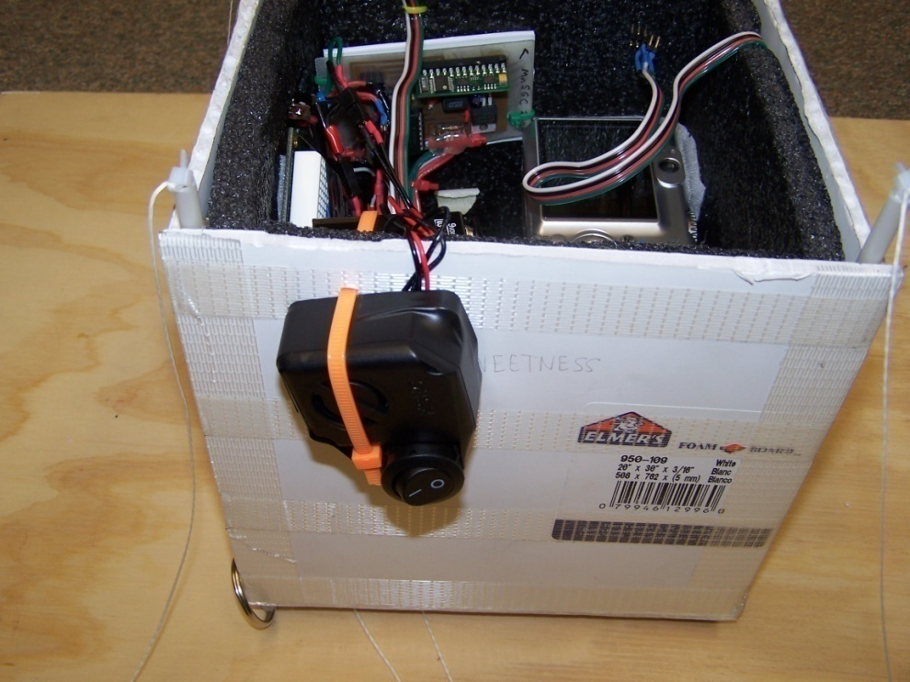
Our payload box preflight with a nice view of the siren and flight computer above that

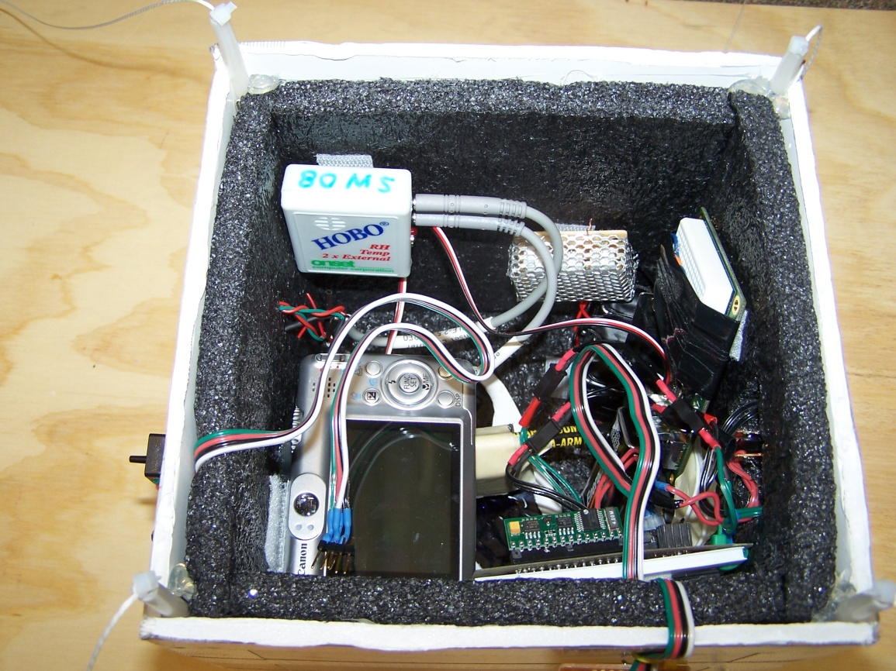
Overhead shot of our payload box preflight. Our camera and and filter wheel below it can be made out in the lower left hand corner, while our flight computer can be seen mounted on the bottom right. Our HOBO and heater are mounted on the opposite wall with our servo taking the right wall.
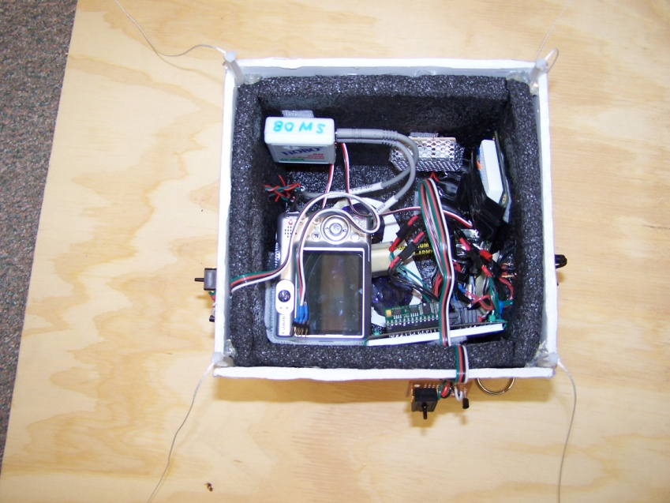
Another overhead view of our payload box for good measure.

7 Test Plan and Results
Our payload was tested in a cold environment by placing it in a container with liquid nitrogen and taking the temperature readings inside and outside the box. We found that our heater kept our box far above the temperature of the outside, although it did let the contents of the box get down to near 0 ° Celsius. Specifically important for these tests is to make sure our heater circuit can sufficiently keep all equipment within the payload warm enough to be in working order. We test our in flight computer by running it through a computer program to make sure it sends the right information back and forth to all of the components attached to it. The main components attached to the in flight computer are the HOBO and the pressure sensors. By having these plugged into the in flight computer we can tell if they are communicating and sending the right information back to the computer. We also will program our camera to take pictures at assigned times. We programmed the camera so that it will take pictures every 15 seconds until we shut it off. We have enough space on our 4 GB memory card for far more than the pictures we will get. We can then tell the camera how often to take pictures. The next thing we need to set up and test is the Servo that will change through our filters in front of the camera lens. This will be set up so it changes filters as often as we would like for taking pictures through different lenses. The last thing to be tested is our solar panels with a Fresnel lens. The panels will be plugged into the HOBO to collect information while the Fresnel lens serves to change the rate at which the solar energy is absorbed. All of the information and data will be relayed from the HOBO back to the in flight computer.

8. Expected Science Results-
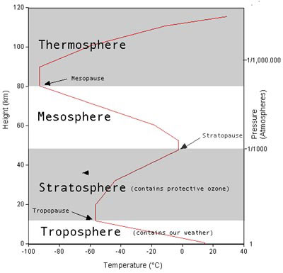
(www.niwa.cri.nz/edu/students/layers) Our payload is primarily concerned with bottom two layers here, until about 27 Km
As far as temperature and pressure go we expect our package to find that it roughly follows this graph. We believe that at the Tropopause the package will experience its coldest temperatures at about -60° Celsius, which is at about 10 Km. At the peak of its ascent the temperature likely will increase slightly to maybe about -50° Celsius before the balloon pops and begins its descent. Atmospheric pressure should decrease steadily until its practically zero at the peak of its ascent.
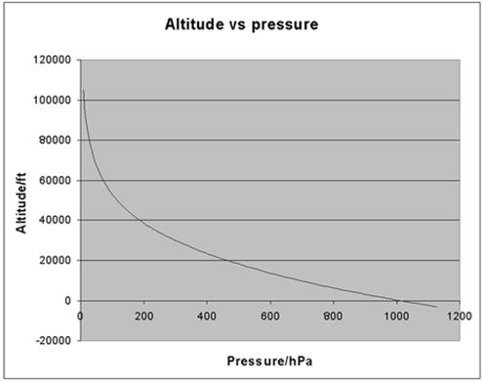
http://www.kitesite.com.au/kiterecord/index_image6511.jpg
UV filters when directed at plants and foliage will make them different colors such as bright pink and purple depending upon the Ultraviolet wavelengths it absorbs. This could tell us which plants begin to be affected by the cold weather and shed their leaves earlier in fall, and if we can find data about what wavelengths certain plants absorb we could find the distribution of that plant in the area we will survey.
This experiment is a challenging one to quantify but I think it will work out that if we compare the black level of the balloon to the black level of the sky and make that comparison into a ratio that we will be able to plot the data versus time and/or altitude. We expect the results to be somewhat linear although at breaks between the atmospheric levels there may be an overall change in how fast the blackness progresses.
Unfortunately there are no graphs with which we can get an idea of how the data may turn out.
9. Flight Day
Flight day for me, Scott, was a bit of a predicament because long beforehand I knew I would be the only team member attending. So, it started on a bit of a low note. It began like this, my alarm making annoying and quite unnecessary blaring noises in my ear. I knew not why my alarm had chosen to torture me so, and took me a while to realize that it was only trying to help me wake up, and make my appointment, promptly, and on time. I finally realized the error in my ways and turned my helpful alarm off and lifted myself out with a herculean effort, and showered and dressed in preparation for the long day ahead. I then rushed out of my dorm to get to Akerman and catch the van. I made it just in time, while munching on a pop tart and climbed into my assigned van. It was wonderfully entertaining to be in a van full of other freshman just as sleep deprived as I was, but before long we were all falling asleep. Before long we were at the launch point next to the church, which itself was near Turtle Lake. The launch preparations went well and didn’t take too much time, although the cold was a bit overbearing at times. Unfortunately David and I must have missed a mistake with our camera because we would find that had not taken any photographs the entire flight. But our flight launch was smooth and routine. The chase also was remarkably quick, with only one small slip up occurring when we turned down the wrong road and had to turn around. In fact, we found the package, easily visible from the road, lying nicely in a row on a farmer’s field.
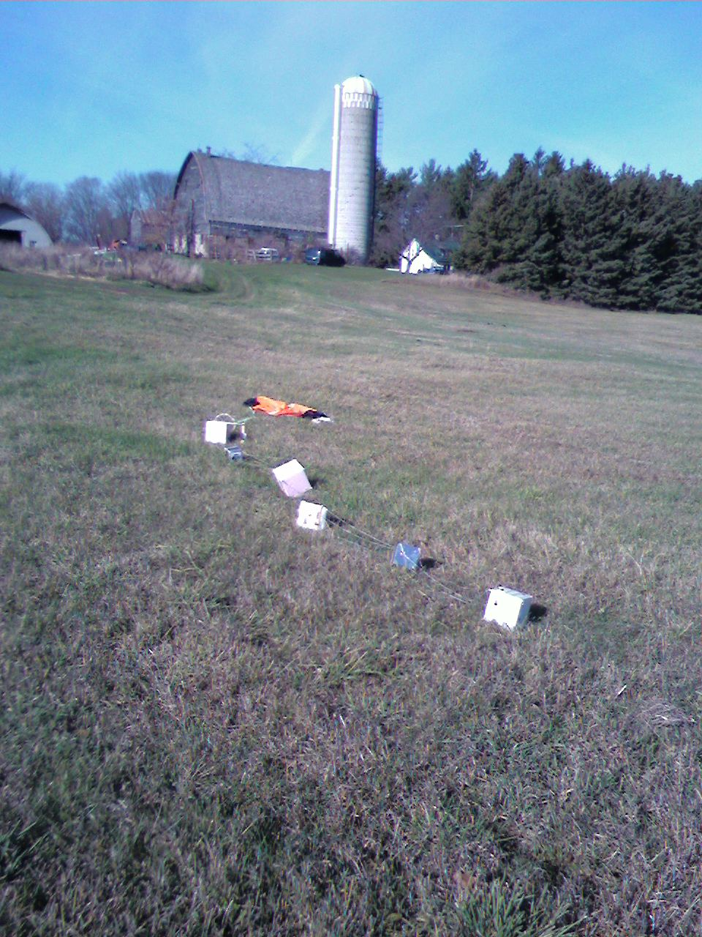
There were also a group of tiny cute kittens frolicking about to lighten the mood for what I was about to find out. What I soon found out was that our UV lens experiment completely failed. That is to say, we got no data whatsoever. I opened the box and found the pencil we had propped our camera up with shattered and everything else in our box had a thin layer of frost on it. I soon found out that there were no pictures to be found on our camera, and our solar panel test obviously didn’t have any useful data because of the absence of a Fresnel lens. So I was a little disappointed with the results of our experiments at that point, but I still left the day with a sense of accomplishment for helping build something that made it to 90000 feet and back in one piece.
10. Science Results
This is the altitude of the graph versus time in minutes.
Pressure in Psi against time in minutes.
Our plot of temperature versus time in minutes, and Temperature in Celsius
Temperature in Celsius against our altitude in feet for the ascent
Pressure in psi against altitude in feet for our balloons ascent.
At first out data seemed almost unusable because we were supposed to deduce the progression of blackness with what seemed like nothing. However with the help of a Photoshop editing tool we were able to quantify the black levels in a number of selected photographs. The blackness plot that is attached is the graph format of the rendered data.
To get this data we had to use a Photoshop editing tool to derive the blackness values. We used close to 25 photos in our data analysis. However, we ran into quite a few problems with trying to make the data consistent. One major problem we had was the sun; it had worked its way directly into some of the photos, so we had to choose different photos from the same time frame to make up for the lost photos. Another problem was the fact that the Photoshop tool we were using only put percentage values on the amount of black that there was in each picture, so this may have led to some error because we were not able to use a ratio like originally planned. Another source of error in time stamping the photos was that a release time was never specifically given so our time data may also be a bit skewed. The largest source of error was related to the way in which it was gathered. We believe that the mirror either was dirty when it was flown or that it had developed condensation as it went up, because the upper photos had a large range of blackness values, so we were reduced to simply choosing the highest values we could find. The source of this variance in the upper atmosphere may also be due to the larger influence of stars other than the sun. One final source of possible error relates back to the ratio problem, the pictures we used all had a balloon blackness value of zero. This takes away the possibility of using a ratio to put eliminate the effects the sun had on altering the blackness levels which we believe caused the more severe breaks from the trend line.
Overall however the data was not that skewed besides a few exceptions. The graph followed the pattern of getting darker as the balloon went up but it followed more of a curved path. There were 2 large changes in the slope of the trend line, these changes occurred between 1600 seconds to 1900 seconds and from 2250 seconds to 2900 seconds. The first change occurred at an average altitude of approximately 35,000 feet and the second at approximately 52,000 feet. The first change happens directly before we go through the barrier between the troposphere and the mesosphere. It is our opinion that the second change happens simply because the atmosphere is becoming so thin that it is getting harder and harder to absorb light, so the camera is picking up less and less of the suns ambiance and more and more of the blackness of space.
We were also going to compare the blackness of the horizon through color comparison and blackness evaluation but it would have been very very difficult to get the data to be consistent because the camera was moving so much. In order to quantify the horizon blackness we were going to pick a point in the picture and continually evaluate that spot for changes, but the camera and the horizon moved so much in the pictures that it would be almost impossible to get enough sample data that was at least somewhat consistent.
If we were to do this again we would have cleaned the mirror directly before launch in order to assure that it took the best pictures possible. We also would have made the box more stable, so that we could take reliable photos of the horizon for analysis. If we launched the camera again we would have make the chords attaching the box to the balloon stronger and put some extra weight in the box so it would not be so easily thrown around. In our data analysis we might also try using a different program for the color identification so our results would take into account the presence of the sun.
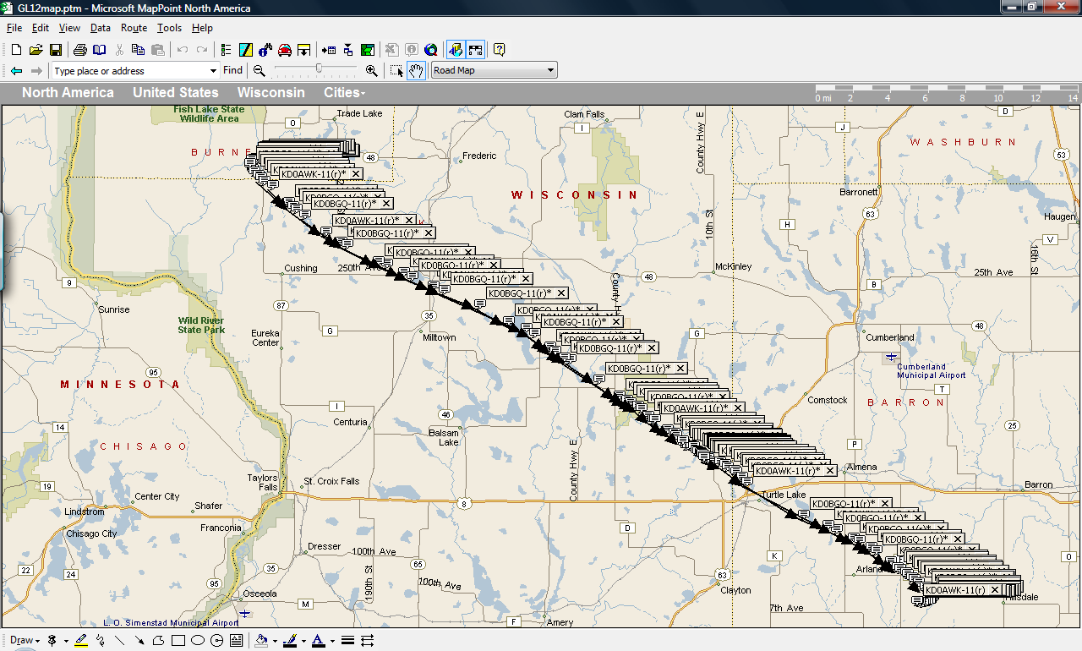
Here is our flight path as given by our GPS beacons in tow with our packages. Our flight followed much of the expected flight path and landed better than we could have possibly expected.
11. Conclusion & Lessons Learned
Throughout this semester our group, Team Sweetness, had earned the
reputation of being one of the only groups to some how find a way of
screwing up both of our launches. Even though neither of the launches were
successful, the group came to the conclusions that we all greatly enhanced
our knowledge in the field of near space, to space flight. Throughout this
past semester we believe that we made leaps and bounds in both our
knowledge on the flight itself, and on the creation of our payload. In
conclusion we leave by saying this one all important thing, never let your
guard down, because one minute you could have a vision of the best payload
box ever, and the next you could possibly realize that your box will never
be perfect, its all in improving it from what you have learned.

