On-line aprs tracking record for GopherLaunch 68A – workshop payload Z – Thursday, August 8, 2013

“Fox” tracker from Stratostar (KC9QBK-6) gave fairly good tracking during the entire flight. Other aprs tracker (RTrak) failed.

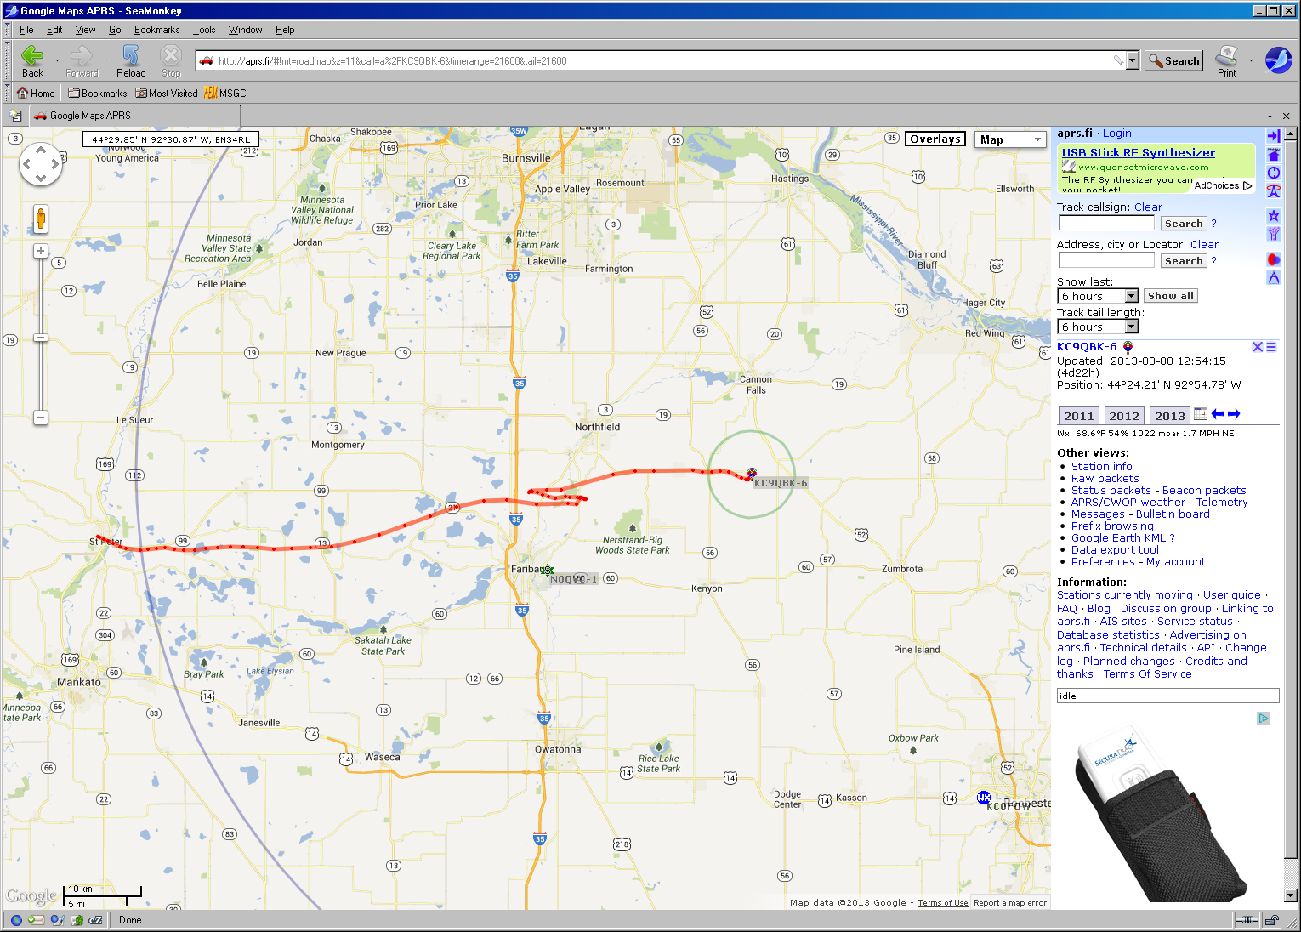

Landing zone and final data point to make it to the internet. Chase vehicles picked up transmissions from the ground upon approach.

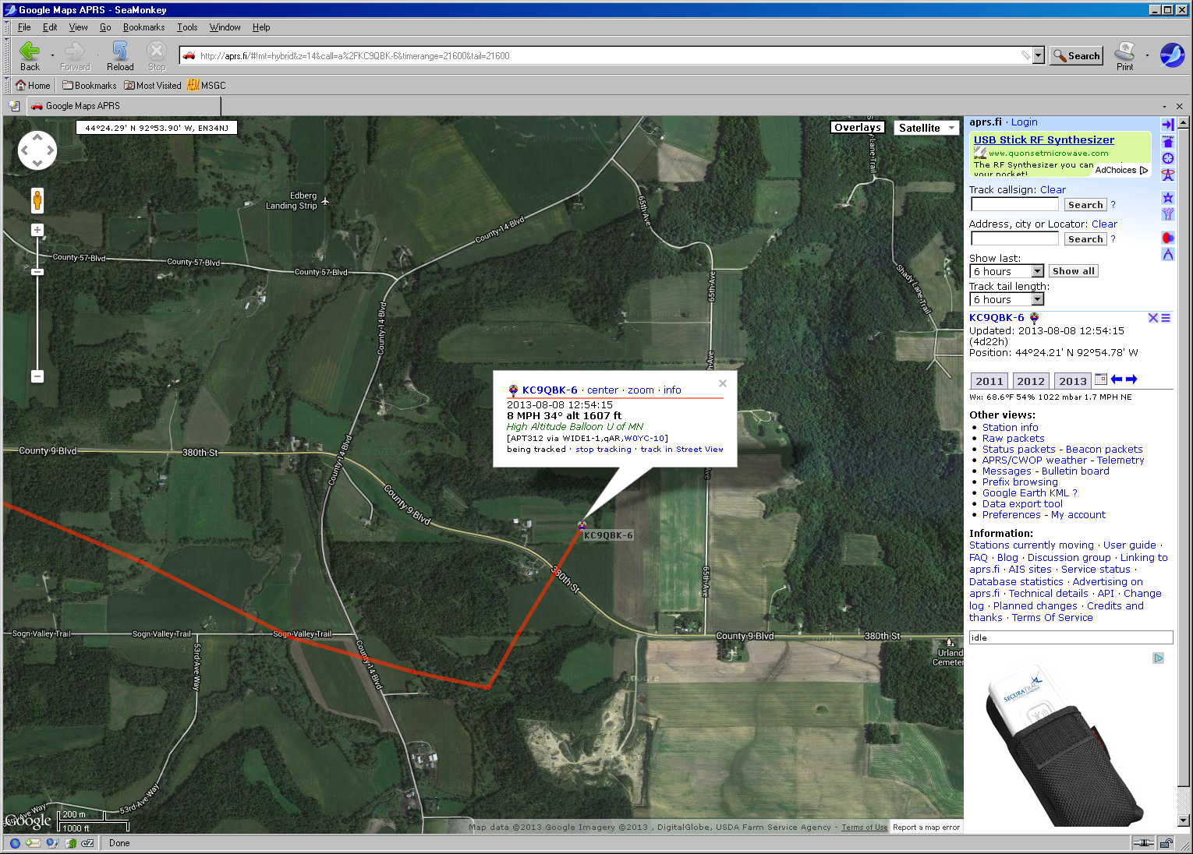

Raw data from KC9QBK-6 (Stratostar aprs) transmitter. (Red text indicating suspect data points has gone missing in cut-and-paste step but still identifiable by warning messages.)

2013-08-08 11:34:59 CDT: [**KC9QBK-6**](http://aprs.fi/?c=raw&limit=&call=KC9QBK-6)>APT312,WIDE1-1,qAR,[W0YC-10](http://aprs.fi/?c=raw&limit=&call=W0YC-10):!4419.88N/09358.12WO089/012/A=005209/High Altitude Balloon U of MN  
2013-08-08 11:35:59 CDT: [**KC9QBK-6**](http://aprs.fi/?c=raw&limit=&call=KC9QBK-6)>APT312,WIDE1-1,qAR,[W0YC-10](http://aprs.fi/?c=raw&limit=&call=W0YC-10):!4419.82N/09357.94WO114/023/A=006357  
2013-08-08 11:37:00 CDT: [**KC9QBK-6**](http://aprs.fi/?c=raw&limit=&call=KC9QBK-6)>APT312,[KD0IXB-2](http://aprs.fi/?c=raw&limit=&call=KD0IXB-2),WIDE1*,qAR,[KB0NLY-2](http://aprs.fi/?c=raw&limit=&call=KB0NLY-2):!4419.73N/09357.55WO091/030/A=007581/High Altitude Balloon U of MN  
2013-08-08 11:38:00 CDT: [**KC9QBK-6**](http://aprs.fi/?c=raw&limit=&call=KC9QBK-6)>APT312,[N0TZH-10*](http://aprs.fi/?c=raw&limit=&call=N0TZH-10),qAR,[W0KGW-10](http://aprs.fi/?c=raw&limit=&call=W0KGW-10):!4419.60N/09357.11WO148/015/A=008851  
2013-08-08 11:38:59 CDT: [**KC9QBK-6**](http://aprs.fi/?c=raw&limit=&call=KC9QBK-6)>APT312,WIDE1-1,qAR,[W0YC-10](http://aprs.fi/?c=raw&limit=&call=W0YC-10):!4419.41N/09356.65WO113/028/A=010081/High Altitude Balloon U of MN  
2013-08-08 11:39:59 CDT: [**KC9QBK-6**](http://aprs.fi/?c=raw&limit=&call=KC9QBK-6)>APT312,WIDE1-1,qAR,[W0YC-10](http://aprs.fi/?c=raw&limit=&call=W0YC-10):!4419.19N/09356.02WO130/027/A=011272  
2013-08-08 11:41:00 CDT: [**KC9QBK-6**](http://aprs.fi/?c=raw&limit=&call=KC9QBK-6)>APT312,WIDE1-1,qAR,[KB0NLY-2](http://aprs.fi/?c=raw&limit=&call=KB0NLY-2):!4419.10N/09355.40WO066/023/A=012456/High Altitude Balloon U of MN  
2013-08-08 11:43:00 CDT: [**KC9QBK-6**](http://aprs.fi/?c=raw&limit=&call=KC9QBK-6)>APT312,WIDE1-1,qAS,[K0GV](http://aprs.fi/?c=raw&limit=&call=K0GV):!4418.97N/09353.97WO081/028/A=014992/High Altitude Balloon U of MN  
2013-08-08 11:44:01 CDT: [**KC9QBK-6**](http://aprs.fi/?c=raw&limit=&call=KC9QBK-6)>APT312,[N0TZH-10*](http://aprs.fi/?c=raw&limit=&call=N0TZH-10),qAR,[W0KGW-10](http://aprs.fi/?c=raw&limit=&call=W0KGW-10):!4419.02N/09353.28WO085/044/A=016337  
2013-08-08 11:45:00 CDT: [**KC9QBK-6**](http://aprs.fi/?c=raw&limit=&call=KC9QBK-6)>APT312,WIDE1-1,qAR,[KB0NLY-2](http://aprs.fi/?c=raw&limit=&call=KB0NLY-2):!4419.09N/09352.46WO093/039/A=017669/High Altitude Balloon U of MN  
2013-08-08 11:46:00 CDT: [**KC9QBK-6**](http://aprs.fi/?c=raw&limit=&call=KC9QBK-6)>APT312,WIDE1-1,qAS,[K0GV](http://aprs.fi/?c=raw&limit=&call=K0GV):!4419.15N/09351.63WO095/042/A=019004  
2013-08-08 11:47:01 CDT: [**KC9QBK-6**](http://aprs.fi/?c=raw&limit=&call=KC9QBK-6)>APT312,WIDE1-1,qAR,[W0YC-10](http://aprs.fi/?c=raw&limit=&call=W0YC-10):!4419.03N/09350.75WO107/036/A=020336/High Altitude Balloon U of MN  
2013-08-08 11:48:01 CDT: [**KC9QBK-6**](http://aprs.fi/?c=raw&limit=&call=KC9QBK-6)>APT312,WIDE1-1,qAR,[KB0NLY-2](http://aprs.fi/?c=raw&limit=&call=KB0NLY-2):!4418.97N/09349.83WO084/035/A=021675  
2013-08-08 11:49:02 CDT: [**KC9QBK-6**](http://aprs.fi/?c=raw&limit=&call=KC9QBK-6)>APT312,[N0QVC-1*](http://aprs.fi/?c=raw&limit=&call=N0QVC-1),qAR,[W0YC-10](http://aprs.fi/?c=raw&limit=&call=W0YC-10):!4418.98N/09348.72WO078/049/A=022977/High Altitude Balloon U of MN  
2013-08-08 11:50:01 CDT: [**KC9QBK-6**](http://aprs.fi/?c=raw&limit=&call=KC9QBK-6)>APT312,WIDE1-1,qAS,[K0GV](http://aprs.fi/?c=raw&limit=&call=K0GV):!4419.05N/09347.63WO084/060/A=024247  
2013-08-08 11:51:03 CDT: [**KC9QBK-6**](http://aprs.fi/?c=raw&limit=&call=KC9QBK-6)>APT312,[WB0MPE-10*](http://aprs.fi/?c=raw&limit=&call=WB0MPE-10),qAR,[N9CHA-4](http://aprs.fi/?c=raw&limit=&call=N9CHA-4):!4419.13N/09346.51WO075/053/A=025556/High Altitude Balloon U of MN  
2013-08-08 11:52:01 CDT: [**KC9QBK-6**](http://aprs.fi/?c=raw&limit=&call=KC9QBK-6)>APT312,WIDE1-1,qAS,[K0GV](http://aprs.fi/?c=raw&limit=&call=K0GV):!4419.17N/09345.28WO084/048/A=026930  
2013-08-08 11:53:02 CDT: [**KC9QBK-6**](http://aprs.fi/?c=raw&limit=&call=KC9QBK-6)>APT312,WIDE1-1,qAS,[K0GV](http://aprs.fi/?c=raw&limit=&call=K0GV):!4419.17N/09344.01WO087/062/A=028226/High Altitude Balloon U of MN  
2013-08-08 11:54:02 CDT: [**KC9QBK-6**](http://aprs.fi/?c=raw&limit=&call=KC9QBK-6)>APT312,[N9XH-3](http://aprs.fi/?c=raw&limit=&call=N9XH-3),WIDE1*,qAR,[N9CHA-4](http://aprs.fi/?c=raw&limit=&call=N9CHA-4):!4419.14N/09342.62WO093/072/A=029571  
2013-08-08 11:55:02 CDT: [**KC9QBK-6**](http://aprs.fi/?c=raw&limit=&call=KC9QBK-6)>APT312,WIDE1-1,qAR,[W0YC-10](http://aprs.fi/?c=raw&limit=&call=W0YC-10):!4419.03N/09341.06WO098/074/A=030857/High Altitude Balloon U of MN  
2013-08-08 11:56:02 CDT: [**KC9QBK-6**](http://aprs.fi/?c=raw&limit=&call=KC9QBK-6)>APT312,WIDE1-1,qAR,[N0RGA](http://aprs.fi/?c=raw&limit=&call=N0RGA):!4419.05N/09339.31WO093/084/A=032222  
2013-08-08 11:57:02 CDT: [**KC9QBK-6**](http://aprs.fi/?c=raw&limit=&call=KC9QBK-6)>APT312,WIDE1-1,qAS,[K0GV](http://aprs.fi/?c=raw&limit=&call=K0GV):!4419.14N/09337.54WO090/069/A=033603/High Altitude Balloon U of MN  
2013-08-08 11:58:02 CDT: [**KC9QBK-6**](http://aprs.fi/?c=raw&limit=&call=KC9QBK-6)>APT312,WIDE1-1,qAR,[W0YC-10](http://aprs.fi/?c=raw&limit=&call=W0YC-10):!4419.22N/09335.47WO082/099/A=034942  
2013-08-08 11:59:03 CDT: [**KC9QBK-6**](http://aprs.fi/?c=raw&limit=&call=KC9QBK-6)>APT312,WIDE1-1,qAS,[K0GV](http://aprs.fi/?c=raw&limit=&call=K0GV):!4419.52N/09333.21WO071/089/A=036418/High Altitude Balloon U of MN  
2013-08-08 12:00:03 CDT: [**KC9QBK-6**](http://aprs.fi/?c=raw&limit=&call=KC9QBK-6)>APT312,WIDE1-1,qAS,[K0GV](http://aprs.fi/?c=raw&limit=&call=K0GV):!4420.01N/09330.89WO070/130/A=037822  
2013-08-08 12:01:03 CDT: [**KC9QBK-6**](http://aprs.fi/?c=raw&limit=&call=KC9QBK-6)>APT312,WIDE1-1,qAR,[KD0KYA](http://aprs.fi/?c=raw&limit=&call=KD0KYA):!4420.68N/09328.38WO068/116/A=039193/High Altitude Balloon U of MN  
2013-08-08 12:02:03 CDT: [**KC9QBK-6**](http://aprs.fi/?c=raw&limit=&call=KC9QBK-6)>APT312,WIDE1-1,qAR,[KD0KYA](http://aprs.fi/?c=raw&limit=&call=KD0KYA):!4421.32N/09325.87WO074/110/A=040620  
2013-08-08 12:03:03 CDT: [**KC9QBK-6**](http://aprs.fi/?c=raw&limit=&call=KC9QBK-6)>APT312,WIDE1-1,qAR,[KD0KYA](http://aprs.fi/?c=raw&limit=&call=KD0KYA):!4421.96N/09323.33WO074/114/A=042054/High Altitude Balloon U of MN  
2013-08-08 12:04:03 CDT: [**KC9QBK-6**](http://aprs.fi/?c=raw&limit=&call=KC9QBK-6)>APT312,WIDE1-1,qAS,[NX0P](http://aprs.fi/?c=raw&limit=&call=NX0P):!4422.35N/09320.69WO082/097/A=043616  
2013-08-08 12:05:04 CDT: [**KC9QBK-6**](http://aprs.fi/?c=raw&limit=&call=KC9QBK-6)>APT312,WIDE1-1,qAS,[K0GV](http://aprs.fi/?c=raw&limit=&call=K0GV):!4422.42N/09318.48WO104/088/A=045125/High Altitude Balloon U of MN  
2013-08-08 12:07:04 CDT: [**KC9QBK-6**](http://aprs.fi/?c=raw&limit=&call=KC9QBK-6)>APT312,WIDE1-1,qAS,[K0GV](http://aprs.fi/?c=raw&limit=&call=K0GV):!4422.17N/09315.59WO096/065/A=048146/High Altitude Balloon U of MN  
2013-08-08 12:10:05 CDT: [**KC9QBK-6**](http://aprs.fi/?c=raw&limit=&call=KC9QBK-6)>APT312,WIDE1-1,qAR,[KD0KYA](http://aprs.fi/?c=raw&limit=&call=KD0KYA):!4422.20N/09312.58WO104/043/A=053284  
2013-08-08 12:12:05 CDT: [**KC9QBK-6**](http://aprs.fi/?c=raw&limit=&call=KC9QBK-6)>APT312,WIDE1-1,qAR,[NG0W-10](http://aprs.fi/?c=raw&limit=&call=NG0W-10):!4422.16N/09311.72WO070/016/A=056968  
2013-08-08 12:14:06 CDT: [**KC9QBK-6**](http://aprs.fi/?c=raw&limit=&call=KC9QBK-6)>APT312,WIDE1-1,qAS,[NX0P](http://aprs.fi/?c=raw&limit=&call=NX0P):!4422.55N/09311.38WO056/021/A=060629  
2013-08-08 12:16:06 CDT: [**KC9QBK-6**](http://aprs.fi/?c=raw&limit=&call=KC9QBK-6)>APT312,WIDE1-1,qAR,[KD0KYA](http://aprs.fi/?c=raw&limit=&call=KD0KYA):!4422.52N/09310.85WO029/028/A=064257  
2013-08-08 12:18:07 CDT: [**KC9QBK-6**](http://aprs.fi/?c=raw&limit=&call=KC9QBK-6)>APT312,WIDE1-1,qAR,[W0KGW-10](http://aprs.fi/?c=raw&limit=&call=W0KGW-10):!4422.52N/09310.99WO273/005/A=067981  
2013-08-08 12:19:07 CDT: [**KC9QBK-6**](http://aprs.fi/?c=raw&limit=&call=KC9QBK-6)>APT312,WIDE1-1,qAR,[W0KGW-10](http://aprs.fi/?c=raw&limit=&call=W0KGW-10):!4422.61N/09311.21WO264/018/A=069772/High Altitude Balloon U of MN  
2013-08-08 12:20:07 CDT: [**KC9QBK-6**](http://aprs.fi/?c=raw&limit=&call=KC9QBK-6)>APT312,WIDE1-1,qAR,[W0KGW-10](http://aprs.fi/?c=raw&limit=&call=W0KGW-10):!4422.61N/09311.44WO221/033/A=071498  
2013-08-08 12:21:07 CDT: [**KC9QBK-6**](http://aprs.fi/?c=raw&limit=&call=KC9QBK-6)>APT312,WIDE1-1,qAS,[K0GV](http://aprs.fi/?c=raw&limit=&call=K0GV):!4422.59N/09311.65WO196/022/A=073378/High Altitude Balloon U of MN  
2013-08-08 12:23:09 CDT: [**KC9QBK-6**](http://aprs.fi/?c=raw&limit=&call=KC9QBK-6)>APT312,[W0MXW-3](http://aprs.fi/?c=raw&limit=&call=W0MXW-3),WIDE1*,qAR,[KC0FOW](http://aprs.fi/?c=raw&limit=&call=KC0FOW):!4422.62N/09312.41WO254/019/A=076940/High Altitude Balloon U of MN  
2013-08-08 12:24:08 CDT: [**KC9QBK-6**](http://aprs.fi/?c=raw&limit=&call=KC9QBK-6)>APT312,[W0MXW-3](http://aprs.fi/?c=raw&limit=&call=W0MXW-3),WIDE1*,qAR,[KC0FOW](http://aprs.fi/?c=raw&limit=&call=KC0FOW):!4422.65N/09312.78WO275/034/A=078600  
2013-08-08 12:26:08 CDT: [**KC9QBK-6**](http://aprs.fi/?c=raw&limit=&call=KC9QBK-6)>APT312,WIDE1-1,qAR,[N0VEK-2](http://aprs.fi/?c=raw&limit=&call=N0VEK-2):!4422.55N/09313.76WO227/020/A=081779  
2013-08-08 12:27:08 CDT: [**KC9QBK-6**](http://aprs.fi/?c=raw&limit=&call=KC9QBK-6)>APT312,WIDE1-1,qAS,[K0GV](http://aprs.fi/?c=raw&limit=&call=K0GV):!4422.68N/09314.46WO305/019/A=083331/High Altitude Balloon U of MN  
2013-08-08 12:28:08 CDT: [**KC9QBK-6**](http://aprs.fi/?c=raw&limit=&call=KC9QBK-6)>APT312,WIDE1-1,qAS,[NX0P](http://aprs.fi/?c=raw&limit=&call=NX0P):!4422.81N/09315.02WO278/027/A=084824  
2013-08-08 12:29:09 CDT: [**KC9QBK-6**](http://aprs.fi/?c=raw&limit=&call=KC9QBK-6)>APT312,WIDE1-1,qAR,[W0KGW-10](http://aprs.fi/?c=raw&limit=&call=W0KGW-10):!4422.98N/09315.55WO306/022/A=082540/High Altitude Balloon U of MN  
2013-08-08 12:30:09 CDT: [**KC9QBK-6**](http://aprs.fi/?c=raw&limit=&call=KC9QBK-6)>APT312,WIDE1-1,qAS,[NX0P](http://aprs.fi/?c=raw&limit=&call=NX0P):!4423.01N/09316.02WO270/018/A=074585  
2013-08-08 12:31:09 CDT: [**KC9QBK-6**](http://aprs.fi/?c=raw&limit=&call=KC9QBK-6)>APT312,WIDE1-1,qAS,[NX0P](http://aprs.fi/?c=raw&limit=&call=NX0P):!4423.01N/09316.28WO286/016/A=068043/High Altitude Balloon U of MN  
2013-08-08 12:32:09 CDT: [**KC9QBK-6**](http://aprs.fi/?c=raw&limit=&call=KC9QBK-6)>APT312,WIDE1-1,qAS,[NX0P](http://aprs.fi/?c=raw&limit=&call=NX0P):!4422.96N/09316.32WO087/006/A=062217  
2013-08-08 12:33:10 CDT: [**KC9QBK-6**](http://aprs.fi/?c=raw&limit=&call=KC9QBK-6)>APT312,WIDE1-1,qAR,[KD0KYA](http://aprs.fi/?c=raw&limit=&call=KD0KYA):!4423.11N/09316.09WO033/018/A=057319/High Altitude Balloon U of MN  
2013-08-08 12:35:10 CDT: [**KC9QBK-6**](http://aprs.fi/?c=raw&limit=&call=KC9QBK-6)>APT312,WIDE1-1,qAR,[KI0EO-1](http://aprs.fi/?c=raw&limit=&call=KI0EO-1):!4423.15N/09314.60WO081/055/A=048819/High Altitude Balloon U of MN  
2013-08-08 12:36:12 CDT: [**KC9QBK-6**](http://aprs.fi/?c=raw&limit=&call=KC9QBK-6)>APT312,[KB0JBF-1](http://aprs.fi/?c=raw&limit=&call=KB0JBF-1),[W0AZR-1](http://aprs.fi/?c=raw&limit=&call=W0AZR-1),WIDE1*,qAS,[NX0P](http://aprs.fi/?c=raw&limit=&call=NX0P):!4423.16N/09313.19WO094/091/A=044534  
2013-08-08 12:38:11 CDT: [**KC9QBK-6**](http://aprs.fi/?c=raw&limit=&call=KC9QBK-6)>APT312,WIDE1-1,qAS,[K0GV](http://aprs.fi/?c=raw&limit=&call=K0GV):!4424.19N/09308.22WO072/102/A=036674  
2013-08-08 12:39:12 CDT: [**KC9QBK-6**](http://aprs.fi/?c=raw&limit=&call=KC9QBK-6)>APT312,WIDE1-1,qAR,[K9JWM-1](http://aprs.fi/?c=raw&limit=&call=K9JWM-1):!4424.42N/09306.04WO089/083/A=033291/High Altitude Balloon U of MN  
2013-08-08 12:40:11 CDT: [**KC9QBK-6**](http://aprs.fi/?c=raw&limit=&call=KC9QBK-6)>APT312,WIDE1-1,qAR,[KB0NLY-2](http://aprs.fi/?c=raw&limit=&call=KB0NLY-2):!4424.41N/09304.21WO091/069/A=030021  
2013-08-08 12:43:14 CDT: [**KC9QBK-6**](http://aprs.fi/?c=raw&limit=&call=KC9QBK-6)>APT312,[WB0MPE-10*](http://aprs.fi/?c=raw&limit=&call=WB0MPE-10),qAR,[W0YC-10](http://aprs.fi/?c=raw&limit=&call=W0YC-10):!4424.47N/09300.49WO096/044/A=022049/High Altitude Balloon U of MN  
2013-08-08 12:44:12 CDT: [**KC9QBK-6**](http://aprs.fi/?c=raw&limit=&call=KC9QBK-6)>APT312,WIDE1-1,qAS,[K0GV](http://aprs.fi/?c=raw&limit=&call=K0GV):!4424.36N/09259.53WO096/038/A=019644  
2013-08-08 12:45:13 CDT: [**KC9QBK-6**](http://aprs.fi/?c=raw&limit=&call=KC9QBK-6)>APT312,WIDE1-1,qAS,[K0GV](http://aprs.fi/?c=raw&limit=&call=K0GV):!4424.36N/09258.64WO079/038/A=017351/High Altitude Balloon U of MN  
2013-08-08 12:46:13 CDT: [**KC9QBK-6**](http://aprs.fi/?c=raw&limit=&call=KC9QBK-6)>APT312,WIDE1-1,qAR,[KD0KYA](http://aprs.fi/?c=raw&limit=&call=KD0KYA):!4424.43N/09257.81WO091/035/A=015304  
2013-08-08 12:47:13 CDT: [**KC9QBK-6**](http://aprs.fi/?c=raw&limit=&call=KC9QBK-6)>APT312,WIDE1-1,qAS,[K0GV](http://aprs.fi/?c=raw&limit=&call=K0GV):!4424.36N/09257.00WO098/040/A=013322/High Altitude Balloon U of MN  
2013-08-08 12:48:13 CDT: [**KC9QBK-6**](http://aprs.fi/?c=raw&limit=&call=KC9QBK-6)>APT312,WIDE1-1,qAR,[KD0KYA](http://aprs.fi/?c=raw&limit=&call=KD0KYA):!4424.13N/09256.24WO114/030/A=011364  
2013-08-08 12:49:14 CDT: [**KC9QBK-6**](http://aprs.fi/?c=raw&limit=&call=KC9QBK-6)>APT312,WIDE1-1,qAR,[KD0KYA](http://aprs.fi/?c=raw&limit=&call=KD0KYA):!4423.95N/09255.74WO102/018/A=009533/High Altitude Balloon U of MN  
2013-08-08 12:50:14 CDT: [**KC9QBK-6**](http://aprs.fi/?c=raw&limit=&call=KC9QBK-6)>APT312,WIDE1-1,qAS,[NX0P](http://aprs.fi/?c=raw&limit=&call=NX0P):!4423.87N/09255.34WO118/019/A=007758  
2013-08-08 12:51:15 CDT: [**KC9QBK-6**](http://aprs.fi/?c=raw&limit=&call=KC9QBK-6)>APT312,[N0TZH-10*](http://aprs.fi/?c=raw&limit=&call=N0TZH-10),qAR,[W0KGW-10](http://aprs.fi/?c=raw&limit=&call=W0KGW-10):!4423.83N/09255.09WO012/004/A=006105/High Altitude Balloon U of MN  
2013-08-08 12:52:14 CDT: [**KC9QBK-6**](http://aprs.fi/?c=raw&limit=&call=KC9QBK-6)>APT312,WIDE1-1,qAR,[KD0KYA](http://aprs.fi/?c=raw&limit=&call=KD0KYA):!4423.96N/09254.99WO035/010/A=004530  
2013-08-08 12:53:15 CDT: [**KC9QBK-6**](http://aprs.fi/?c=raw&limit=&call=KC9QBK-6)>APT312,[N0QVC-1*](http://aprs.fi/?c=raw&limit=&call=N0QVC-1),qAR,[W0YC-10](http://aprs.fi/?c=raw&limit=&call=W0YC-10):!4424.10N/09254.87WO031/010/A=003031/High Altitude Balloon U of MN  
2013-08-08 12:54:15 CDT: [**KC9QBK-6**](http://aprs.fi/?c=raw&limit=&call=KC9QBK-6)>APT312,WIDE1-1,qAR,[W0YC-10](http://aprs.fi/?c=raw&limit=&call=W0YC-10):!4424.21N/09254.78WO034/007/A=001607