On-line aprs tracking record for GopherLaunch 68B – workshop payload X & Y – Thursday, August 8, 2013

“Augsburg Trackuino” worked well early on but appears to have quit at just above 34,000 ft on ascent.

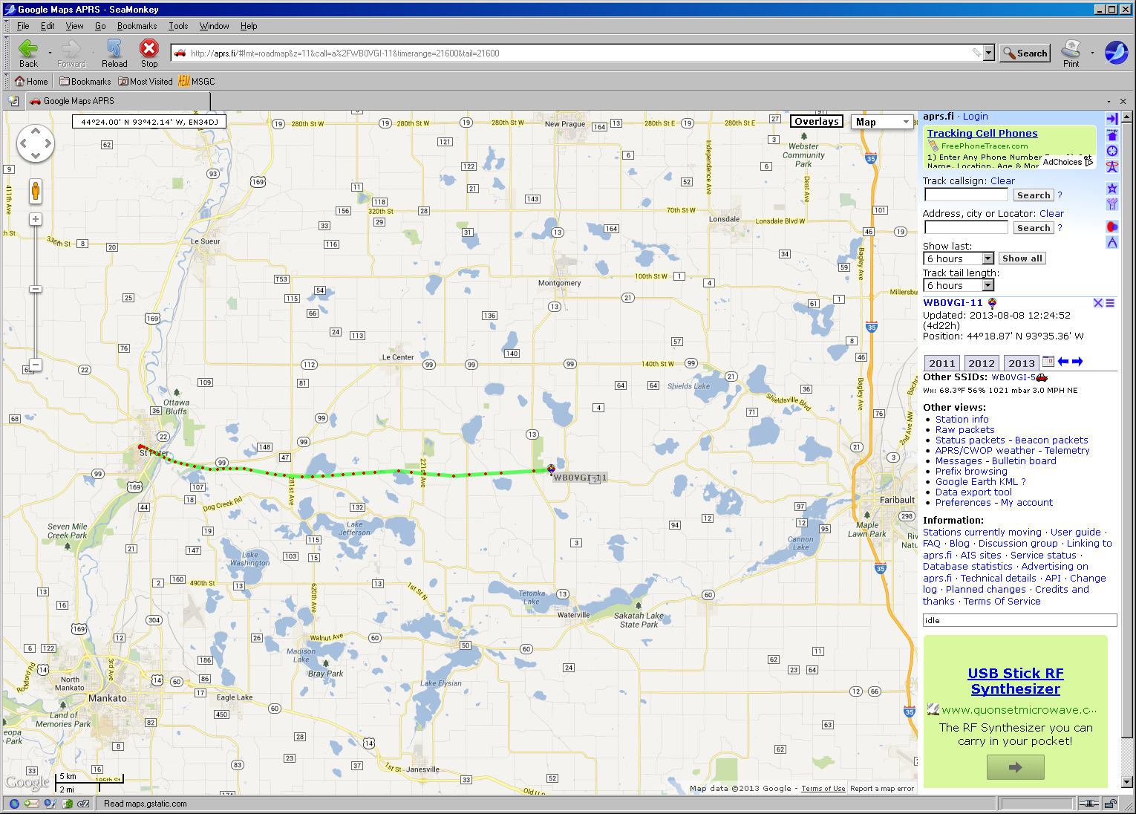

Final data point to make it to the internet – relatively early in ascent.

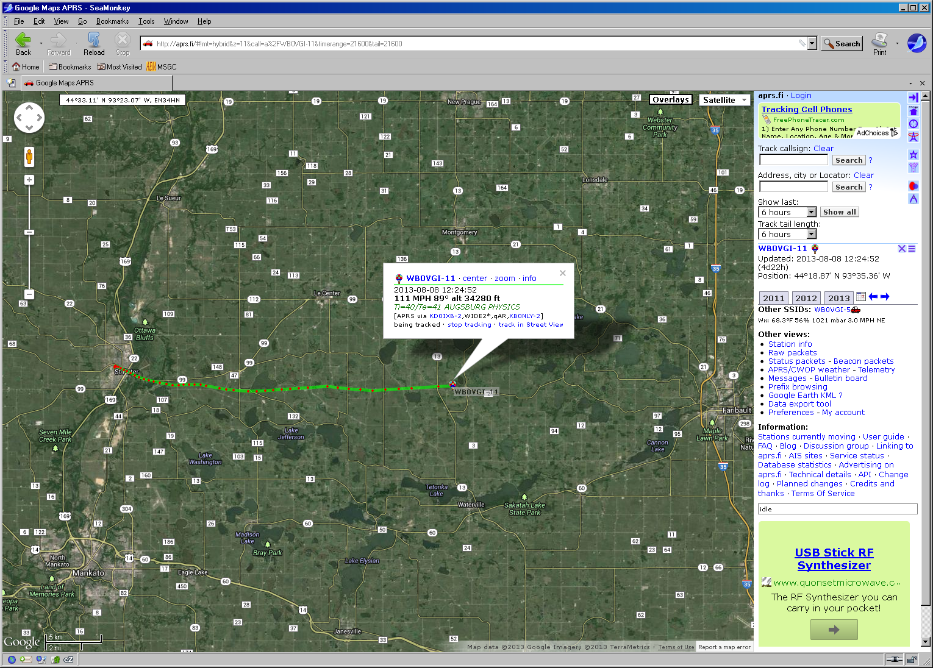

Raw data from WB0VGI-11 (Augsburg “Trackuino”) transmitter. (Red text indicating suspect data points has gone missing in cut-and-paste step but still identifiable by warning messages.)

2013-08-08 12:01:21 CDT: [**WB0VGI-11**](http://aprs.fi/?c=raw&limit=&call=WB0VGI-11)>APRS,[N0TZH-10*](http://aprs.fi/?c=raw&limit=&call=N0TZH-10),WIDE2,qAR,[W0KGW-10](http://aprs.fi/?c=raw&limit=&call=W0KGW-10):/170118h4419.75N/09358.19WO057/012/A=004138/Ti=107/Te=107 AUGSBURG PHYSICS  
2013-08-08 12:01:51 CDT: [**WB0VGI-11**](http://aprs.fi/?c=raw&limit=&call=WB0VGI-11)>APRS,[N0TZH-10*](http://aprs.fi/?c=raw&limit=&call=N0TZH-10),WIDE2,qAR,[W0KGW-10](http://aprs.fi/?c=raw&limit=&call=W0KGW-10):/170148h4419.82N/09358.18WO097/005/A=004832/Ti=107/Te=107 AUGSBURG PHYSICS  
2013-08-08 12:02:21 CDT: [**WB0VGI-11**](http://aprs.fi/?c=raw&limit=&call=WB0VGI-11)>APRS,[N0TZH-10*](http://aprs.fi/?c=raw&limit=&call=N0TZH-10),WIDE2,qAR,[N0GEF-7](http://aprs.fi/?c=raw&limit=&call=N0GEF-7):/170218h4419.84N/09358.14WO101/010/A=005510/Ti=107/Te=107 AUGSBURG PHYSICS  
2013-08-08 12:02:52 CDT: [**WB0VGI-11**](http://aprs.fi/?c=raw&limit=&call=WB0VGI-11)>APRS,[N0TZH-10*](http://aprs.fi/?c=raw&limit=&call=N0TZH-10),WIDE2,qAR,[N0GEF-7](http://aprs.fi/?c=raw&limit=&call=N0GEF-7):/170248h4419.82N/09358.06WO122/015/A=006183/Ti=107/Te=107 AUGSBURG PHYSICS  
2013-08-08 12:03:21 CDT: [**WB0VGI-11**](http://aprs.fi/?c=raw&limit=&call=WB0VGI-11)>APRS,[N0TZH-10*](http://aprs.fi/?c=raw&limit=&call=N0TZH-10),WIDE2,qAR,[W0KGW-10](http://aprs.fi/?c=raw&limit=&call=W0KGW-10):/170318h4419.78N/09357.94WO123/011/A=006833/Ti=107/Te=107 AUGSBURG PHYSICS  
2013-08-08 12:03:51 CDT: [**WB0VGI-11**](http://aprs.fi/?c=raw&limit=&call=WB0VGI-11)>APRS,[N0TZH-10*](http://aprs.fi/?c=raw&limit=&call=N0TZH-10),WIDE2,qAR,[W0KGW-10](http://aprs.fi/?c=raw&limit=&call=W0KGW-10):/170348h4419.73N/09357.75WO111/017/A=007535/Ti=107/Te=107 AUGSBURG PHYSICS  
2013-08-08 12:04:21 CDT: [**WB0VGI-11**](http://aprs.fi/?c=raw&limit=&call=WB0VGI-11)>APRS,[N9XH-3](http://aprs.fi/?c=raw&limit=&call=N9XH-3),WIDE2*,qAS,[W9ABA](http://aprs.fi/?c=raw&limit=&call=W9ABA):/170418h4419.65N/09357.56WO099/021/A=008203/Ti=107/Te=107 AUGSBURG PHYSICS  
2013-08-08 12:04:53 CDT: [**WB0VGI-11**](http://aprs.fi/?c=raw&limit=&call=WB0VGI-11)>APRS,[KD0IXB-2](http://aprs.fi/?c=raw&limit=&call=KD0IXB-2),WIDE2*,qAR,[KB0NLY-2](http://aprs.fi/?c=raw&limit=&call=KB0NLY-2):/170448h4419.58N/09357.35WO120/029/A=008893/Ti=107/Te=107 AUGSBURG PHYSICS  
2013-08-08 12:05:22 CDT: [**WB0VGI-11**](http://aprs.fi/?c=raw&limit=&call=WB0VGI-11)>APRS,[KD0BXJ-2*](http://aprs.fi/?c=raw&limit=&call=KD0BXJ-2),WIDE2*,qAR,[KD0BXJ-3](http://aprs.fi/?c=raw&limit=&call=KD0BXJ-3):/170518h4419.48N/09357.10WO124/028/A=009570/Ti=107/Te=107 AUGSBURG PHYSICS  
2013-08-08 12:05:50 CDT: [**WB0VGI-11**](http://aprs.fi/?c=raw&limit=&call=WB0VGI-11)>APRS,WIDE2-1,qAS,[NX0P](http://aprs.fi/?c=raw&limit=&call=NX0P):/170548h4419.37N/09356.83WO113/026/A=010211/Ti=107/Te=107 AUGSBURG PHYSICS  
2013-08-08 12:06:20 CDT: [**WB0VGI-11**](http://aprs.fi/?c=raw&limit=&call=WB0VGI-11)>APRS,WIDE2-1,qAS,[NX0P](http://aprs.fi/?c=raw&limit=&call=NX0P):/170618h4419.28N/09356.54WO101/027/A=010893/Ti=107/Te=107 AUGSBURG PHYSICS  
2013-08-08 12:06:50 CDT: [**WB0VGI-11**](http://aprs.fi/?c=raw&limit=&call=WB0VGI-11)>APRS,WIDE2-1,qAS,[NX0P](http://aprs.fi/?c=raw&limit=&call=NX0P):/170648h4419.19N/09356.21WO114/035/A=011590/Ti=107/Te=107 AUGSBURG PHYSICS  
2013-08-08 12:07:20 CDT: [**WB0VGI-11**](http://aprs.fi/?c=raw&limit=&call=WB0VGI-11)>APRS,WIDE2-1,qAS,[NX0P](http://aprs.fi/?c=raw&limit=&call=NX0P):/170718h4419.13N/09355.88WO091/035/A=012299/Ti=107/Te=107 AUGSBURG PHYSICS  
2013-08-08 12:07:50 CDT: [**WB0VGI-11**](http://aprs.fi/?c=raw&limit=&call=WB0VGI-11)>APRS,WIDE2-1,qAS,[NX0P](http://aprs.fi/?c=raw&limit=&call=NX0P):/170748h4419.09N/09355.52WO094/030/A=013005/Ti=107/Te=107 AUGSBURG PHYSICS  
2013-08-08 12:08:20 CDT: [**WB0VGI-11**](http://aprs.fi/?c=raw&limit=&call=WB0VGI-11)>APRS,WIDE2-1,qAS,[NX0P](http://aprs.fi/?c=raw&limit=&call=NX0P):/170818h4419.03N/09355.11WO104/040/A=013684/Ti=107/Te=107 AUGSBURG PHYSICS  
2013-08-08 12:08:50 CDT: [**WB0VGI-11**](http://aprs.fi/?c=raw&limit=&call=WB0VGI-11)>APRS,WIDE2-1,qAS,[NX0P](http://aprs.fi/?c=raw&limit=&call=NX0P):/170848h4418.97N/09354.66WO093/042/A=014348/Ti=107/Te=107 AUGSBURG PHYSICS  
2013-08-08 12:09:20 CDT: [**WB0VGI-11**](http://aprs.fi/?c=raw&limit=&call=WB0VGI-11)>APRS,WIDE2-1,qAS,[NX0P](http://aprs.fi/?c=raw&limit=&call=NX0P):/170918h4418.91N/09354.25WO096/040/A=014987/Ti=107/Te=107 AUGSBURG PHYSICS  
2013-08-08 12:09:50 CDT: [**WB0VGI-11**](http://aprs.fi/?c=raw&limit=&call=WB0VGI-11)>APRS,WIDE2-1,qAS,[NX0P](http://aprs.fi/?c=raw&limit=&call=NX0P):/170948h4418.90N/09353.86WO093/029/A=015580/Ti=107/Te=107 AUGSBURG PHYSICS  
2013-08-08 12:10:20 CDT: [**WB0VGI-11**](http://aprs.fi/?c=raw&limit=&call=WB0VGI-11)>APRS,WIDE2-1,qAS,[NX0P](http://aprs.fi/?c=raw&limit=&call=NX0P):/171018h4418.92N/09353.52WO101/026/A=016235/Ti=107/Te=107 AUGSBURG PHYSICS  
2013-08-08 12:10:50 CDT: [**WB0VGI-11**](http://aprs.fi/?c=raw&limit=&call=WB0VGI-11)>APRS,WIDE2-1,qAS,[NX0P](http://aprs.fi/?c=raw&limit=&call=NX0P):/171048h4418.93N/09353.15WO094/038/A=016885/Ti=107/Te=107 AUGSBURG PHYSICS  
2013-08-08 12:11:20 CDT: [**WB0VGI-11**](http://aprs.fi/?c=raw&limit=&call=WB0VGI-11)>APRS,WIDE2-1,qAS,[NX0P](http://aprs.fi/?c=raw&limit=&call=NX0P):/171118h4418.94N/09352.79WO079/033/A=017518/Ti=107/Te=107 AUGSBURG PHYSICS  
2013-08-08 12:11:50 CDT: [**WB0VGI-11**](http://aprs.fi/?c=raw&limit=&call=WB0VGI-11)>APRS,WIDE2-1,qAR,[KB0NLY-2](http://aprs.fi/?c=raw&limit=&call=KB0NLY-2):/171148h4418.94N/09352.37WO098/044/A=018231/Ti=107/Te=107 AUGSBURG PHYSICS  
2013-08-08 12:12:20 CDT: [**WB0VGI-11**](http://aprs.fi/?c=raw&limit=&call=WB0VGI-11)>APRS,WIDE2-1,qAR,[KB0NLY-2](http://aprs.fi/?c=raw&limit=&call=KB0NLY-2):/171218h4418.88N/09351.99WO109/032/A=018848/Ti=107/Te=107 AUGSBURG PHYSICS  
2013-08-08 12:13:20 CDT: [**WB0VGI-11**](http://aprs.fi/?c=raw&limit=&call=WB0VGI-11)>APRS,WIDE2-1,qAR,[KB0NLY-2](http://aprs.fi/?c=raw&limit=&call=KB0NLY-2):/171318h4418.74N/09351.09WO113/039/A=020114/Ti=107/Te=107 AUGSBURG PHYSICS  
2013-08-08 12:13:50 CDT: [**WB0VGI-11**](http://aprs.fi/?c=raw&limit=&call=WB0VGI-11)>APRS,WIDE2-1,qAR,[KB0NLY-2](http://aprs.fi/?c=raw&limit=&call=KB0NLY-2):/171348h4418.68N/09350.63WO087/047/A=020809/Ti=107/Te=107 AUGSBURG PHYSICS  
2013-08-08 12:14:20 CDT: [**WB0VGI-11**](http://aprs.fi/?c=raw&limit=&call=WB0VGI-11)>APRS,WIDE2-1,qAR,[KB0NLY-2](http://aprs.fi/?c=raw&limit=&call=KB0NLY-2):/171418h4418.65N/09350.15WO101/036/A=021429/Ti=107/Te=107 AUGSBURG PHYSICS  
2013-08-08 12:15:22 CDT: [**WB0VGI-11**](http://aprs.fi/?c=raw&limit=&call=WB0VGI-11)>APRS,[KD0IXB-2](http://aprs.fi/?c=raw&limit=&call=KD0IXB-2),WIDE2*,qAR,[KB0NLY-2](http://aprs.fi/?c=raw&limit=&call=KB0NLY-2):/171518h4418.60N/09349.15WO085/041/A=022611/Ti=107/Te=107 AUGSBURG PHYSICS  
2013-08-08 12:15:52 CDT: [**WB0VGI-11**](http://aprs.fi/?c=raw&limit=&call=WB0VGI-11)>APRS,[KD0IXB-2](http://aprs.fi/?c=raw&limit=&call=KD0IXB-2),WIDE2*,qAR,[KB0NLY-2](http://aprs.fi/?c=raw&limit=&call=KB0NLY-2):/171548h4418.62N/09348.58WO083/056/A=023300/Ti=107/Te=107 AUGSBURG PHYSICS  
2013-08-08 12:16:20 CDT: [**WB0VGI-11**](http://aprs.fi/?c=raw&limit=&call=WB0VGI-11)>APRS,WIDE2-1,qAS,[NX0P](http://aprs.fi/?c=raw&limit=&call=NX0P):/171618h4418.63N/09348.00WO082/051/A=023939/Ti=107/Te=107 AUGSBURG PHYSICS  
2013-08-08 12:16:50 CDT: [**WB0VGI-11**](http://aprs.fi/?c=raw&limit=&call=WB0VGI-11)>APRS,WIDE2-1,qAS,[NX0P](http://aprs.fi/?c=raw&limit=&call=NX0P):/171648h4418.65N/09347.44WO081/049/A=024565/Ti=107/Te=107 AUGSBURG PHYSICS  
2013-08-08 12:17:01 CDT: [**WB0VGI-11**](http://aprs.fi/?c=raw&limit=&call=WB0VGI-11)>APRS,[KB0JBF-1*](http://aprs.fi/?c=raw&limit=&call=KB0JBF-1),WIDE2,qAR,[KC0VII](http://aprs.fi/?c=raw&limit=&call=KC0VII):/171618h4418.63N/09348.00WO082/051/A=023939/Ti=107/Te=107 AUGSBURG PHYSICS **[Delayed or out-of-order packet (timestamp)]**  
2013-08-08 12:17:20 CDT: [**WB0VGI-11**](http://aprs.fi/?c=raw&limit=&call=WB0VGI-11)>APRS,WIDE2-1,qAS,[NX0P](http://aprs.fi/?c=raw&limit=&call=NX0P):/171718h4418.69N/09346.87WO078/053/A=025162/Ti=107/Te=107 AUGSBURG PHYSICS  
2013-08-08 12:17:50 CDT: [**WB0VGI-11**](http://aprs.fi/?c=raw&limit=&call=WB0VGI-11)>APRS,WIDE2-1,qAS,[K0GV](http://aprs.fi/?c=raw&limit=&call=K0GV):/171748h4418.73N/09346.32WO086/057/A=025698/Ti=107/Te=107 AUGSBURG PHYSICS  
2013-08-08 12:18:20 CDT: [**WB0VGI-11**](http://aprs.fi/?c=raw&limit=&call=WB0VGI-11)>APRS,WIDE2-1,qAS,[K0GV](http://aprs.fi/?c=raw&limit=&call=K0GV):/171818h4418.75N/09345.74WO090/058/A=026360/Ti=107/Te=107 AUGSBURG PHYSICS  
2013-08-08 12:18:50 CDT: [**WB0VGI-11**](http://aprs.fi/?c=raw&limit=&call=WB0VGI-11)>APRS,WIDE2-1,qAS,[K0GV](http://aprs.fi/?c=raw&limit=&call=K0GV):/171848h4418.78N/09345.13WO094/054/A=026963/Ti=107/Te=107 AUGSBURG PHYSICS  
2013-08-08 12:19:50 CDT: [**WB0VGI-11**](http://aprs.fi/?c=raw&limit=&call=WB0VGI-11)>APRS,WIDE2-1,qAS,[NX0P](http://aprs.fi/?c=raw&limit=&call=NX0P):/171948h4418.84N/09343.81WO089/062/A=028188/Ti=107/Te=107 AUGSBURG PHYSICS  
2013-08-08 12:20:20 CDT: [**WB0VGI-11**](http://aprs.fi/?c=raw&limit=&call=WB0VGI-11)>APRS,WIDE2-1,qAS,[NX0P](http://aprs.fi/?c=raw&limit=&call=NX0P):/172018h4418.79N/09343.09WO097/066/A=028730/Ti=107/Te=107 AUGSBURG PHYSICS  
2013-08-08 12:20:50 CDT: [**WB0VGI-11**](http://aprs.fi/?c=raw&limit=&call=WB0VGI-11)>APRS,WIDE2-1,qAS,[NX0P](http://aprs.fi/?c=raw&limit=&call=NX0P):/172048h4418.72N/09342.33WO095/066/A=029259/Ti=107/Te=107 AUGSBURG PHYSICS  
2013-08-08 12:21:23 CDT: [**WB0VGI-11**](http://aprs.fi/?c=raw&limit=&call=WB0VGI-11)>APRS,[K0LAV-8](http://aprs.fi/?c=raw&limit=&call=K0LAV-8),WIDE2*,qAR,[KD0KYA](http://aprs.fi/?c=raw&limit=&call=KD0KYA):/172118h4418.68N/09341.56WO094/073/A=029969/Ti=107/Te=107 AUGSBURG PHYSICS  
2013-08-08 12:21:50 CDT: [**WB0VGI-11**](http://aprs.fi/?c=raw&limit=&call=WB0VGI-11)>APRS,WIDE2-1,qAS,[NX0P](http://aprs.fi/?c=raw&limit=&call=NX0P):/172148h4418.64N/09340.75WO088/073/A=030676/Ti=106/Te=107 AUGSBURG PHYSICS  
2013-08-08 12:22:20 CDT: [**WB0VGI-11**](http://aprs.fi/?c=raw&limit=&call=WB0VGI-11)>APRS,WIDE2-1,qAS,[NX0P](http://aprs.fi/?c=raw&limit=&call=NX0P):/172218h4418.68N/09339.87WO085/070/A=031325/Ti=99/Te=100 AUGSBURG PHYSICS  
2013-08-08 12:22:53 CDT: [**WB0VGI-11**](http://aprs.fi/?c=raw&limit=&call=WB0VGI-11)>APRS,[K0LAV-8](http://aprs.fi/?c=raw&limit=&call=K0LAV-8),WIDE2*,qAR,[KD0KYA](http://aprs.fi/?c=raw&limit=&call=KD0KYA):/172248h4418.71N/09338.97WO085/070/A=031913/Ti=93/Te=94 AUGSBURG PHYSICS  
2013-08-08 12:23:20 CDT: [**WB0VGI-11**](http://aprs.fi/?c=raw&limit=&call=WB0VGI-11)>APRS,WIDE2-1,qAS,[NX0P](http://aprs.fi/?c=raw&limit=&call=NX0P):/172318h4418.74N/09338.12WO084/071/A=032490/Ti=81/Te=82 AUGSBURG PHYSICS  
2013-08-08 12:24:20 CDT: [**WB0VGI-11**](http://aprs.fi/?c=raw&limit=&call=WB0VGI-11)>APRS,WIDE2-1,qAS,[NX0P](http://aprs.fi/?c=raw&limit=&call=NX0P):/172418h4418.83N/09336.31WO084/082/A=033592/Ti=75/Te=74 AUGSBURG PHYSICS  
2013-08-08 12:24:52 CDT: [**WB0VGI-11**](http://aprs.fi/?c=raw&limit=&call=WB0VGI-11)>APRS,[KD0IXB-2](http://aprs.fi/?c=raw&limit=&call=KD0IXB-2),WIDE2*,qAR,[KB0NLY-2](http://aprs.fi/?c=raw&limit=&call=KB0NLY-2):/172448h4418.87N/09335.36WO089/096/A=034280/Ti=40/Te=41 AUGSBURG PHYSICS  
2013-08-08 12:26:35 CDT: [**WB0VGI-11**](http://aprs.fi/?c=raw&limit=&call=WB0VGI-11)>APRS,[N9XH-3](http://aprs.fi/?c=raw&limit=&call=N9XH-3),WIDE2*,qAR,[N9CHA-4](http://aprs.fi/?c=raw&limit=&call=N9CHA-4):/000000h0000.00N/00000.00EO000/000/A=000000/Ti=105/Te=100 AUGSBURG PHYSICS **[Latitude and longitude are both 0]**  
2013-08-08 12:27:03 CDT: [**WB0VGI-11**](http://aprs.fi/?c=raw&limit=&call=WB0VGI-11)>APRS,WIDE2-1,qAS,[NX0P](http://aprs.fi/?c=raw&limit=&call=NX0P):/000000h0000.00N/00000.00EO000/000/A=000000/Ti=106/Te=104 AUGSBURG PHYSICS **[Latitude and longitude are both 0]**  
2013-08-08 12:28:08 CDT: [**WB0VGI-11**](http://aprs.fi/?c=raw&limit=&call=WB0VGI-11)>APRS,[K0LAV-8](http://aprs.fi/?c=raw&limit=&call=K0LAV-8),WIDE2*,qAR,[W0YC-10](http://aprs.fi/?c=raw&limit=&call=W0YC-10):/000000h0000.00N/00000.00EO000/000/A=000000/Ti=90/Te=89 AUGSBURG PHYSICS **[Latitude and longitude are both 0]**  
2013-08-08 12:29:07 CDT: [**WB0VGI-11**](http://aprs.fi/?c=raw&limit=&call=WB0VGI-11)>APRS,[K0LAV-8](http://aprs.fi/?c=raw&limit=&call=K0LAV-8),WIDE2*,qAR,[KD0KYA](http://aprs.fi/?c=raw&limit=&call=KD0KYA):/000000h0000.00N/00000.00EO000/000/A=000000/Ti=67/Te=66 AUGSBURG PHYSICS **[Latitude and longitude are both 0]**